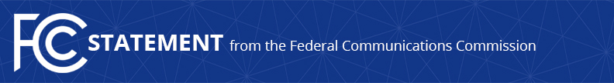

Media Contact:
David Grossman, (202) 418-2100
david.grossman@fcc.gov

For Immediate Release

STATEMENT OF COMMISSIONER MIGNON CLYBURN
On the Net Neutrality Day of Action
-
WASHINGTON, July 12, 2017 – The following statement can be attributed to FCC Commissioner Mignon Clyburn:

“Today I stand with those who believe that a free and open internet is a foundational principle of our democracy. Its benefits can be felt across our economy and around the globe. That is why I am excited that on this day consumers, entrepreneurs and companies of all sizes, including broadband providers and internet startups, are speaking out with a unified voice in favor of strong net neutrality rules grounded in Title II. Knowing that the arc of success is bent in our favor and we are on the right side of history, I remain committed to doing everything I can to protect the most empowering and inclusive platform of our time.”
###

Office of Commissioner Mignon Clyburn: (202) 418-2100
Twitter: @MClyburnFCC
www.fcc.gov

This is an unofficial announcement of Commission action. Release of the full text of a Commission order constitutes official action. See MCI v. FCC, 515 F.2d 385 (D.C. Cir. 1974).

