FEDERAL COMMUNICATIONS COMMISSION
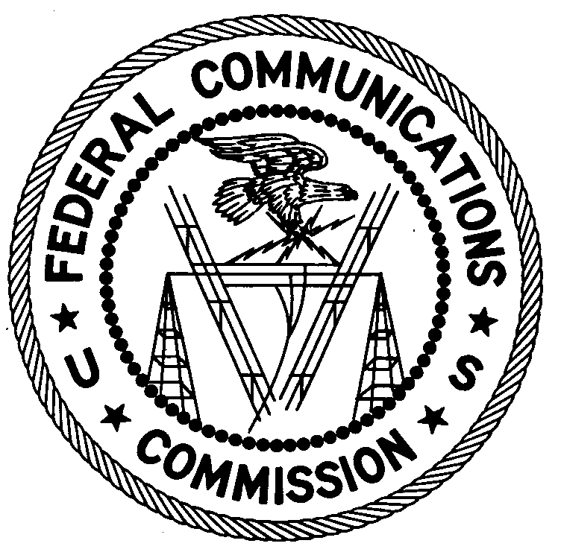ENFORCEMENT BUREAU
REGION TWO

Atlanta Regional Office
3600 Hiram Lithia Springs Rd SW
Powder Springs, GA 30127
(678) 293-3194

August 21, 2017

Gilberto Cerrato and Jamie Cerrato
Sherwood, Arkansas

NOTICE OF UNLICENSED OPERATION

Case Number: EB-FIELDSCR-17-00024373

The New Orleans Office (New Orleans Office) of the Federal Communications Commission’s (FCC’s or Commission’s) Enforcement Bureau (Bureau) received information that an unlicensed broadcast radio station on 97.9 MHz was allegedly operating in Sherwood, Arkansas. On June 13, 2017, agents from this office confirmed by direction finding techniques that radio signals on frequency 97.9 MHz were emanating from a registered antenna structure with registration number 1058440, located in Sherwood, Arkansas. The Commission’s records show that no license was issued for operation of a broadcast station on 97.9 MHz at this location in Sherwood, Arkansas.

Radio stations operating on a range of frequencies, including 97.9 MHz, must be licensed by the FCC pursuant to Section 301 of the Communications Act of 1934, as amended. The only exception to this licensing requirement is for certain transmitters using or operating at a power level or mode of operation that complies with the standards established in Part 15 of the Commission’s rules. The field strength of the signal on frequency 97.9 MHz was measured at 1,320,691 microvolts per meter (µV/m) at 4955.7 meters, which exceeded the maximum permitted level of 250 µV/m at 3 meters for non-licensed devices. Thus, this station is operating in violation of Section 301 of the Act.

You are hereby warned that operation of radio transmitting equipment without a valid radio station authorization constitutes a violation of the Federal laws cited above and could subject the operator to severe penalties, including, but not limited to, substantial monetary fines, in rem arrest action against the offending radio equipment, and criminal sanctions including imprisonment.

UNLICENSED OPERATION OF THIS RADIO STATION MUST BE DISCONTINUED IMMEDIATELY.

You have ten (10) days from the date of this notice to respond with any evidence that you have authority to operate granted by the FCC. Your response should be sent to the address in the letterhead and reference the listed case number. Under the Privacy Act of 1974, we are informing you that the Commission’s staff will use all relevant material information before it to determine what, if any, enforcement action is required to ensure your compliance with FCC Rules. This will include any information that you disclose in your reply.

You may contact this office if you have any questions.

Ronald Ramage
Regional Director
Region Two
Enforcement Bureau
Federal Communications Commission

Attachments:
Excerpts from the Communications Act of 1934, As Amended
Enforcement Bureau, "Inspection Fact Sheet", March 2005

47 CFR 73.201.
47 U.S.C. § 301.
47 CFR §§ 15.1 et seq.
47 U.S.C. § 301.
See 47 U.S.C. § 401, 501, 503, 510.
5 U.S.C. § 552a(e)(3),

