FEDERAL COMMUNICATIONS COMMISSION
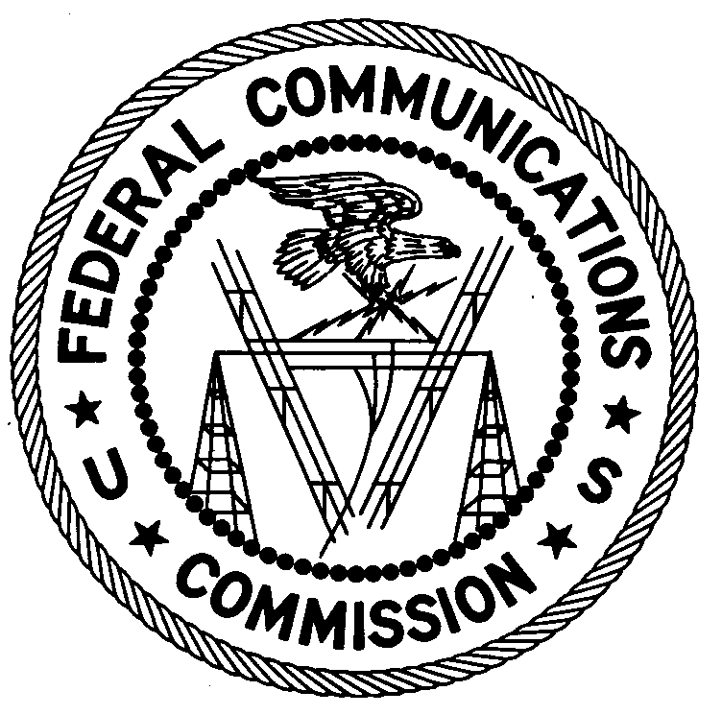
ENFORCEMENT BUREAU
REGION ONE

Columbia Office
9200 Farm House Lane

Columbia, Maryland 21046
301-725-1996

August 28, 2017

Jonathan Michael Campbell
Uniontown, Pennsylvania

NOTICE OF UNLICENSED OPERATION

Case Number: EB-FIELDNER-17-00024774

On July 18, 2017, an Agent from the Columbia office (Columbia Office) of the Federal Communications Commission’s (FCC’s or Commission’s) Enforcement Bureau (Bureau) responded to a complaint from Fayette County 911 alleging that a person was making unauthorized radio transmissions on frequency 155.190 MHz. Upon further investigation, the Agent determined that you improperly operated a radio transmitter on the frequency 155.190 MHz and caused harmful interference to emergency fire communications on 155.190 MHz. Commission records show that you are not authorized to operate on the frequency 155.190 MHz. You admitted to an Agent that you were responsible for the unauthorized transmissions and that you have no authorization to operate on the frequency 155.190 MHz.

Radio stations must be licensed by the FCC pursuant to Section 301 of the Communications Act of 1934, as amended (Act). The only exception to this licensing requirement is for certain transmitters using or operating at a power level that complies with the standards established in Part 15 of the Commission’s rules. On July 18, 2017, you operated on frequency 155.190 MHz without an authorization. Thus, your station is operating in violation of Section 301 of the Act.

You are hereby warned that operation of radio transmitting equipment without a valid radio station authorization constitutes a violation of the Federal laws cited above and could subject the operator to severe penalties, including, but not limited to, substantial monetary fines, in rem arrest action against the offending radio equipment, and criminal sanctions including imprisonment.

UNLICENSED OPERATION OF THIS RADIO STATION MUST BE DISCONTINUED IMMEDIATELY.

You have ten (10) days from the date of this notice to respond with any evidence that you have authority to operate granted by the FCC. Your response should be sent to the address in the letterhead and reference the listed case and document number. Under the Privacy Act of 1974, we are informing you that the Commission’s staff will use all relevant material information before it to determine what, if any, enforcement action is required to ensure your compliance with FCC Rules. This will include any information that you disclose in your reply.

You may contact this office if you have any questions.

David C. Dombrowski
Regional Director
Region One
Enforcement Bureau
Federal Communications Commission

Attachments:
Excerpts from the Communications Act of 1934, As Amended
Enforcement Bureau, "Inspection Fact Sheet", March 2005

47 U.S.C. § 301.
47 CFR §§ 15.1 et seq.
47 U.S.C. § 301.
See 47 U.S.C. §§ 401, 501, 503 and 510.
5 U.S.C. § 552a(e)(3),

