FEDERAL COMMUNICATIONS COMMISSION
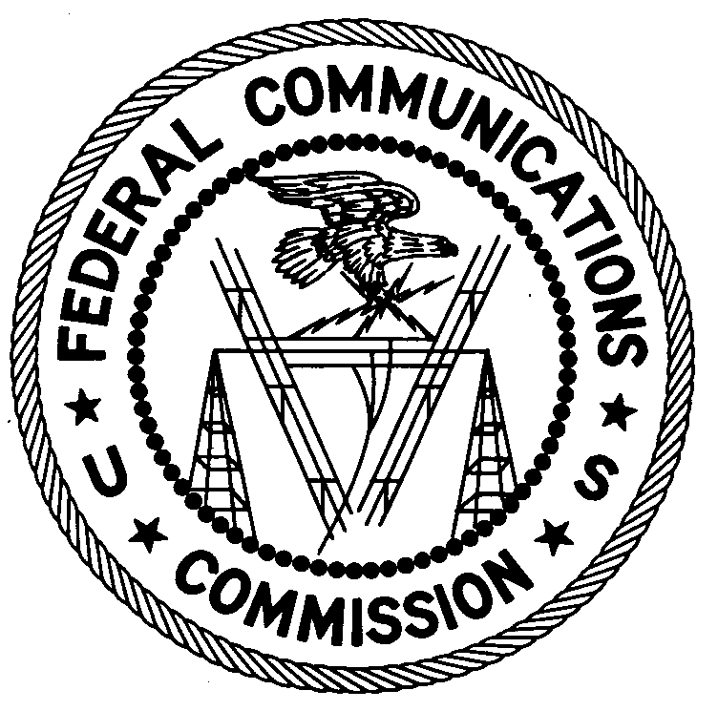
ENFORCEMENT BUREAU
REGION THREE

Los Angeles Regional Office
18000 Studebaker Rd., #660
Cerritos, CA 90703
(562) 860-7474

August 28, 2017

Anchorage Baptist Temple
Anchorage, AK 99504

NOTICE OF UNLICENSED OPERATION

Case Number: EB-FIELDWR-17-00024477

On July 26, 2017, Agents from the San Francisco and Los Angeles Offices of the Federal Communications Commission’s (FCC’s or Commission’s) Enforcement Bureau (Bureau) confirmed by direction finding techniques that radio signals on frequency 99.9 MHz were emanating from your church located at 6401 E. Northern Lights Blvd. in Anchorage, Alaska. The Commission’s records show that no license was issued for operation of a broadcast station at this location on 99.9 MHz in Anchorage, Alaska.

Radio stations operating on a range of frequencies, including 99.9 MHz, must be licensed by the FCC pursuant to Section 301 of the Communications Act of 1934, as amended (Act). The only exception to this licensing requirement is for certain transmitters using or operating at a power level that complies with the standards established in Part 15 of the Commission’s rules. On July 26, 2017, the field strength of the signal on frequency 99.9 MHz exceeded the maximum permitted level of 250 microvolts per meter (µV/m) at 3 meters for non-licensed devices. Thus, this station was operating in violation of Section 301 of the Act.

You are hereby warned that operation of radio transmitting equipment without a valid radio station authorization constitutes a violation of the Federal laws cited above and could subject the operator to severe penalties, including, but not limited to, substantial monetary fines, in rem arrest action against the offending radio equipment, and criminal sanctions including imprisonment.

UNLICENSED OPERATION OF THIS RADIO STATION MUST NOT RESUME.

You have ten (10) days from the date of this notice to respond with any evidence that you have authority to operate granted by the FCC. Your response should be sent to the address in the letterhead and reference the listed case and document number. Under the Privacy Act of 1974, we are informing you that the Commission’s staff will use all relevant material information before it to determine what, if any, enforcement action is required to ensure your compliance with FCC Rules. This will include any information that you disclose in your reply.

You may contact this office if you have any questions.

Lark Hadley
Regional Director
Region Three
Enforcement Bureau
Federal Communications Commission

Attachments:
Excerpts from the Communications Act of 1934, As Amended
Enforcement Bureau, "Inspection Fact Sheet," March 2005

47 CFR § 73.201.
47 U.S.C. § 301.
47 CFR §§ 15.1 et seq.
47 U.S.C. § 301.
See 47 U.S.C. §§ 401, 501, 503 and 510.
5 U.S.C. § 552a(e)(3).

