Communications Status Report for
Areas Impacted by Hurricane Irma
September 8, 2017

The following is a report on the status of communications services in geographic areas impacted by Hurricane Irma as of September 8, 2017 at 11:00 a.m. EDT. This report incorporates network outage data submitted by communications providers to the Federal Communications Commission’s Disaster Information Reporting System (DIRS). DIRS is currently activated for all areas of Puerto Rico and the U.S. Virgin Islands. Note that the operational status of communications services during a disaster may evolve rapidly, and this report represents a snapshot in time. It should also be noted that not all communications providers have reported in DIRS, so some outage information may be missing.

Yesterday’s report covered only the northern and eastern counties of Puerto Rico and all three counties of the U.S. Virgin Islands. Based on the information in yesterday’s report, the Department of Homeland Security and the Federal Communications Commission decided to extend the data collection to all counties/municipalities in Puerto Rico.

The following counties are in the current geographic area that is covered by the DIRS activation (the “disaster area”).

Puerto Rico: Adjuntas, Aguada, Aguadilla, Aguas Buenas, Aibonito, Anasco, Arecibo, Arroyo, Barceloneta, Barranquitas, Bayamon, Cabo Rojo, Caguas, Camuy, Canovanas, Carolina, Catano, Cayey, Ceiba, Ciales, Cidra, Coamo, Comerio, Corozal, Culebra, Dorado, Fajardo, Florida, Guanica, Guayama, Guayanilla, Guaynabo, Gurabo, Hatillo, Hormigueros, Humacao, Isabela, Jayuya, Juana Diaz, Juncos, Lajas, Lares, Las Marias, Las Piedras, Loiza, Luquillo, Manati, Maricao, Maunabo, Mayaguez, Moca, Morovis, Naguabo, Naranjito, Orocovis, Patillas, Penuelas, Ponce, Quebradillas, Rincon, Rio Grande, Sabana Grande, Salinas, San German, San Juan, San Lorenzo, San Sebastian, Santa Isabel, Toa Alta, Toa Baja, Trujillo Alto, Utuado, Vega Alta, Vega Baja, Vieques, Villalba, Yabucoa, Yauco
U.S. Virgin Islands: St. Croix, St. John, St. Thomas

911 Services
The Public Safety and Homeland Security Bureau (PSHSB) learns the status of each Public Safety Answering Point (PSAP) through the filings of 911 Service Providers in the Disaster Information Reporting System (DIRS), reporting to the FCC’s Public Safety Support Center (PSSC), coordination with state 911 Administrators, and, if necessary, from individual PSAPs.

There are a total of 4 PSAPs affected in the reporting area:

- Operational without Automatic Location Information (ALI): 2 (Centro de Guaynabo, PR and Centro de Hato Rey, PR)
- Operational without ALI or Automatic Numbering Information (ANI): 2 (both PSAPs in the U.S. Virgin Islands)

Wireless Services
The following section describes the status of wireless communications services and restoration in the disaster area, including the percentage of cell sites out of service for each county.

The following map of the disaster area illustrates which counties in Puerto Rico are most affected:

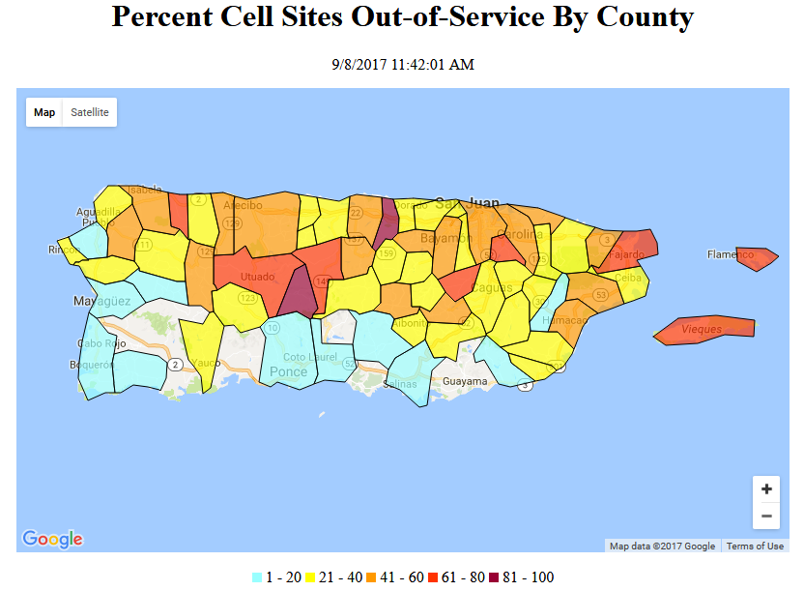

The following table provides the percentage of cell sites out of service by county. 38.9% of cell sites are out of service in the affected area. Note: Comparisons should not be made with the overall percentage in yesterday’s report, as that report did not include all of Puerto Rico, only most of the hardest hit areas.
Over 50% of cell sites are out of service in the following counties:
- Puerto Rico: Aguas Buenas, Barranquitas, Carolina, Ciales, Cidra, Culebra, Fajardo, Isabela, Jayuya, Lares, Loiza, Luquillo, Quebradillas, San Juan, Trujillo Alto, Utuado, Vega Alta and Vieques.
- U.S. Virgin Islands: St. John and St. Thomas
The information shown was provided by the signatories to the Wireless Resiliency Cooperative Framework and one additional company that agreed to allow us to include its data in the aggregated data:

State | Affected Counties | Cell Sites Served | Cell Sites Out | Percent Out
PR | AGUADILLA | 34 | 8 | 23.5%
PR | AGUAS BUENAS | 11 | 8 | 72.7%
PR | ARECIBO | 43 | 20 | 46.5%
PR | BARCELONETA | 15 | 6 | 40.0%
PR | BAYAMON | 104 | 44 | 42.3%
PR | CAGUAS | 67 | 24 | 35.8%
PR | CAMUY | 11 | 4 | 36.4%
PR | CANOVANAS | 20 | 7 | 35.0%
PR | CAROLINA | 88 | 52 | 59.1%
PR | CATANO | 14 | 3 | 21.4%
PR | CEIBA | 8 | 3 | 37.5%
PR | COROZAL | 13 | 5 | 38.5%
PR | CULEBRA | 5 | 4 | 80.0%
PR | DORADO | 28 | 11 | 39.3%
PR | FAJARDO | 25 | 17 | 68.0%
PR | FLORIDA | 4 | 1 | 25.0%
PR | GUAYNABO | 66 | 23 | 34.8%
PR | GURABO | 22 | 8 | 36.4%
PR | HATILLO | 19 | 8 | 42.1%
PR | HUMACAO | 29 | 12 | 41.4%
PR | ISABELA | 20 | 11 | 55.0%
PR | JUNCOS | 14 | 4 | 28.6%
PR | LAS PIEDRAS | 12 | 2 | 16.7%
PR | LOIZA | 7 | 4 | 57.1%
PR | LUQUILLO | 9 | 5 | 55.6%
PR | MANATI | 21 | 8 | 38.1%
PR | MAUNABO | 8 | 2 | 25.0%
PR | MOROVIS | 11 | 5 | 45.5%
PR | NAGUABO | 16 | 7 | 43.8%
PR | NARANJITO | 15 | 5 | 33.3%
PR | QUEBRADILLAS | 13 | 8 | 61.5%
PR | RIO GRANDE | 30 | 8 | 26.7%
PR | SAN JUAN | 251 | 133 | 53.0%
PR | SAN LORENZO | 13 | 3 | 23.1%
PR | TOA ALTA | 31 | 14 | 45.2%
PR | TOA BAJA | 41 | 15 | 36.6%
PR | TRUJILLO ALTO | 32 | 22 | 68.8%
PR | VEGA ALTA | 22 | 18 | 81.8%
PR | VEGA BAJA | 26 | 12 | 46.2%
PR | VIEQUES | 8 | 6 | 75.0%
PR | YABUCOA | 17 | 4 | 23.5%
PR | ADJUNTAS | 5 | 2 | 40.0%
PR | AGUADA | 11 | 2 | 18.2%
PR | AIBONITO | 13 | 3 | 23.1%
PR | ANASCO | 9 | 3 | 33.3%
PR | ARROYO | 6 | 0 | 0.0%
PR | BARRANQUITAS | 8 | 4 | 50.0%
PR | CABO ROJO | 34 | 4 | 11.8%
PR | CAYEY | 26 | 7 | 26.9%
PR | CIALES | 9 | 6 | 66.7%
PR | CIDRA | 16 | 9 | 56.3%
PR | COAMO | 11 | 1 | 9.1%
PR | COMERIO | 13 | 5 | 38.5%
PR | GUANICA | 9 | 0 | 0.0%
PR | GUAYAMA | 16 | 0 | 0.0%
PR | GUAYANILLA | 5 | 0 | 0.0%
PR | HORMIGUEROS | 8 | 0 | 0.0%
PR | JAYUYA | 4 | 4 | 100.0%
PR | JUANA DIAZ | 21 | 2 | 9.5%
PR | LAJAS | 11 | 1 | 9.1%
PR | LARES | 6 | 3 | 50.0%
PR | LAS MARIAS | 5 | 1 | 20.0%
PR | MARICAO | 3 | 0 | 0.0%
PR | MAYAGUEZ | 44 | 8 | 18.2%
PR | MOCA | 9 | 4 | 44.4%
PR | OROCOVIS | 8 | 3 | 37.5%
PR | PATILLAS | 10 | 2 | 20.0%
PR | PENUELAS | 12 | 0 | 0.0%
PR | PONCE | 74 | 4 | 5.4%
PR | RINCON | 10 | 4 | 40.0%
PR | SABANA GRANDE | 7 | 0 | 0.0%
PR | SALINAS | 23 | 4 | 17.4%
PR | SAN GERMAN | 13 | 0 | 0.0%
PR | SAN SEBASTIAN | 13 | 3 | 23.1%
PR | SANTA ISABEL | 11 | 0 | 0.0%
PR | UTUADO | 10 | 7 | 70.0%
PR | VILLALBA | 4 | 0 | 0.0%
PR | YAUCO | 13 | 3 | 23.1%
VI | ST. CROIX | 44 | 19 | 43.2%
VI | ST. JOHN | 12 | 9 | 75.0%
VI | ST. THOMAS | 79 | 44 | 55.7%
TOTAL |  | 1,888 | 735 | 38.9%

Cable Systems and Wireline (Combined)
Since there are widespread power outages over Puerto Rico and the U.S. Virgin Islands, the FCC has received reports that large percentages of consumers are without either cable services or wireline service.

Broadcast
Based on the limited input into DIRS, there are no stations reported out of service.

