FEDERAL COMMUNICATIONS COMMISSION
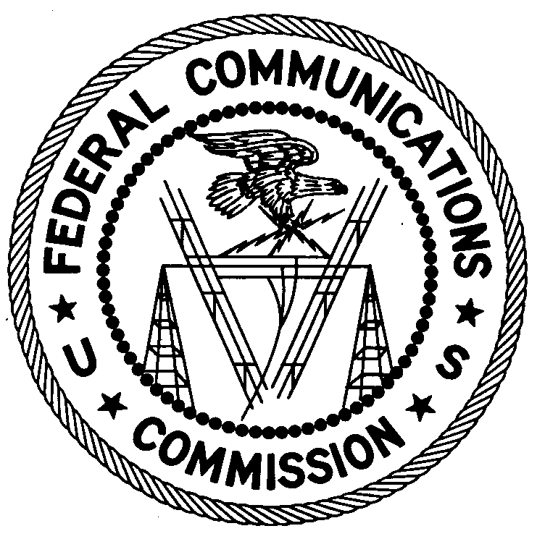
ENFORCEMENT BUREAU
REGION THREE

Los Angeles Regional Office
18000 Studebaker Rd., #660

Cerritos, CA 90703

Field@FCC.gov
(562) 860-7474

September 12, 2017

Bosch Communications Systems
8601 East Cornhusker Hwy
Lincoln, NE 68507

NOTICE OF UNLICENSED OPERATION

Case Number: EB-FIELDWR-17-00024754

On July 25, 2017, an Agent from the San Francisco Office (San Francisco Office) of the Federal Communications Commission’s (FCC’s or Commission’s) Enforcement Bureau (Bureau) responded to a complaint from the National Oceanic and Atmospheric Administration (NOAA) concerning interference to their Search And Rescue Satellite Aided Tracking (SARSAT) operation in Lincoln, Nebraska. The Agent from the San Francisco Office confirmed by direction finding techniques that a signal on frequency 406.012 MHz was emanating from Bosch Communications Systems (BCS) in Lincoln, Nebraska.

At the time of inspection, the Agent found that a radio transmitter operating as part of BCS’s trunking system was transmitting a signal on 406.012 MHz. After turning off this transmitter, the interference to NOAA’s SARSAT system ceased. BCS’s trunking system was being tested for use as part of the FirstNet system. The BCS manager, Mr. Ninh, stated that he does not have an FCC station license on this frequency.

Radio stations must be licensed by the FCC pursuant to the Communications Act of 1934, as amended (Act). The only exception to this licensing requirement is for certain transmitters using or operating at a power level that complies with the standards established in Part 15 of the Commission’s rules. This station is operating in violation of Section 301 of the Act.

You are hereby warned that operation of radio transmitting equipment without a valid radio station authorization constitutes a violation of the Federal laws cited above and could subject the operator of this illegal operation to severe penalties, including, but not limited to, substantial monetary forfeitures, in rem arrest action against the offending radio equipment, and criminal sanctions including imprisonment.

UNLICENSED OPERATION OF THIS RADIO STATION MUST BE DISCONTINUED IMMEDIATELY.

You have ten (10) days from the date of this notice to respond with any evidence that you have authority to operate granted by the FCC. Your response should be sent to the address in the letterhead and reference the listed case number.

Under the Privacy Act of 1974, we are informing you that the Commission’s staff will use all relevant material information before it to determine what, if any, enforcement action is required to ensure your compliance with FCC Rules. This will include any information that you disclose in your reply.

You may contact this office if you have any questions.

Lark Hadley
Regional Director
Region Three
Enforcement Bureau

Attachments:
Excerpts from the Communications Act of 1934, As Amended
Enforcement Bureau, "Inspection Fact Sheet," March 2005

47 U.S.C. § 301.
47 CFR §§ 15.1 et seq.
47 U.S.C. § 301.
See 47 U.S.C. §§ 401, 501, 503 and 510.
5 U.S.C. § 552a(e)(3).

