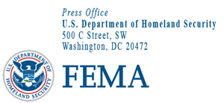

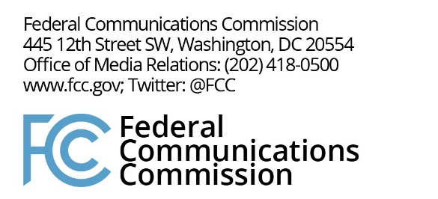

September 25, 2017
FEMA Media Contact:
FEMA News Desk, (202) 646-3272
FCC Media Contact:
Rochelle Cohen, (202) 418-1162
rochelle.cohen@fcc.gov

For Immediate Release
Nationwide Emergency Alert System Test Planned for September 27
FEMA and FCC Share Key Points About Test
WASHINGTON – The Federal Emergency Management Agency (FEMA), in coordination with the Federal Communications Commission (FCC), will conduct a mandatory nationwide test of the Emergency Alert System (EAS) on Wednesday, September 27, 2017, at 2:20 p.m. EDT. In light of the upcoming test, the agencies share the following key informational points:
- The purpose of the nationwide test is to ensure that the EAS remains an effective means of warning the public about emergencies. Periodic testing of public alert and warning systems helps to assess the operational readiness of alerting infrastructure, and to identify any needed technological and administrative improvements.
- FEMA will administer the nationwide test, in cooperation with the FCC and National Weather Service, and with the participation of broadcast TV, radio, cable, satellite, wireline video, and other service providers, known as “EAS participants.” After the test, EAS participants are required to file reports with the FCC, which the agency will analyze to determine how the test performed.
- FEMA’s nationwide test message will be similar to regular monthly EAS test messages, in that the public should receive both audio and on-screen text conveying that it is only a test. The nationwide test message language will differ slightly as it will say, “This is a national test of the Emergency Alert System. This is only a test.” (Emphasis added.)
- The test message will be transmitted in both English and Spanish, with EAS participants deciding which version to use for their communities. The test is intended to last approximately one minute.
- How EAS works: Emergency alerts are created and sent by authorized government agencies. EAS participants receive the alerts through a central Internet-based system administered by FEMA or through local “over the air” monitoring sources. EAS participants then disseminate the emergency alerts to affected communities. The FCC prescribes technical and procedural rules for communications providers’ participation in this process.
- Public safety officials need to be sure that in times of an emergency or disaster, they have reliable methods and systems to deliver urgent alerts and warnings to the public when needed.
- Wireless Emergency Alerts will not be part of the test.
- The back-up date for the test is October 4, 2017, in case the September 27 test is cancelled due to widespread severe weather or other significant events.
- The test was first officially announced on July 24, 2017. FEMA and the FCC have been coordinating with EAS participants and other stakeholders in preparation for the test. Additionally, FEMA announced the test September 19, 2017.
- You can also access a video, FEMA Accessible Emergency Alert System IPAWS Test Message, in American Sign Language.
###

