FEDERAL COMMUNICATIONS COMMISSION
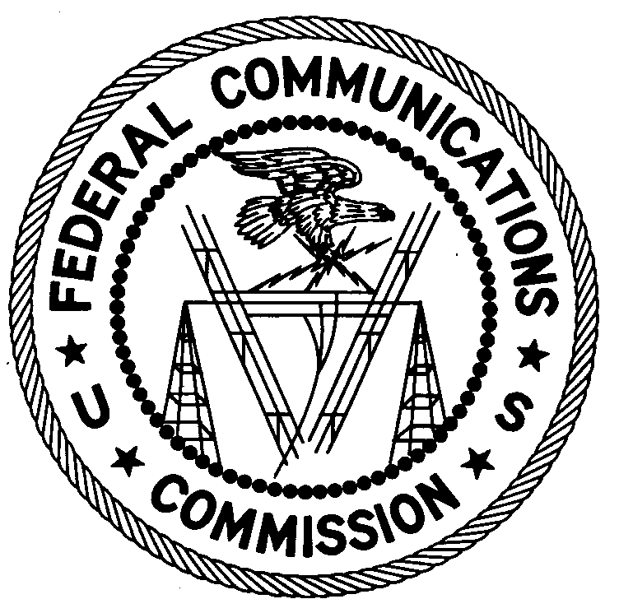
ENFORCEMENT BUREAU
REGION ONE

Columbia Regional Office

9200 Farm House Lane

Columbia, Maryland 21046

(301) 725-1996

October 12, 2017

Chapter Communications
13820 Sunrise Valley Dr.
Herndon, Virginia 20171
Case No.: EB-FIELDNER-17-00024529

NOTIFICATION OF HARMFUL INTERFERENCE

On June 27, 2017, in response to an interference complaint, agents from the New York Office (New York Office) of the Federal Communications Commission’s (FCC’s or Commission’s) Enforcement Bureau (Bureau) confirmed by direction finding techniques that radio emission on 699.9967 MHz were emanating from a radio transmitter device located at 25 Lafayette Avenue, Brooklyn, New York 11217. These transmissions were interfering with the wireless network operated by T-Mobile US Inc. (T-Mobile). Agents determined that the device was a ZonePlex Dual Band 11n Sector Outdoor Access Point (Model 7762-S, Serial No. 191255001192) manufactured by Ruckus Wireless and certificated for use by the FCC. Agents confirmed that interference to T-Mobile ceased when your equipment was turned off on August 9, 2017.

Radio stations operating on many frequencies, including the 700 MHz band, must be licensed by the Federal Communications Commission (“FCC”) pursuant to the Communications Act of 1934, as amended. The only exception to this licensing requirement is for certain transmitters using or operating at a power level or mode of operation that complies with the standards established in Part 15 of the Commission’s rules. Wireless Access Points are authorized to be operated without a license pursuant to Part 15. Such nonlicensed operation, however, is conditioned upon compliance with all applicable regulations in the subpart. Under Section 15.5(b), nonlicensed operation of a radio transmitter is subject to the condition that it must not cause harmful interference and, if harmful interference occurs, operation of the device must cease. Harmful interference is defined as “[a]ny emission, radiation or induction that endangers the functioning of a radio navigation service or of other safety services or seriously degrades, obstructs or repeatedly interrupts a radio communications service.”

You are hereby notified, pursuant to Sections 15.5(c) of the Commission’s rules, that the Ruckus equipment listed above was causing harmful interference to licensed communications. Continued operation of this device in a manner that causes harmful interference after your receipt of this warning constitutes a violation of the Federal laws cited above and could subject the operator to severe penalties, including, but not limited to, substantial monetary fines, in rem arrest action against the offending radio equipment, and criminal sanctions including imprisonment.

OPERATION OF THIS TRANSMITTING DEVICE ON FREQUENCIES THAT CAUSE INTERFERENCE MUST NOT RESUME

You have ten (10) days from the date of this notice to respond concerning your operation of this Part 15 device. Your response should also describe the steps you are taking to ensure that your operation does not interfere with T-Mobile US Inc. Your response should be sent to the address in the letterhead and reference the listed case number. Under the Privacy Act of 1974, we are informing you that the Commission’s staff will use all relevant material information before it to determine what, if any, enforcement action is required to ensure your compliance with the Communications Act and FCC rules. This will include any information that you disclose in your reply.

You may contact this office if you have any questions.

David C. Dombrowski
Regional Director
Region One
Enforcement Bureau
Federal Communications Commission

47 U.S.C. § 301.
47 C.F.R. §§ 15.1 et seq.
See 47 C.F.R. § 15.1(b).
See 47 C.F.R. § 15.5(b).
See 47 C.F.R. § 15.3(m).
47 C.F.R. § 15.5(c)
See 47 U.S.C. §§ 401, 501, 503 and 510.
5 U.S.C. § 552a(e)(3).

