FEDERAL COMMUNICATIONS COMMISSION
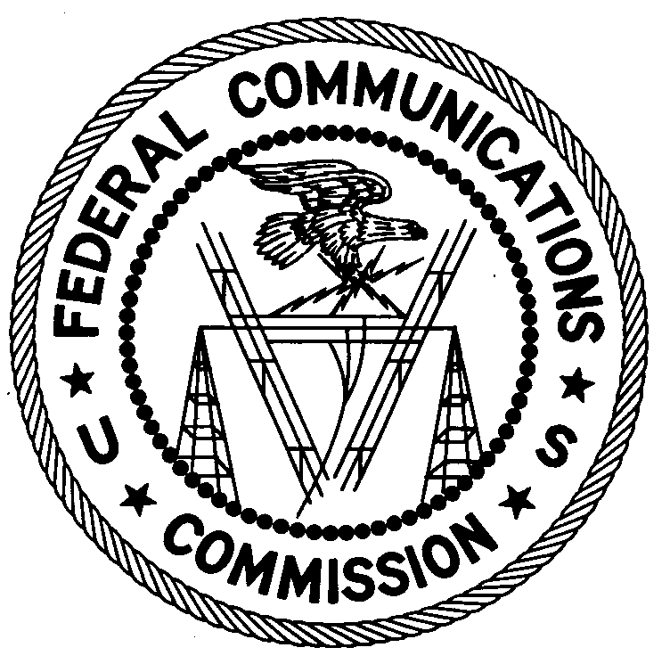
ENFORCEMENT BUREAU
REGION THREE

Los Angeles Regional Office
18000 Studebaker Rd., # 660
Cerritos, CA 90703
Field@FCC.gov
(562) 860-7474

October 16, 2017

San Luis Valley Regional Airport
Alamosa, Colorado

NOTICE OF UNLICENSED OPERATION

Case Number: EB-FIELDWR-17-00025207

The Denver Office (Denver Office) of the Federal Communications Commission’s (FCC’s or Commission’s) Enforcement Bureau (Bureau) received a complaint from the San Luis Valley Regional Airport (SLVRA or Airport) concerning possible interference to its aeronautical advisory station (Unicom) frequency, 122.8 MHz. On September 19, 2017, Agents from the Denver Office investigated the matter on-scene, observing operation by SLVRA employees and aircraft on frequency 122.8 MHz at the airport. The Commission’s records show that there is no valid authorization for operation on 122.8 MHz at this location in Alamosa, Colorado.

Radio stations operating on many frequencies, including 122.8 MHz, must be licensed by the FCC pursuant to Section 301 of the Communications Act of 1934, as amended (Act). The only exception to this licensing requirement is for certain transmitters using or operating at a power level or mode of operation that complies with the standards established in Part 15 of the Commission’s rules. The radio station operating on 122.8 MHz exceeded the maximum permitted Part 15 power level for non-licensed devices. Thus, this station is operating in violation of Section 301 of the Act.

You are hereby warned that operation of radio transmitting equipment without a valid radio station authorization constitutes a violation of the Federal laws cited above and could subject the operator to severe penalties, including, but not limited to, substantial monetary fines, in rem arrest action against the offending radio equipment, and criminal sanctions including imprisonment.

UNLICENSED OPERATION OF THIS RADIO STATION MUST BE DISCONTINUED IMMEDIATELY.

You have ten (10) days from the date of this notice to respond with any evidence that you have authority to operate granted by the FCC. Your response should be sent to the address in the letterhead and reference the listed case and document number. Under the Privacy Act of 1974, we are informing you that the Commission’s staff will use all relevant material information before it to determine what, if any, enforcement action is required to ensure your compliance with FCC Rules. This will include any information that you disclose in your reply.

You may contact this office if you have any questions.

Lark Hadley
Regional Director
Region Three
Enforcement Bureau

Attachments:
Excerpts from the Communications Act of 1934, As Amended
Enforcement Bureau, "Inspection Fact Sheet", March 2005

47 CFR § 87.173(b).
47 U.S.C. § 301.
47 C.F.R. §§ 15.1 et seq.
47 U.S.C. § 301.
See 47 U.S.C. §§ 401, 501, 503 and 510.
5 U.S.C. § 552a(e)(3),

