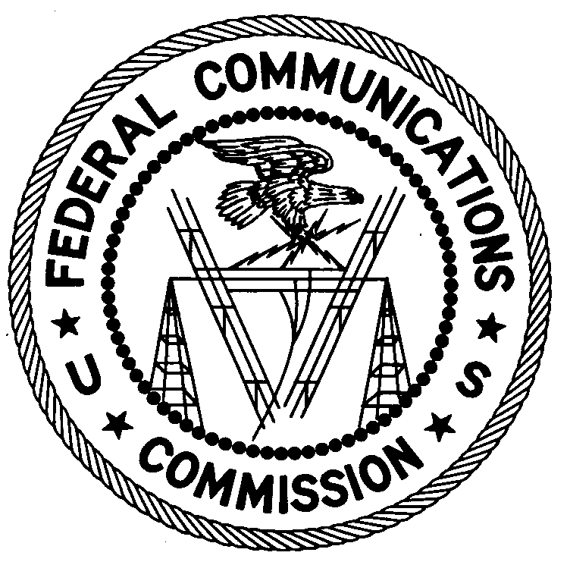
FEDERAL COMMUNICATIONS COMMISSION
ENFORCEMENT BUREAU
REGION ONE

Columbia Regional Office
9200 Farm House Lane

Columbia, Maryland 21046

(301) 725-1996

November 1, 2017

Ludwig Freiberg
Oxford, New Jersey

NOTICE OF UNLICENSED OPERATION

Case Number: EB-FIELDNER-17-00024810

On October 4, 2017, Agents from the New York Office (New York Office) of the Federal Communications Commission’s (FCC’s or Commission’s) Enforcement Bureau (Bureau) responded to complaints of an unlicensed FM station operating on the frequency 90.7 MHz in Oxford, New Jersey. The Agents confirmed by direction finding techniques that radio signals on frequency 90.7 MHz were emanating from a residential property on Pine Street, Oxford, New Jersey. The Commission’s records show that no license was issued for operation of a radio station on 90.7 MHz at this location in Oxford, New Jersey. You admitted to the Agents that you operated the unlicensed FM station on 90.7 MHz.

Radio stations operating on a range of frequencies, including 90.7 MHz, must be licensed by the FCC pursuant to Section 301 of the Communications Act of 1934, as amended (Act). The only exception to this licensing requirement is for certain transmitters using or operating at a power level or mode of operation that complies with the standards established in Part 15 of the Commission’s rules. Agents measured the field strength of the signal on the frequency 90.7 MHz for the station and found that it exceeded the maximum permitted level of 250 µV/m at 3 meters for non-licensed devices. Thus, the station was operating in violation of Section 301 of the Act.

You are hereby warned that operation of radio transmitting equipment without a valid radio station authorization, or in violation of the Commission’s RF radiation limits, constitutes a violation of the Federal laws cited above and could subject the operator to severe penalties, including, but not limited to, substantial monetary fines, in rem arrest action against the offending radio equipment, and criminal sanctions, including imprisonment.

UNLICENSED OPERATION OF THESE RADIO STATIONS MUST BE DISCONTINUED IMMEDIATELY AND MUST NOT RESUME.

You have ten (10) days from the date of this notice to respond with any evidence that you have authority to operate granted by the FCC. Your response should be sent to the address in the letterhead and reference the listed case number. Under the Privacy Act of 1974, we are informing you that the Commission’s staff will use all relevant material information before it to determine what, if any, enforcement action is required to ensure your compliance with FCC Rules. This will include any information that you disclose in your reply.

You may contact this office if you have any questions.

David C. Dombrowski
Regional Director
Region One
Enforcement Bureau
Federal Communications Commission

Attachments:
Excerpts from the Communications Act of 1934, As Amended
Enforcement Bureau, "Inspection Fact Sheet", March 2005

47 CFR § 73.201.
47 U.S.C. § 301.
47 CFR §§ 15.1 et seq.
47 U.S.C. § 301.
See 47 U.S.C. §§ 401, 501, 503 and 510.
5 U.S.C. § 552a(e)(3).

