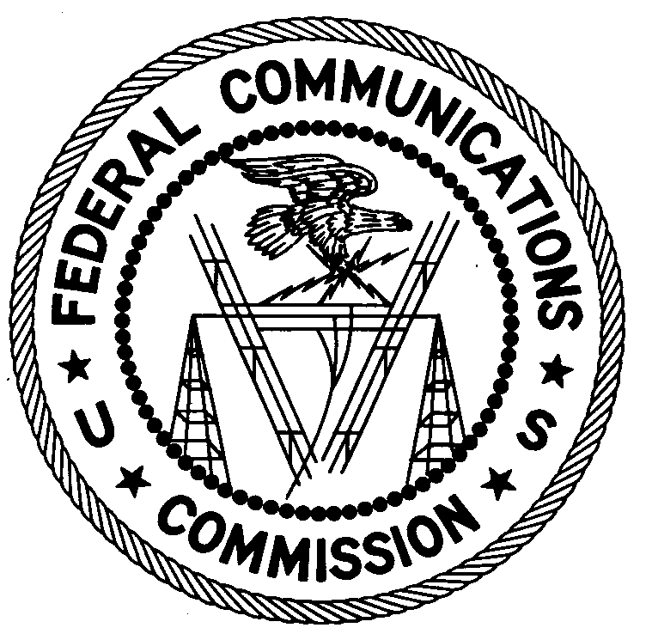
FEDERAL COMMUNICATIONS COMMISSION
ENFORCEMENT BUREAU
REGION ONE

Columbia Regional Office
9200 Farm House Lane

Columbia, Maryland 21046

(301) 725-1996

November 9, 2017

Oraine Ennis
Trumball, Connecticut

NOTICE OF UNLICENSED OPERATION

Case Number: EB-FIELDNER-17-00025135

EB-FIELDNER-17-00025136

EB-FIELDNER-17-00025137

EB-FIELDNER-17-00025138

On September 20, 2017, Region One of the Federal Communications Commission’s (FCC’s or Commission’s) Enforcement Bureau (Bureau) dispatched Agents to investigate a complaint of an unlicensed FM station operating on the frequency 93.3 MHz in Hartford, Connecticut. The Agents confirmed by direction finding techniques that radio signals on frequency 93.3 MHz were emanating from a multi-family dwelling on Enfield Street, Hartford, Connecticut. The Commission’s records show that no license was issued for operation of a radio station on 93.3 MHz at this location in Hartford, Connecticut. The Agents investigated and determined you are the owner or operator of the FM broadcast station on 93.3 MHz in Hartford, Connecticut.

On September 21, 2017, Region One of the Federal Communications Commission’s (FCC’s or Commission’s) Enforcement Bureau (Bureau) dispatched Agents to investigate a complaint of an unlicensed FM station operating on the frequency 106.5 MHz in Stamford, Connecticut. The Agents confirmed by direction finding techniques that radio signals on frequency 106.5 MHz were emanating from a residence on Virgil Street, Stamford, Connecticut. The Commission’s records show that no license was issued for operation of a radio station on 106.5 MHz at this location in Stamford, Connecticut. The Agents investigated and determined you are the owner or operator of the FM broadcast station on 106.5 MHz in Stamford, Connecticut.

On September 21, 2017, Region One of the Federal Communications Commission’s (FCC’s or Commission’s) Enforcement Bureau (Bureau) dispatched Agents to investigate a complaint of an unlicensed FM station operating on the frequency 106.5 MHz in Bridgeport, Connecticut. The Agents confirmed by direction finding techniques that radio signals on frequency 106.5 MHz were emanating from a single family dwelling on Marion Street, Bridgeport, Connecticut. The Commission’s records show that no license was issued for operation of a radio station on 106.5 MHz at this location in Bridgeport, Connecticut. The Agents investigated and determined you are the owner or operator of the FM broadcast station on 106.5 MHz in Bridgeport, Connecticut.

On September 21, 2017, Region One of the Federal Communications Commission’s (FCC’s or Commission’s) Enforcement Bureau (Bureau) dispatched Agents to investigate a complaint of an unlicensed FM station operating on the frequency 106.3 MHz in Waterbury, Connecticut. The Agents confirmed by direction finding techniques that radio signals on frequency 106.3 MHz were emanating from a single family residence on Westport Drive, Waterbury, Connecticut. The Commission’s records show that no license was issued for operation of a radio station on 106.3 MHz at this location in Waterbury, Connecticut. The Agents investigated and determined you are the owner or operator of the FM broadcast station on 106.3 MHz in Waterbury, Connecticut.

Radio stations operating on a range of frequencies, including 93.3 MHz, 106.3 MHz, and 106.5 MHz, must be licensed by the FCC pursuant to Section 301 of the Communications Act of 1934, as amended (Act). The only exception to this licensing requirement is for certain transmitters using or operating at a power level or mode of operation that complies with the standards established in Part 15 of the Commission’s rules. Agents measured the field strength of the signal on the frequency on which each unlicensed station was operating and found that it exceeded the maximum permitted level of 250 µV/m at 3 meters for non-licensed devices. Thus, these four stations were operating in violation of Section 301 of the Act.

You are hereby warned that operation of radio transmitting equipment without a valid radio station authorization constitutes a violation of the Federal laws cited above and will subject the operator to severe penalties, including, but not limited to, in rem seizure of the offending radio equipment without further notice, substantial fines, and criminal sanctions, including imprisonment.

UNLICENSED OPERATION OF THESE RADIO STATIONS MUST BE DISCONTINUED IMMEDIATELY.

You have ten (10) days from the date of this notice to respond with any evidence that you have authority to operate granted by the FCC. Your response should be sent to the address in the letterhead and reference the listed case number. Under the Privacy Act of 1974, we are informing you that the Commission’s staff will use all relevant material information before it to determine what, if any, enforcement action is required to ensure your compliance with FCC Rules. This will include any information that you disclose in your reply.

You may contact this office if you have any questions.

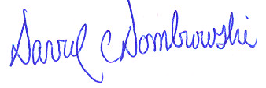
David C. Dombrowski
Regional Director
Region One
Enforcement Bureau
Federal Communications Commission

Attachments:
Excerpts from the Communications Act of 1934, As Amended
Enforcement Bureau, "Inspection Fact Sheet", March 2005

47 CFR § 73.201.
47 U.S.C. § 301.
47 CFR §§ 15.1 et seq.
47 U.S.C. § 301.
See 47 U.S.C. §§ 401, 501, 503 and 510.
5 U.S.C. § 552a(e)(3).

