FEDERAL COMMUNICATIONS COMMISSION
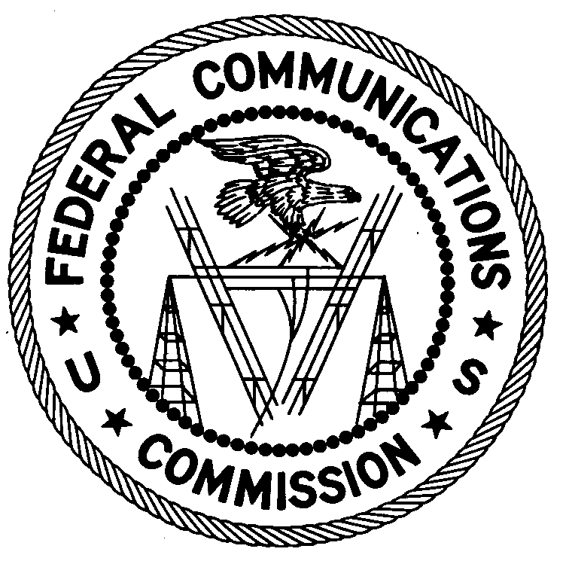
ENFORCEMENT BUREAU
REGION TWO

Atlanta Regional Office
3600 Hiram Lithia Springs Rd SW
Powder Springs, GA 30127

November 16, 2017

Rose Monique Almonor
Pompano Beach, Florida

NOTICE OF UNLICENSED OPERATION

Case Number: EB-FIELDSCR-17-00025286

On September 19 and 28, and October 25 and 26, 2017, Agents from the Miami Office of the Federal Communications Commission’s (FCC’s or Commission’s) Enforcement Bureau (Bureau) confirmed by direction finding techniques that radio signals on frequency 98.5 MHz were emanating from a residential property located on 44th St. in Pompano Beach, Florida. Florida property records indicate that you are the owner of this property. On October 26, 2017, Miami agents, escorted by a household member, inspected the backyard of the premises where they observed an FM transmitting antenna mounted in a tree, and an antenna coaxial cable leading from the antenna into a small locked enclosure in the backyard where the transmitter was located. The Commission’s records show that no license was issued for operation of a radio station at this location on 98.5 MHz in Pompano Beach, Florida.

Radio stations operating on a range of frequencies, including 98.5 MHz, must be licensed by the FCC pursuant to Section 301 of the Communications Act of 1934, as amended (Act). The only exception to this licensing requirement is for certain transmitters using or operating at a power level that complies with the standards established in Part 15 of the Commission’s rules. On September 19 and October 25, 2017, Agents made field strength measurements of the signal on frequency 98.5 MHz which exceeded the maximum permitted level of 250 microvolts per meter (µV/m) at 3 meters for non-licensed devices. Thus, this station is operating in violation of Section 301 of the Act.

You are hereby warned that operation of radio transmitting equipment without a valid radio station authorization constitutes a violation of the Federal laws cited above and will subject the operator to severe penalties, including, but not limited to, in rem seizure of the offending radio equipment without further notice, substantial fines, and criminal sanctions including imprisonment.

UNLICENSED OPERATION OF THIS RADIO STATION MUST BE DISCONTINUED IMMEDIATELY AND MUST NOT RESUME.

You have ten (10) days from the date of this notice to respond with any evidence that you have authority to operate granted by the Commission. Your response should be sent to the address in the letterhead and reference the listed case number. Under the Privacy Act of 1974, we are informing you that the Commission’s staff will use all relevant material information before it to determine what, if any, enforcement action is required to ensure your compliance with the Commission’s rules. This will include any information that you disclose in your reply.

You may contact this office if you have any questions.

Ronald D. Ramage
Regional Director
Region Two
Enforcement Bureau
Federal Communications Commission

Attachments:
Excerpts from the Communications Act of 1934, As Amended
Enforcement Bureau, "Inspection Fact Sheet," March 2005

47 CFR § 73.201.
47 U.S.C. § 301.
47 CFR §§ 15.1 et seq.
47 U.S.C. § 301.
See 47 U.S.C. §§ 401, 501, 503 and 510.
5 U.S.C. § 552a(e)(3).

