FEDERAL COMMUNICATIONS COMMISSION
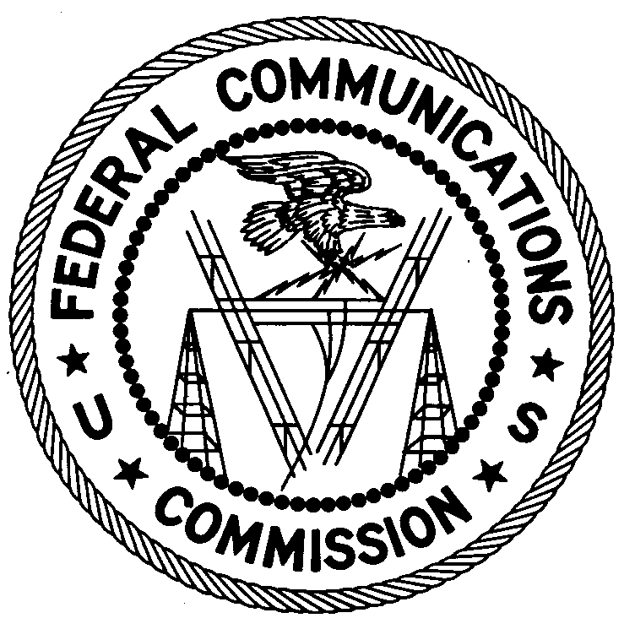
ENFORCEMENT BUREAU
REGION TWO

Atlanta Regional Office
3600 Hiram Lithia Springs Rd SW
Powder Springs, GA 30127

November 20, 2017

1973 Bay Ridge Parkway, Inc.
Pompano Beach, Florida

NOTICE OF UNLICENSED OPERATION

Case Number: EB-FIELDSCR-17-00025577

On July 18, 2017, Agents from the Miami Office (Miami Office) and New Orleans Office (New Orleans Office) of the Federal Communications Commission’s (FCC’s or Commission’s) Enforcement Bureau (Bureau) confirmed by direction finding techniques that radio signals on frequency 92.5 MHz were emanating from a commercial property on Atlantic Blvd. in Pompano Beach, Florida. On October 25, 2017, Agents from the Miami Office confirmed by direction finding techniques that radio signals on frequency 106.5 MHz were emanating from the same commercial property. Public records list you as the property owner. The Commission’s records show that no license was issued for operation of a broadcast station at this location on 92.5 MHz or 106.5 MHz in Pompano Beach, Florida.

Radio stations operating on a range of frequencies, including 92.5 MHz and 106.5 MHz, must be licensed by the FCC pursuant to Section 301 of the Communications Act of 1934, as amended (Act). The only exception to this licensing requirement is for certain transmitters using or operating at a power level that complies with the standards established in Part 15 of the Commission’s rules. On July 18, 2017, the field strength of the signal on frequency 92.5 MHz exceeded the maximum permitted level of 250 microvolts per meter (µV/m) at 3 meters for non-licensed devices. On October 25, 2017, the field strength of the signal on frequency 106.5 MHz exceeded the maximum permitted level of 250 µV/m at 3 meters for non-licensed devices. Thus, this station is operating in violation of Section 301 of the Act.

You are hereby warned that operation of radio transmitting equipment without a valid radio station authorization constitutes a violation of the Federal laws cited above and could subject the operator to severe penalties, including, but not limited to, substantial monetary fines, in rem arrest action against the offending radio equipment, and criminal sanctions including imprisonment.

UNLICENSED OPERATION OF THIS RADIO STATION MUST BE DISCONTINUED IMMEDIATELY.

You have ten (10) days from the date of this notice to respond with any evidence that you have authority to operate granted by the FCC. Your response should be sent to the address in the letterhead and reference the listed case and document number. Under the Privacy Act of 1974, we are informing you that the Commission’s staff will use all relevant material information before it to determine what, if any, enforcement action is required to ensure your compliance with FCC Rules. This will include any information that you disclose in your reply.

You may contact this office if you have any questions.

Ronald D. Ramage
Regional Director
Region Two
Enforcement Bureau
Federal Communications Commission

Attachments:
Excerpts from the Communications Act of 1934, As Amended
Enforcement Bureau, "Inspection Fact Sheet," March 2005

47 CFR § 73.201.
47 U.S.C. § 301.
47 CFR §§ 15.1 et seq.
47 U.S.C. § 301.
See 47 U.S.C. §§ 401, 501, 503 and 510.
5 U.S.C. § 552a(e)(3).

