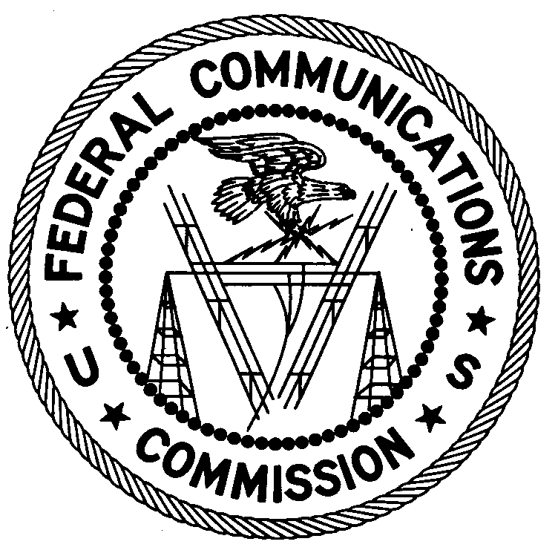
FEDERAL COMMUNICATIONS COMMISSION
ENFORCEMENT BUREAU
REGION ONE

Columbia Regional Office
9200 Farm House Lane

Columbia, Maryland 21046

(301) 725-1996

November 20, 2017

Shaneka N Abdul-Lateef
Bridgeport, Connecticut

RESCISSION OF NOTICE OF UNLICENSED OPERATION

Case Number: EB-FIELDNER-17-00025136

Dear Ms. Shaneka Abudul-Lateef,

We are writing to inform you that you were sent a Notice of Unlicensed Operation (NOUO) in the above-captioned matter in error. By this letter, and pursuant to the Bureau’s existing delegated authority, including, to the extent applicable, Section 1.113 of the Federal Communications Commission’s rules, the undersigned clarifies that that NOUO is rescinded, null and void, and has no legal or other effect. Furthermore, the above-captioned investigation is closed and the NOUO has been removed from our website.

David C. Dombrowski
Regional Director
Region One
Enforcement Bureau
Federal Communications Commission

Shaneka N Abdul Abdullateef, Notice of Unlicensed Operation, November 9, 2017 (EB-FIELDNER-17-00025136).
See 47 C.F.R. § 1.113.

