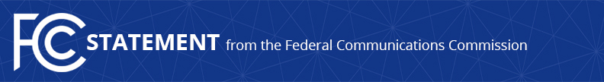
Media Contact:
Brian Hart, (202) 418-0500
brian.hart@fcc.gov

For Immediate Release

CHAIRMAN PAI STATEMENT ON ENSURING SECURITY
FOR THE LIFELINE NATIONAL VERIFIER

WASHINGTON, December 1, 2017—Today, the FCC’s Wireline Competition Bureau announced that the launch of the Lifeline National Verifier would be delayed until early 2018 due to ongoing work by the Universal Service Administrative Company (USAC) to ensure Federal Information Security Management Act (FISMA) compliance. The following statement may be attributed to Chairman Ajit Pai:

“The Lifeline program is an important tool for closing the digital divide but for too long, it’s plagued by waste, fraud, and abuse. To tackle one aspect of that problem, the FCC has tasked USAC with developing a National Verifier to determine whether an individual is in fact eligible for Lifeline benefits. This tool was scheduled to debut in six states this month.

“Unfortunately, I learned yesterday that the National Verifier will not be able to pass key security checks this year that USAC is responsible for completing. As a result, USAC cannot launch the National Verifier before the end of the year. Having a functioning National Verifier is critical to the success of the Lifeline program, but we cannot ignore our duty to safeguard consumers’ personal information. We must get this right.

“I have asked Commission staff to work with USAC to address these security concerns fully and expeditiously. Given the nature of the task, I now expect the National Verifier to launch in early 2018.”

###
Office of Chairman Ajit Pai: (202) 418-2000
Twitter: @AjitPaiFCC
www.fcc.gov/leadership/ajit-pai

This is an unofficial announcement of Commission action. Release of the full text of a Commission order constitutes official action. See MCI v. FCC, 515 F.2d 385 (D.C. Cir. 1974).

