FEDERAL COMMUNICATIONS COMMISSION
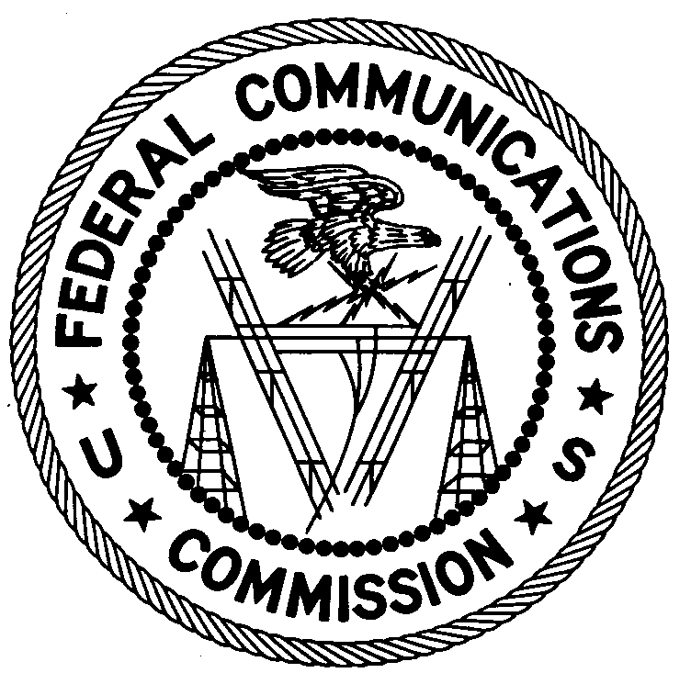
ENFORCEMENT BUREAU
REGION TWO

P.O. Box 1493
Powder Springs, GA 30127

December 8, 2017

Wilfrid Salomon
Lauderdale Lakes, Florida

NOTICE OF UNLICENSED OPERATION

Case Number: EB-FIELDSCR-17-00024576

On August 16, 24, 27, and 28, 2017, September 28, 2017, and October 25, 2017, Agents from the Miami Office (Miami Office) of the Federal Communications Commission’s (FCC’s or Commission’s) Enforcement Bureau (Bureau) confirmed by direction finding techniques that radio signals on frequency 107.1 MHz were emanating from a residential property located on NW 4th Ct. in Lauderhill, Florida. Additionally, on November 8 and 16, 2017, Agents confirmed by direction finding techniques that radio signals on frequency 87.9 MHz were emanating from the same residential property located on NW 4th Ct. in Lauderhill, Florida. Through investigation, the Miami Office has determined that you are the operator of the radio station. The Commission’s records show that no license was issued for operation of a broadcast station on 107.1 MHz or 87.9 MHz at this location in Lauderhill, Florida.

Radio stations operating on a range of frequencies, including 107.1 MHz, must be licensed by the FCC pursuant to Section 301 of the Communications Act of 1934, as amended (Act). The only exception to this licensing requirement is for certain transmitters using or operating at a power level that complies with the standards established in Part 15 of the Commission’s rules. On August 16 and October 25, 2017, Agents made field strength measurements of the signal on frequency 107.1 MHz, which exceeded the maximum permitted level of 250 microvolts per meter (µV/m) at 3 meters for non-licensed devices. Thus, this station is operating in violation of Section 301 of the Act.

Radio stations operating on a range of frequencies, including 87.9 MHz, must also be licensed by the FCC pursuant to Section 301 of the Act. The only exception to this licensing requirement is for certain transmitters using or operating at a power level or mode of operation that complies with the standards established in Part 15 of the Commission’s rules. On November 8, Agents made field strength measurements of the signal on frequency 87.9 MHz, which exceeded the maximum permitted level of 100 microvolts per meter (µV/m) at 3 meters for non-licensed devices operating in the 30-88 MHz frequency band. Thus, this station is operating in violation of Section 301 of the Act.4

You are hereby warned that operation of radio transmitting equipment without a valid radio station authorization constitutes a violation of the Federal laws cited above and could subject the operator to severe penalties, including, but not limited to, substantial monetary fines, in rem seizure of the offending radio equipment, and criminal sanctions including imprisonment.

UNLICENSED OPERATION OF THIS RADIO STATION MUST BE DISCONTINUED IMMEDIATELY AND MUST NOT RESUME.

You have ten (10) days from the date of this notice to respond with any evidence that you have authority to operate granted by the Commission. Your response should be sent to the address in the letterhead and reference the listed case number. Under the Privacy Act of 1974, we are informing you that the Commission’s staff will use all relevant material information before it to determine what, if any, enforcement action is required to ensure your compliance with the Commission’s rules. This will include any information that you disclose in your reply.

You may contact this office if you have any questions.

Ronald D. Ramage
Regional Director
Region Two
Enforcement Bureau
Federal Communications Commission

Attachments:
Excerpts from the Communications Act of 1934, As Amended
Enforcement Bureau, "Inspection Fact Sheet," March 2005

47 CFR § 73.201.
47 U.S.C. § 301.
47 CFR §§ 15.1 et seq.
47 U.S.C. § 301.
47 CFR § 73.603.
47 U.S.C. § 301.
47 CFR § 15.209.
See 47 U.S.C. §§ 401, 501, 503 and 510.
5 U.S.C. § 552a(e)(3).

