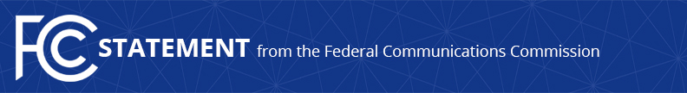

Media Contact:
David Grossman, (202) 418-2100
david.grossmand@fcc.gov

For Immediate Release

FCC COMMISSIONER CLYBURN STATEMENT ON COLLABORATION BETWEEN THE FCC AND NATIONAL CANCER INSTITUTE
--
WASHINGTON, December 12, 2017 – The following statement can be attributed to FCC Commissioner Mignon Clyburn:

“I am thrilled that the FCC has signed a Memorandum of Understanding with the National Cancer Institute. Building on the work of the FCC’s Connect2Health Task Force, this collaboration will enable the two agencies to further examine the relationship between access to broadband and the treatment of cancer, the second leading cause of death in the United States.

“The agreement will also help to accelerate the development of policies and partnerships that leverage broadband infrastructure with a wider array of treatment options which could lead to an improved quality of life for all Americans, particularly those living in rural ‘cancer hotspot’ areas. Working together we can help support a path toward a healthier America.”

###

Office of Commissioner Mignon Clyburn: (202) 418-2100
Twitter: @MClyburnFCC
www.fcc.gov

This is an unofficial announcement of Commission action. Release of the full text of a Commission order constitutes official action. See MCI v. FCC, 515 F.2d 385 (D.C. Cir. 1974).

