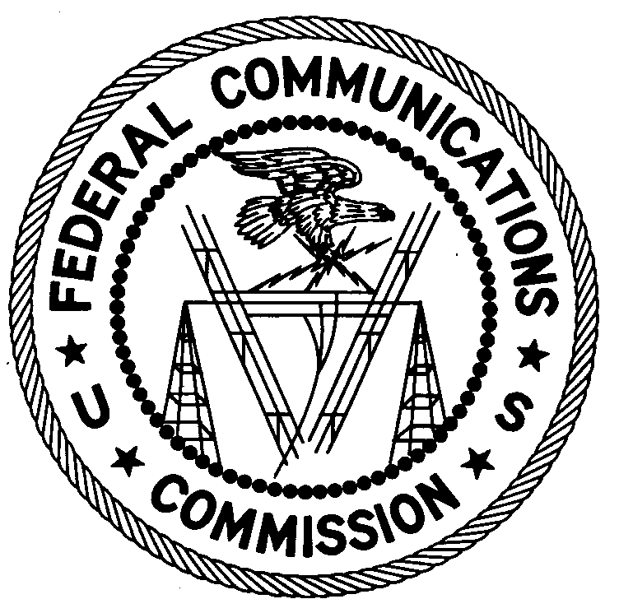
FEDERAL COMMUNICATIONS COMMISSION
ENFORCEMENT BUREAU
REGION ONE

Columbia Regional Office
P.O Box 130

Columbia, Maryland 21045

(301) 725-1996

December 20, 2017

Cesar Gerlens
Mattapan, Massachusetts

NOTICE OF UNLICENSED OPERATION

Case Numbers: EB-FIELDNER-17-00025342

EB-FIELDNER-17-00025344

EB-FIELDNER-17-00024874

On December 4, 2017, an Agent from the Boston Office (Boston Office) of the Federal Communications Commission’s (FCC’s or Commission’s) Enforcement Bureau (Bureau) investigated an unlicensed FM station operating on the frequency 90.1 MHz in Boston, Massachusetts. The Agent confirmed by direction finding techniques that radio signals on frequency 90.1 MHz were emanating from a multi-family residence on Duke St in Boston, Massachusetts. The Commission’s records show that no license was issued for operation of a radio station on 90.1 MHz at this location in Boston, Massachusetts.

On December 4, 2017, an Agent from the Boston Office investigated an unlicensed FM station operating on the frequency 92.1 MHz in Randolph, Massachusetts. The Agent confirmed by direction finding techniques that radio signals on frequency 92.1 MHz were emanating from a single family residence on Himoor Circle in Randolph, Massachusetts. The Commission’s records show that no license was issued for operation of a radio station on 92.1 MHz at this location in Randolph, Massachusetts.

On November 15, 2017, Agents from the Boston Office investigated an unlicensed FM station operating on the frequency 92.1 MHz in Brockton, Massachusetts. The Agents confirmed by direction finding techniques that radio signals on frequency 92.1 MHz were emanating from a multi-family residence on Cherry Street in Brockton, Massachusetts. The Commission’s records show that no license was issued for operation of a radio station on 92.1 MHz at this location in Brockton, Massachusetts.

The Boston Office investigated and determined you are the owner or operator of the unlicensed FM stations on 90.1 MHz in Boston, on 92.1 MHz in Randolph, and on 92.1 MHz in Brockton, Massachusetts.

Radio stations operating on a range of frequencies, including 90.1 MHz, and 92.1 MHz, must be licensed by the FCC pursuant to Section 301 of the Communications Act of 1934, as amended (Act). The only exception to this licensing requirement is for certain transmitters using or operating at a power level that complies with the standards established in Part 15 of the Commission’s rules. Agents measured the field strength of the signals on the frequencies 90.1 MHz and 92.1 MHz for each station and found that they exceeded the maximum permitted level of 250 µV/m at 3 meters for non-licensed devices. Thus, these stations are operating in violation of Section 301 of the Act.

You are hereby warned that operation of radio transmitting equipment without a valid radio station authorization constitutes a violation of the Federal laws cited above and may subject the operator to severe penalties, including, but not limited to, substantial monetary fines, in rem arrest action against the offending radio equipment without further notice, and criminal sanctions, including imprisonment.

UNLICENSED OPERATION OF THIS RADIO STATION MUST BE DISCONTINUED IMMEDIATELY.

You have ten (10) days from the date of this notice to respond with any evidence that you have authority to operate granted by the FCC. Your response should be sent to the address in the letterhead and reference the listed case number. Under the Privacy Act of 1974, we are informing you that the Commission’s staff will use all relevant material information before it to determine what, if any, enforcement action is required to ensure your compliance with FCC Rules. This will include any information that you disclose in your reply.

You may contact this office if you have any questions.

David C. Dombrowski
Regional Director
Region One
Enforcement Bureau
Federal Communications Commission

Attachments:
Excerpts from the Communications Act of 1934, As Amended
Enforcement Bureau, "Inspection Fact Sheet", March 2005

47 CFR § 73.201.
47 U.S.C. § 301.
47 CFR §§ 15.1 et seq.
47 U.S.C. § 301.
See 47 U.S.C. §§ 401, 501, 503 and 510.
5 U.S.C. § 552a(e)(3).

