FEDERAL COMMUNICATIONS COMMISSION
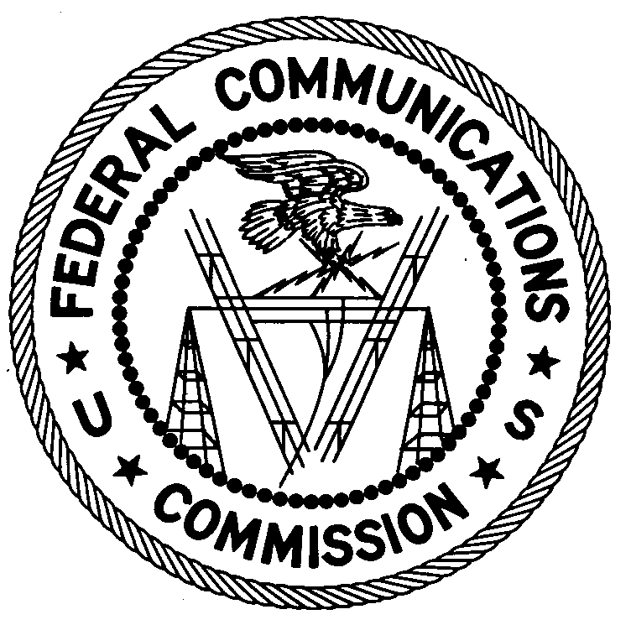
ENFORCEMENT BUREAU
REGION TWO

Regional Office
3600 Hiram-Lithia Springs Road

Powder Springs, GA 30127

January 3, 2017

Lucas Medina
Cristo la Solucion
Knightdale, North Carolina

NOTICE OF UNLICENSED OPERATION

Case Number: EB-FIELDSCR-16-00023234

Document Number: W201732640001

On December 14, 2016, an agent from this office confirmed by direction finding techniques that radio signals on frequency 92.9 MHz were emanating from your church on 1205 North Smithfield Road in Knightdale, North Carolina. The Commission’s records show that no license was issued for operation of a broadcast station at this location on 92.9 MHz in Knightdale, North Carolina.

Radio stations operating on many frequencies, including 92.9 MHz, must be licensed by the FCC pursuant to 47 U.S.C. § 301. The only exception to this licensing requirement is for certain transmitters using or operating at a power level or mode of operation that complies with the standards established in Part 15 of the Commission’s rules, 47 C.F.R. §§ 15.1 et seq. The field strength of the signal on frequency 92.9 MHz was measured at 102,329 microvolts per meter (µV/m) at 136 meters, which exceeded the maximum permitted level of 250 µV/m at 3 meters for non-licensed devices. Thus, this station is operating in violation of 47 U.S.C. § 301.

You are hereby warned that operation of radio transmitting equipment without a valid radio station authorization constitutes a violation of the Federal laws cited above and could subject the operator to severe penalties, including, but not limited to, substantial monetary fines, in rem arrest action against the offending radio equipment, and criminal sanctions including imprisonment. (See 47 U.S.C. §§ 401, 501, 503 and 510.)

UNLICENSED OPERATION OF THIS RADIO STATION MUST BE DISCONTINUED IMMEDIATELY.

You have ten (10) days from the date of this notice to respond with any evidence that you have authority to operate granted by the FCC. Your response should be sent to the address in the letterhead and reference the listed case and document number. Under the Privacy Act of 1974, 5 U.S.C. § 552a(e)(3), we are informing you that the Commission’s staff will use all relevant material information before it to determine what, if any, enforcement action is required to ensure your compliance with FCC Rules. This will include any information that you disclose in your reply.

You may contact this office if you have any questions.

Ronald Ramage
Regional Director

Attachments:
Excerpts from the Communications Act of 1934, As Amended
Enforcement Bureau, "Inspection Fact Sheet," March 2005

