FEDERAL COMMUNICATIONS COMMISSION
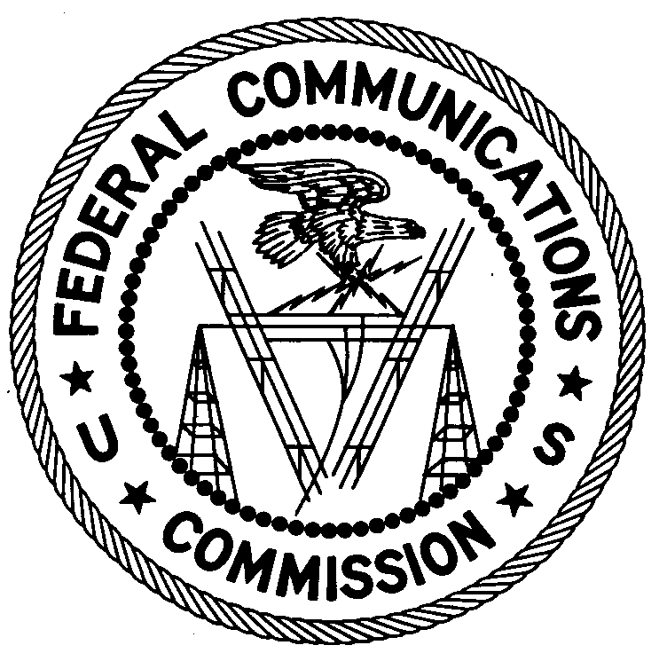
ENFORCEMENT BUREAU
REGION TWO

Atlanta Office
3575 Koger Blvd, Suite 320

Duluth, GA 30096

April 3, 2017

Pastor Angelo Cabrera
Catedral De Jesus
717 S. Arendell Ave.
Zebulon, North Carolina

NOTICE OF UNLICENSED OPERATION

Case Number: EB-FIELDSCR-17-0023628

Document Number: W201732400006

On March 2, 2017, an agent from this office confirmed by direction finding techniques that radio signals on frequency 92.9 MHz were emanating from Catedral De Jesus Church, 717 S. Arendell Ave., Zebulon, North Carolina, 27597, where you are currently the Pastor. The Commission’s records show that no license was issued for operation of a broadcast station at this location on 92.9 MHz in Zebulon, North Carolina. On March 14, 2017, you stated to the agent that your transmitter has been shut down and the Church is currently streaming online exclusively.

Radio stations operating on many frequencies, including 92.9 MHz, must be licensed by the FCC pursuant to 47 U.S.C. § 301. The only exception to this licensing requirement is for certain transmitters using or operating at a power level that complies with the standards established in Part 15 of the Commission’s rules, 47 CFR §§ 15.1 et seq. Thus, this station was operating in violation of 47 U.S.C. § 301.

You are hereby warned that operation of radio transmitting equipment without a valid radio station authorization constitutes a violation of the Federal laws cited above and could subject the operator to severe penalties, including, but not limited to, substantial monetary fines, in rem arrest action against the offending radio equipment, and criminal sanctions including imprisonment. (See 47 U.S.C. §§ 401, 501, 503 and 510.)

UNLICENSED OPERATION OF THIS RADIO STATION MUST NOT RESUME.

You have ten (10) days from the date of this notice to respond with any evidence that you have authority to operate granted by the FCC. Your response should be sent to the address in the letterhead and reference the listed case and document number. Under the Privacy Act of 1974, 5 U.S.C. § 552a(e)(3), we are informing you that the Commission’s staff will use all relevant material information before it to determine what, if any, enforcement action is required to ensure your compliance with FCC Rules. This will include any information that you disclose in your reply.

You may contact this office if you have any questions.

Ronald D. Ramage
Regional Director
Region Two
Enforcement Bureau
Federal Communications Commission

