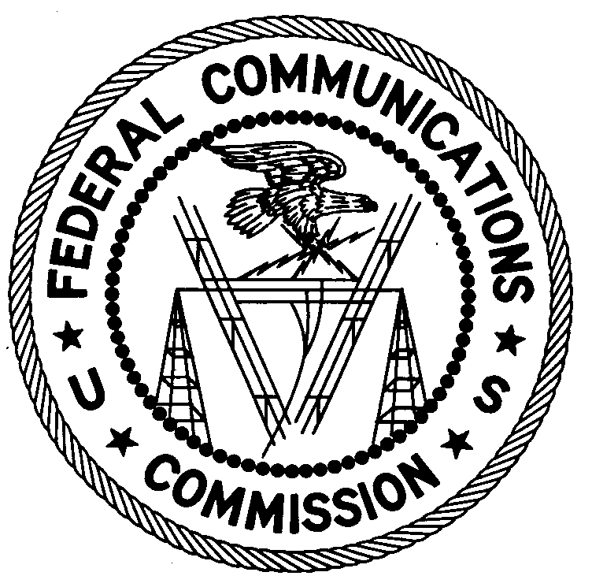
FEDERAL COMMUNICATIONS COMMISSION
ENFORCEMENT BUREAU
REGION THREE

Los Angeles Regional Office
11331 183rd St., PMB #365

Cerritos, CA 90703

Field@FCC.gov

(562) 860-7474

February 12, 2018

William John Nurre
Ashland, Oregon 97520

NOTICE OF UNLICENSED OPERATION

Case Number: EB-FIELDWR-17-00025296

On October 25, 2017, an Agent from the Portland Office (Portland Office) of the Federal Communications Commission’s (FCC’s or Commission’s) Enforcement Bureau (Bureau) responded to a complaint of an unlicensed FM station operating on the frequency 91.1 MHz in Ashland, Oregon. The Agent confirmed by direction finding techniques that radio signals on frequency 91.1 MHz were emanating from your residence on Siskiyou Blvd., Ashland, Oregon. Through investigation, the Agent determined that you were the operator of the station. The Commission’s records show that no license was issued for operation of a radio station on 91.1 MHz at this location in Ashland, Oregon.

Radio stations operating on a range of frequencies, including 91.1 MHz, must be licensed by the FCC pursuant to Section 301 of the Communications Act of 1934, as amended (Act). The only exception to this licensing requirement is for certain transmitters using or operating at a power level or mode of operation that complies with the standards established in Part 15 of the Commission’s rules. On October 25, 2017, the field strength of your signal on frequency 91.1 MHz exceeded the maximum permitted level of 250 microvolts per meter (µV/m) at 3 meters for non-licensed devices. Thus, this station is operating in violation of Section 301 of the Act.

You are hereby warned that operation of radio transmitting equipment without a valid radio station authorization constitutes a violation of the Federal laws cited above and could subject the operator to severe penalties, including, but not limited to, substantial monetary fines, in rem arrest action against the offending radio equipment, and criminal sanctions, including imprisonment.

UNLICENSED OPERATION OF THIS RADIO STATION MUST BE DISCONTINUED IMMEDIATELY.

You have ten (10) days from the date of this notice to respond with any evidence that you have authority to operate granted by the FCC. Your response should be sent to the address in the letterhead and reference the listed case number. Under the Privacy Act of 1974, we are informing you that the Commission’s staff will use all relevant material information before it to determine what, if any, enforcement action is required to ensure your compliance with FCC Rules. This will include any information that you disclose in your reply.

You may contact this office if you have any questions.

Lark Hadley
Regional Director
Region Three
Enforcement Bureau

Attachments:
Excerpts from the Communications Act of 1934, As Amended
Enforcement Bureau, "Inspection Fact Sheet", March 2005

47 CFR § 73.201.
47 U.S.C. § 301.
47 CFR §§ 15.1 et seq.
47 U.S.C. § 301.
See 47 U.S.C. §§ 401, 501, 503 and 510.
5 U.S.C. § 552a(e)(3).

