FEDERAL COMMUNICATIONS COMMISSION
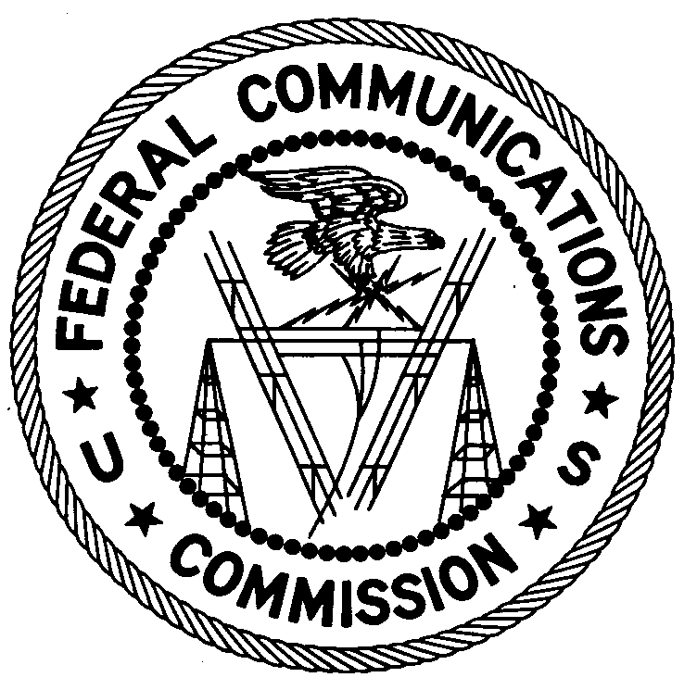
ENFORCEMENT BUREAU
REGION ONE

Columbia Regional Office

P.O. Box 130

Columbia, Maryland 21045

(301) 725-1996

February 15, 2018

Victor Rosario
Brooklyn, New York, 11229

Case No.: EB-FIELDNER-17-00025658

NOTIFICATION OF HARMFUL INTERFERENCE

The Commission received a complaint from T-Mobile concerning interference to its 700 MHz LTE network in Brooklyn, New York. On November 30, 2017, in response to the complaint agents from the Enforcement Bureau’s New York Office confirmed by direction finding techniques that radio emissions in the 700 MHz band were emanating from your residence in Brooklyn, New York. When the interfering device was turned off the interference ceased. You identified the device as an Antminer s5 Bitcoin Miner. The device was generating spurious emissions on frequencies assigned to T-Mobile’s broadband network and causing harmful interference.

Section 15.5(b) of the FCC Rules states that operation of an intentional, unintentional, or incidental radiator is subject to the conditions that no harmful interference is caused. Section 15.5(c) of the Rules states that the operator of a radio frequency device shall be required to cease operating the device upon notification by a Commission representative that the device is causing harmful interference. Operation shall not resume until the condition causing the harmful interference has been corrected.

You are hereby notified, pursuant to Section 15.5(c) of the Commission’s rules, 47 CFR § 15.5(c), that the Antminer s5 Bitcoin Miner in use at your residence is causing harmful interference to T-Mobile’s operation in Brooklyn, New York. Continued operation of this device that causes harmful interference after your receipt of this warning constitutes a violation of the Federal laws cited above and could subject the operator to severe penalties, including, but not limited to, substantial monetary fines, in rem arrest action to seize the offending radio equipment, and criminal sanctions including imprisonment. (See 47 U.S.C. §§ 401, 501, 503 and 510.)

Pursuant to Section 403 of the Communications Act of 1934, as amended, and Section 1.17 of the Rules, you are directed to provide a complete response to the following questions along with the requested information and any relevant documents:

- Are you still actively using the device?
- Please provide the following information on the device: Manufacturer, Model, Serial Number, and if there is any FCC labeling identification.
- What steps do you intend to take to ensure that your device that is installed at your residence does not cause harmful interference in the future?
- Where did you purchase the device? Please provide receipt of purchase.

You have twenty (20) days from the date of this warning to respond concerning your operation of the Part 15 device. Your response should be sent to the address in the letterhead and reference the listed case and document number. Under the Privacy Act of 1974, we are informing you that the Commission’s staff will use all relevant material information before it to determine what, if any, enforcement action is required to ensure your compliance with the Communications Act and the Commission’s rules. This will include any information that you disclose in your reply.

You may contact this office if you have any questions.

David C. Dombrowski
Regional Director
Region One
Enforcement Bureau
Federal Communications Commission

[This Notification of Harmful Interference is addressed to the particular device at issue, not its brand or model and is not meant to suggest or find that all Antminer s5 devices are noncompliant. Further, although we are aware that even compliant devices can be modified in a manner that creates harmful interference, we make no finding as to whether this particular device conforms to its original manufacturer’s specifications, ]
47 CFR § 15.5(b).
47 CFR § 15.5(c).
47 U.S.C. § 403.
47 CFR §§ 1.17 and 73.3526(e)(12).
5 U.S.C. § 552a(e)(3).

