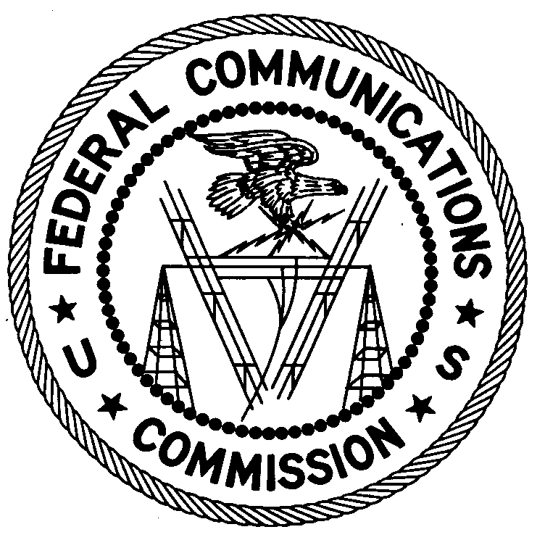
FEDERAL COMMUNICATIONS COMMISSION
ENFORCEMENT BUREAU
REGION THREE

Los Angeles Regional Office
11331 183rd Street, PMB #365
Cerritos, CA 90703
Field@FCC.gov
(562) 860-7474

February 15, 2018

Town of Ward
Ward, Colorado

NOTICE OF UNLICENSED OPERATION

Case Number: EB-FIELDWR-17-00025894

On January 24, 2018, Agents from the Denver Office (Denver Office) of the Federal Communications Commission’s (FCC’s or Commission’s) Enforcement Bureau (Bureau) investigated information regarding an unlicensed FM station operating on the frequency 90.5 MHz. The Agents confirmed by direction finding techniques that radio signals on frequency 90.5 MHz were emanating from a trailer parked next to the Town Hall located on Columbia Street in Ward, Colorado. Public records list the Town of Ward as the owner of this property. The Commission’s records show that no license was issued for a broadcast station on 90.5 MHz at this location in Ward, Colorado.

Radio stations operating on a range of frequencies, including 90.5 MHz, must be licensed by the FCC pursuant to Section 301 of the Communications Act of 1934, as amended (Act). The only exception to this licensing requirement is for certain transmitters using or operating at a power level or mode of operation that complies with the standards established in Part 15 of the Commission’s rules. Agents measured the field strength of the signal on the frequency 90.5 MHz for the station and found that it exceeded the maximum permitted level of 250 µV/m at 3 meters for non-licensed devices. Thus, the station was operating in violation of Section 301 of the Act.

You are hereby warned that operation of radio transmitting equipment without a valid radio station authorization, constitutes a violation of the Federal laws cited above and could subject the operator to severe penalties, including, but not limited to, substantial monetary fines, in rem arrest action against the offending radio equipment, and criminal sanctions, including imprisonment.

UNLICENSED OPERATION OF THIS RADIO STATION MUST BE DISCONTINUED IMMEDIATELY.

You have ten (10) days from the date of this notice to respond with any evidence that you have authority to operate granted by the Commission. Your response should be sent to the address in the letterhead and reference the listed case number. Under the Privacy Act of 1974, we are informing you that the Commission’s staff will use all relevant material information before it to determine what, if any, enforcement action is required to ensure your compliance with FCC Rules. This will include any information that you disclose in your reply.

You may contact this office if you have any questions.

Lark Hadley
Regional Director
Region Three
Enforcement Bureau

Attachments:
Excerpts from the Communications Act of 1934, As Amended
Enforcement Bureau, "Inspection Fact Sheet", March 2005

47 CFR § 73.201.
47 U.S.C. § 301.
47 CFR §§ 15.1 et seq.
47 U.S.C. § 301.
See 47 U.S.C. §§ 401, 501, 503 and 510.
5 U.S.C. § 552a(e)(3).

