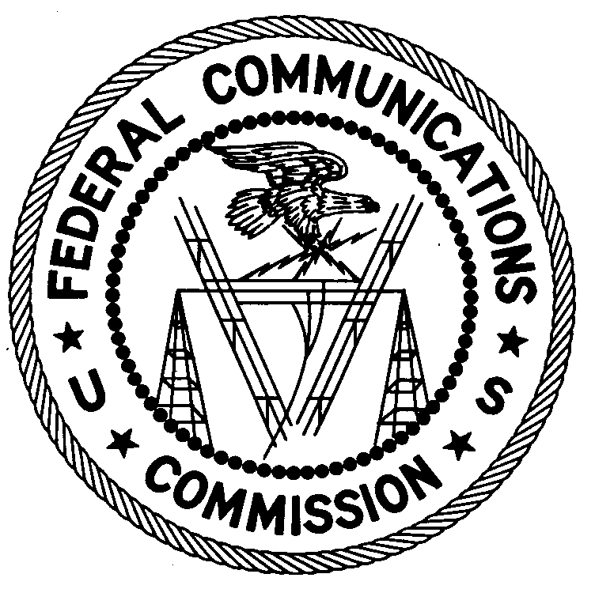 FEDERAL COMMUNICATIONS COMMISSION
ENFORCEMENT BUREAU
REGION ONE

Columbia Regional Office

P.O. Box 130

Columbia, Maryland 21045
(301) 725-1996

February 21, 2018

Department of Public Works
Attn: Emanuel Grella - General Foreman
Glen Cove, New York
-

NOTICE OF UNLICENSED OPERATION

Case Number: EB-FIELDNER-18-00025985

On January 9, 2018, an Agent from the New York Office of the Federal Communications Commission’s (FCC or Commission’s) Enforcement Bureau (Bureau) investigated a complaint of an unauthorized Land Mobile Radio Service Station operating on the frequency 450.500 MHz in Glen Cove, New York. During an inspection, the Agent found that the Department of Public Works of Glen Cove, New York (DPWGC), was operating with a base and mobile stations on 450.500 MHz. The Commission’s records show that no license was issued for your operation on the frequency 450.5000 MHz at this location in Glen Cove, New York.

Radio stations must be licensed by the FCC pursuant to Section 301 of the Communication Act of 1934, as amended (Act). The only exception to this licensing requirement is for certain transmitters using or operating at a power level or mode of operation that complies with the standards established in Part 15 of the Commission’s rules. On January 9, 2018, you operated on frequency 450.500 MHz without an authorization. Thus, this station is operating in violation of Section 301 of the Act.

You are hereby warned that operation of radio transmitting equipment without a valid radio station authorization constitutes a violation of the Federal laws cited above and may subject the operator to severe penalties, including, but not limited to, substantial monetary fines, in rem arrest action against the offending radio equipment, and criminal sanctions, including imprisonment.

UNLICENSED OPERATION OF THIS RADIO STATION MUST BE DISCONTINUED IMMEDIATELY.

You have ten (10) days from the date of this notice to respond with any evidence that you have authority to operate granted by the FCC. Your response should be sent to the address in the letterhead and reference the listed case number. Under the Privacy Act of 1974, we are informing you that the Commission’s staff will use all relevant material information before it to determine what, if any, enforcement action is required to ensure your compliance with FCC Rules. This will include any information that you disclose in your reply.

You may contact this office if you have any questions.

David C. Dombrowski
Regional Director
Region One
Enforcement Bureau
Federal Communications Commission

Attachments:
Excerpts from the Communications Act of 1934, As Amended
Enforcement Bureau, "Inspection Fact Sheet", March 2005

47 U.S.C. § 301.
47 CFR §§ 15.1 et seq.
47 U.S.C. § 301.
See 47 U.S.C. §§ 401, 501, 503 and 510.
5 U.S.C. § 552a(e)(3).

