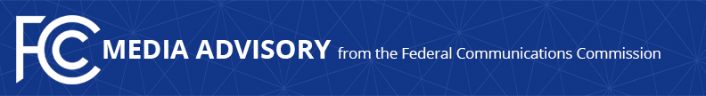

Media Contact:
Evan Swarztrauber, (202) 418-2261
evan.swarztrauber@fcc.gov

For Immediate Release
--
MEDIA ADVISORY: U.S. Black Chambers, HTTP, and AAJC to Host Commissioner Carr to Discuss Broadband Infrastructure Reform
Event Focuses on FCC Efforts to Spur Wireless Deployment in Underserved Communities

WASHINGTON—On Tuesday, March 20, FCC Commissioner Brendan Carr will discuss spurring wireless deployment in underserved communities at a fireside chat hosted by the U.S. Black Chambers, the Hispanic Technology and Telecommunications Partnership (HTTP), and Asian Americans Advancing Justice (AAJC). The chat will be moderated by Dr. Nicol Turner-Lee, Fellow at the Brookings Institution’s Center for Technology Innovation.

WHO: Commissioner Carr
Dr. Nicol Turner-Lee, Brookings Institution
Ron Busby, U.S. Black Chambers
Rosa Mendoza, HTTP
John C. Yang, AAJC

WHAT: Fireside chat on spurring wireless deployment

WHEN: Tuesday, March 20
2:00 pm – 3:00pm

WHERE: Davis Wright Tremaine LLP
1919 Pennsylvania Avenue, NW, Suite 800
Washington, DC 20006

This event is free and open to the public. Members of the media are welcome to attend. RSVP to rosamendoza@httponline.org.

The fireside chat will be followed by a panel discussion of Commissioner Carr’s proposed wireless infrastructure order—to be voted on at the FCC on Thursday—and how policies to get the U.S. 5G Ready will impact communities of color, jobs, and the digital divide.

###

Office of Commissioner Brendan Carr: (202) 418-2200
ASL Videophone: (844) 432-2275
TTY: (888) 835-5322
Twitter: @BrendanCarrFCC
www.fcc.gov/about/leadership/brendan-carr

This is an unofficial announcement of Commission action. Release of the full text of a Commission order constitutes official action. See MCI v. FCC, 515 F.2d 385 (D.C. Cir. 1974).

