FEDERAL COMMUNICATIONS COMMISSION
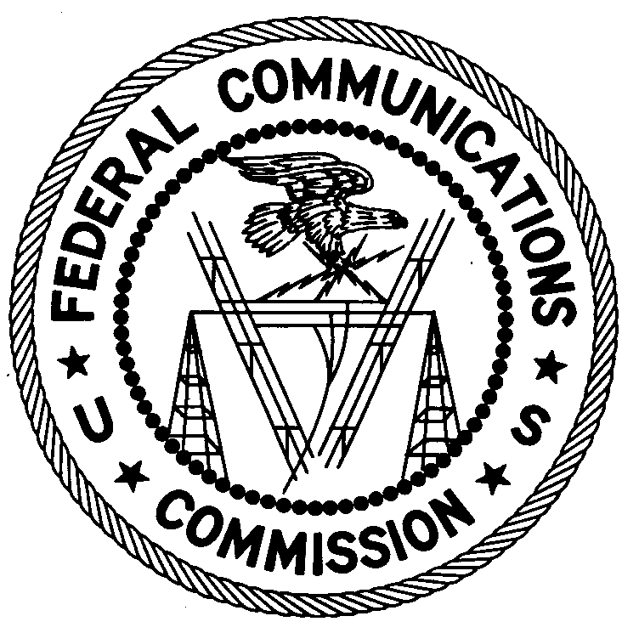ENFORCEMENT BUREAU
REGION THREE

Los Angeles Regional Office
11331 183rd Street, PMB #365
Cerritos, CA 90703
Field@FCC.gov
(562) 860-7474

April 13, 2018

Sears Holdings
Attn: Jim Chagnon – Manager, Logistics Operations Support
Brighton, CO

NOTICE OF UNLICENSED OPERATION

Case Number: EB-FIELDNER-18-00026401

On March 9, 2018, in response to an interference complaint, an Agent from the Denver Office of the Federal Communications Commission’s (FCC or Commission’s) Enforcement Bureau (Bureau) confirmed by direction-finding techniques that radio signals on the frequency 463.3375 MHz were emanating from a warehouse at 18875 Bromley Lane in Brighton, Colorado. During an inspection, the Agent found that Sears Holdings (Sears) was operating multiple transmitters on 463.3375 MHz. The Agent confirmed that the interference ceased when the Sears equipment was unplugged. The Commission’s records show that the license issued to Sears, under call sign WQCM387, for operation on the frequency 463.3375 MHz at this location in Brighton, Colorado, expired in April 2015 and no renewal application is pending.

Radio stations must be licensed by the FCC pursuant to Section 301 of the Communication Act of 1934, as amended (Act). The only exception to this licensing requirement is for certain transmitters using or operating at a power level or mode of operation that complies with the standards established in Part 15 of the Commission’s rules. On March 9, 2018, you operated on frequency 463.3375 MHz without an authorization. Thus, this station was operating in violation of Section 301 of the Act. During the investigation, you indicated that the subject transmitters were replaced by a separate system and were removed from operation while the Agent was on-scene.

You are hereby warned that operation of radio transmitting equipment without a valid radio station authorization constitutes a violation of the Federal laws cited above and may subject the operator to severe penalties, including, but not limited to, substantial monetary fines, in rem arrest action against the offending radio equipment, and criminal sanctions, including imprisonment.

UNLICENSED OPERATION OF THIS RADIO STATION MUST BE DISCONTINUED IMMEDIATELY.

You have ten (10) days from the date of this notice to respond with any evidence that you have authority to operate granted by the FCC. Your response should be sent to the address in the letterhead and reference the listed case number. Under the Privacy Act of 1974, we are informing you that the Commission’s staff will use all relevant material information before it to determine what, if any, enforcement action is required to ensure your compliance with FCC Rules. This will include any information that you disclose in your reply.

You may contact this office if you have any questions.

Lark Hadley
Regional Director
Region Three
Enforcement Bureau

Attachments:
Excerpts from the Communications Act of 1934, As Amended
Enforcement Bureau, "Inspection Fact Sheet", March 2005

47 U.S.C. § 301.
47 CFR §§ 15.1 et seq.
47 U.S.C. § 301.
See 47 U.S.C. §§ 401, 501, 503 and 510.
5 U.S.C. § 552a(e)(3).

