FEDERAL COMMUNICATIONS COMMISSION
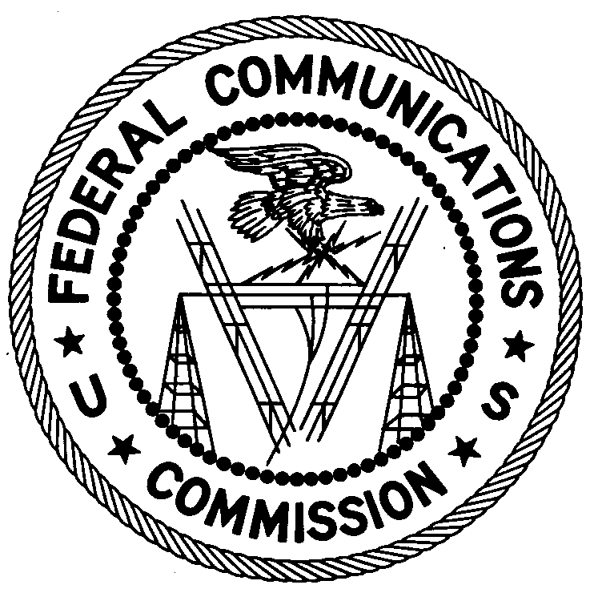
ENFORCEMENT BUREAU
Region Three

Los Angeles Regional Office
11331 183’rd St
PMB #365

Cerritos, CA 90703

Field@FCC.gov

(562) 860-7474

April 27, 2018

LV.Net
Las Vegas, NV 89104
Case Number: EB-FIELDWR-17-00024915

NOTICE OF UNLICENSED OPERATION AND
NOTIFICATION OF HARMFUL INTERFERENCE

The Federal Communications Commission (FCC or Commission) received a complaint from the Federal Aviation Administration (FAA) concerning interference to their Terminal Doppler Weather Radar (TDWR) operating on 5645 MHz in Las Vegas, Nevada. On September 6, 2017, Agents from the Los Angeles Office of the FCC’s Enforcement Bureau (Bureau) conducted an investigation and determined that the source of the interference to FAA’s TDWR was a wideband signal centered on 5660 MHz. The signal was emanating from an antenna connected to a Ubiquiti Prism Rocket 5AC transmitter on the roof of a hotel in Henderson, Nevada operated by LV.Net. After the Agents notified LV.Net of the interference issue, LV.Net changed the frequency of the transmitter to 5575 MHz. Soon after, the Agents verified the interference to the TDWR had ceased.

Radio stations must be licensed by the FCC pursuant to Section 301 of the Communications Act of 1934, as amended (Act). The only exception to this licensing requirement is for certain transmitters using or operating at a power level or mode of operation that complies with the standards established in Part 15 of the Commission’s rules. Non-licensed operation pursuant to Part 15 of the Commission’s rules, however, is conditioned upon compliance with all applicable regulations in the subpart. All intentional radiators operating pursuant to Part 15 of the FCC’s rules must be certified for use as a Part 15 device, and failure to operate such device consistent with its authorization violates Part 15 of the Commission’s rules.

The investigation determined the transmitter was certified as a Part 15 device and labeled with FCC ID: SWX-R5ACPRISM. However, FCC records indicate the transmitter is authorized to operate only on frequencies between 5735-5840 MHz. Accordingly, your operation of the Ubiquiti Prism Rocket 5AC, FCC ID: SWX-R5ACPRISM on the frequencies 5575 and 5660 MHz do not comply with the requirements of Part 15 of the FCC’s rules, and the FCC has no record of a license being issued to you to operate a transmitter on either 5575 or 5660 MHz in Henderson, NV. Thus, your operation was in violation of 47 U.S.C. § 301 and Part 15 of the FCC’s rules.

Had the transmitter been certified for operation on 5660 MHz, additional conditions apply. Non-licensed operation of a Part 15 device is subject to the condition that it must not cause harmful interference and, if harmful interference occurs, operation of the device must cease.. Harmful interference is defined as “[a]ny emission, radiation or induction that endangers the functioning of a radio navigation service or of other safety services or seriously degrades, obstructs or repeatedly interrupts a radio communications service operating in accordance with this chapter.”

You are hereby notified that your Ubiquiti Prism Rocket 5AC device operating on 5660 MHz was causing harmful interference to the FAA TDWR in Las Vegas, Nevada and that your operation of this Unlicensed National Information Infrastructure (U-NII) device must not resume until the interference can be resolved. You are also warned that a U-NII device’s FCC equipment authorization is no longer valid if the device (a) has been installed or configured in a way to defeat the Dynamic Frequency Selection radar detection mechanism, (b) uses antennas other than those certified for the device and/or (c) has been modified in a manner that enables the device to operate outside of its authorized operating parameters. Any unauthorized changes may invalidate the grant of equipment authorization. Using uncertified U-NII devices, or certified U-NII devices in a non-compliant manner, violates provisions of Part 15 of the Commission’s rules.

Operation of radio transmitting equipment without a valid FCC authorization or license is a violation of Section 301 of the Act and may subject the responsible parties to substantial monetary fines, in rem arrest action against the offending radio equipment, and criminal sanctions including imprisonment. Because unlicensed operation creates a danger of interference to important radio communications services and may subject the operator to severe penalties, this letter emphasizes the importance of complying strictly with these legal requirements.

OPERATION OF A U-NII DEVICE THAT IS OPERATING WITH PARAMETERS OUTSIDE ITS GRANT OF CERTIFICATION MUST CEASE IMMEDIATELY.

OPERATION OF THIS DEVICE MAY NOT RESUME UNTIL YOU RESOLVE THE HARMFUL INTERFERENCE.

You have ten (10) days from the date of this notice to respond concerning your operation of this Part 15 device. Your response should describe the steps you are taking to avoid operating on unauthorized frequencies, and preventing future interference to the FAA TDWR. Your response should be sent to the address in the letterhead and reference the listed case number. Under the Privacy Act of 1974, 5 U.S.C. § 552a(e)(3), we are informing you that the Commission’s staff will use all relevant material information before it to determine what, if any, enforcement action is required to ensure your compliance with FCC rules. This will include any information that you disclose in your reply.

You may contact this office if you have any questions.

Lark Hadley
Regional Director
Region Three
Enforcement Bureau

47 U.S.C. § 301.
47 CFR § 15.1, et seq.
47 C.F.R. § 15.1(b).
47 C.F.R. § 15.201(b).
47 CFR §§ 15.5(c), 15.405.
47 C.F.R. § 15.3(m).
47 CFR § 15.1(c).
47 U.S.C. § 301.
See 47 U.S.C. §§ 401, 501, 503 and 510

