Statement of
commissioner michael o’rielly

Re: Amendment of Parts 0, 1, 5, 73, and 74 of the Commission’s Rules Regarding Posting of Station Licenses and Related Information, MB Docket No. 18-121; Modernization of Media Regulation Initiative, MB Docket No. 17-105

Last month I had the opportunity to visit One World Trade Center, or, known by some as Freedom Tower. This visit has been on my list for a while, as broadcasters such as Fox, NBC, and CBS have relocated or plan to relocate in the near future their broadcast antennas from the Empire State Building to One World Trade Center, facilitating the repack process.

When we arrived, we were escorted to an elevator bank used exclusively by the building’s tenants and sent up to Floor 64. From there, we walked to another elevator bank that climbed to Floor 90. On the 90th Floor, the engineer we were with proceeded through multiple security layers to take us into the World Trade Center installation. Once inside, not only did I have the opportunity to view this amazing facility, but I also had the privilege of seeing the location where broadcaster licenses and authorizations were literally taped to the wall.

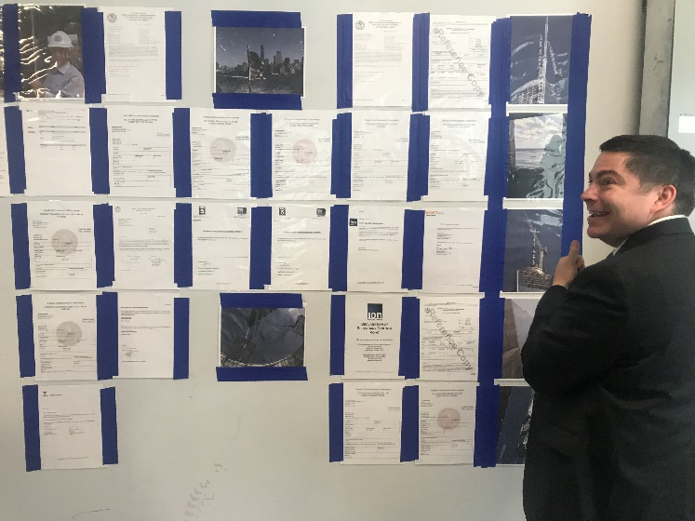

No member of the public has access to this facility to view this paperwork, which was in fact conspicuously placed. On point, I have pushed to remove certain FCC rules over the years to allow broadcasters to better secure their premises and promote safety. In such an environment, it then begs the question, how is this rule serving the public interest? Indeed, the genesis of this requirement stems from the Federal Radio Commission and we can find “no explicit rationale for the posting requirements.” I truly believe that this proceeding will confirm that this rule should be set into an appropriate waste bin.

I thank the chairman for teeing this item up and continuing to modernize our media rules. I approve.

