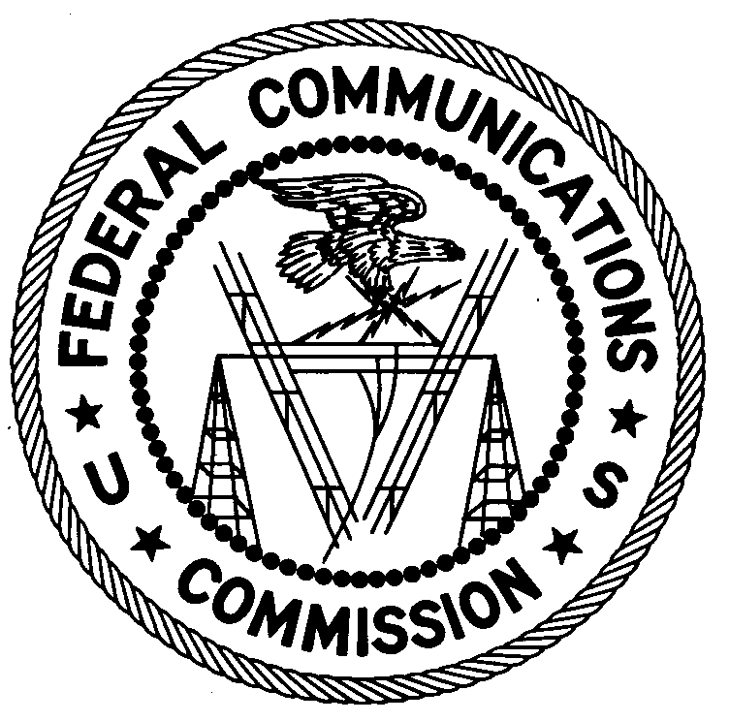
FEDERAL COMMUNICATIONS COMMISSION
ENFORCEMENT BUREAU
REGION TWO

Atlanta Regional Office
P.O. Box 1493

Powder Springs, GA 30127

May 22, 2018

Francisco Guzman, Pastor
Iglesia La Nueva Jerusalen, Ciudad De La Verdad, Monte De Santidad Inc.
Baton Rouge, Louisiana 70810

NOTICE OF UNLICENSED OPERATION

Case Number: EB-FIELDSCR-17-00025638

On May 16, 2018, an Agent from the New Orleans Office (New Orleans Office) of the Federal Communications Commission’s (FCC’s or Commission’s) Enforcement Bureau (Bureau) responded to a complaint of an unlicensed FM station operating on the frequency 87.9 MHz and 1710 KHz in Baton Rouge, Louisiana. The Agent confirmed by direction finding techniques that radio signals on the frequencies 87.9 MHz and 1710 kHz were emanating from your location at 8290 Siegen Ln., Suite A, Baton Rouge, Louisiana. The Commission’s records show that no licenses were issued for operation of radio stations on 87.9 MHz and 1710 kHz at this location in Baton Rouge, Louisiana. The New Orleans Office investigated and determined you are the owner or operator of the unlicensed FM station on 87.9 MHz and unlicensed AM station on 1710 kHz.

Radio stations operating on a range of frequencies, including 87.9 MHz and 1710 kHz, must be licensed by the FCC pursuant to Section 301 of the Communications Act of 1934, as amended (Act). The only exception to this licensing requirement is for certain transmitters using or operating at a power level or mode of operation that complies with the standards established in Part 15 of the Commission’s rules. The Agent found that the stations at your location were operating at power levels that exceed the levels permitted by Part 15. The field strength of the signal on frequency 87.9 MHz was measured at levels exceeding the maximum permitted level of 100 microvolts per meter (µV/m) at 3 meters for non-licensed devices operating between 30 and 88 MHz. The field strength of the signal on frequency 1710 kHz was measured at levels exceeding the maximum permitted level of 30 µV/m at 30 meters for non-licensed devices operating between 1705 kHz and 30 MHz. Therefore, the stations are operating in violation of Section 301 of the Act.

You are hereby warned that operation of radio transmitting equipment without a valid radio station authorization constitutes a violation of the Federal laws cited above and could subject the operator to severe penalties, including, but not limited to, substantial monetary fines, in rem arrest action against the offending radio equipment, and criminal sanctions, including imprisonment.

UNLICENSED OPERATION OF THESE RADIO STATIONS MUST BE DISCONTINUED IMMEDIATELY AND MUST NOT RESUME.

You have ten (10) days from the date of this notice to respond with any evidence that you have authority to operate granted by the FCC. Your response should be sent to the address in the letterhead and reference the listed case number. Under the Privacy Act of 1974, we are informing you that the Commission’s staff will use all relevant material information before it to determine what, if any, enforcement action is required to ensure your compliance with FCC Rules. This will include any information that you disclose in your reply.

You may contact this office if you have any questions.

Ronald D. Ramage
Regional Director
Region Two
Enforcement Bureau
Federal Communications Commission

Attachments:
Excerpts from the Communications Act of 1934, As Amended
Enforcement Bureau, "Inspection Fact Sheet", March 2005

47 CFR §§ 73.25-73.27 and 73.201.
47 U.S.C. § 301.
47 CFR §§ 15.1 et seq.
47 U.S.C. § 301.
See 47 U.S.C. §§ 401, 501, 503 and 510.
5 U.S.C. § 552a(e)(3).

