Media Contact:
Evan Swarztrauber, (202) 418-2261
evan.swarztrauber@fcc.gov

For Immediate Release

Carr Wraps Up 1,204-Mile Great Plains Broadband Tour
From a 180-foot Water Tower to Main Street Businesses, from Small Cells to Big Farms

SIOUX FALLS, SOUTH DAKOTA, June 1, 2018—Commissioner Brendan Carr wrapped up his week-long trip through the Great Plains with stops in Brookings and Sioux Falls, South Dakota, today.

With South Dakota’s Senator John Thune, Chairman of the Senate Commerce Committee, and Governor Dennis Daugaard, Carr attended a ribbon-cutting for the opening of a tower climber training facility. Carr learned firsthand about the skill required to climb towers for a living when Sioux Falls Tower & Communications led the Commissioner up a 60-foot cell tower.

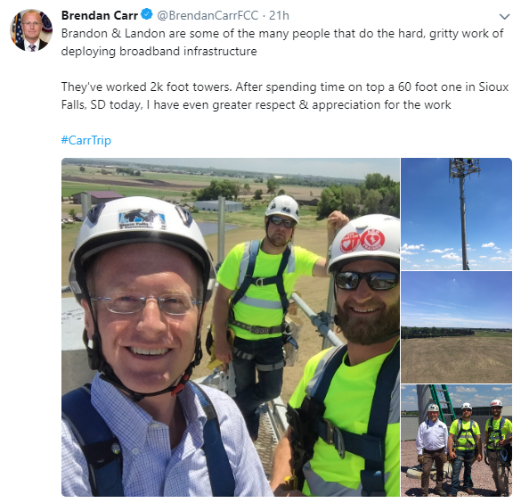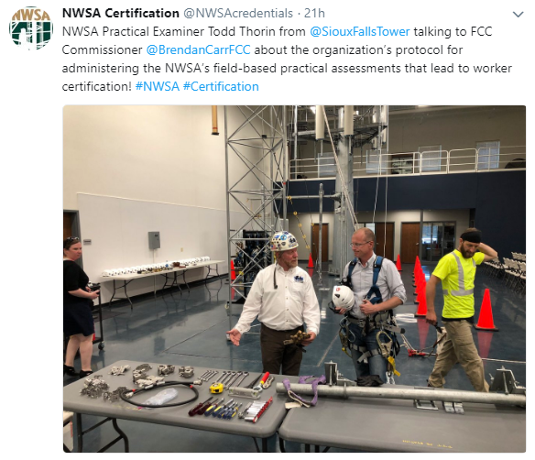

Coverage of Carr’s swing through South Dakota:

“FCC Commissioner Carr Tries His Hand at Tower Climbing,” Inside Towers

“NATE appreciates Commissioner Carr and his colleagues who serve on the Commission for their commitment and willingness to get out in the field and receive these hands-on, tangible experiences,” stated Executive Director Todd Schlekeway. “Commissioner Carr’s climbs serve to reinforce the prominent role that highly-skilled tower technicians play every day to safely deploy infrastructure and enable connectivity in the United States and beyond,” he added.
While in Sioux Falls yesterday, Carr saw some of the advanced deployments that demonstrate the importance of next-generation networks in the U.S.’s more rural regions. He visited Avera eCare, a healthcare technology company that connects medical experts with rural doctors over a broadband connection. It is estimated that Avera’s support has saved nearly 2,000 lives in rural communities to date.

Carr began his Great Plains broadband tour in Nebraska and Iowa earlier in the week. Carr highlighted the communications infrastructure jobs created in the region. He visited Sabre Industries, an Iowa manufacturer of wireless support structures and antenna shrouds. More than 500 people have well-paying jobs at Sabre, some having been with the company for more than 20 years. Carr also was guided through a live fiber trenching project in rural Plymouth County, Iowa.

Senator Deb Fischer hosted Carr in the Cornhusker State, where they were joined by Governor Pete Ricketts, Lincoln Mayor Chris Buetler, and other senior officials. Fischer and Carr met with students at Northeast Community College to learn about their precision agriculture training program. Carr also participated in a rural broadband deployment roundtable hosted by Fischer in Stanton. Carr did a main street business walking tour in Fremont to discuss broadband, and he met with AgTech innovator Quantified Ag, which invented the “Fitbit for cows,” as well.

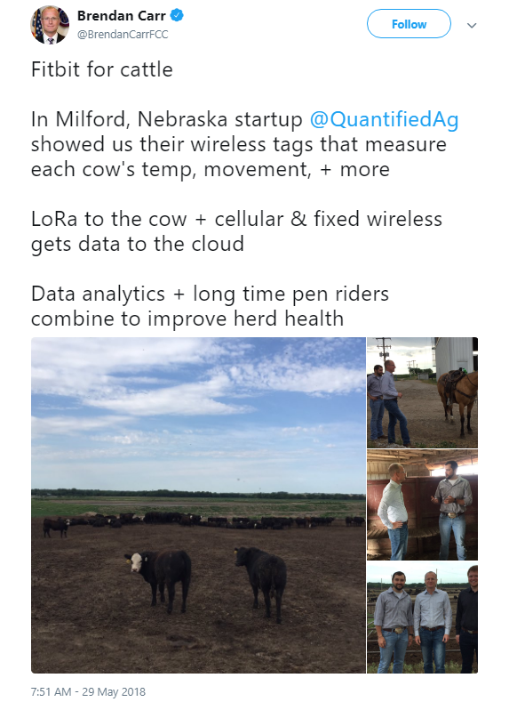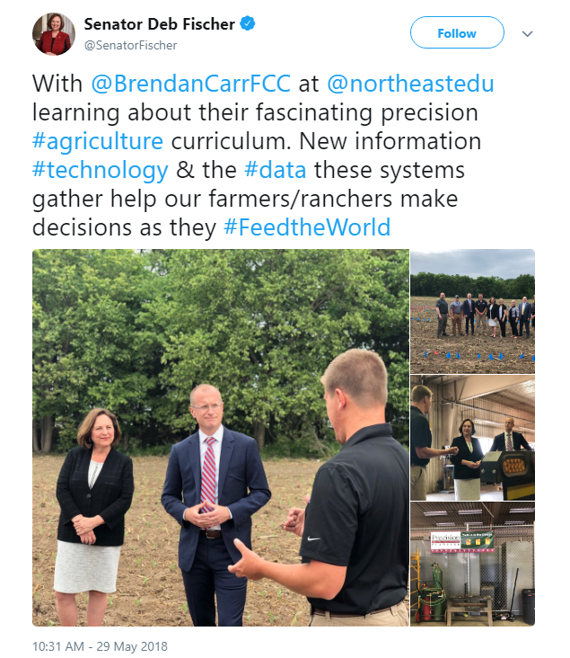

Coverage of Carr’s trip earlier in the week:

“Agriculture and connectivity,” op-ed by Sen. Deb Fischer and Commissioner Brendan Carr, Norfolk Daily News

We look forward to learning more about geographic information systems, the principles of data-based decision making, and how the next generation of ag producers are preparing to modernize agriculture — the backbone of Nebraska’s economy.

“Rural telecom needs federal help, Nebraskans tell visiting FCC commissioner, Sen. Fischer,” Omaha World-Herald

“We need to do our work in D.C. to make sure that broadband and next-gen connectivity is getting out to the farmers and ranchers,” Carr said.

“Lincoln firm Quantified Ag highlights rural internet needs, draws visit from FCC official,” Lincoln Journal Star

Carr said making sure rural residents and businesses have access to internet service is a priority for the FCC. “I want Milford to have the same opportunity as someone living in New York, but that’s going to take a lot of work,” he said.

“FCC’s Carr makes stops in Fremont, talks broadband,” Fremont Tribune

“We try to get out of (Washington) D.C. as much as we can to see what we can do to get more broadband and more connectivity across rural America, really all parts of the country,” [Carr] said while meeting with Mayor Getzschman at City Hall.

“Fischer, FCC official seek to boost rural connectivity,” Norfolk Daily News

“Great ideas are generated across this country,” Carr said. “If you lack the ability to spread those ideas, and put them online and put them on the market, it can hold you back.” A critical issue going forward, according to Carr, is making sure federal funds are available to help rural providers upgrade their services. “It’s incredibly capital intensive to deploy broadband in rural communities,” Carr said. “So we want to take a look and see how we can provide long-term stability to these providers.”

“FCC Commisioner, Sen. Deb Fischer look into rural Nebraska broadband business,” KTIV TV

“When you think about today’s farm, there’s a massive, massive amount of data that’s being collected at these farms. To truly put that data to use you need to get a broadband connection to take that data back to the cloud where it can be crunched and then put back in the farm,” says FCC Commissioner Brendan Carr.

“FCC Commissioner Brendan Carr visits northeast Nebraska,” KTIC Radio

Brendan Carr, one of five members of the FCC that oversees federal communications policy and regulations, joined Senator Deb Fischer Tuesday in Stanton to hear from telecom executives about making the transition to next-generation Internet connectivity.

###

Office of Commissioner Brendan Carr: (202) 418-2200
ASL Videophone: (844) 432-2275
TTY: (888) 835-5322
Twitter: @BrendanCarrFCC
www.fcc.gov/about/leadership/brendan-carr

This is an unofficial announcement of Commission action. Release of the full text of a Commission order constitutes official action. See MCI v. FCC, 515 F.2d 385 (D.C. Cir. 1974).

