FEDERAL COMMUNICATIONS COMMISSION
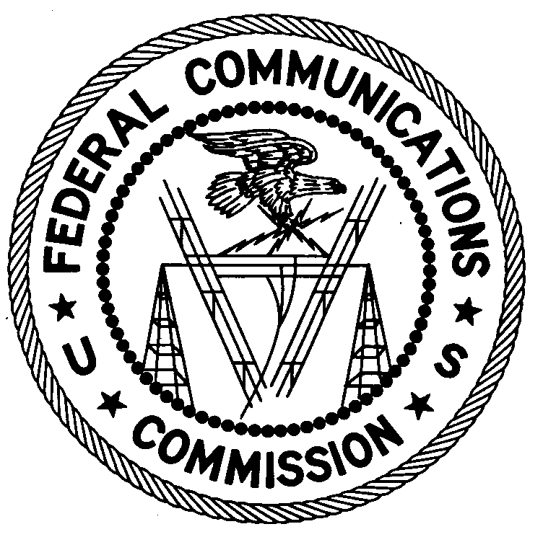
ENFORCEMENT BUREAU
REGION THREE

Los Angeles Regional Office
11331 183rd Street, PMB #365
Cerritos, CA 90703
Field@FCC.gov
(562) 860-7474

May 18, 2018

Primera Iglesia Bautista Del Sur SF
San Francisco, California 94110
Case No.: EB-FIELDWR-18-00026457

notification of UNLICENSED OPERATION AND harmful INTERFERENCE

On March 15, 2018, an Agent from the San Francisco Office of the Federal Communications Commission’s (FCC or Commission’s) Enforcement Bureau (Bureau) investigated a complaint from the Federal Aviation Administration (FAA) that a signal was interfering with their Northern California Terminal Radar Approach Control (TRACON) on 125.25 MHz. The Agent investigated and found that the interfering signal was emanating from the antenna on the roof of the Primera Iglesia Bautista Del Sur SF in San Francisco, California. Through investigation, the Agent found that you are an operator of this station. The Commission’s records show that no license was issued for operation of a radio station on 87.9 MHz at this location in San Francisco, California.

Radio stations operating on many frequencies, including 87.9 MHz, must be licensed by the FCC pursuant to Section 301 of the Communications Act of 1934, as amended (Act). The only exception to this licensing requirement is for certain transmitters using or operating at a power level or mode of operation that complies with the standards established in Part 15 of the Commission’s rules. Agents measured the field strength of the signal on the frequency 87.9 MHz for the station and found that it exceeded the maximum permitted level of 100 µV/m at 3 meters for non-licensed devices. Thus, the station was operating in violation of Section 301 of the Act.

Operation of radio transmitting equipment without a valid radio station authorization is a violation of the Federal laws cited above and may subject the responsible parties to substantial monetary fines, in rem arrest action against the offending radio equipment, and criminal sanctions including imprisonment. Because unlicensed operation creates a danger of interference to important radio communications services and may subject the operator to severe penalties, this letter emphasizes the importance of complying strictly with these legal requirements.

You have ten (10) days from the date of this notice to respond with a report detailing what steps you have taken to ensure that this unauthorized operation on 87.9 MHz has ceased and will not occur again. Your response should be sent to the address in the letterhead and reference the listed case number. Under the Privacy Act of 1974, we are informing you that the Commission’s staff will use all relevant material information before it to determine what, if any, enforcement action is required to ensure your compliance with FCC Rules. This will include any information that you disclose in your reply.

You may contact this office if you have any questions.

Lark Hadley
Regional Director
Region Three
Enforcement Bureau

Attachments:
Excerpts from the Communications Act of 1934, As Amended
Enforcement Bureau, "Inspection Fact Sheet", March 2005

47 CFR §§ 73.603.
47 U.S.C. § 301.
47 CFR §§ 15.209 et seq.
47 U.S.C. § 301.
See 47 U.S.C. §§ 401, 501, 503 and 510.
5 U.S.C. § 552a(e)(3).

