2017 Atlantic Hurricane Season Impact on Communications
Report and Recommendations
Public Safety Docket No. 17-344

A Report of the Public Safety and Homeland Security Bureau
Federal Communications Commission
August 2018
Table of Contents

I. EXECUTIVE SUMMARY 3
II. BACKGROUND 4
III. Effects on Communications 5
A. Hurricane Harvey 6
B. Hurricane Irma 8
C. Hurricane Maria 15
D. Hurricane Nate 18
IV. COMMISSION response and recovery efforts 19
A. Incident Management Activity 19
B. Regulatory Relief 20
C. Situational Awareness 23
D. Industry Engagement 25
E. Public Engagement 25
F. Recovery Actions 26
V. Lessons Learned and NEXT STEPS 28
A. Improvements to FCC’s Emergency Response and Recovery Efforts 28
B. Recommended Best Practices for Governments, Service Providers, and Related Stakeholders 31
VI. Conclusion 34

APPENDIX: List of Commenting Parties, PS Docket No. 17-344

EXECUTIVE SUMMARY
- The 2017 Atlantic hurricane season was notable for the devastation wrought to various types of infrastructure, including communications. A larger-than-expected number of significant storms caused billions of dollars of damages and significant loss of life. All told, it was the most expensive hurricane season in United States history, almost doubling the cost of the 2005 hurricane season that included Katrina. According to initial estimates, the combined storms caused over $200 billion in damages in the United States and its territories. The National Oceanic and Atmospheric Administration (NOAA) estimates that Hurricane Harvey caused $125 billion in damages, mostly around the densely-populated Houston, Texas, area, and over 100 deaths, and just a few weeks later, the havoc wreaked by Hurricane Maria in Puerto Rico alone is projected to have caused at least $100 billion in damage and widely differing estimates regarding the number of deaths.
- The adverse effect of the 2017 Atlantic hurricane season on communications increased in magnitude as the season went on. While the damage caused by the August 2017 landing of Hurricane Harvey in the Gulf Coast region, especially Houston, was quickly remedied (within a week, ninety-eight percent of cell towers were back to operational), recovery times for communications became more challenging as the intensity of destruction increased. The early September 2017 arrival of Hurricane Irma, first in the U.S. Virgin Islands (USVI) and Puerto Rico, and then parts of Florida, followed in short order by Hurricane Maria, again in Puerto Rico and the USVI just two weeks after Irma, largely destroyed the communications infrastructures of both territories. Finally, the October 2017 arrival of Hurricane Nate caused damage primarily through flooding in the north Gulf Coast region (Mississippi to Florida).
- Emergency call centers on the American mainland seem to have survived each storm relatively well; the Federal Communications Commission (FCC or Commission) did not receive reports of wide-spread 911 call center outages in those areas affected by the storms. In contrast, the 911 call centers serving Puerto Rico and the USVI were impacted, and were either completely out of service for a period of time (as happened in the USVI), or could not receive the types of information (location, call back number, etc., as happened in both Puerto Rico and the USVI) that both they and the American public have come to expect. Between them, Puerto Rico and the USVI have only four 911 call centers (two each) to serve 3.4 million people; for some time, none of those call centers were fully functional.
- The FCC responded to these hurricanes, sending personnel with the appropriate expertise to assist in response and recovery. For each storm, the Commission stood up an internal Incident Management Team with representatives from all corners of the agency, participated in the overall federal government response through the Department of Homeland Security (DHS)-led Emergency Support Function #2, and activated the Disaster Information Reporting System (DIRS) in affected counties. Licensees received expedited regulatory action such as special temporary authorizations, often within hours. The Commission provided other regulatory relief, such as waiving or relaxing requirements so providers could focus on restoration in the immediate aftermath of the storms. Public information efforts were ramped up. For example, daily reports on the status of communications services in affected areas were issued and reports regarding the effects of Hurricane Maria were translated into Spanish. With respect to Hurricane Maria, the Commission advanced money from the Universal Service Fund and temporarily eased aspects of the Lifeline, E-rate, and Rural Health Care programs. For all storms except Hurricane Nate, the Commission deployed personnel to affected areas to assist response efforts to restore communications services.
- Leadership at the Commission undertook fact-finding missions to the hardest-hit regions. To determine what went right, what went wrong, and how to better prepare for future hurricane seasons, the Commission sought comment from stakeholders through a variety of means, including a public notice, critical information needs workshop, and after-action reporting both within the Commission and with federal emergency response partners. Significantly, the Commission stood up a Hurricane Recovery Task Force (Task Force), charged with coordinating a comprehensive approach to support the rebuilding of communications infrastructure and restoration of communications services, particularly for Puerto Rico and the USVI.
- This Report includes actions the Commission took during, and in response to, the 2017 Atlantic hurricane season; lessons learned and observations to assist the Commission, service providers, local and regional emergency response authorities, and other stakeholders when confronting hurricanes; and next steps that the Commission will take to improve its disaster response and recovery efforts.

BACKGROUND
- The 2017 Atlantic hurricane season struck geographically diverse areas of the United States, from the Gulf of Mexico to the USVI, with unusual ferocity, exceeding most forecasters’ predictions regarding the number and severity of storms. The year saw 17 named storms, of which 10 became hurricanes (sustained winds of at least 74 mph). Of those 10, six (Harvey, Irma, Jose, Lee, Maria, and Ophelia) became major hurricanes, reaching at least a Category 3 level (sustained winds of between 111-128 mph). According to NOAA, 2017 “was the seventh most active season in the historical record dating to 1851 and was the most active season since 2005.” For the first time in 12 years, the continental United States was hit by two storms of Category 3 or greater: Harvey in Texas, and Irma in Florida. Puerto Rico and the USVI were hit in quick succession by two massive storms–first, Irma and then Maria, causing devastation and tragic loss of life throughout the Caribbean, including the U.S. territories.
- The financial impact of the 2017 Atlantic hurricane season was enormous. Initial estimates have the combined storms causing $370 billion in damage worldwide, including over $200 billion just in the United States and its territories. The havoc wreaked by Maria in Puerto Rico alone is projected to have caused at least $100 billion in damage. NOAA estimated that Harvey caused $125 billion in damages, mostly around the Houston, Texas area, and almost 100 fatalities.

Effects on Communications
- The effect of the 2017 Atlantic hurricane season on communications platforms varied, according to local conditions and topography, the intensity of each storm, the population density of the region hit, and the ability of communications service providers and local emergency management officials to prepare for impact. On the one hand, recovery from early season storms was relatively rapid. In addition to traditional methods of communicating (i.e., cell phones, broadcasting – television and radio – cable, and wireline), first responders found help using alternate methods, including amateur radio and satellite phones.
- On the other hand, the later storms more severely impacted communities and their corresponding communications infrastructure. According to Commission statistics from its DIRS, during the initial impact of Hurricane Irma in USVI, 55.2 percent of cell sites were reported out of service (21.1 percent in St. Croix, 49.2 percent in St. Thomas, and 91.7 percent in St. John).
- Hurricane Maria struck the Caribbean islands just two weeks after Hurricane Irma; it further damaged the still-recovering communications infrastructure in the USVI, and severely degraded that of Puerto Rico; essentially, the communications infrastructures of both Puerto Rico and the USVI were almost completely destroyed. The Commission noted that after the hurricanes, and in particular after Hurricane Maria, 95.2 percent of cell sites in Puerto Rico were out of service. All municipios in Puerto Rico had greater than 75 percent of their cell sites out of service. Forty-eight out of the 78 municipios in Puerto Rico had 100 percent of their cell sites out of service.

Hurricane Harvey
- Bureau analysis of DIRS reports suggests that Hurricane Harvey had a limited impact on wireless communications infrastructure, and that providers were able to restore services faster than during Hurricanes Irma and Maria. DIRS was activated for 55 counties in Texas and Louisiana for Hurricane Harvey. The maps following illustrate the impact of the hurricane on wireless communications and where wireless service was restored a week and a half after landfall.
- Wireless communications services generally. On the first day of reporting, four percent of the cell sites in the affected area were out of service in addition to five out-of-service switching centers and 38 switching centers operating on back-up power. By September 5, the eleventh and final day of DIRS reporting, only 1.6 percent of cell sites were out of service in the disaster area, and all switching centers were fully operational.
- Public Safety Answering Points (PSAPs). On the first day after landfall, nine PSAPs were affected (eight in Texas, and one in Louisiana), each in different ways. Some were unable to receive incoming calls with no re-routing available; others received 911 calls without location information. Still more could re-route a 911 call to an administrative line or were able to re-route to another PSAP. By September 5, 2017, only five PSAPs remained affected. Traffic to each of these PSAPs was re-routed at that time to different, fully functional PSAPs.

Hurricane Harvey – Texas
Day 1 (August 27, 2017) of DIRS filing vs. Day 11 (September 5, 2017)

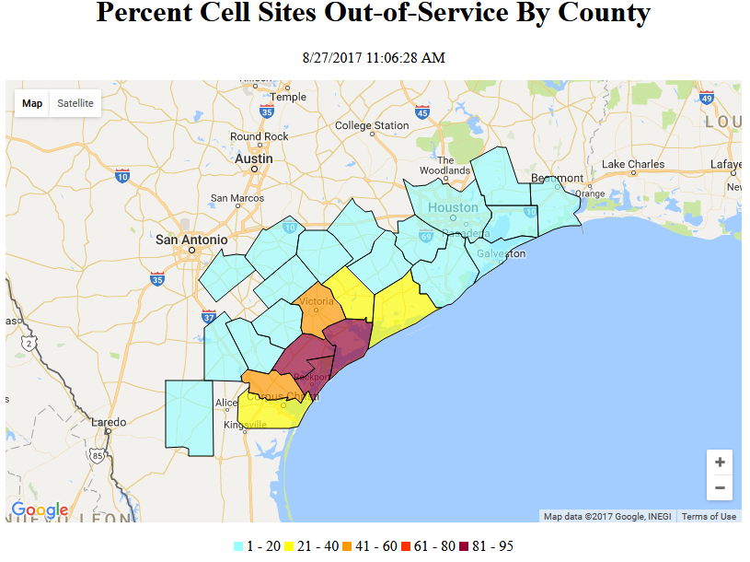

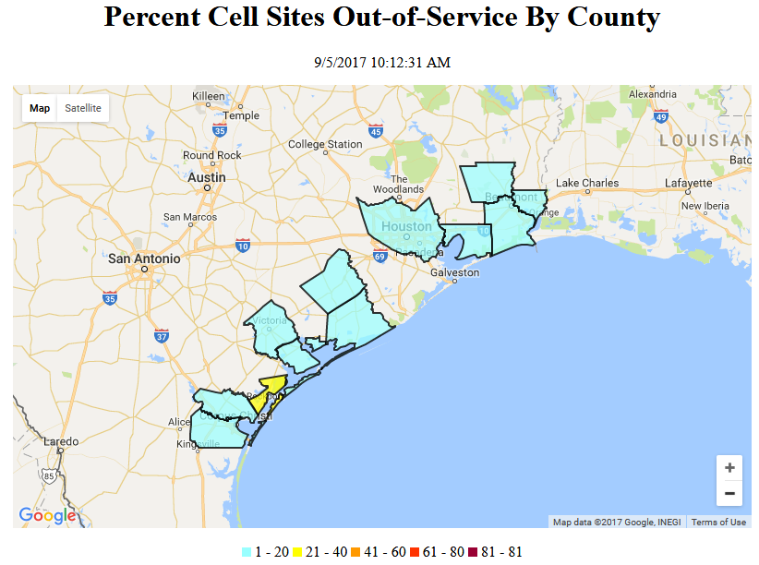

- The following chart shows that Hurricane Harvey had only minor effects on wireless communications and that, by the eleventh day, only 1.7 percent of the cell sites remained affected. We acknowledge, however, some areas within a designated disaster zone were highly impacted. For example, three Texas counties (Aransas, Refugio, and San Patricio) all suffered cell outages in excess of 50 percent.

- Impact on other communications platforms. Hurricane Harvey had minimal impact on radio and television stations. Only 12 radio stations and two TV broadcast stations reported in DIRS that they were affected by the hurricane at any one time. Also, about 150,000 cable subscribers lacked service at some point during the Hurricane Harvey DIRS reporting period (August 26-September 5, 2017).

Hurricane Irma
- Hurricane Irma devastated the telecommunications infrastructure of the USVI and severely impacted that of Puerto Rico; restoration took longer than for Hurricane Harvey, particularly in the USVI. On September 7, 2017, the Commission activated DIRS for all 78 municipios in Puerto Rico and the three counties of the USVI (St. Thomas, St. John, and St Croix), and on September 11, 2017, DIRS was expanded to include all 67 counties in Florida. While Irma has been described as among the costliest storms to hit Florida, the communications sector appears to have been relatively resilient there.
- Wireless communications services generally. The maps below show representative snapshots in time of the impact of the hurricane on wireless communication and present a county-level look at restoration of wireless service. On September 8, 2018, 39 percent of the cell sites in Puerto Rico and the USVI were out of service. By September 11, Irma was impacting Florida as well, with twenty-seven percent of cell towers out of service. By September 14, 2018, fifty-four percent of cell service in the USVI remained out of service (23 percent in St Croix, 90 percent in St. John and 68 percent in St Thomas), and six percent of cell sites remained out of service in Puerto Rico. By the time DIRS was deactivated on September 18, 2018, wireless service in Florida was at 97 percent, but remained at only 46 percent in the USVI (70 percent in service in St Croix, 36 percent in St. Thomas, and only 10 percent in St. John).
Hurricane Irma – Puerto Rico
Day 2 (September 8, 2017) of DIRS Filing vs. Day 8 (September 14, 2017)

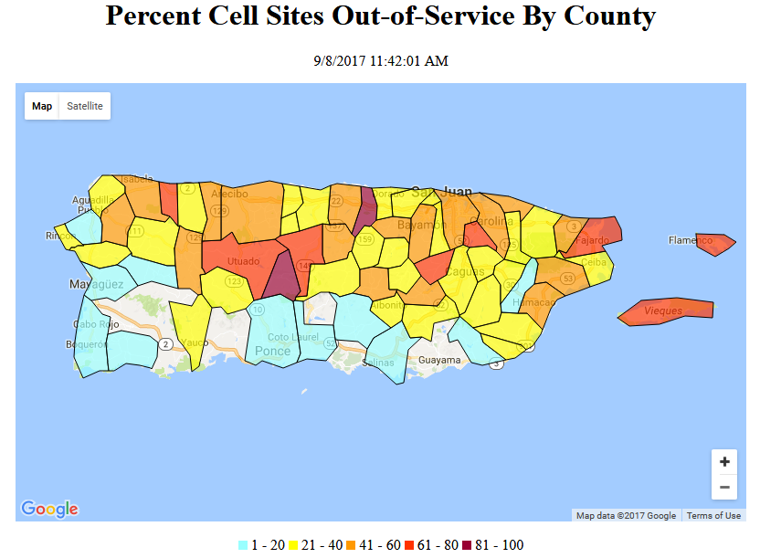

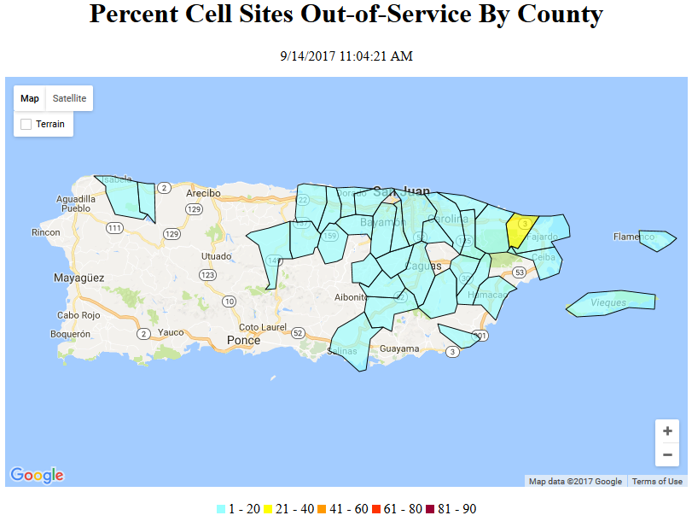

Hurricane Irma – St. Thomas and St. John, USVI
Day 3 (September 9, 2017) of DIRS Filing vs. Day 12 (September 17, 2017)

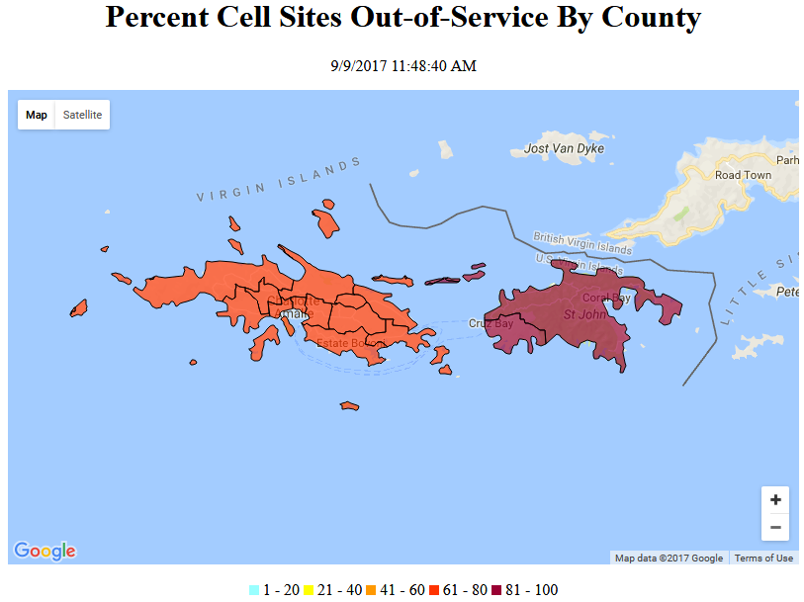

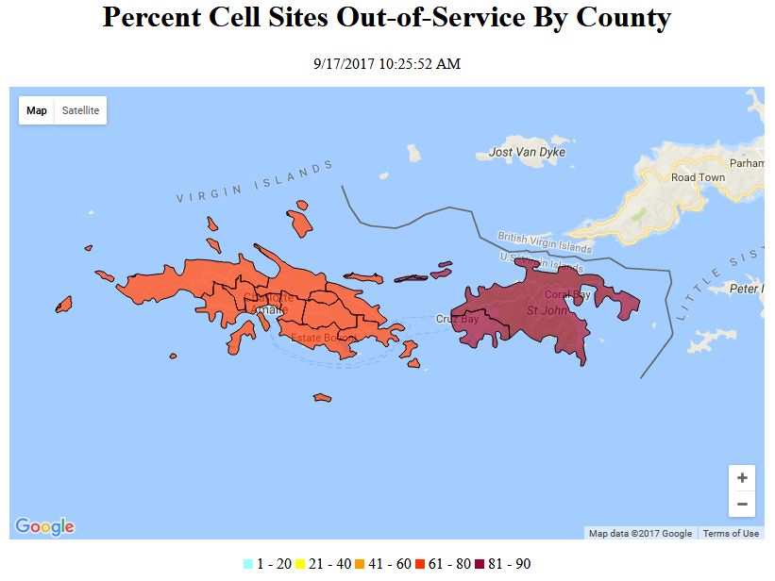
Hurricane Irma – St. Croix, USVI
Day 3 (September 9, 2017) of DIRS Filing vs. Day 12 (September 17, 2017)

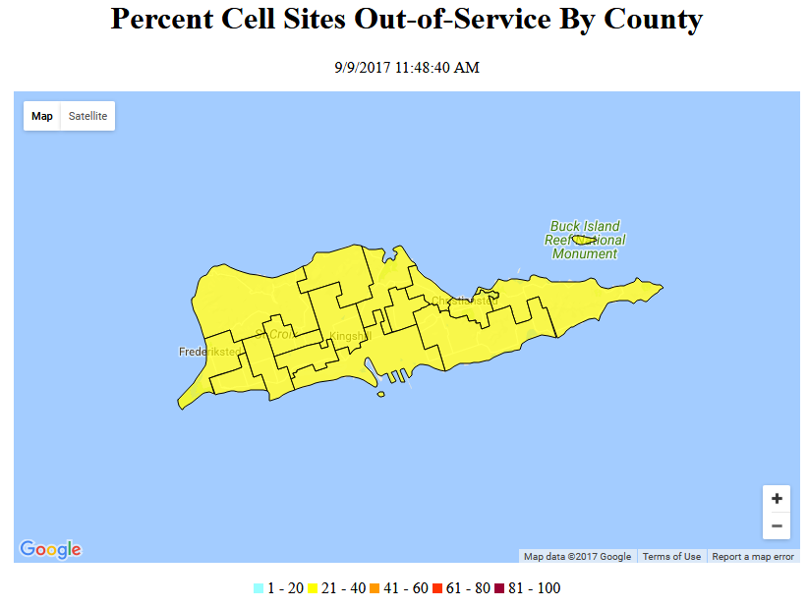
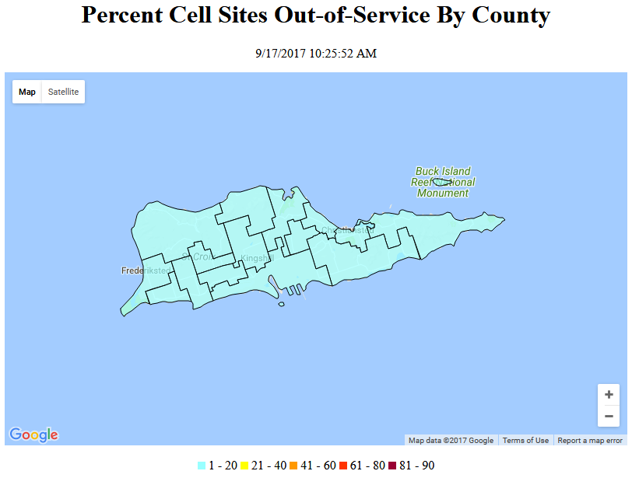

Hurricane Irma – Florida
Day 4 (September 11, 2017) of DIRS Filing vs. Day 12 (September 18, 2017)

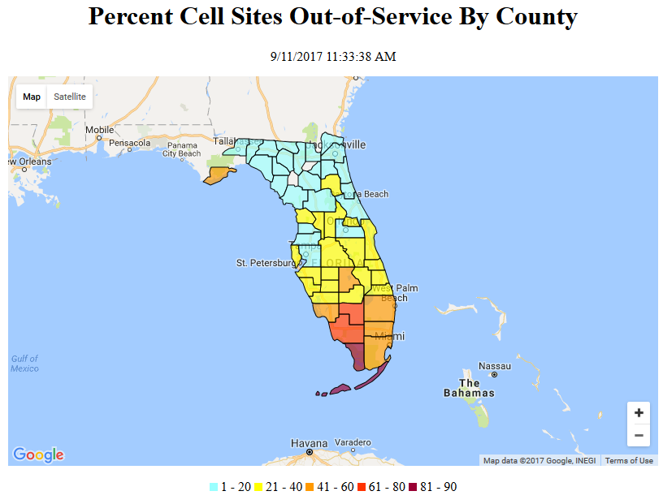

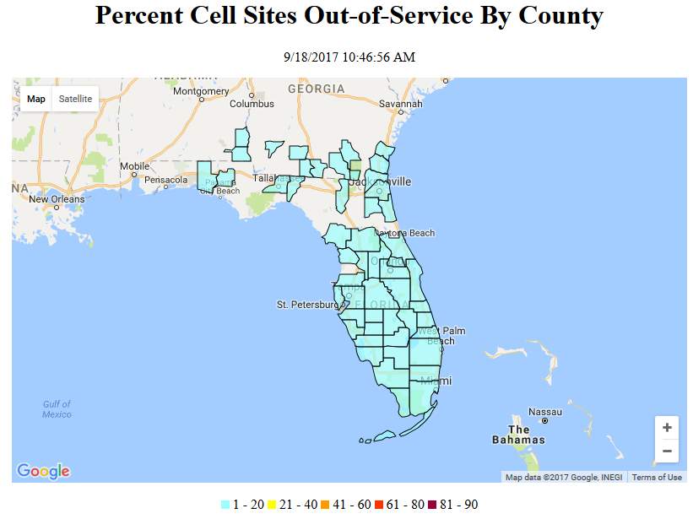

- The following chart shows the percentage of cell sites out per day for Puerto Rico and the USVI in the aftermath of Hurricane Irma. The chart shows that for Puerto Rico there was a steady improvement in the number of cell sites out of service per day, but for the USVI the percentage of cell sites out remained high at around 50 percent.

- The following chart shows that in Florida at the height of the storm 27.1 percent of the cell sites were out of service. After eight days, three percent of the state’s cell sites were still affected, indicating rapid recovery.

- PSAPs. On September 8, 2018, all four PSAPs in the region initially affected by Hurricane Irma (two in Puerto Rico and two in USVI) were affected; they were able to receive calls, but without automatic location identifiers (ALI). By September 11, 2017, as the storm moved northwestward toward Florida, an additional 27 PSAPs in that state were also affected -- either unable to receive 911 calls with no re-routing available, receiving 911 calls without location information, or re-routed to administrative lines or another PSAP.
- Almost two weeks after DIRS was first activated, only four PSAPs in Florida and the two PSAPs in the USVI remained affected; the two PSAPs in Puerto Rico were fully functioning. The remaining affected PSAPs in Florida were re-routed to other PSAPs along with location information. The PSAPs in the USVI could receive calls, but still without location information.
- Impact on other communications platforms. Throughout Hurricane Irma, the number of cable system subscribers that suffered loss of service fluctuated widely, reaching a high of several million at one point throughout all affected areas (i.e., Florida, Puerto Rico, and the USVI). Similarly, the number and location of radio stations that were unable to broadcast varied. In Florida, several dozen stations reported being inoperable, while in Puerto Rico and the USVI, many broadcasters were not even able to report their own inoperability.

Hurricane Maria
- Hurricane Maria had the greatest impact on the communications infrastructure among the major storms of the 2017 Atlantic hurricane season. Hurricane Maria caused significantly more damage to the telecommunications and other critical infrastructures (particularly the electrical and transportation infrastructures) in Puerto Rico and the USVI, resulting in much longer recovery times compared to Hurricane Harvey’s effect on Texas, Hurricane Irma’s effect on Florida, or Hurricane Nate’s effects along the Gulf Coast.
- Wireless telecommunications service. At its worst, 95.6 percent of the cell sites were out of service in Puerto Rico, and 76.6 percent of the cell sites were out of service in the USVI. Forty-eight out of 78 municipios in Puerto Rico had 100 percent of their cell sites out of service. Wireless service was restored gradually over a six-month period, considerably longer than for any other storm. After six months, 4 percent of cells sites remained out of service (i.e., completely inoperable) in Puerto Rico and 12 percent continued to be out of service in the USVI -- outages more typical of a few days after, not many months after, a significant hurricane.

Hurricane Maria – Puerto Rico
Day 1 (September 21, 2017) of DIRS Filing vs. Day 180 (March 21, 2018)

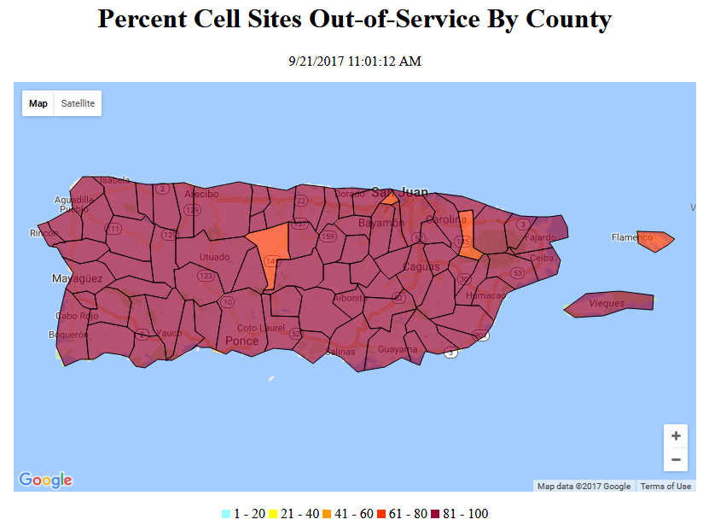

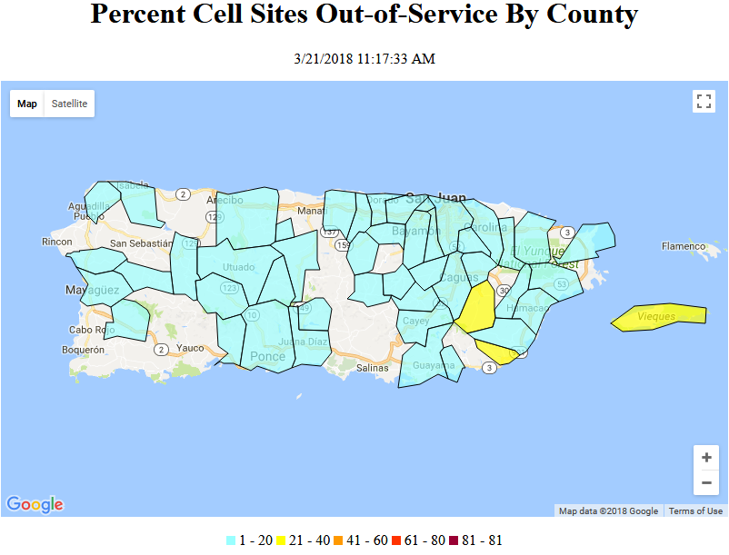

- The following chart shows that large percentages of cell sites were out of service throughout September and October of 2017 in Puerto Rico and the USVI. Six months after Hurricane Maria made landfall, 4.3 percent and 12 percent of the cell sites in Puerto Rico and the USVI respectively were still out of service.

- PSAPs. The two PSAPs in Puerto Rico functioned throughout Hurricane Maria, albeit not always with the full functionality (location information, call back number) that 911 call center personnel need to fully carry out their work. However, the St. Croix 9-1-1 Call Center in the USVI was completely out of service (i.e., not receiving 911 calls) for at least 10 days after Hurricane Maria made landfall.
- Impact on other communications platforms. Communications beyond wireless service also came to a virtual stand-still for weeks after Hurricane Maria. Downed broadcasting antennas, lack of power, a dearth of resources, destroyed telephone poles, and similar factors, combined to devastate communications on Puerto Rico and the USVI for months. As a snapshot-in-time, on December 6, 2017, several weeks after Hurricane Maria made landfall, five television stations in Puerto Rico were reported as operational, while 100 were not functioning. Roughly one-third of AM and FM radio stations remained out-of-service. Cable system and wireline phone service remained generally non-existent, owing mostly to the lack of power. On the same date, the USVI had no operational television broadcasting, cable system, and wireline service; and only two AM and two FM radio stations were confirmed functioning.

Hurricane Nate
- The Commission activated DIRS in the wake of Hurricane Nate on October 8, 2017 for one day. According to DIRS, “[t]here ha[d] been virtually no effect on communication.” Of the 1,644 cell towers that were the subject of DIRS reporting from the affected areas (two counties in Alabama, three in Mississippi, and three in Florida), only one tower, constituting 0.006 percent of towers, was reported out of service. The map below illustrates the cell site outage caused by Hurricane Nate, which occurred in Mobile County, Alabama:
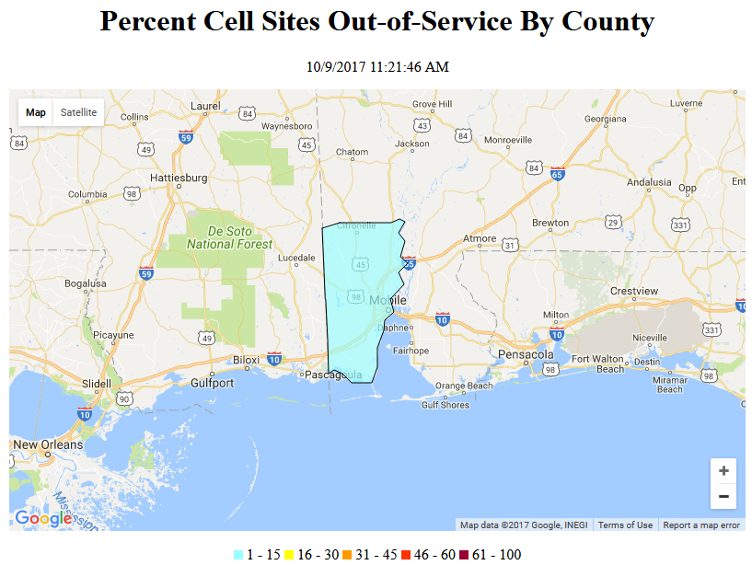
- Despite the minimal effects of communications, Hurricane Nate caused an estimated $2.5 billion in damages in the Gulf Region. No deaths were attributed to it within the United States.

COMMISSION response and recovery efforts

Incident Management Activity
- Throughout the hurricane season, the Federal Emergency Management Agency (FEMA) and the FCC coordinated communications-related efforts through Emergency Support Function #2 - Communications (ESF#2), which coordinates federal actions to help restore public communications infrastructure and to facilitate overall communications restoration and response. ESF#2 is a DHS-coordinated group, for which the FCC is a support agency. The group supports the restoration of the communications infrastructure following disasters, facilitates the recovery of systems and applications from cyberattacks, and coordinates federal communications support to response efforts during incidents requiring a coordinated federal response. ESF#2 also provides communications support to federal, state, local, Tribal, and territorial (SLTT) governments and first responders when their systems have been impacted and provides communications and information technology (IT) support to the Joint Field Office (JFO) and JFO field teams.
- To optimize support to hurricane response activities and ensure effective coordination across the Commission, the FCC activated its Incident Management Team (IMT). The IMT is a collaborative body consisting of technical and policy experts drawn from the Commission’s Bureaus and Offices. The IMT provided immediate support to requests for information and requests for action from federal, state, local, Tribal, and territorial government entities, first responder agencies and communications providers. This support included providing waivers of FCC rules, grants of special temporary authority, personnel support to Roll Call, and other over-the-air spectrum management capabilities.
- During the 2017 Atlantic hurricane season, the Commission deployed 11 personnel in support of FEMA response activities. While the Commission has a variety of capabilities and functions to support response, FEMA requested two specific functions under formal mission assignment: Roll Call and spectrum management support to Joint Field Offices. In response to Hurricane Harvey, the FCC deployed two personnel to perform Roll Call and two personnel to perform spectrum management responsibilities. In response to Hurricane Irma, the Commission deployed four personnel to perform Roll Call. During the aftermath of Hurricane Maria, the FCC deployed three personnel to support spectrum management activities at the Joint Field Office in San Juan, Puerto Rico. The FCC continues to provide direct personnel support for Hurricane Maria recovery by maintaining the deployment of one staff member who is an expert in public safety spectrum issues for approximately one week per month; this deployment is expected to continue for another twelve months.

Regulatory Relief
- The Commission has taken numerous steps to ensure that Universal Service Fund (USF) programs were and will be fully utilized to assist with the response and recovery. For example, within two weeks of Hurricane Maria’s landfall, the Commission made available immediately nearly $77 million from the Universal Service Fund High Cost Program in advanced funding to eligible telecommunications carriers (ETCs) for restoration of communications networks in Puerto Rico and the USVI.
- Further, the Commission adopted an Order and Notice of Proposed Rulemaking earlier this year providing additional funds and re-purposed monies to restore and expand networks in Puerto Rico and USVI. Specifically, the Commission established the Uniendo a Puerto Rico and Connect USVI Funds, which has made available an immediate infusion of an additional $64 million for short-term restoration efforts; and proposed to allocate $259 million in medium-term funding for the restoration and expansion of 4G LTE mobile broadband connectivity and approximately $631 million in long-term funding for the restoration and expansion of fixed broadband connectivity in Puerto Rico and USVI. The Commission opened the first stage of funding to all facilities-based providers in Puerto Rico or the USVI, so long as they certify their eligibility in accordance with the Commission’s May 2018 Order.
- The Commission also waived certain rules under the Lifeline, E-rate and Rural Health Care programs as well as regulations related to USF contributions. For example, the Commission waived recertification rules and non-usage rules to ensure that Lifeline subscribers would not lose their Lifeline service at a time when they needed it most. The Commission noted that the damage caused by Hurricanes Irma and Maria in Puerto Rico and the USVI had made it difficult for Lifeline subscribers in those territories to receive, or respond to, messages from their Lifeline provider or the Universal Service Administrative Company (USAC) to complete the recertification process. Because of this, the Commission temporarily waived the recertification rules for subscribers there who could not be recertified.
- Regarding the E-rate program, the Commission approved targeted and flexible E-rate support to help restore connectivity of schools and libraries. Specifically, on October 26, 2017, the FCC adopted temporary rules providing immediate relief to schools and libraries confronting the devastation caused by the hurricanes that struck the United States and its territories in August and September 2017. The rules provided support to schools and libraries forced to rebuild facilities and replace equipment damaged by the hurricanes and provided increased flexibility for eligible services to be restored through service substitutions. The Commission also made available additional E-rate support for schools incurring additional costs for eligible services, e.g., for increased bandwidth demand.
- The Commission expedited regulatory action during the critical hours and days after the hurricanes including waiving rules when needed to support service continuity or restoration and assisting communications service providers in restoring facilities, establishing temporary facilities in stricken areas, and obtaining access to backup power. Over the course of the hurricane season, the Commission granted over 900 requests for Special Temporary Authority, as outlined below:

Special Temporary Authorizations (STAs) by Bureau
Bureau | Harvey | Irma | Maria
Wireless Telecommunications | 22 | 16 | 717
Public Safety & Homeland Security | 6 | 6 | 8
Media | 8 | 29 | 85
FCC Operations Center | 3 | 0 | 0
International Bureau | 0 | 4 | 5
Office of Engineering & Technology | 1 | 0 | 9
Totals | 40 | 55 | 824

- The Commission also published 40 hurricane-related public notices and issued 20 hurricane-related orders during the 2017 Atlantic hurricane season intended to provide the information, flexibility and other relief for service providers attempting to restore service. It also expedited evaluation and approval of experimental licenses to provide voice and data services to residents (e.g., Alphabet’s Project Loon).
- The Wireless Telecommunications Bureau (WTB) granted a request from the American Radio Relay League (ARRL) for a temporary waiver to permit amateur data transmissions at a higher symbol rate than normally permitted, to facilitate hurricane relief communications between the continental United States and Puerto Rico. In granting the request, WTB noted that ARRL already had dispatched large amounts of communications equipment and fifty trained amateur radio operators to Puerto Rico to conduct disaster relief communications, and that grant of the request would facilitate the work of amateur radio operators assisting in the recovery efforts.
- On September 15, 2017, the Office of Managing Director (OMD) extended the maximum relief allowed by law with respect to the payment of Fiscal Year (FY) 2017 Regulatory Fees for regulatees affected by Hurricane Maria in Puerto Rico and USVI. OMD staff also conducted extensive outreach to individual fee payors affected by Hurricane Maria that could not meet the extended payment deadline and provided options, such as filing waivers of fees or entering installment plans under the Debt Collection Improvement Act. Further, OMD also declined to charge late fees for debt payments from payors affected by the catastrophe.
- The Commission’s Public Safety and Homeland Security Bureau (PSHSB) temporarily waived location accuracy obligations for 911 calls for certain service providers in areas affected by Hurricane Maria. It also waived rules, allowing public safety use of interoperable channels in Puerto Rico and USVI that would otherwise be off-limits. The Bureau also extended filing deadlines for affected service providers with respect to 911 Reliability Certifications and the September 2017 Nationwide Emergency Alert System (EAS) Test. Jointly, with WTB, the Bureau extended filing and regulatory deadlines and streamlined the environmental notification process for areas affected by Hurricane Maria.
- The Media Bureau (MB) twice extended deadlines for broadcasters in Puerto Rico and USVI with respect to the maintenance of public files, and accelerated the post-Incentive Auction transition to enable broadcasters in Puerto Rico and the USVI to restore television services in their post-auction channels instead of rebuilding on their pre-auction channels, to preclude having to transition soon thereafter. The MB also waived certain rules for Auction 100 participants in Puerto Rico to expedite the construction of critical new broadcast facilities. Finally, the MB advised licensees in Puerto Rico and the USVI that it would be favorably inclined to grant licensees additional time in which to transition to online public files.

Situational Awareness
- The Commission activated DIRS in FEMA-designated areas in response to Hurricanes Harvey, Irma, Maria, and Nate via Public Notice, and the DIRS team targeted additional outreach directly to service providers. Throughout the DIRS activations, the Commission coordinated with DHS and providers reporting into DIRS to expand and contract the scope of the data collections, as needed.
- DIRS remained activated for 11 days for Hurricane Harvey, 12 days for Hurricane Irma, 182 days for Hurricane Maria (by far the longest DIRS activation on record), and one day for Hurricane Nate. During these activations, the Commission collected 5,316 reports for Hurricane Harvey; 24,422 reports for Hurricane Irma; 75,712 reports for Hurricane Maria, and 1,644 for Hurricane Nate. Throughout these activations, PSHSB generated non-public daily situation reports and maps that were shared with federal partners to assist the ESF#2 response efforts. Consistent with the Wireless Resiliency Cooperative Framework (Wireless Framework), the Commission issued public reports on the status of communications services in affected areas—11 for Hurricane Harvey, 12 for Hurricane Irma, 107 for Hurricane Maria, and one for Hurricane Nate.
- The Commission used its Roll Call teams, along with long-range and fixed remote monitoring, to determine the status of key broadcasters in impacted areas. Particularly in Puerto Rico, the broadcast community significantly assisted this effort by polling within the community and providing the status of stations.
- As an example, below is a synopsis of Roll Call scans made by staff prior to and after Hurricane Irma. The yellow circles represent locations where pre-event baseline radio frequency spectrum activity was measured, while the green represents post-event measurements. Identifying which spectrum is operating, and which is not, is vitally important to ensure that public welfare and evacuation information is disseminated to the disaster area in a timely and accurate manner.

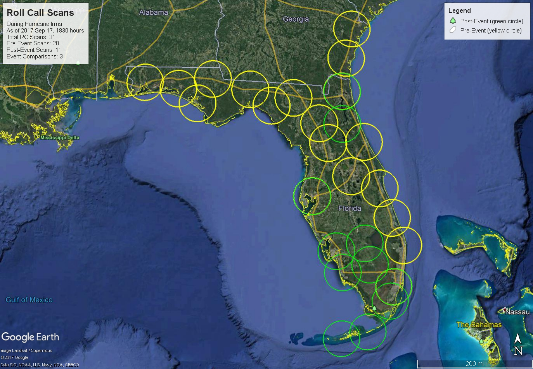

Industry Engagement
- The Commission began outreach to industry partners in advance of each storm. As a designated federal partner of DHS’s National Coordinating Center for Communications (NCC), the Commission participates in year-round weekly coordination calls with DHS and the Communications Sector Information Sharing and Analysis Center (Comm-ISAC). Through the 2017 Atlantic Hurricane season and continuing into recovery, the NCC and Comm-ISAC held both government-only and government-industry calls to coordinate communications sector preparedness and response actions. Commission staff reached out to broadcasters through the National Association of Broadcasters and state broadcast associations in the affected areas. This outreach ensured critical dialog between Commission staff and broadcasters regarding Commission actions and notices and critical broadcast issues.

Public Engagement
- The Commission published and maintained a comprehensive webpage on the Commission’s website for each of the major hurricanes to promote transparency, inform the public, and increase a general understanding of what actions it was taking before, during, and after each hurricane. Each webpage included: storm-related orders and public notices; communications status reports; outage information updated daily from DIRS; relevant orders; and related news releases, statements, and presentations. The Commission, in cooperation with FEMA, also published a “tip sheet” in six languages on how consumers can prepare for an emergency, as well as communicate during such an emergency.
- On December 7, 2017 (at the conclusion of the hurricane season), PSHSB released a Public Notice seeking comment on communications infrastructure resiliency in the 2017 Atlantic hurricane season. The Bureau sought comment on what actions the FCC could change or improve to ensure communications continuity during disasters, and what government and industry actions proved effective in preparation, response and recovery. Stakeholder input was robust. Filers in the docket commented on numerous topics including: overall resiliency, the role of amateur radio during and in the aftermath of the hurricanes, the effect of the storms on PSAPs, how DIRS assisted in recovery efforts and what actions might improve DIRS, how the Wireless Framework played a key role in helping restore communications infrastructure, the extent to which innovative technologies could fill critical gaps, and how service providers (telecommunications and broadcasting) can improve outreach efforts to members of the disabilities community.
- Building on the record from the Public Notice, on April 13, 2018, PSHSB hosted a workshop of government and consumer stakeholders to identify critical information needs during disasters and to facilitate access to such information in support of preparedness and response activities. Workshop participants asked the Commission to consider a number of actions, including:
- having on-the-ground capability to validate granular cellular coverage and functionality;

- amending DIRS reporting by including specific tower outages and services impacted (e.g., 3G, 4G LTE, etc.), and whether critical infrastructure and PSAPs are known to have been impacted by the storm;

- encouraging more service providers to participate in the voluntary DIRS program;

- encouraging service providers filing into DIRS to also make the same information to SLTT partners;

- considering regular pre-season communications baseline assessments of areas typically impacted by hurricanes;

- continuing to encourage service providers to create more resilient broadband / telecommunications in geographically isolated areas (e.g., islands, mountainous and rural areas);

- becoming more assertive in its role in ESF#2 exercises, and regional and local emergency management agencies’ training; and

- engaging with stakeholders to identify, improve, and/or develop means to get critical information to residents with disabilities.

Recovery Actions
- Hurricane Recovery Task Force. As part of shifting from short-term incident management to a longer-term recovery phase, the Commission established an internal Hurricane Recovery Task Force (HRTF or Task Force) on October 6, 2017, comprised of subject matter experts representing Bureaus and Offices throughout the agency. The Task Force continued the Commission’s work in support of the restoration of communications services in areas affected by the 2017 hurricanes, with an emphasis on addressing the longer-term recovery challenges faced by Puerto Rico and the USVI. The HRTF facilitated a coordinated and comprehensive approach to this work within the FCC. With representatives from all corners of the agency, the Task Force was able to look comprehensively at how the Commission could best support recovery efforts and enhance its efforts in future years. The Task Force also provided outside entities, such as the Puerto Rico Telecommunications Regulatory Board (PRTRB), commercial providers, and entities seeking experimental authorizations or offering solutions, with a centralized point to engage the Commission on hurricane recovery issues.
- As discussed below in Section V, the Commission is moving forward to implement several recommendations of the Task Force. In addition, on July 27, 2018, Chairman Pai announced formation of a working group within the Broadband Deployment Advisory Committee (BDAC) to address infrastructure and disaster recovery issues. The new working group will assist BDAC in providing advice and recommendations to the Commission on steps that can be taken to improve disaster preparation, response, and recovery for broadband infrastructure.
  - Site Visits
- The Chairman and other Commissioners undertook fact-finding trips to the affected areas as soon as feasible after a storm had passed. Chairman Ajit Pai visited Texas to survey the damage caused by Hurricane Harvey in September 2017. He met with local, state, and federal officials who were engaged in recovery efforts. He and then-Commissioner Mignon Clyburn visited South Florida in September in the wake of Hurricane Irma. There, he noted the important role first responders and the broadcast community played in response and recovery efforts.
- The Chairman visited Puerto Rico in November 2017, and in March 2018 he returned to the island and also visited the USVI, accompanied by members of the FCC Hurricane Recovery Task Force. The Chairman noted the massive devastation to the communications infrastructure (e.g., poles down, cell towers toppled, electrical power depleted and otherwise unavailable, wireless infrastructure completely destroyed, many radio and television broadcast facilities impacted). He also recounted his meetings with a wide variety of stakeholders, beginning with the citizens of the municipio (county) of rural Utuado, which was among the most hard-hit areas of the island, and the creative and innovative ways they responded to Maria and its aftermath. The Chairman also met with the governors of Puerto Rico and the USVI, territory-wide service commissions, first responders, school and hospital officials, service providers, and government officials at various levels. The Chairman met numerous radio and TV broadcasters on both territories, including an on-air appearance on a local radio station. Following the March visit, the Chairman pointed out the need for the Commission and FEMA to continue coordinating to ensure vital communication links are properly prioritized. Commissioner Jessica Rosenworcel also visited Puerto Rico in March 2018 to assess the damage to the communications sector and observe recovery efforts.

Lessons Learned and NEXT STEPS
- Based on information, analysis and feedback received by various stakeholders as well as the HRTF, the Commission presents the following lessons learned and next steps towards enhancing its disaster response and recovery efforts.

Improvements to FCC’s Emergency Response and Recovery Efforts
- DIRS Enhancements. During the 2017 Atlantic Hurricane season, DIRS reporting by broadcasters lagged other communications sectors. In addition, during Hurricane Maria, the major incumbent local exchange carrier and cable providers in Puerto Rico and the USVI did not provide detailed information in DIRS. In some cases, the lack of participation was due to service providers’ loss of communications which precluded access to the DIRS platform. In other cases, service providers may not have been aware of DIRS prior to the hurricanes. Lastly, the Commission received public comments and other feedback that both the publicly-available, aggregated DIRS information and the non-public DIRS reports did not provide adequate information to reflect the consumers’ communications experience. To address these gaps, PSHSB will take the following steps:
- design and deploy a vigorous outreach program targeted at communications service providers to promote the value of DIRS participation; and
- retool the DIRS data model to (a) include data elements that better reflect degraded customer experience, especially as a disaster migrates from near-term response to long-term recovery, and (b) consistently include geospatial information in formats that are most helpful to user communities, especially to support decision making for deploying response personnel and assets.
- Wireless Resiliency Cooperative Framework. In response to the 2017 Hurricane Season Public Notice, the Commission received substantial feedback regarding the Wireless Framework. CTIA stated that the Wireless Framework “enhance[ed] service continuity and information sharing” and “helped wireless providers and their representatives on the ground restore service as quickly as possible.” CTIA also commented that the Wireless Framework’s structure gave wireless service providers the flexibility necessary to tailor network resiliency and continuity of service efforts to the individualized needs of affected communities and the unique challenges presented by each storm. Spectrum Financial noted that a “remarkable and civic outcome . . . is the agreement among operators to allow free roaming among the networks in disaster areas.” Verizon noted that the Wireless Framework “gave providers the ability to adapt to diverse and changing circumstances on the ground and to develop innovative responses as events unfolded.” The PRTB stated that a “positive impact” of the Wireless Framework was the creation of a dedicated Command Center to centralize restoration efforts for telecommunications that was operational for seven days a week, a joint effort by the PTRB and Puerto Rico Innovation and Technology Services (PRITS), in coordination with the Governor of Puerto Rico.
- Among these success stories, commenters also identified areas for improvement. T-Mobile stated that while the Wireless Framework worked well, it focused on wireless providers and “promote[d] a tilted outlook of overall telecom restoration,” and recommended that the Commission consider a similar approach to cover the entire communications ecosystem, including backhaul providers to “provide faster and more complete service restoration.” Similarly, APCO recommended that the Commission expand the Wireless Framework to include non-nationwide wireless providers. Spectrum Financial recommended that roaming under the Wireless Framework be triggered prior to landfall “so that revised roaming tables can be loaded into devices while networks are still operating at full capacity and phones are charged.” Finally, some commenters recommended that the Commission seek more granular information from Wireless Framework participants that can be included in public reports on an aggregated and anonymous basis. To address these gaps, the PSHSB, in coordination with WCB and WTB, will take the following actions:
- Encourage backhaul providers to participate in the Wireless Framework and work cooperatively with wireless service providers and other stakeholders to develop:

(a) a process for sharing restoration information with one another and the FCC, including a timeline of expected restoration efforts based on either the prioritized list of circuits or circuits designated for high traffic during emergencies;

(b) best practices for information sharing and network restoration prioritization efforts, including coordination with federal, state, and local emergency agencies and power companies; and

(c) a sustainable process for preparing and sharing contact information of emergency response agencies and power companies for emergency response, network restoration, and continuity of operations with other Wireless Framework signatories, affected providers, and the Commission; and

- Seek voluntary industry commitments from Wireless Framework signatories to provide data of greater granularity that could be made public on an aggregated, anonymous basis when the Wireless Framework is triggered.
- Radio Frequency Survey Application. During the 2017 Atlantic Hurricane season, the Task Force noted that the Commission lacked a mechanism to independently verify information on the availability of commercial wireless services that providers voluntarily submitted into DIRS. To address this issue and to provide a geospatial view of wireless coverage, the Office of Engineering & Technology (OET) and Enforcement Bureau (EB) investigated leveraging ongoing work with a third-party smartphone app developer to create a prototype radio frequency (RF) survey application that senses the presence of RF signals in commercial wireless bands of interest. While initial distribution would be limited to authorized emergency responders deployed to a particular disaster area, the app could ultimately be made available via application stores so that it can be distributed widely. Making the app widely available would increase the range and the granularity of the RF survey. OET, EB and PSHSB plan to work collectively with emergency responders on the distribution and use of the app to assist with future disaster response and recovery efforts. In addition, OET, EB and PSHSB will design a dashboard for analyzing wireless service availability during disaster events.
- Over-the-Air Information (OTA) Collection During Disasters. OTA collection is the direct measurement of the electromagnetic spectrum (broadcast, land mobile radio, etc.) to confirm post-impact spectrum usage. During the 2017 Atlantic Hurricane season, the Commission used over-the-air technologies such as the National Shared Remote Equipment Network (NSREN) and its High-Frequency Direction-Finding network to collect situational awareness information about emergency communications, including alert system operations. This information was shared with FEMA and other federal partners. In response to the Public Notice and the workshop, the Commission received favorable comments about the use of these technologies. In light of this positive feedback, PSHSB is now considering developing more integrated reporting from the various OTA observation systems which might increase reporting speed and free Roll Call teams for additional scans, analysis and reporting. As part of this consideration, PSHSB will also examine whether OTA capability can be used to validate coverage and capacity of wireless telecommunications networks in disaster areas.
- Increase Engagement with Emergency Management Partners. The 2017 Atlantic Hurricane season underscored the importance of relationships for effective incident response. Cross-sector dependencies greatly affected communications services, which are often highly dependent on electric power, fuel distribution (in the absence of electricity), and transportation at the local level (for access to sites and facilities) and regional level (for transportation of restoration crews and equipment). Various interagency ad hoc efforts have attempted to address cross-sector dependencies, but more cross-sector incident response engagement is needed.
- Going forward, PSHSB will more actively engage with Critical Infrastructure (CI) sectors and SLTT governments to better address and position communications needs in times of disaster. On the federal level, PSHSB will engage more substantively with other ESFs, particularly Transportation (ESF#1) and Energy (ESF#12), to learn more about how these sectors can coordinate better during emergencies to work more effectively together to support service restoration. Commission personnel also should become more active with DHS cross-sector risk identification and risk mitigation activities and increase the FCC’s participation in interagency exercises that address these cross-dependencies. PSHSB will also take a more active role in promoting the Commission’s relationships with its SLTT partners, to ensure it engages the appropriate response managers, who are the focal point of decision-making and allocations of scarce resources during disasters related to power, logistics, and access.
- Efficient Communication in Languages Other Than English and In Additional Formats. As seen during the 2017 Atlantic hurricane season, providing emergency information in languages other than English can be critical to allowing a great number of consumers an opportunity to make lifesaving decisions for themselves and their families. The Commission maintains on its website tips for communicating in emergencies in five of the most commonly-spoken languages in the United States other than English – Spanish, Chinese, Korean, Vietnamese, and Tagalog – and is adding French, a language spoken by many along the Gulf Coast, as the 2018 season gets underway. There is an opportunity and a need to expand the languages in which this information is available and to increase the type and format of information that is available in languages other than English. The Commission’s Consumer & Governmental Affairs Bureau (CGB) will lead the creation and dissemination of both English and non-English digital audio-visual content on additional platforms that can be downloaded for use on-air by radio and television broadcasters, linked to/from other emergency officials at all levels, and featured on social media.
- PSHSB will lead internal outreach to FCC staff to leverage the non-English languages skills of FCC personnel. We expect this will lead to the creation of a database where FCC staff volunteers would be able to self-identify non-English language skills—including American Sign Language—and willingness to assist in outreach as a component of the FCC’s emergency response. To this end, IMTs in the future will add non-English language outreach as a component of preparing for and responding to disasters.

Recommended Best Practices for Governments, Service Providers, and Related Stakeholders
- In addition to FCC actions, many comments in response to the Public Notice and by participants in the workshop recommended best practices and actions that various stakeholders should consider to enhance disaster response and recovery in the future. The Commission encourages adoption of these best practices, developed with industry participation.
Federal Government Partners

- Agencies tasked with supporting the National Response Framework (NRF) should maintain a sufficient cadre of trained responders; successful response requires trained and knowledgeable surge capacity forces.

- Agencies should engage with ESF#2 to inform and hasten response through task development in coordination and capabilities plans (a) pre-event and (b) during initial deployment to an affected area.

- FEMA and support agencies, especially the FCC, should develop and maintain pre-event spectrum observational data for areas most likely to be affected by disasters.

  - Having pre-event awareness of emergency communication, emergency alerting, and cellular system capabilities in these areas will help focus response efforts when coverage gaps occur due to a disaster.

  - Agencies should also consider geographic information system (GIS) mapping as a vital tool.

- As part of the pre-event planning process, agencies should evaluate the potential effectiveness of using novel or experimental systems to help restore critical communications during disaster response, prior-coordinate spectrum support for those systems ahead of landfall, when possible and preposition equipment. ESF#2 partners noted the difficulty in deploying such systems during disaster response, particularly when there had been no opportunity for evaluation prior to the disaster response activation.

- Responding agencies should harmonize reporting templates and common definitions before a response begins. Agencies tasked with overseeing emergency communications planning should encourage all partners to regularly update/validate plans and procedures.
Communications Service Providers

- Because interagency and inter-jurisdictional relationship-building and co-training is essential for successful response, communications providers and responders should participate in local communications and alerting planning events, information exchanges, and exercises well before a disaster to validate response plans and processes, ensure capable and qualified communications response personnel, and cultivate critical interagency relationships.

- Those providing critical communications services should ensure there is sufficient physical path diversity, which may include addition of satellite networks, microwave links, or alternate wireline connections.

- Service providers, network operators, and others should ensure they have reviewed, and are implementing where practicable, best practices issued by the Communications Security, Reliability, and Interoperability Council (CSRIC) and applicable standards bodies. Relevant CSRIC best practices include:

  - coordinating hurricane and other disaster restoration work with electrical and other utilities as appropriate;

  - coordinating with local, state and/or federal emergency management and law enforcement agencies for pre-credentialing to help facilitate access by technicians to restricted areas during an event;

  - placing all power and network equipment in a location, (such as higher ground) to increase reliability in case of disaster (e.g., floods, broken water mains, fuel spillage); in storm surge areas, placing all power related equipment above the highest predicted or recorded storm surge levels;

  - placing standby generators on line and verifying proper operation of all subsystems (e.g., in cases of heavy ice, snow, flood, hurricanes); and

  - service providers should ensure the availability of emergency/backup power (e.g., batteries, generators, fuel cells) to maintain critical communications services during times of commercial power failures, including natural and manmade events; the emergency/backup power generators should be located onsite, when appropriate.”

- 911 service providers should establish alternate routing arrangements where possible and, in the longer term, leverage the potential benefits of IP-enabled NG911 networks.

- Service providers should perform rigorous system maintenance and preventive measures, to promote resiliency—system testing, re-fueling generators, moving equipment as needed, sandbags, pre-positioning fuel trucks, blocking hotel rooms for workers.

PSAPs

- PSAPs should, where possible and feasible, prepare for an event by pre-arranging for 911 calls to roll over to secondary, and even tertiary sites, and pre-arrange for access to a mobile PSAP.

Amateur Radio Operators

- High frequency (HF) radio communication, including amateur radio operators, was essential during these disasters, particularly in Puerto Rico and the USVI. The ARRL partnered with the Red Cross and Salvation Army in an initiative known as the “Force of 50,” in which volunteer amateur radio operators assisted in relief efforts by providing information on survivors for their families on the continental United States. Notable lessons learned from these operations include:

  - Island and other isolated environments may particularly benefit from HF communications, due to HF’s ability to function even in highly degraded infrastructure environments;

  - The effectiveness of Amateur Radio Service (ARS) Emergency Communications (EmComm) would have benefitted from a more comprehensive disaster response/deployment plan coordinated in advance with DHS (FEMA, National Coordinating Center for Communications (NCC), and Office of Emergency Communications (OEC)) and the Red Cross; and

  - An EmComm calling/monitor frequency on each ARS HF band would have better facilitated monitoring EmComm traffic.
Consumers

- Consumers should familiarize themselves with information and guidance the Commission and the consumers’ service providers issue on communications during an emergency, and what steps they can take to increase the likelihood that their communications devices will be useful during a crisis.

Conclusion
- The storms of the 2017 Atlantic hurricane season put considerable, and in some cases unprecedented, stress on numerous communications infrastructures—wireless, cable, wireline, and broadcasting. Consideration and implementation of the lessons learned from the 2017 season can help ensure that the communications ecosystem continues to harden and become ever more resilient. Although last year was an anomaly as far as the severity and number of named storms, all members of the communications community should take what steps they can, now, to lessen a storm’s impact. PSHSB looks forward to sharing lessons learned with its partners within the Commission, with its federal partners, with state, local, territorial, and Tribal governments, and with communication service provider.; Even though following all recommendations cannot preclude an adverse communications event, diligent and early adoption will lessen the impact of that event.
- With publication of this Report, PS Docket No. 17-344, “Response Efforts Undertaken During 2017 Hurricane Season,” is closed.
APPENDIX
List of Commenting Parties
Docket No. 17-344

Commenters:

American Radio Relay League
Association of Public-Safety Communications Officials-International, Inc.
Carson, Janis
Charter Communications, Inc.
Comcast Corporation
CTIA
Davis, Anita
Elefante Group, Inc.
Elfelt, Joseph
Houston, Texas, City of
Hughes Network Systems, LLC
Johnson, John
Ligado Networks Subsidiary LLC
Moloney, Timothy
Motorola Solutions, Inc.
National Public Radio, Inc.
Neptuno Media, Inc. dba Neptuno Networks
Public Knowledge
Puerto Rico Telecommunications Regulatory Board
Puerto Rico Telephone Company, Inc., dba Claro
Rodriquez Colon, Juanita
Satellite Industry Association
SES S.A. and O3b Limited
Sorenson Communications, LLC
Spectrum Financial Partners, LLC
T-Mobile USA, Inc.
Verizon
Virgin Islands Public Broadcasting System
Virgin Islands Telephone Corp., dba Viya
Waterman, Steve
Wireless Infrastructure Association

Reply Commenters:

Amateur Radio Safety Foundation, Inc.
AT&T Services, Inc.
Cameron, Skip
Claro
CTIA
CW Operators’ Club
Department of Homeland Security (DHS), National Coordinating Center for Communications
Kolarik, Ron
McVey, W. Lee
National Association of Broadcasters
Rappaport, Theodore
Robinson, Jason
Talens, James
Taylor, Collin
Verizon
Viya
White, Dan
Wireless Infrastructure Association
WorldNet Telecommunications, Inc.

Ex Parte Presentations:

Anonymous
AT&T Services, Inc.
DHS, Office of Emergency Communications
Free Press
Hughes Network Systems, LLC
Liberty Cablevision of Puerto Rico LLC
National Consumer Law Center
National Hispanic Media Coalition
Rappaport, Theodore
Rehabilitation Engineering Research Center for Wireless Inclusive Technologies
Star Solutions
Telecommunications Regulatory Board of Puerto Rico
T-Mobile USA, Inc.
WorldNet Telecommunications, Inc.

Sheri Fink, New Data Sheds Light on Death Toll of Hurricane Maria in Puerto Rico (updated Jun. 8, 2018), https://www.nytimes.com/2018/06/02/us/puert-rico-death-tolls.html; see also Frances Robles, Hurricane Killed 1,427, Not 64, Puerto Rico Admits in Funding Request, (updated Aug. 20, 2018), https://www.nytimes.com/2018/08/09/us/puerto-rico-death-toll-maria.html.
See National Oceanic and Atmospheric Administration (NOAA), Extremely active 2017 Atlantic hurricane season finally ends (Nov. 31, 2017), http://www.noaa.gov/media-release/extremely-active-2017-atlantic-hurricane-season-finally-ends (NOAA November 2017 Hurricane Season Release).
See NOAA November 2017 Hurricane Season Release.
Estimates of the number of fatalities related to Hurricane Maria in particular (including deaths related to the devastation caused to the island’s communications infrastructure) vary widely. See, e.g., Nishant Kishore et al., Mortality in Puerto Rico after Hurricane Maria, Special Article, New Eng. J. Med. (2018), available at https://www.nejm.org/doi/pdf/10.1056/NEJMsa1803972 (estimating over 5,000 deaths); Alexis R. Santo-Lozada, Pennsylvania State University, Estimates of excess deaths in Puerto Rico following Hurricane María (Apr. 2, 2018), Health Affairs, https://osf.io/preprints/socarxiv/s7dmu/ (suggesting roughly 1,200 died during Hurricane Maria, and in its aftermath); Frances Robles, Hurricane Killed 1,427, Not 64, Puerto Rico Admits in Funding Request, (updated Aug. 20, 2018), https://www.nytimes.com/2018/08/09/us/puerto-rico-death-toll-maria.html (revising fatality count upward).
Daniel Uria, Record 2017 season cost $370B, hundreds of lives (Nov. 30, 2017), https://www.upi.com/Record-2017-hurricane-season-cost-370B-hundreds-of-lives/7711511317614/; see also Brian K Sullivan, The Most Expensive U.S. Hurricane Season Ever: By the Numbers (Nov. 26, 2017), https://www.bloomberg.com/news/articles/2017-11-26/the-most-expensive-u-s-hurricane-season-ever-by-the-numbers; Manuel Torres, Hurricane Nate sets record as fastest moving storm in Gulf of Mexico (Oct. 7, 2017), http://www.nola.com/hurricane/index.ssf/2017/10/hurricane_nate_sets_record_as.html.
Jill Disis, Hurricane Maria could be a $95 billion storm for Puerto Rico (Sep. 28, 2017), http://money.cnn.com/2017/09/28/news/economy/puerto-rico-hurricane-maria-damage-estimate/index.html; Jeff Masters, Hurricane Maria Damage Estimate of $102 Billion Surpassed Only by Katrina (Nov. 22, 2017), https://www.wunderground.com/cat6/hurricane-maria-damages-102-billion-surpassed-only-katrina (“[a]n early estimate of insured damages from Maria from insurance broker AIR Worldwide was $40 - $85 billion; since total damage is typically about double insured damage, Maria's price tag may end up being well in excess of $100 billion”).
National Hurricane Center, NOAA, Costliest U.S. tropical cyclones tables updated (Jan. 26, 2018), https://www.nhc.noaa.gov/news/UpdatedCostliest.pdf (last visited Jun. 11, 2018). The damage caused by Harvey in 2017 equaled that caused by Katrina to the American Gulf Coast region in 2005. Id. Tawnell D. Hobbs, Two Months After Harvey, Houston Continues to Count the Costs (Oct. 31, 2017), https://www.wsj.com/articles/two-months-after-harvey-houston-continues-to-count-the-cost-1509442203.
See, e.g., After Hurricane Irma, Southern Florida Market Quickly Heads Back to Business: Pre-Storm Preparations, Years in the Making, Helped Reduce the Damage, October 15, 2017, https://www.mansionglobal.com/articles/after-hurricane-irma-southern-florida-market-quickly-heads-back-to-business-77241 (last visited July 12, 2018).
Response Efforts Undertaken During the 2017 Hurricane Season, PS Docket No. 17-344, Comments of ARRL, The National Association for Amateur Radio, formally known as the American Radio Relay League, at Section IV (Hurricane Maria and the Amateur Radio Response); see also ARRL After Action Report for 2017 Hurricane Season, Section 3.1: Overview of the ARRL/American Red Cross Collaborative Deployment to Puerto Rico, http://www.arrl.org/files/file/Public%20Service/ARES/2017%20Hurricane%20Season%20AAR.pdf.
DIRS is a voluntary web-based database into which communications providers (including wireless, wireline, broadcast, and cable) can report infrastructure status and situational awareness during crises; it streamlines the reporting process and enables communications providers to share network status information with the Commission quickly and efficiently.
Communications Status Report, FCC, Communications Status Report for Areas Impacted by Hurricane Irma, September 7, 2017 (rel. Sep. 7, 2017), https://www.fcc.gov/document/hurricane-irma-communications-status-report-sept-7 (last visited Jun. 12, 2018).
We note that Puerto Rico does not have “counties” as that term is used in English-speaking, common law nations, but rather 78 municipios, or “county-equivalents.” See “Geographic Terms and Concepts – Puerto Rico,” https://www.census.gov/geo/reference/gtc/gtc_pr.html (last visited Jul. 16, 2018). The U.S. Census notes that “[t]he primary legal divisions of Puerto Rico are termed ‘municipios.’ For data presentation purposes, the Census Bureau treats a municipio as the equivalent of a county in the United States.” Id.
Communications Status Report, FCC, Communications Status Report for Areas Impacted by Hurricane Maria, September 21, 2017 (rel. Sep. 21, 2017), https://www.fcc.gov/document/hurricane-maria-communications-status-report-sept-21 (last visited Jun. 12, 2018).
See, Communications Status Report for Areas Impacted by Hurricane Harvey, August 26, 2017, https://www.fcc.gov/document/fcc-releases-first-hurricane-harvey-communications-status-report (last visited Jun. 18, 2018)
See generally Hurricane Harvey, “Communications Status Report” (Cable Systems and Wireline (combined), Broadcast) section of each report.
See, e.g., Arian Campo-Flores and Valerie Bauerlein, Hurricane Irma’s Major Economic Toll on Florida Takes Shape (Sep. 14, 2017), https://www.wsj.com/articles/hurricane-irmas-major-economic-toll-on-florida-takes-shape-1505381401#comments_sector (last visited Jul. 17, 2018).
See The FCC’s Public Safety & Homeland Security Bureau Announces Deactivation of the Disaster Information Reporting System for Hurricane Irma, Public Notice, 32 FCC Rcd 6978 (PSHSB 2017).
We note that, based on the path of Hurricane Irma, DIRS reporting was deactivated for, among other places, all the municipios (counties) in Puerto Rico. See Public Safety & Homeland Security Bureau Announces Partial Deactivation of the Disaster Information Reporting System for Hurricane Irma, Public Notice, 32 FCC Rcd 6963 (PSHSB 2017). DIRS reporting continued for the three counties of the USVI (i.e., St. Thomas, St. John, and St. Croix). Id.
See, e.g., Communications Status Report for Areas Impacted by Hurricane Irma, September 14, 2017, https://www.fcc.gov/document/hurricane-irma-communications-status-report-sept-14 (last visited Jun. 28, 2018).
The logistical challenges (non-operational ports, unpassable roads, etc.) of getting material to Puerto Rico and the USVI that were necessary for recovery added to delay.
See Presentation, NG911 Lunch and Learn, When Disaster Strikes – The Critical Role of 911 During Major Disasters (Jan. 17, 2018), https://www.ng911institute.org/wp-content/uploads/2018/01/Lunch-and-Learn-When-Disaster-Strikes-Slide-Deck.pdf (last visited Jul. 17, 2018).
Communication State Report for Areas Impacted by Hurricane Maria, December 6, 2017, https://www.fcc.gov/document/hurricane-maria-communications-status-report-dec-6 (last visited Jul. 2, 2018).
Public Safety & Homeland Security Bureau Announces the Activation of the Disaster Information Reporting System in Response to Hurricane Nate, Public Notice, 32 FCC Rcd 7470 (PSHSB 2017).
The FCC’s Public Safety & Homeland Security Bureau Announces Deactivation of the Disaster Information Reporting System for Hurricane Nate, Public Notice, 32 FCC Rcd 7472 (PSHSB 2017).
Communications Status Report for Areas Impacted by Hurricane Nate, October 9, 2017, https://www.fcc.gov/document/hurricane-nate-communications-status-report-oct-9 (last visited Jun. 28, 2018).
Communications Status Report for Areas Impacted by Hurricane Nate, October 9, 2017, https://www.fcc.gov/document/hurricane-nate-communications-status-report-oct-9 (last visited Jun. 28, 2018).
AJ Willingham, A look at four storms from one brutal hurricane season (Nov. 21, 2017), https://www.cnn.com/2017/10/10/weather/hurricane-nate-maria-irma-harvey-impact-look-back-trnd/index.htmlhttps://www.cnn.com/2017/10/10/weather/hurricane-nate-maria-irma-harvey-impact-look-back-trnd/index.html (last visited Jun. 28, 2018).
A Joint Field Office (JFO) is a temporary federal facility established locally to provide a central point for federal, state, local, and tribal executives with responsibility for incident oversight, direction, and/or assistance to effectively coordinate protection, prevention, preparedness, response, and recovery actions. See Joint Field Office Activation and Operations (DHS 2006 ed.), https://www.fema.gov/pdf/emergency/nrf/NRP_JFO_SOP.pdf (last visited Jun. 17, 2018).
See National Response Framework (NRF), Department of Homeland Security, 3rd ed., June 2016, at 34 (https://www.fema.gov/media-library-data/1466014682982-9bcf8245ba4c60c120aa915abe74e15d/National_Response_Framework3rd.pdf); see also NRF, Emergency Support Function Annexes: Introduction (Jan. 2008), https://www.fema.gov/pdf/emergency/nrf/nrf-annexes-all.pdf.
Roll Call is a joint FCC/FEMA effort through which the Commission can ascertain needs by studying the radio frequency spectrum before and after a disaster. The Commission compares those results and licensee databases to determine which public safety or critical infrastructure systems are unexpectedly off the air.
See Connect America Fund, Order, 32 FCC Rcd 7981 (2017) (making up to $76.9 million immediately available for the restoration of communications networks in Puerto Rico and the U.S. Virgin Island, and clarifying that eligible telecommunications carriers (ETCs) operating in Puerto Rico and the U.S. Virgin Islands may use high-cost universal service support that they are currently receiving in order to repair and maintain telecommunications infrastructure damaged by Hurricane Maria and thus provide service to consumers).
Statement, FCC, Chairman Pai Unveils $954 Million Plan to Restore and Expand Networks in Puerto Rico and U.S. Virgin Islands (rel. Mar. 6, 2018); see also, The Uniendo a Puerto Rico Fund and USVI Fund et al., WC Docket No. 18-143 et al., Order and Notice of Proposed Rulemaking, FCC 18-57 (rel. May 29, 2018).
The Commission has made available $64.2 million in Stage 1 funding to providers in Puerto Rico and the U.S. Virgin Islands to help restore voice and broadband services. See FCC Releases $64.2M to Telecom Providers in PR/USVI for Recover Efforts (Aug. 9, 2018), https://newsismybusiness.com/releases-providers-recovery/.
Id.
See id. at paras. 19 and 44.
Lifeline and Link Up Reform and Modernization, et al., WC Docket No. 11-42 et al., Order, 33 FCC Rcd 1129 (WCB 2018)) (Lifeline Hurricanes Order). See also Lifeline and Link Up Reform and Modernization, Order, 32 FCC Rcd 6846 (WCB 2017); School and Libraries Universal Support Mechanism et al., Order, 32 FCC Rcd 7456, 7460-61, paras. 10-13 (WCB 2017); Lifeline and Link Up Reform and Modernization, Order, 32 FCC Rcd 9240 (WCB 2017) (each Order temporarily suspending various Lifeline-related rules, including recertification).
Lifeline providers may elect to have USAC complete the annual recertification process. See Lifeline Hurricanes Order, 33 FCC Rcd at 1130 para. 4.
Lifeline Hurricanes Order, 33 FCC Rcd at 1130 para. 4.
Schools and Libraries Universal Service Support Mechanism, Order, 32 FCC Rcd 9538 (2017).
Id.
News, FCC, FCC Grants Experimental License for Project Loon to Operate in Puerto Rico (Oct. 7, 2017).
See American Radio Relay League Emergency Request for a Temporary Waiver of Section 97.307(f) of the Commission’s Rules, Order, 32 FCC Rcd 7428 (WTB 2017).
See Regulatory Fee Filing Window for Those Regulatees Affected by Hurricanes Harvey or Irma Is Extended to Friday, September 29, 2017, Public Notice, 32 FCC Rcd 6968 (OMD 2017).
See Public Safety and Homeland Security Bureau Temporarily Waives Location Accuracy Obligations for 911 Calls for Certain Service Providers in Areas Affected by Hurricane Maria, Public Notice, 32 FCC Rcd 7493 (PSHSB 2017).
See Commonwealth of Puerto Rico and United States Virgin Islands, Order, 32 FCC Rcd 7327 (PSHSB 2017).
See Public Safety and Homeland Security Bureau Extends Annual 911 Reliability Certification Deadline, Public Notice, 32 FCC Rcd 7340 (PSHSB 2017).
See ETRS Filing Dates for EAS Participants Affected by Hurricanes Harvey, Irma, or Maria Extended to Monday, November 13, 2017, Public Notice, 32 FCC Rcd 7015 (PSHSB 2017).
See Wireless Telecommunications Bureau and Public Safety and Homeland Security Bureau Extend Filing and Regulatory Deadlines and Streamline Environmental Notification Process for Areas Affected by Hurricane Maria, Public Notice, 32 FCC Rcd 7453 (WTB & PSHSB 2017).
See Public File Dates for Broadcast Licenses Affected by Hurricanes Irma and Maria Further Extended to Wednesday, January 10, 2018, Public Notice, 32 FCC Rcd 9400 (MB 2017).
News, FCC, Chairman Pai on Accelerating the Post-Incentive Auction Transition to Support Broadcasters in Puerto Rico and the U.S. Virgin Islands (Jan. 11, 2018).
Media Bureau and Wireless Bureau Waive Minor Changes Rule for Auction 100 Applicants in Puerto Rico, Public Notice, DA 18-448 (MB & WTB 2018).
Expansion of Online Public File Obligations to Cable and Satellite TV Operators and Broadcast and Satellite Radio Licensees; Requests for Additional Time to Comply with the Online Public Inspection File Requirement, Order, DA 18-412, n.25 (MB 2018).
Disaster Information Reporting System (DIRS) Activated for Hurricane Harvey, Public Notice, 32 FCC Rcd 6690 (PSHSB 2017); FCC Activates Disaster Information Reporting System for Hurricane Irma, Public Notice, 32 FCC Rcd 6828 (PSHSB 2017); FCC Activates Disaster Information Reporting System for Hurricane Maria, Public Notice, 32 FCC Rcd 6992 (PSHSB 2017); Public Safety & Homeland security Bureau Announces Activation of the Disaster Information Reporting System in Response to Hurricane Nate, Public Notice, 32 FCC Rcd 7470 (PSHSB 2017).
Federal Communications Commission, Hurricane Harvey, https://www.fcc.gov/harvey (last visited May 22, 2018).
Federal Communications Commission, Hurricane Irma, https://www.fcc.gov/irma (last visited May 22, 2018).
Federal Communications Commission, Hurricane Maria, https://www.fcc.gov/maria (last visited May 22, 2018). Prior to the DIRS activation for Hurricane Maria, the longest activations had been for Hurricane Irma in 2017 Super Storm Sandy in 2012, both for 12 days.
The Wireless Framework is a voluntary industry commitment to promote resilient wireless communications and situational awareness during disasters. It sets out a five-pronged approach for enhancing coordination during an emergency: (1) providing for reasonable roaming under disaster arrangements when technically feasible; (2) fostering mutual aid among wireless providers during emergencies; (3) enhancing municipal preparedness and restoration by convening with local government public safety representatives to develop best practices, and establishing a provider/PSAP contact database; (4) increasing consumer readiness and preparation through development and dissemination with consumer groups of a Consumer Readiness Checklist; and (5) improving public awareness and stakeholder communications on service and restoration status, through Commission posting of data on cell site outages on an aggregated, county-by-county basis in the relevant area through its Disaster Information Reporting System. See Improving the Resiliency of Mobile Wireless Communications Networks, et al., Order, 31 FCC Rcd 13745 (PSHSB 2016).
All public reports published are available on the designated pages for each of the hurricanes. The Commission made available all non-public reports to ESF#2 partners, who comprise the FEMA-led interagency group that focuses on the response efforts related to the communications infrastructure.
See “Roll Call,” https://www.fcc.gov/general/roll-call (last visited Jul. 2, 2018).
See https://www.fcc.gov/harvey (last visited May 30, 2018); https://www.fcc.gov/irma (last visited May 30, 2018); and https://www.fcc.gov/maria (last visited May 30, 2018); see also https://www.fcc.gov/nate (last visited Jun. 6, 2018). We note that beginning Oct. 19, 2017, Communication Status Reports for Hurricane Maria were published in both English and Spanish. See, e.g., Informe del estado de las comunicaciones para las áreas afectadas por el huracán María 19 de octubre de 2017, https://www.fcc.gov/document/hurricane-maria-communications-status-report-oct-19 (Spanish version) (last visited Jun. 13, 2018).
See FCC/FEMA Tips for Communicating During an Emergency, https://transition.fcc.gov/cgb/consumerfacts/emergency-communications-tips.pdf (last visited Jun. 17, 2018). In addition to English, the Commission’s tip sheet is available in Spanish, Chinese, Korean, Vietnamese, and Tagalog.17, 2018).
See Public Safety and Homeland Security Bureau Seeks Comments on Response Efforts Undertaken During 2017 Hurricane Season, Public Notice, 32 FCC Rcd 10245 (PSHSB 2017) (2017 Hurricane Season Public Notice).
The Commission received 32 comments, 19 timely-filed reply comments related to this docket (several comments were filed in response to an unrelated docket), and numerous ex parte notifications. See Electronic Comment Filing System (ECFS), https://www.fcc.gov/ecfs/, Proceeding PS Docket No. 17-344, “Hurricane Response” (last visited Jun. 6, 2018). A list of commenters, reply commenter, and ex parte presenters is included in the Appendix.
The full record is available online. See https://www.fcc.gov/ecfs/, Proceeding 17-344, “Hurricane Response.”
See Public Safety and Homeland Security Bureau Announces Workshop to Identify Critical Information Needs to Improve Communications During Disasters, Public Notice, DA 18-292 (rel. Mar. 23, 2018 (PSHSB 2018) (Critical Information Needs Workshop). The full workshop is available for viewing at FCC, Improving Critical Information During Disasters, https://www.fcc.gov/news-events/events/2018/04/improving-critical-information-during-disasters (last visited May 30, 2018) (Critical Information Needs Workshop Video).
See generally Critical Information Needs Workshop Video.
News, FCC, FCC Chair Announces Hurricane Recovery Task Force (rel. Oct. 6, 2017) (HRTF News Release).
HRTF News Release.
Angelina Panettieri, How The Broadband Deployment Advisory Committee Could Shape Cities’ Digital Future (updated Aug. 20, 2018), https://citiesspeak.org/2018/07/30/how-the-broadband-deployment-advisory-committee-could-shape-cities-digital-future/. (“[d]uring the [July 27, 2018] public meeting of the BDAC, Chairman Pai told participants that he intended to task the group with additional work focusing on network resilience and recovery after disasters such as hurricanes and wildfires.”)
See FCC Solicits Nominations For New Disaster Response and Recovery Working Group of the Broadband Deployment Advisory Committee, Public Notice, GN Docket No. 17-83, DA 18-837 (Aug. 9, 2018).
News, FCC, FCC Chairman Visits Texas and Gets Firsthand Views of Hurricane Harvey Damage, https://www.fcc.gov/document/chairman-pai-visits-texas-and-gets-firsthand-views-harvey-damage (last visited Jun. 11, 2018); Ted Johnson, FCC Chairman to Visit Texas in Aftermath of Hurricane Harvey (Aug. 30, 2017), https://variety.com/2017/biz/news/hurricane-harvey-ajit-pai-fcc-1202542866/ (last visited Jun. 6, 2018).
News, FCC, Chairman Pai & Commissioner Clyburn to Visit Florida, Inspect Damage Caused by Hurricane Irma, https://www.fcc.gov/document/chairman-pai-and-commissioner-clyburn-tour-irma-damage-florida (last visited Jun. 11, 2018); Emily M. Reigart, Pai and Clyburn Met With Broadcasters, Emergency Responders in Miami (Sep. 19, 2017), https://www.radioworld.com/news-and-business/pai-and-clyburn-met-with-broadcasters-emergency-responders-in-miami (last visited Jun. 6, 2017) (“Pai and Clyburn also hosted a joint press event, during which Pai said of broadcasters, ‘[s]ometimes quite literally, they’re the lifeline to people in those communities.’”).
Blog, FCC Chairman Ajit Pai, In the Aftermath of Hurricanes Irma and Maria, Resilience and Challenges in Puerto Rico and the U.S. Virgin Islands (Mar. 19, 2018), https://www.fcc.gov/news-events/blog/2018/03/19/aftermath-hurricanes-irma-and-maria-resilience-and-challenges-puerto (last visited Jun. 6, 2018).
Id.
Id.
Id.
This includes commenters to the 2017 Hurricane Season Public Notice, participants in the April 13, 2018, Critical Information Needs Workshop, the after-action draft report compiled by Commission staff and ESF#2 partners, Chairman and Commissioner visits to affected areas, analysis of information received in Commission databases and offices (e.g., DIRS, FCC Operations Center), internal analysis by the Hurricane Recovery Task Force and PSHSB, and feedback provided through interagency relationships with federal partners.
CTIA Comments, PS Docket No. 17-344, at 2-3 (Jan. 22, 2018).
CTIA Reply, PS Docket No. 17-344 at 6 (Feb. 21, 2018).
Spectrum Financial Comments, PS Docket No. 17-344, at 1 (Jan. 22, 2018) (Spectrum Financial Comments).
Verizon Reply, PS Docket No. 17-344, at 9 (Feb. 21, 2018).
Puerto Rico Telecommunications Regulatory Board Comments, PS Docket No. 17-344, at 13-14 (Jan. 22, 2018).
T-Mobile Comments, PS Docket No. 17-344, at 13 (Jan. 22, 2018).
APCO Comments, PS Docket No. 17-344 at 5 (Jan. 22, 2018).
Spectrum Financial Comments at 17-18.
See, e.g., APCO Comments at 4 (suggesting the Commission augment DIRS data with local, ground-based reports); Puerto Rico Telecommunications Regulatory Board Comments at 6 (stating its belief that DIRS should be mandatory and provide data coverage in the affected areas, and that “cooperation on the provision of information needs to be improved”).
See, e.g., APCO Comments at 2 (applauding the Commission for deploying Roll Call resources to all of the storms); see generally Critical Information Needs Workshop Video.
There are 15 ESFs; the underlying goal of each is to assist FEMA in coordinating federal response to incidents. See Emergency Support Function Annexes: Introduction, https://www.fema.gov/media-library-data/20130726-1825-25045-0604/emergency_support_function_annexes_introduction_2008_.pdf (last visited Jun. 7, 2018).
“GIS models and simulation capabilities enable decision-makers to both exercise response and recovery plans during non-disaster times and also understand near real-time possibilities during an event. Essentially, if you have data, it can be mapped, analyzed and utilized to make better decisions in a measureable [sic] amount of time.” Eric Holdeman, How GIS Can Aid Emergency Management (Nov. 4, 2014), http://www.govtech.com/em/disaster/How-GIS-Can-Aid-Emergency-Management.html.
See 47 CFR § 12.4(b) (requiring covered 911 service providers to take reasonable measures to provide reliable 911 service with respect to circuit diversity); see also, e.g., Hughes Network Systems LLC Comments at 5 (“The cellular and 9-1-1 networks, can also benefit from increased resiliency by employing true technological path diversity through the addition of satellite networks as an alternate path”) (filed Jan. 22, 2018).
See, e.g., AT&T Reply Comments at 3 (filed Feb. 21, 2018) (indicating its compliance with Telecommunications Industry Association (TIA) standards on resilience through performing tower inspection); see also Verizon Comments at 2-7 (indicting Verizon’s adherence to best practice which allowed the carrier to continue to provider service); see generally, Motorola Reply Comments (noting that those providers that adhered to industry best practices fared relatively well throughout the 2017 hurricane season).
CSRIC Best Practice No: 9-9-0655. CSRIC Best Practices are available to the public using an FCC Open Data search tool. See FCC, Open Data, CSRIC Best Practices, https://opendata.fcc.gov/Public-Safety/CSRIC-Best-Practices/qb45-rw2t/data (last visited May 23, 2018).
CSRIC Best Practice No: 9-7-0491.
CSRIC Best Practice No: 9-7-5214.
CSRIC Best Practice No: 9-9-1067.
CSRIC Best Practice No: 9-9-5204.
See, e.g., 47 CFR § 12.4, “Reliability of covered 911 service providers” (requiring physical diversity between end points).
See FCC/FEMA Tips for Communicating During An Emergency, https://www.fcc.gov/fcc-fema-emergency-tips (last visited May 24, 2018); see also Make A Plan, https://www.ready.gov/make-a-plan (last visited May 24, 2018).

