FEDERAL COMMUNICATIONS COMMISSION
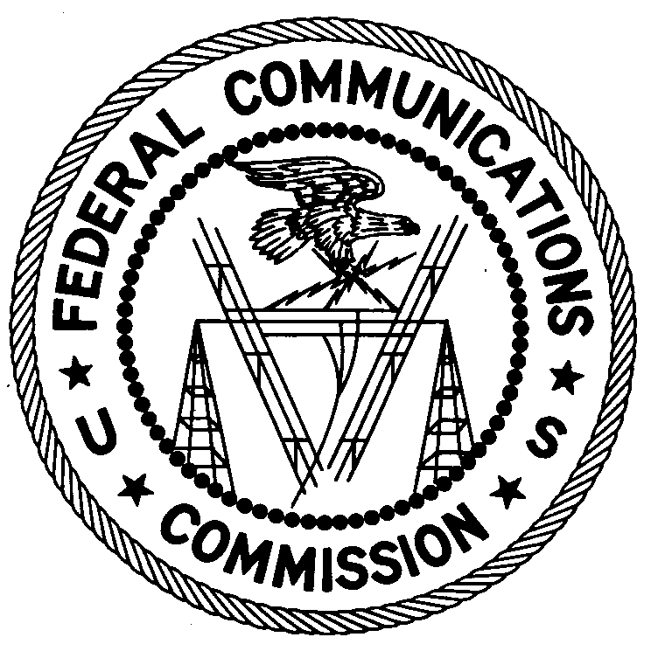
ENFORCEMENT BUREAU
REGION TWO

Atlanta Regional Office
3600 Hiram Lithia Springs Rd SW
Powder Springs, GA 30127
(678) 293-3194
field@fcc.gov

August 27, 2018

BY UPS AND FIRST CLASS MAIL

Wilfrid Pressa
Florida City, Florida

NOTICE OF UNLICENSED OPERATION

Case Number: EB-FIELDSCR-18-00027390

The Miami Office of the Federal Communications Commission’s (Commission’s) Enforcement Bureau has received a complaint from the Federal Aviation Administration of an unlicensed FM station causing harmful interference to aircraft communications in the Miami and Homestead areas. On July 26, 2018, Agents from the Miami Office confirmed by direction finding techniques that radio signals on frequency 107.7 MHz and spurious emissions in the aviation communications band were emanating from your residence on Southwest 6th Avenue in Florida City, Florida. The Agents observed that the station went off the air on July 26, 2018, shortly after they attempted an inspection of the station at your residence. An agent subsequently contacted you by telephone, and you admitted that you were the operator of the station.The Commission’s records show that no license was issued for operation of a radio station at this location on 107.7 MHz in Miami, Florida.

Radio stations operating on a range of frequencies, including 107.7 MHz, must be licensed by the Commission pursuant to Section 301 of the Communications Act of 1934, as amended (Act). The only exception to this licensing requirement is for certain transmitters using or operating at a power level that complies with the standards established in Part 15 of the Commission’s rules. The Agents found that the station at your residence was operating at a power level that exceeds the level permitted by Part 15. The field strength of the signal on frequency 107.7 MHz was measured at levels exceeding the maximum permitted level of 250 microvolts per meter at 3 meters for non-licensed devices. Thus, this station is operating in violation of Section 301 of the Act.

A spurious radio signal associated with the operation of this station was detected on the frequency of 122.76 MHz, which was causing harmful interference to aircraft communications. The spurious signal is within the radio frequency band assigned for communications between aircraft and/or aircraft and aviation ground facilities. The signal may present a safety hazard to the operation of aircraft since air/ground communications could be affected.

You are hereby warned that operation of radio transmitting equipment without a valid radio station authorization constitutes a violation of the Federal laws cited above and could subject the operator to severe penalties, including, but not limited to, substantial monetary fines, in rem seizure of the offending radio equipment, and criminal sanctions including imprisonment.

UNLICENSED OPERATION OF THIS RADIO STATION MUST BE DISCONTINUED IMMEDIATELY AND MUST NOT RESUME.

You have ten (10) days from the date of this notice to respond with any evidence that you have authority to operate granted by the Commission. Your response should be sent to the address in the letterhead and reference the listed case number. Under the Privacy Act of 1974, we are informing you that the Commission’s staff will use all relevant material information before it to determine what, if any, enforcement action is required to ensure your compliance with the Commission’s rules. This will include any information that you disclose in your reply.

You may contact this office if you have any questions.

Ronald D. Ramage
Regional Director
Region Two
Enforcement Bureau
Federal Communications Commission

Attachments:
Excerpts from the Communications Act of 1934, As Amended
Enforcement Bureau, "Inspection Fact Sheet"

47 CFR § 73.201.
47 U.S.C. § 301.
47 CFR §§ 15.1 et seq.
47 U.S.C. § 301.
See 47 U.S.C. §§ 401, 501, 503 and 510.
5 U.S.C. § 552a(e)(3).

