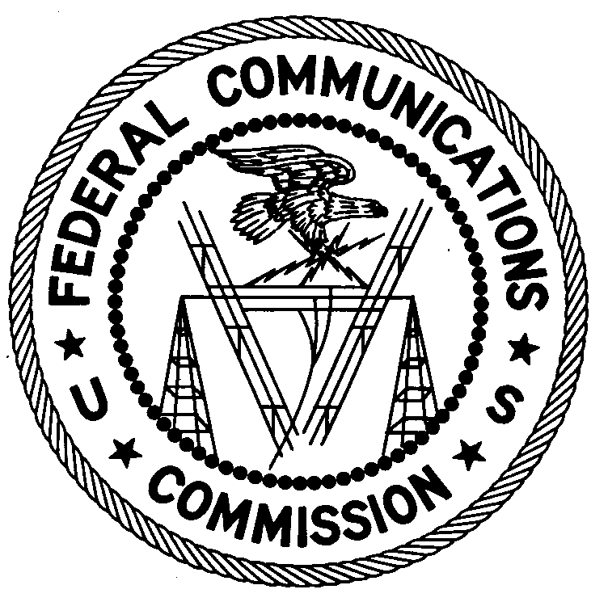
FEDERAL COMMUNICATIONS COMMISSION
ENFORCEMENT BUREAU
REGION ONE

Columbia Regional Office

9050 Junction Drive

Annapolis Junction, MD 20701

(301) 725-1996

field@fcc.gov

November 20, 2018

Greg Lynn and Katherine Sweitzer
Red Lion, Pennsylvania
Case No.: EB-FIELDNER-18-00027995

NOTICE OF UNLICENSED OPERATION AND
NOTIFICATION OF HARMFUL INTERFERENCE

On October 30, 2018, in response to an interference complaint, Agents from the Columbia Office of the Federal Communications Commission’s (FCC’s or Commission’s) Enforcement Bureau (Bureau) confirmed, by direction finding techniques, that radio emissions in the 788-798 MHz band were emanating from a radio transmitter device located on Weaver Lane in Red Lion, Pennsylvania. These emissions were interfering with AT&T’s uplink channel for its FirstNet system and were originating from your media streaming device manufactured by MaggTV. Agents confirmed that interference to AT&T ceased when your device was unplugged.
Radio stations operating on certain frequencies, including the 700 MHz band, must be licensed by the Commission, pursuant to the Communications Act of 1934, as amended (Act). The only exception to this licensing requirement is for certain transmitters using or operating at a power level or mode of operation that complies with the standards established in Part 15 of the Commission’s rules.
Such nonlicensed operation, however, is conditioned upon compliance with all applicable regulations. All intentional radiators operating pursuant to Part 15 of the FCC’s rules must be certified for use as a Part 15 device. Your MaggTV device did not have an FCC certification. Accordingly, your operation of the MaggTV device is in violation of 47 U.S.C. § 301.

Had the transmitter been certified for operation, additional conditions would apply. Under Section 15.5(b), nonlicensed operation of a radio transmitter is subject to the condition that it must not cause harmful interference and, if harmful interference occurs, operation of the device must cease. Harmful interference is defined as “[a]ny emission, radiation or induction that endangers the functioning of a radio navigation service or of other safety services or seriously degrades, obstructs or repeatedly interrupts a radio communications service.”
You are hereby notified, pursuant to Sections 15.5(c) of the Commission’s rules, that the MaggTV media streaming equipment was causing harmful interference to licensed communications. Continued operation of this device in a manner that causes harmful interference after your receipt of this warning constitutes a violation of the Federal laws cited above and could subject the operator to severe penalties, including, but not limited to, substantial monetary fines, in rem arrest action against the offending radio equipment, and criminal sanctions including imprisonment.
OPERATION OF THIS TRANSMITTING DEVICE MUST CEASE IMMEDIATELY AND MUST NOT RESUME
You have ten (10) days from the date of this notice to respond concerning your operation of this Part 15 device. Your response should also describe the steps you are taking to ensure that your operation does not interfere with AT&T. Your response should be sent to the address in the letterhead and reference the listed case number. Under the Privacy Act of 1974, we are informing you that the Commission’s staff will use all relevant material information before it to determine what, if any, enforcement action is required to ensure your compliance with the Act and FCC rules. This will include any information that you disclose in your reply.
You may contact this office if you have any questions.

David C. Dombrowski
Regional Director
Region One
Enforcement Bureau
Federal Communications Commission

47 U.S.C. § 301.
47 CFR §§ 15.1, et seq.
47 CFR § 15.1(b).
47 CFR § 15.201(b).
47 CFR § 15.5(b).
47 CFR § 15.3(m).
47 CFR § 15.5(c)
See 47 U.S.C. §§ 401, 501, 503 and 510.
5 U.S.C. § 552a(e)(3).

