FEDERAL COMMUNICATIONS COMMISSION
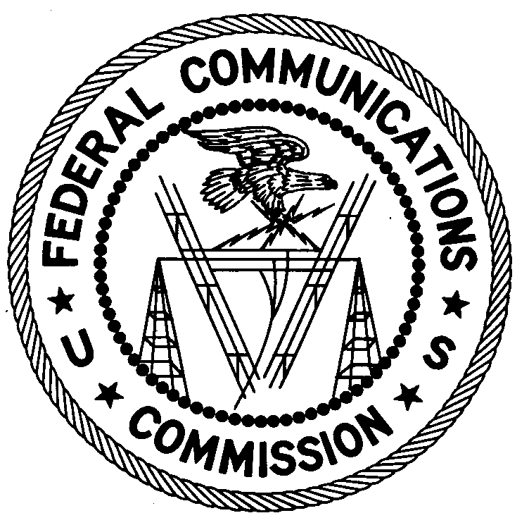
ENFORCEMENT BUREAU
REGION ONE

Columbia Regional Office

9050 Junction Drive

Annapolis Junction, Maryland 20701

Field@FCC.gov

(301) 725-1996

November 20, 2018

Meeting Street
1000 Eddy Street
Providence, Rhode Island

Case No.: EB-FIELDNER-18-00028014

NOTIFICATION OF HARMFUL INTERFERENCE

On November 2, 2018, in response to an interference complaint, an Agent from the Boston Office (Boston Office) of the Federal Communications Commission’s (FCC’s or Commission’s) Enforcement Bureau (Bureau) confirmed by direction finding techniques that radio emissions in the 900 MHz band were emanating from antennas on the roof of the school building located at 1000 Eddy Street, Providence, Rhode Island. These transmissions were interfering with the licensed Non-Multilateration Location and Monitoring Service Station operated by the Rhode Island Department of Transportation (RIDOT) on the frequency 915.750 MHz for the collection of EZ Pass tolls. The Agent determined that the interfering devices were Ubiquity Networks NanoStation M5 Systems operated by Meeting Street to provide point-to-multipoint communication with the temporary classrooms in the trailers.

Radio stations operating on many frequencies, including 900 MHz band, must be licensed by the Federal Communications Commission (“FCC”) pursuant to the Communications Act of 1934, as amended. The only exception to this licensing requirement is for certain transmitters using or operating at a power level or mode of operation that complies with the standards established in Part 15 of the Commission’s rules. The NanoStation M5 devices are is authorized to be operated without a license pursuant to Part 15. Such nonlicensed operation, however, is conditioned upon compliance with all applicable regulations in the subpart. Under Section 15.5(b), nonlicensed operation of a radio transmitter is subject to the condition that it must not cause harmful interference and, if harmful interference occurs, operation of the device must cease. Harmful interference is defined as “[a]ny emission, radiation or induction that endangers the functioning of a radio navigation service or of other safety services or seriously degrades, obstructs or repeatedly interrupts a radio communications service.”

You are hereby notified, pursuant to Sections 15.5(c) of the Commission’s rules, that the NanoStation M5 devices were causing harmful interference to licensed communications. Continued operation of these devices in a manner that causes harmful interference after your receipt of this warning constitutes a violation of the Federal laws cited above and could subject the operator to severe penalties, including, but not limited to, substantial monetary fines, in rem arrest action against the offending radio equipment, and criminal sanctions including imprisonment.

OPERATION OF THIS TRANSMITTING DEVICE ON FREQUENCIES THAT CAUSE INTERFERENCE MUST NOT RESUME

You have ten (10) days from the date of this notice to respond concerning your operation of this Part 15 device. Your response should also describe the steps you are taking to ensure that your operation does not interfere with RIDOT. Your response should be sent to the address in the letterhead and reference the listed case number. Under the Privacy Act of 1974, we are informing you that the Commission’s staff will use all relevant material information before it to determine what, if any, enforcement action is required to ensure your compliance with the Communications Act and FCC rules. This will include any information that you disclose in your reply.

You may contact this office if you have any questions.

David C. Dombrowski
Regional Director
Region One
Enforcement Bureau
Federal Communications Commission

Rhode Island Department of Transportation holds Non-Multilateration Location and Monitoring Service Station licenses under the call signs WRAK521, WRAR933, and WRAR943.
47 U.S.C. § 301.
47 C.F.R. §§ 15.1 et seq.
See 47 C.F.R. § 15.1(b).
See 47 C.F.R. § 15.5(b).
See 47 C.F.R. § 15.3(m).
47 C.F.R. § 15.5(c)
See 47 U.S.C. §§ 401, 501, 503 and 510.
5 U.S.C. § 552a(e)(3).

