FEDERAL COMMUNICATIONS COMMISSION
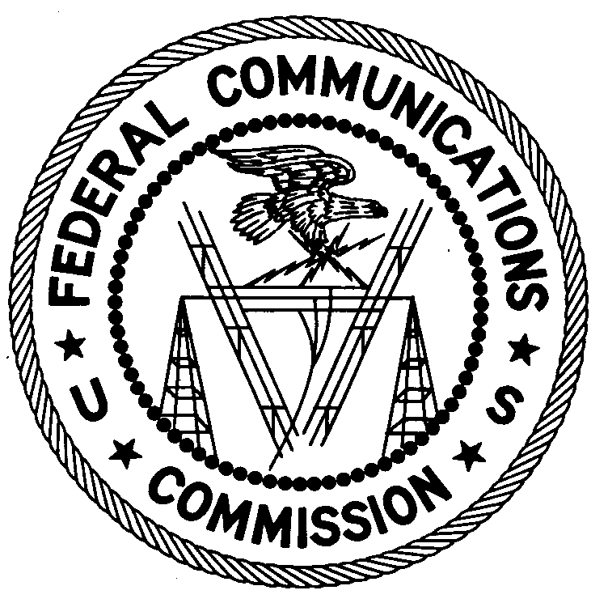
ENFORCEMENT BUREAU
REGION TWO

Atlanta Regional Office
P.O. Box 1493
Powder Springs, GA 30127
field@fcc.gov

December 3, 2018

Miami Office Center LLC
Miami Gardens, Florida

NOTICE OF UNLICENSED OPERATION

Case Number: EB-FIELDSCR-18-00027923

On November 5, 2018, Agents from the Miami Office of the Federal Communications Commission’s (Commission’s) Enforcement Bureau confirmed by direction finding techniques that radio signals on frequency 91.7 MHz were emanating from a commercial property at 18350 NW 2nd Ave., Miami Gardens, Florida. Public records list you as the property owner. The Commission’s records show that no license was issued for operation of a radio station at this location on 91.7 MHz in Miami Gardens, Florida.

Radio stations operating on a range of frequencies, including 91.7 MHz, must be licensed by the FCC pursuant to Section 301 of the Communications Act of 1934, as amended (Act). The only exception to this licensing requirement is for certain transmitters using or operating at a power level that complies with the standards established in Part 15 of the Commission’s rules. On November 5, 2018, the Agents found that the station on your property was operating at a power level that exceeds the level permitted by Part 15. The field strength of the signal on frequency 91.7 MHz was measured at levels exceeding the maximum permitted level of 250 microvolts per meter (µV/m) at 3 meters for non-licensed devices. Therefore, the station is operating in violation of Section 301.

You are hereby warned that operation of radio transmitting equipment without a valid radio station authorization constitutes a violation of the Federal laws cited above and could subject the operator to severe penalties, including, but not limited to, substantial monetary fines, in rem seizure of the offending radio equipment, and criminal sanctions including imprisonment.

UNLICENSED OPERATION OF THIS RADIO STATION MUST BE DISCONTINUED IMMEDIATELY AND MUST NOT RESUME.

You have ten (10) days from the date of this notice to respond with any evidence that you have authority to operate granted by the Commission. Your response should be sent to the address in the letterhead and reference the listed case number. Under the Privacy Act of 1974, we are informing you that the Commission’s staff will use all relevant material information before it to determine what, if any, enforcement action is required to ensure your compliance with the Commission’s rules. This will include any information that you disclose in your reply.

You may contact this office if you have any questions.

Ronald D. Ramage
Regional Director
Region Two
Enforcement Bureau
Federal Communications Commission

Attachments:
Excerpts from the Communications Act of 1934, As Amended
Enforcement Bureau, "Inspection Fact Sheet," March 2005

47 CFR § 73.201.
47 U.S.C. § 301.
47 CFR §§ 15.1 et seq.
47 U.S.C. § 301.
See 47 U.S.C. §§ 401, 501, 503 and 510.
5 U.S.C. § 552a(e)(3).

