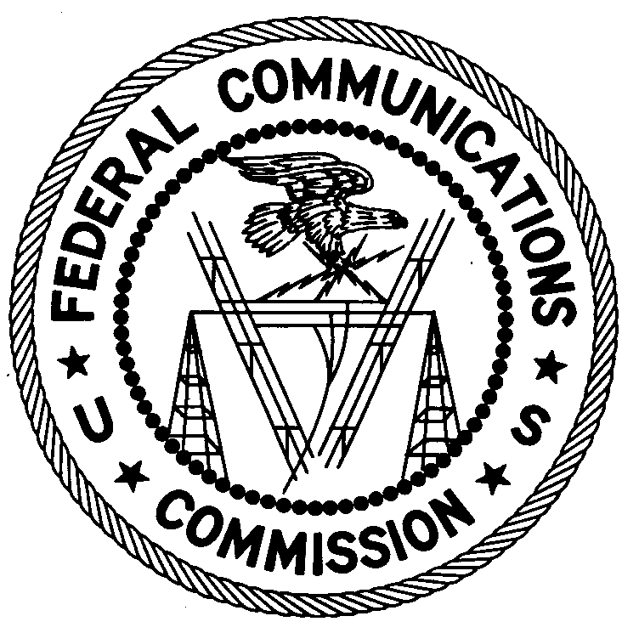
FEDERAL COMMUNICATIONS COMMISSION
ENFORCEMENT BUREAU
REGION ONE

Columbia Regional Office

9050 Junction Drive

Annapolis Junction, Maryland 20701

Field@FCC.gov
(301) 725-1996

December 6, 2018

Jerletha Cosby
Elizabeth, New Jersey

NOTICE OF UNLICENSED OPERATION AND
NOTIFICATION OF HARMFUL INTERFERENCE

Case Number: EB-FIELDNER-18-00027947

The Federal Communications Commission (FCC or Commission) received a complaint from FAA Spectrum Engineering Services concerning an apparent unauthorized broadcast station causing harmful interference to a frequency used by the FAA to communicate with pilots operating airplanes in airspace in the New Jersey Metropolitan Area. On October 24, 2018, Agents from the New York Office (New York Office) of the Federal Communications Commission’s (FCC’s or Commission’s) Enforcement Bureau (Bureau) conducted an investigation and determined that the source of the interference to FAA frequency 120.4 MHz was spurious emissions from the unauthorized broadcast station. The Agents confirmed by direction finding techniques that the source of the interference was an FM station operating on the frequency 91.7 MHz from a residential property on Planten Avenue, Prospect Park, New Jersey. The Commission’s records show that no license was issued for operation of a broadcast station on 91.7 MHz at this location. Agents confirmed, through investigation, that you are an operator of the unlicensed radio station.

Radio stations operating on a range of frequencies, including 91.7 MHz, must be licensed by the FCC pursuant to Section 301 of the Communications Act of 1934, as amended (Act). The only exception to this licensing requirement is for certain transmitters using or operating at a power level or mode of operation that complies with the standards established in Part 15 of the Commission’s rules. Agents measured the field strength of the signal on the frequency 91.7 MHz for the station and found that it exceeded the maximum permitted level of 250 µV/m at 3 meters for non-licensed devices. Thus, this station is operating in violation of Section 301 of the Act.

Operation of radio transmitting equipment without a valid FCC authorization or license is a violation of Section 301 of the Act and may subject the responsible parties to substantial monetary fines, in rem arrest action against the offending radio equipment, and criminal sanctions including imprisonment. Because unlicensed operation creates a danger of interference to important radio communications services and may subject the operator to severe penalties, this letter emphasizes the importance of complying strictly with these legal requirements.

UNAUTHORIZED OPERATION OF THIS RADIO TRANSMITTING DEVICE AND ASSOCIATED HARMFUL INTERFERENCE MUST CEASE IMMEDIATELY AND MUST NOT RESUME.

You have ten (10) days from the date of this notice to respond with any evidence that you have authority to operate granted by the FCC. Your response should be sent to the address in the letterhead and reference the listed case number. Under the Privacy Act of 1974, we are informing you that the Commission’s staff will use all relevant material information before it to determine what, if any, enforcement action is required to ensure your compliance with FCC Rules. This will include any information that you disclose in your reply.

You may contact this office if you have any questions.

David C. Dombrowski
Regional Director
Region One
Enforcement Bureau
Federal Communications Commission

Attachments:
Excerpts from the Communications Act of 1934, As Amended
Enforcement Bureau, "Inspection Fact Sheet", March 2005

47 CFR § 73.201.
47 U.S.C. § 301.
47 CFR §§ 15.1 et seq.
47 U.S.C. § 301.
47 U.S.C. § 301.
See 47 U.S.C. §§ 401, 501, 503 and 510.
5 U.S.C. § 552a(e)(3).

