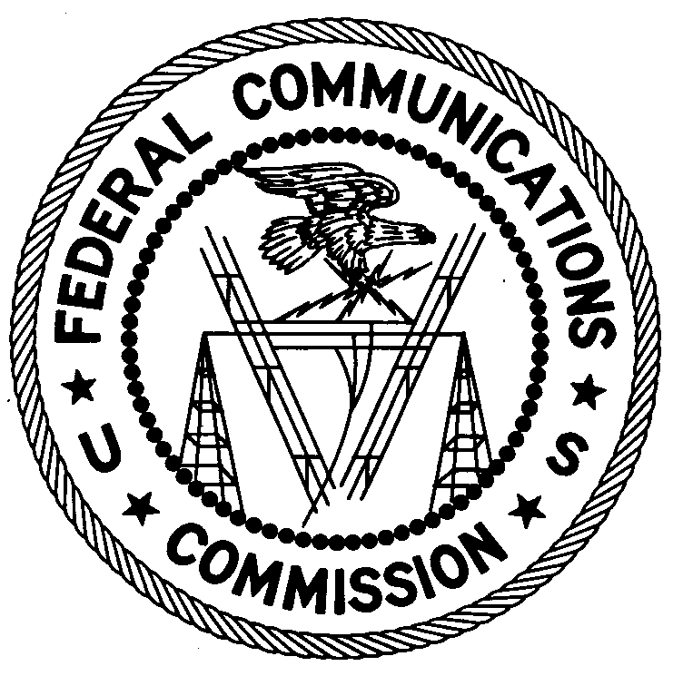
FEDERAL COMMUNICATIONS COMMISSION
ENFORCEMENT BUREAU
REGION ONE

Columbia Regional Office
P.O. Box 130
Columbia, Maryland 21045
Field@FCC.gov
(301) 725-1996

January 31, 2019

Barnstable High School
Barnstable, Massachusetts

NOTICE OF UNLICENSED OPERATION

Case Number: EB-FIELDNER-18-00026485

On May 8, 2018, an Agent from the Boston Office of the Federal Communications Commission’s (FCC’s or Commission’s) Enforcement Bureau (Bureau) investigated a complaint that Barnstable High School in Barnstable, Massachusetts was operating radio transmitting equipment without authorization. The Agent found that Barnstable High School was operating a Motorola XPR-8400 repeater on the Land Mobile Radio Service frequency 463.375 MHz at 744 West Main Street, Barnstable, Massachusetts. The agent also found that Barnstable High School was operating Kenwood KPG-134D two-way radios programmed with multiple frequencies in the Land Mobile Radio Service (LMRS), Family Radio Service (FRS), and General Mobile Radio Service (GMRS).

The Commission’s records show that the Town of Barnstable does not hold a license to operate any radio transmitting equipment on the LMRS frequencies 463.3750 MHz, 464.3250 MHz, or 468.3750 MHz. Furthermore, there is no evidence that the Town of Barnstable holds, or is eligible to hold, a license to operate radio transmitting equipment on any GMRS frequency. Although an individual license is not required to operate radio transmitting equipment in the FRS, the radio transmitting equipment must be certificated for use in the FRS in accordance with subpart J of part 2 of the Commission’s Rules. The Town of Barnstable would not be authorized to operate its Kenwood KPG-134D two way radios on any FRS frequency because that radio is not certificated for use in the FRS.

Radio stations operating on a range of frequencies, including 463.3750 MHz, 464.3250 MHz, and 468.3750 MHz, must be licensed by the FCC pursuant to Section 301 of the Communications Act of 1934, as amended (Act). The only exception to this licensing requirement is for certain transmitters using or operating at a power level or mode of operation that complies with the standards established in Part 15 of the Commission’s rules. The above described operations by Barnstable on these frequencies violates Section 301 of the Act.

You are hereby warned that operation of radio transmitting equipment without a valid radio station authorization constitutes a violation of the Federal laws cited above and will subject the operator to severe penalties, including, but not limited to, in rem seizure of the offending radio equipment without further notice, substantial fines, and criminal sanctions, including imprisonment.

UNLICENSED OPERATION OF THESE RADIO STATIONS MUST BE DISCONTINUED IMMEDIATELY AND MUST NOT RESUME.

You have ten (10) days from the date of this notice to respond with any evidence that you have authority to operate granted by the FCC. Your response should be sent to the address in the letterhead and reference the listed case number. Under the Privacy Act of 1974, we are informing you that the Commission’s staff will use all relevant material information before it to determine what, if any, enforcement action is required to ensure your compliance with FCC Rules. This will include any information that you disclose in your reply.

You may contact this office if you have any questions.

David C. Dombrowski
Regional Director
Region One
Enforcement Bureau
Federal Communications Commission

Attachments:
Excerpts from the Communications Act of 1934, As Amended
Enforcement Bureau, "Inspection Fact Sheet", March 2005

The LMRS frequencies are 468.3750 and 464.3250 MHz and the FRS/GMRS frequencies are 462.6125, 464.3250, 462.6375, 462.5625, 462.6875, 462.7125, 462.6125, and 462.5625 MHz.
The Land Mobile Radio Service license WPDK848 authorized the Town of Barnstable to operate radio transmitting equipment on the frequencies 463.3750 MHz, 463.8500 MHz, and 468.3750 MHz. However, that license expired on October 12, 2003.
Pursuant to Section 95.1705 of the Rules, a valid individual license is required to operate a GMRS station. 47 CFR § 95.1705.
47 CFR § 95.603(d).
47 U.S.C. § 301.
47 CFR §§ 15.1 et seq.
47 U.S.C. § 301.
See 47 U.S.C. §§ 401, 501, 503, and 510.
5 U.S.C. § 552a(e)(3).

