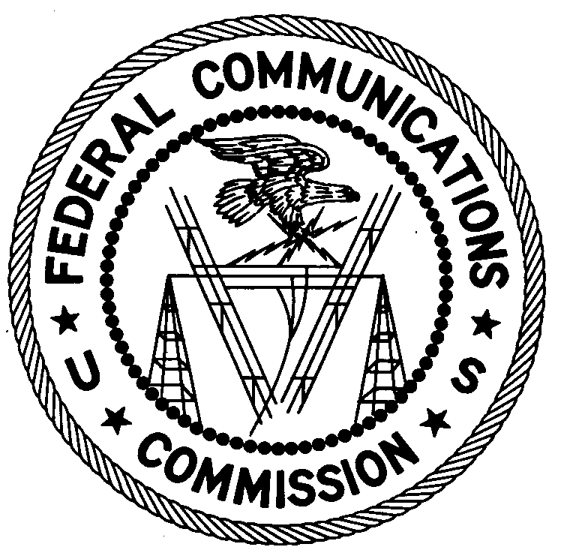
FEDERAL COMMUNICATIONS COMMISSION
ENFORCEMENT BUREAU
REGION ONE

Columbia Regional Office

9050 Junction Drive

Annapolis Junction, Maryland 20701

Field@FCC.gov
(301) 725-1996

February 22, 2019

BY FIRST CLASS MAIL AND UPS

Rafael Rosario
Bronx, NY 10458

NOTICE OF UNLICENSED OPERATION AND
NOTIFICATION OF HARMFUL INTERFERENCE

Case Number: EB-FIELDNER-19-00028465

On February 6, 2019, Agents from the New York Office of the Federal Communications Commission’s (FCC’s or Commission’s) Enforcement Bureau (Bureau) investigated a suspicious signal centered on the frequency 1575.75 MHz in Bronx, New York that was causing interference to the Global Positioning System (GPS) receiver in their government vehicle. The agents confirmed by direction finding techniques that the radio signal on the frequency 1575.75 MHz was emanating from a GPS Jammer in a Stuart Dean commercial vehicle that was parked at G & Sons Parking Lot Inc., 2740 Webster Avenue, Bronx, New York 10458. Through investigation, it was determined that you were the driver of the vehicle and operator of the GPS jammer.
Persons operating or using radio transmitters must be licensed or authorized by the FCC, pursuant to Section 301 of the Communications Act of 1934, as amended. In addition, radio transmitting equipment must comply with FCC rules. Section 333 of the Act prohibits willful or malicious interference with any radio communications of any station licensed or authorized by or under the Act or operated by the United States Government. In addition, Section 302(b) of the Act, and Section 2.803 of the Commission’s rules, prohibit the manufacture, importation, marketing, sale or operation of devices deliberately designed to jam or disrupt wireless communications.

The Commission has issued multiple Public Notices specifically stating that the sale and use of transmitters designed to prevent, jam, or interfere with the operation of cellular and personal communications service (PCS) telephones or other communications devices is unlawful.

The operation of the device utilized by you may constitute a violation of Sections 333, 302(b), and 301 of the Act, as described above. Such operation may subject you to substantial monetary forfeitures, in rem arrest action against the offending radio equipment, and criminal sanctions including imprisonment. Because unauthorized operation creates a danger of interference to important radio communications services, and may subject the operator to severe penalties, this warning emphasizes the importance of complying strictly with these legal requirements.

UNAUTHORIZED OPERATION OF THIS RADIO TRANSMITTING DEVICE AND ASSOCIATED HARMFUL INTERFERENCE MUST NOT RESUME

You have ten (10) days from the date of this notice to respond to the allegations in this letter. Your response should be sent to the address in the letterhead and reference the listed case and document number. Under the Privacy Act of 1974, we are informing you that the Commission’s staff will use all relevant material information before it to determine what, if any, enforcement action is required to ensure your compliance with FCC Rules. This will include any information that you disclose in your reply.

You may contact this office if you have any questions.

David C. Dombrowski
Regional Director
Region One
Enforcement Bureau
Federal Communications Commission

Attachments:
Enforcement Advisory No. 2014-05

47 U.S.C. § 301. The only exception to this licensing requirement is for certain transmitters using or operating at a power level that complies with the standards established in Part 15 of the Commission's rules. 47 C.F.R. §§ 15.1 et seq.
47 C.F.R. Part 2, Subpart J.
47 U.S.C. § 333.
47 U.S.C. § 302a(b); 47 C.F.R. § 2.803.
See, e.g., Office of Engineering and Technology and Compliance and Information Bureau Warn Against the Manufacture, Importation, Marketing or Operation of Transmitters Designed to Prevent or Otherwise Interfere with Cellular Radio Communications, 15 RCC Rcd 6997 (OET/CIB 1999); Sale or Use of Transmitters Designed to Prevent, Jam or Interfere with Cell Phone Communications is Prohibited in the United States, 20 FCC Rcd 11134 (EB/OET/WTB 2005); CONSUMERS BEWARE: It is Unlawful to Use “Cell Jammers” and Other Equipment that Blocks, Jams, or Interferes with Authorized Radio Communications in the U.S., 26 FCC Rcd 1329 (EB 2011); CONSUMER ALERT: Using or Importing Jammers is Illegal; Monetary Penalties Can Exceed $100,000 per Violation, 27 FCC Rcd 2309 (EB 2012); WARNING: Jammer Use is Prohibited, Prohibition Applies to Use by the Public and State and Local Government Agencies, Including State and Local Law Enforcement Agencies, 29 FCC Rcd 14737 (EB 2014).
47 U.S.C. §§ 301, 302a(b), 333.
See 47 U.S.C. §§ 401, 501, 503, 510.
5 U.S.C. § 552a(e)(3)

