FEDERAL COMMUNICATIONS COMMISSION
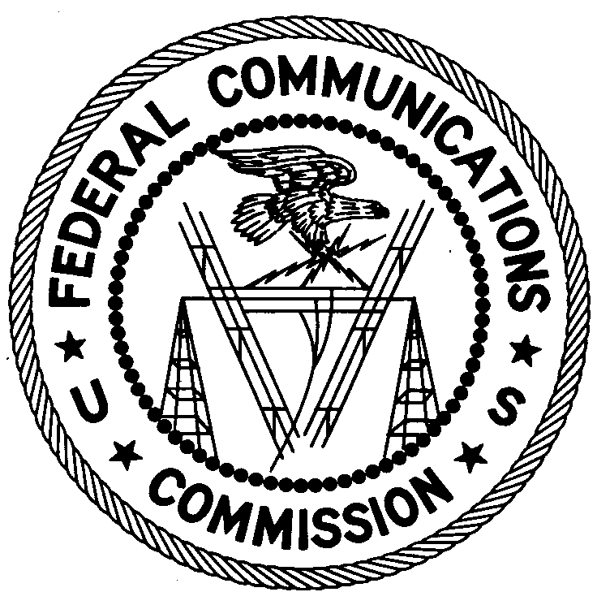
ENFORCEMENT BUREAU
REGION ONE

Columbia Regional Office
9050 Junction Drive
Annapolis Junction, Maryland 20701
FIELD@FCC.gov

(301) 725-1996

March 4, 2019

BY UPS AND FIRST CLASS MAIL

Jonathan Campbell
Uniontown, PA

NOTICE OF UNLICENSED OPERATION AND
NOTIFICATION OF HARMFUL INTERFERENCE

Case Number: EB-FIELDNER-19-00028401

The Columbia Office of the Federal Communications Commission’s (FCC or Commission’s) Enforcement Bureau (Bureau) received a complaint from Fayette County Emergency Management Association (Fayette County EMA/911) concerning harmful interference and unauthorized transmission on the frequency 155.190 MHz used for fire communications in Uniontown, Pennsylvania. On February 7, 2019, Agents from the Columbia Office of the FCC’s Enforcement Bureau (Bureau) investigated and determined that Jonathan Campbell of Uniontown, Pennsylvania was the source of the unauthorized transmissions and harmful interference to Fayette County EMA/911. Jonathan Campbell admitted to operating a Baofeng UV-5R VHF/UHF two-way radio on the frequency 155.190 MHz. The Commission’s records show that no license was issued for his operation on the Public Safety frequency 155.190 MHz in the Uniontown, Pennsylvania area.

Radio stations operating on a range of frequencies, including the Land Mobile Radio Service frequency 155.190 MHz, must be licensed by the FCC pursuant to Section 301 of the Communication Act of 1934, as amended (Act). The only exceptions to this licensing requirement are certain transmitters using or operating at a power level or mode of operation that complies with the standards established in Part 15 of the Commission’s rules. Non-licensed operation pursuant to Part 15 of the Commission’s rules, however, is conditioned upon compliance with all applicable regulations in the subpart. All intentional radiators operating pursuant to Part 15 of the FCC’s rules must be certified for use as a Part 15 device, and failure to operate such device consistent with its authorization violates Part 15 of the Commission’s rules. In addition, operation on 155.190 MHz is limited to public safety entities. The Fayette County EMA/911 stated that you do not have permission to operate on the frequency 155.190 MHz and alleged that you caused harmful interference to public safety users operating on this frequency. Thus, your station is operating in violation of 47 U.S.C. § 301.

Operation of radio transmitting equipment without a valid FCC authorization or license is a violation of Section 301 of the Act and may subject the responsible parties to substantial monetary fines, in rem arrest action against the offending radio equipment, and criminal sanctions including imprisonment. Because unlicensed operation creates a danger of interference to important radio communications services and may subject the operator to severe penalties, this letter emphasizes the importance of complying strictly with these legal requirements.
UNAUTHORIZED OPERATION OF THIS RADIO TRANSMITTING DEVICE AND ASSOCIATED HARMFUL INTERFERENCE MUST CEASE IMMEDIATELY AND MUST NOT RESUME

You have ten (10) days from the date of this notice to respond concerning your operation of this Part 15 device. Your response should describe the steps you are taking to avoid operating on unauthorized frequencies and preventing future interference. Your response should be sent to the address in the letterhead and reference the listed case number. Under the Privacy Act of 1974, we are informing you that the Commission’s staff will use all relevant material information before it to determine what, if any, enforcement action is required to ensure your compliance with FCC rules. This will include any information that you disclose in your reply.

You may contact this office if you have any questions.

David C. Dombrowski
Regional Director
Region One
Enforcement Bureau
Federal Communications Commission

Enclosures
Excerpts from the Communications Act of 1934, As Amended
Enforcement Bureau, "Inspection Fact Sheet", March 2005

47 U.S.C. § 301.
47 CFR §§ 15.1 et seq.
47 CFR § 90.20(c)(2).
47 U.S.C. § 301.
See 47 U.S.C. §§ 401, 501, 503 and 510.
See 47 U.S.C. §§ 401, 501, 503 and 510.
5 U.S.C. § 552a(e)(3).

