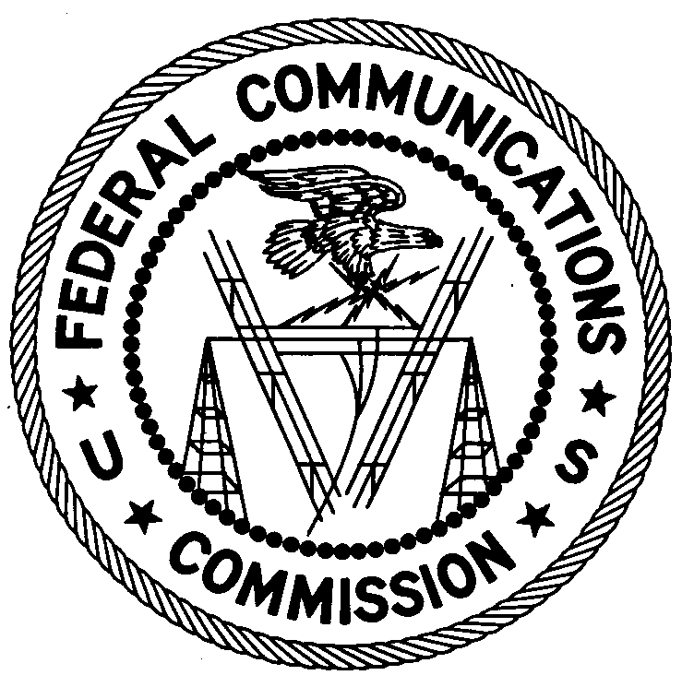
FEDERAL COMMUNICATIONS COMMISSION
ENFORCEMENT BUREAU
REGION ONE

Columbia Regional Office

9050 Junction Drive

Annapolis Junction, Maryland 20701

Field@FCC.gov
(301) 725-1996

March 12, 2019

Fernando Navarro
Bronx, New York

NOTICE OF UNLICENSED OPERATION

Case Number: EB-FIELDNER-18-00028149

On December 12, 2018, Agents from the New York Office of the Federal Communications Commission’s (FCC or Commission’s) Enforcement Bureau (Bureau) investigated an unlicensed FM station operating on the frequency 89.3 MHz in Bronx, New York. The Agents confirmed by direction finding techniques that radio signals on the frequency 89.3 MHz were emanating from a multi-family dwelling at 2450 Creston Avenue in Bronx, New York. Agents confirmed, through investigation, that you are the operator of the unlicensed radio station. The Commission’s records show that no license was issued for operation of a radio station on 89.3 MHz at this location in Bronx, New York.

Radio stations operating on a range of frequencies, including 89.3 MHz, must be licensed by the FCC pursuant to Section 301 of the Communications Act of 1934, as amended (Act). The only exception to this licensing requirement is for certain transmitters using or operating at a power level or mode of operation that complies with the standards established in Part 15 of the Commission’s rules. The Agents found that the station was operating at a power level that exceeds the level permitted by Part 15. On December 12, 2018, the Agents measured the field strength of the signal on the frequency 89.3 MHz for the station and found that it exceeded the maximum permitted level of 250 µV/m at 3 meters for non-licensed devices. Therefore, this station was operating in violation of Section 301 of the Act.

You are hereby warned that operation of radio transmitting equipment without a valid radio station authorization constitutes a violation of the Federal laws cited above and will subject the operator to severe penalties, including, but not limited to, in rem seizure of the offending radio equipment without further notice, substantial fines, and criminal sanctions, including imprisonment.

UNLICENSED OPERATION OF THIS RADIO STATION MUST BE DISCONTINUED IMMEDIATELY AND MUST NOT RESUME.

You have ten (10) days from the date of this notice to respond with any evidence that you have authority to operate granted by the FCC. Your response should be sent to the address in the letterhead and reference the listed case number. Under the Privacy Act of 1974, we are informing you that the Commission’s staff will use all relevant material information before it to determine what, if any, enforcement action is required to ensure your compliance with FCC Rules. This will include any information that you disclose in your reply.

You may contact this office if you have any questions.

David C. Dombrowski
Regional Director
Region One
Enforcement Bureau
Federal Communications Commission

Attachments:
Excerpts from the Communications Act of 1934, As Amended
Enforcement Bureau, "Inspection Fact Sheet", March 2005

47 CFR § 73.201.
47 U.S.C. § 301.
47 CFR §§ 15.1 et seq.
47 U.S.C. § 301.
See 47 U.S.C. §§ 401, 501, 503 and 510.
5 U.S.C. § 552a(e)(3).

