FEDERAL COMMUNICATIONS COMMISSION
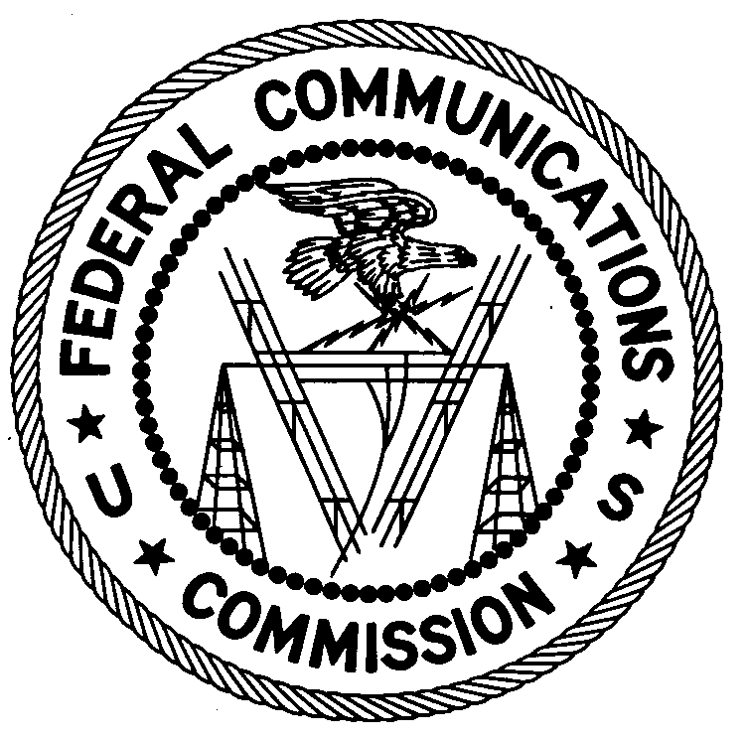
ENFORCEMENT BUREAU
REGION ONE

Columbia Regional Office
9050 Junction Drive
Annapolis Junction, Maryland 20701
FIELD@FCC.gov
301-725-1996

October 29, 2018

BY UPS AND FIRST CLASS MAIL

Erron Simmonds
Bridgeport, Connecticut

WARNING FOR UNLICENSED RADIO OPERATION

Case Number: EB-FIELDNER-17-00025137

On October 10, 2018, the Regional Director of the Federal Communications Commission’s (FCC or Commission’s) Enforcement Bureau, Region One investigated an unlicensed FM station operating on the frequency 106.3 MHz in Bridgeport, Connecticut. The Regional Director confirmed by direction finding techniques that radio signals on frequency 106.3 MHz were emanating from a residential property on Westfield Avenue, Bridgeport, Connecticut. Property records list you as the owner of the property. The Commission’s records show that no license was issued for operation of a radio station on 106.3 MHz at this location in Bridgeport, Connecticut.

Radio stations, including those operating on 106.3 MHz, must be licensed by the FCC pursuant to the Communications Act of 1934, as amended. The only exception to this licensing requirement is for certain transmitters using or operating at a power level or mode of operation that complies with the standards established in Part 15 of the Commission’s rules.

You are hereby warned that operation of radio transmitting equipment without a valid radio station authorization constitutes a violation of the Federal laws cited above and could subject the operator to severe penalties, including, but not limited to, substantial monetary fines, in rem arrest action against the offending radio equipment, and criminal sanctions including imprisonment.

UNLICENSED OPERATION OF THIS RADIO STATION MUST BE DISCONTINUED IMMEDIATELY.

You have ten (10) days from the date of this notice to respond with any evidence that you have authority to operate granted by the FCC. Your response should be sent to the address in the letterhead and reference the listed case and document number. Under the Privacy Act of 1974, we are informing you that the Commission’s staff will use all relevant material information before it to determine what, if any, enforcement action is required to ensure your compliance with FCC Rules. This will include any information that you disclose in your reply.

You may contact this office if you have any questions.

David C. Dombrowski
Regional Director
Region One
Enforcement Bureau

Attachments:
Excerpts from the Communications Act of 1934, As Amended
Enforcement Bureau, "Inspection Fact Sheet", March 2005

47 U.S.C. § 301; 47 CFR 73.603(a).
47 CFR §§ 15.1 et seq.
See 47 U.S.C. §§ 401, 501, 503 and 510.
5 U.S.C. § 552a(e)(3),

