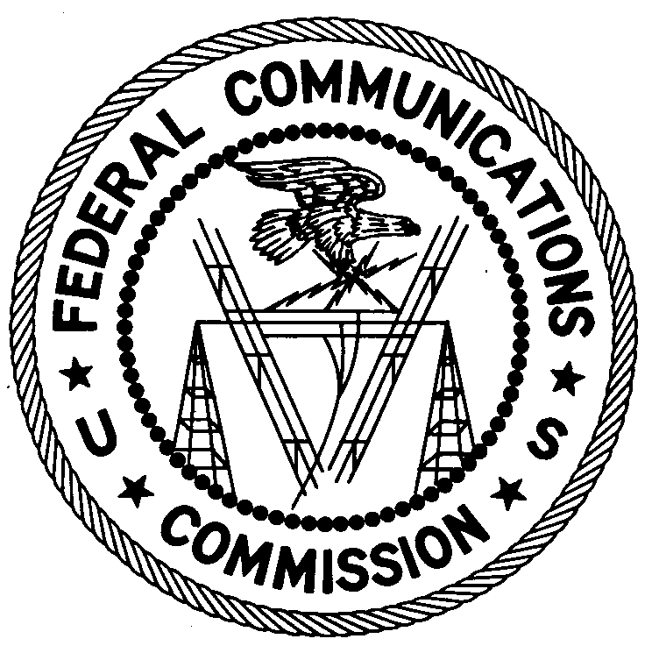
FEDERAL COMMUNICATIONS COMMISSION
ENFORCEMENT BUREAU
REGION ONE

Columbia Regional Office

9050 Junction Drive

Annapolis Junction, Maryland 20701

Field@FCC.gov
(301) 725-1996

April 11, 2019

Frank Reimer
East Brunswick, New Jersey

NOTICE OF UNLICENSED OPERATION AND
NOTIFICATION OF HARMFUL INTERFERENCE

Case Number: EB-FIELDNER-18-00028232

On March 28, 2019, Agents from the New York Office of the Federal Communications Commission’s (FCC’s or Commission’s) Enforcement Bureau (Bureau) investigated a complaint from the Federal Aviation Administration alleging that spurious emissions on the frequency 1575.42 MHz were routinely causing harmful interference to their Global Positioning System (GPS) receivers at the Newark Airport. The agents confirmed by direction finding techniques that radio signals in the restricted 1568 MHz - 1595 MHz band were emanating from a GPS jammer located in a vehicle traveling southbound on the New Jersey Turnpike in Newark, New Jersey. The Agents investigated and determined that the vehicle is owned by your employer. The Agents then provided your employer with the vehicle’s license plate number and were advised that you were the driver of the vehicle on March 28, 2019.
Radio stations must be licensed by the FCC pursuant to Section 301 of the Communications Act of 1934, as amended (Act). Section 333 of the Act prohibits willful or malicious interference with any radio communications of any station licensed or authorized by or under the Act or operated by the United States Government. In addition, Section 302(b) of the Act prohibits the manufacture, importation, marketing, sale or operation of devices deliberately designed to jam or disrupt wireless communications.

The Commission has issued multiple Public Notices specifically stating that the sale and use of transmitters designed to prevent, jam, or interfere with the operation of cellular and personal communications service (PCS) telephones, police radar, Global Positioning Systems (GSP), wireless networking services (WiFi), or other communications devices is unlawful.

The operation of the device utilized by you may constitute a violation of Sections 333, 302(b), and 301 of the Act, as described above. Such operation may subject the responsible parties to substantial monetary forfeitures, in rem arrest action against the offending radio equipment, and criminal sanctions including imprisonment. Because unauthorized operation creates a danger of interference to important radio communications services, and may subject the operator to severe penalties, this warning emphasizes the importance of complying strictly with these legal requirements.

UNAUTHORIZED OPERATION OF THIS RADIO TRANSMITTING DEVICE AND ASSOCIATED HARMFUL INTERFERENCE MUST NOT RESUME

You have ten (10) days from the date of this notice to respond to the allegations contained herein. Your response should describe the steps you are taking to avoid operating on unauthorized frequencies and to prevent future interference. Your response should be sent to the address in the letterhead and reference the listed case and document number. Under the Privacy Act of 1974, we are informing you that the Commission’s staff will use all relevant material information before it to determine what, if any, enforcement action is required to ensure your compliance with FCC Rules. This will include any information that you disclose in your reply.

You may contact this office if you have any questions.

David C. Dombrowski
Regional Director
Region One
Enforcement Bureau
Federal Communications Commission

Attachments:
Enforcement Advisory No. 2014-05: WARNING: Jammer Use is Prohibited

47 U.S.C. § 301.
47 U.S.C. § 333.
47 U.S.C. § 302a(b).
See, e.g., Office of Engineering and Technology and Compliance and Information Bureau Warn Against the Manufacture, Importation, Marketing or Operation of Transmitters Designed to Prevent or Otherwise Interfere with Cellular Radio Communications, 15 RCC Rcd 6997 (OET/CIB 1999); Sale or Use of Transmitters Designed to Prevent, Jam or Interfere with Cell Phone Communications is Prohibited in the United States, 20 FCC Rcd 11134 (EB/OET/WTB 2005); CONSUMERS BEWARE: It is Unlawful to Use “Cell Jammers” and Other Equipment that Blocks, Jams, or Interferes with Authorized Radio Communications in the U.S., 26 FCC Rcd 1329 (EB 2011); CONSUMER ALERT: Using or Importing Jammers is Illegal; Monetary Penalties Can Exceed $100,000 per Violation, 27 FCC Rcd 2309 (EB 2012); WARNING: Jammer Use is Prohibited, Prohibition Applies to Use by the Public and State and Local Government Agencies, Including State and Local Law Enforcement Agencies, 29 FCC Rcd 14737 (EB 2014).
47 U.S.C. §§ 301, 302a(b), 333.
See 47 U.S.C. §§ 401, 501, 503, 510.
5 U.S.C. § 552a(e)(3).

