FEDERAL COMMUNICATIONS COMMISSION
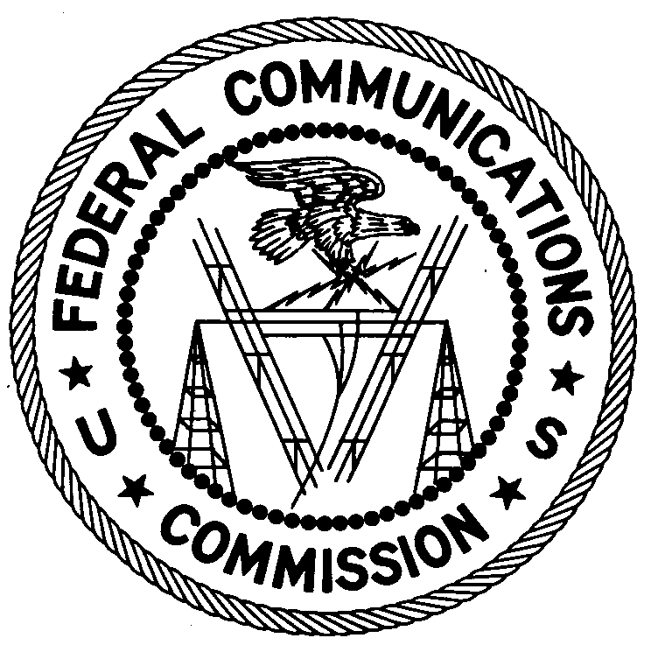
ENFORCEMENT BUREAU
REGION THREE

Los Angeles Regional Office
18000 Studebaker Rd., #660

Cerritos, CA 90703
(562) 860-7474

April 18, 2017

Ministerio Cristiano Hombres de Valor
Attn: Julio Naves
Omaha, NE

NOTICE OF UNLICENSED OPERATION

Case Number: EB-FIELDWR-1700023838 Document Number: W201732800001

The Denver Office received information that an unlicensed broadcast radio station on 95.9 MHz was allegedly operating in Omaha, NE. On March 19 and again on March 20, 2017, an agent from this office confirmed by direction finding techniques that radio signals on frequency 95.9 MHz were emanating from an antenna mounted on the rooftop of a commercial / residential mixed-use building, and the associated coaxial cabling was found to enter the building at 4729 S. 24th Street. On March 21, 2017, you stated to the agent that you had the station removed from the air, which was subsequently verified via the agent’s on-scene investigation. The Commission’s records show that no license was issued for operation of a broadcast station on 95.9 MHz at this location in Omaha, NE.

Radio stations operating on many frequencies, including 95.9 MHz, must be licensed by the FCC pursuant to 47 U.S.C. § 301. The only exception to this licensing requirement is for certain transmitters using or operating at a power level or mode of operation that complies with the standards established in Part 15 of the Commission’s rules, 47 CFR §§ 15.1 et seq. The agent found that the station at this location was operating at a power level that exceeds the level permitted by Part 15. Therefore, this station was operating in violation of 47 U.S.C. § 301.

You are hereby warned that operation of radio transmitting equipment without a valid radio station authorization constitutes a violation of the Federal laws cited above and could subject the operator to severe penalties, including, but not limited to, substantial monetary fines, in rem arrest action against the offending radio equipment, and criminal sanctions including imprisonment. (See 47 U.S.C. §§ 401, 501, 503 and 510.)

UNLICENSED OPERATION OF THIS RADIO STATION MUST BE DISCONTINUED IMMEDIATELY.

You have ten (10) days from the date of this notice to respond with any evidence that you have authority to operate granted by the FCC. Your response should be sent to the address in the letterhead and reference the listed case and document number. Under the Privacy Act of 1974, 5 U.S.C. § 552a(e)(3), we are informing you that the Commission’s staff will use all relevant material information before it to determine what, if any, enforcement action is required to ensure your compliance with FCC Rules. This will include any information that you disclose in your reply.

You may contact this office if you have any questions.

Lark Hadley
Regional Director
Region Three
Enforcement Bureau

Attachments:
Excerpts from the Communications Act of 1934, As Amended
Enforcement Bureau, "Inspection Fact Sheet", March 2005

