FEDERAL COMMUNICATIONS COMMISSION
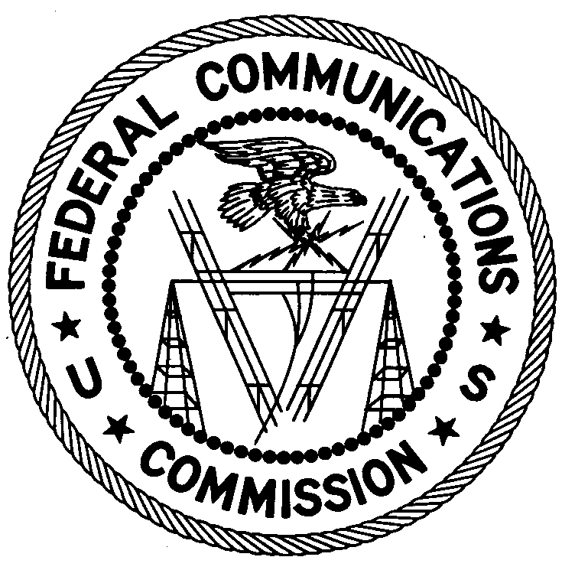
ENFORCEMENT BUREAU
REGION TWO

Miami Office
P.O. Box 266468

Weston, FL 33326

March 14, 2017

Nixon Ceme
Lake Worth, Florida

NOTICE OF UNLICENSED OPERATION

Case Number: EB-FIELDSCR-17-00023416

Document Number: W201732600010

On January 25 and February 2, 2017, agents from this office confirmed by direction finding techniques that radio signals on frequency 104.1 MHz were emanating from a residential property on 12th Court North in Lake Worth, Florida. Public records list you as the property owner. During an inspection on February 2, 2017, you told agents that you were leasing a locked room to “Bato” and would provide a lease agreement. As of the date of this letter, the Miami Office has not received the lease agreement. The Commission’s records show that no license was issued for operation of a broadcast station at this location on 104.1 MHz in Lake Worth, Florida.

Radio stations operating on many frequencies, including 104.1 MHz, must be licensed by the FCC pursuant to 47 U.S.C. § 301. The only exception to this licensing requirement is for certain transmitters using or operating at a power level that complies with the standards established in Part 15 of the Commission’s rules, 47 CFR §§ 15.1 et seq. On both January 25 and February 2, 2017, the field strength of the signal on frequency 104.1 MHz exceeded the maximum permitted level of 250 microvolts per meter (µV/m) at 3 meters for non-licensed devices. Thus, this station was operating in violation of 47 U.S.C. § 301.

You are hereby warned that operation of radio transmitting equipment without a valid radio station authorization constitutes a violation of the Federal laws cited above and could subject the operator to severe penalties, including, but not limited to, substantial monetary fines, in rem arrest action against the offending radio equipment, and criminal sanctions including imprisonment. (See 47 U.S.C. §§ 401, 501, 503 and 510.)

UNLICENSED OPERATION OF THIS RADIO STATION MUST NOT RESUME.

You have ten (10) days from the date of this notice to respond with any evidence that you have authority to operate granted by the FCC. Your response should be sent to the address in the letterhead and reference the listed case and document number. Under the Privacy Act of 1974, 5 U.S.C. § 552a(e)(3), we are informing you that the Commission’s staff will use all relevant material information before it to determine what, if any, enforcement action is required to ensure your compliance with FCC Rules. This will include any information that you disclose in your reply.

You may contact this office if you have any questions.

Ronald D. Ramage
Regional Director
Region Two
Enforcement Bureau
Federal Communications Commission

Attachments:
Excerpts from the Communications Act of 1934, As Amended
Enforcement Bureau, "Inspection Fact Sheet," March 2005

