FEDERAL COMMUNICATIONS COMMISSION
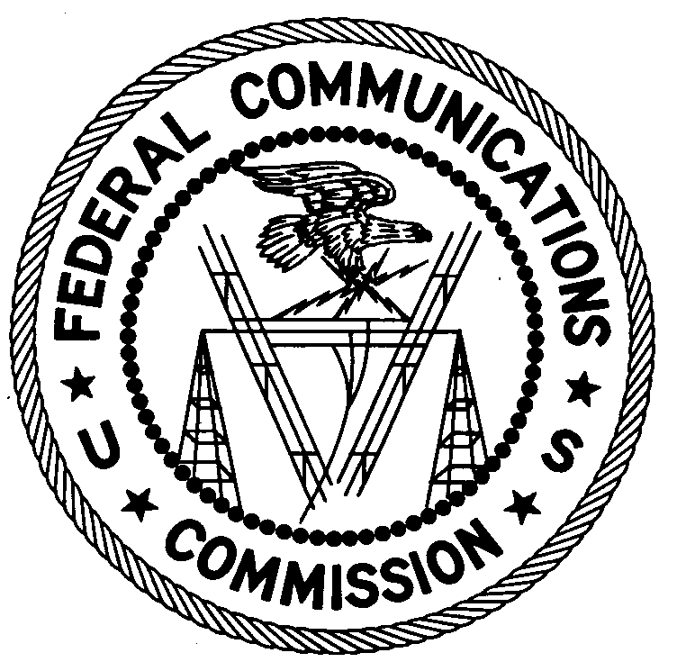
ENFORCEMENT BUREAU
REGION ONE

Columbia Regional Office
9050 Junction Drive
Annapolis Junction, Maryland 20701
FIELD@FCC.gov
(301) 725-1996

April 18, 2019

By UPS and First Class Mail

Emmanuel Noël
Pawtucket, Rhode Island

NOTICE OF Unlicensed Radio Operation

Case Numbers: EB-FIELDNER-18-00028214
EB-FIELDNER-19-00028660
EB-FIELDNER-19-00028812

The Boston Office of the Federal Communications Commission’s (FCC or Commission’s) Enforcement Bureau (Bureau) received multiple complaints that unlicensed FM station was operating on the frequencies 87.7 MHz and 96.7 MHz in Pawtucket, Rhode Island and causing harmful interference to radio communications in the Private Land Mobile Radio Services and Aeronautical Radio Service.

On February 26, 2019 and March 12, 2019, an Agent from the Boston Office confirmed by direction finding techniques that radio signals on the frequency 87.7 MHz were emanating from a single-family dwelling on South Street in Pawtucket, Rhode Island. In response to a complaint, on March 12, 2019, the Agent confirmed that the station operating on 87.7 MHz was generating spurious emissions in the 72 MHz band and causing harmful interference to the radio communications of the Pawtucket Fire Department. The Agent confirmed, through investigation, that you are the operator of the unlicensed radio station. The Commission’s records show that no license was issued for operation of a radio station on 87.7 MHz at this location in Pawtucket, Rhode Island.

After receiving a verbal warning on March 12, 2019 that your station was causing harmful interference to the Pawtucket Fire Department, you apparently changed the operating frequency of the station from 87.7 MHz to 96.7 MHz. Subsequently, the Federal Aviation Administration (FAA) began receiving harmful interference to the approach frequency for the T.F. Green Airport in Providence Airport. On March 19, 2019, an FAA technician confirmed by direction finding techniques that the broadcast station operating on your property on South Main Street in Pawtucket, Rhode Island was now transmitting on the frequency 96.7 MHz and generating spurious emissions in the 123 MHz band that were source of the harmful interference to the airport approach frequency. The Commission’s records show that no license was issued for operation of a radio station on 96.7 MHz at this location in Pawtucket, Rhode Island.

Radio stations operating on a range of frequencies, including 87.7 MHz and 96.7 MHz, must be licensed by the FCC pursuant to Section 301 of the Communications Act of 1934, as amended (Act). The only exception to this licensing requirement is for certain transmitters using or operating at a power level or mode of operation that complies with the standards established in Part 15 of the Commission’s rules. The Agents found that the station was operating at a power level that exceeds the level permitted by Part 15. On February 26, 2019, the Agent measured the field strength of the signal on the frequency 87.7 MHz for the station and found that it exceeded the maximum permitted level of 100 µV/m at 3 meters for non-licensed devices. Therefore, this station was operating in violation of Section 301 of the Act.

You are hereby warned that operation of radio transmitting equipment without a valid radio station authorization constitutes a violation of the Federal laws cited above and will subject the operator to severe penalties, including, but not limited to, in rem seizure of the offending radio equipment without further notice, substantial fines, and criminal sanctions, including imprisonment.

UNLICENSED OPERATION OF THIS RADIO STATION MUST BE DISCONTINUED IMMEDIATELY AND MUST NOT RESUME.

You have ten (10) days from the date of this notice to respond with any evidence that you have authority to operate granted by the FCC. Your response should be sent to the address in the letterhead and reference the listed case number. Under the Privacy Act of 1974, we are informing you that the Commission’s staff will use all relevant material information before it to determine what, if any, enforcement action is required to ensure your compliance with FCC Rules. This will include any information that you disclose in your reply.

You may contact this office if you have any questions.

David C. Dombrowski
Regional Director
Region One
Enforcement Bureau
Federal Communications Commission

Attachments:
Excerpts from the Communications Act of 1934, As Amended
Enforcement Bureau, "Inspection Fact Sheet", March 2005

47 CFR § 73.603.
47 U.S.C. § 301.
47 CFR §§ 15.1 et seq.
47 U.S.C. § 301.
See 47 U.S.C. §§ 401, 501, 503 and 510.
5 U.S.C. § 552a(e)(3).

