FEDERAL COMMUNICATIONS COMMISSION
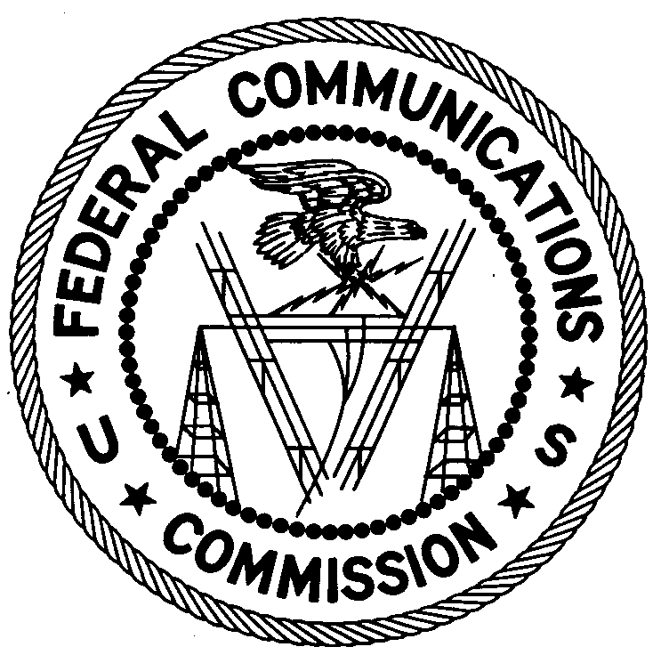
ENFORCEMENT BUREAU
REGION ONE

Columbia Regional Office
9050 Junction Dr.

Annapolis Junction, Annapolis 20701

Field@FCC.gov

(301) 725-1996

April 18, 2019

Noah Gyamfi
Worcester, Massachusetts

NOTICE OF UNLICENSED OPERATION

Case Number: EB-FIELDNER-19-00028708

On February 22, 2019, an Agent from the Boston Office of the Federal Communications Commission’s (FCC or Commission’s) Enforcement Bureau (Bureau) investigated a complaint of an unlicensed FM station operating on the frequency 103.9 MHz. The Agent confirmed by direction finding techniques that radio signals on the frequency 103.9 MHz were emanating from the commercial property at 45 Fremont Street, Suite B, Worcester Massachusetts. The Agent also observed spurious emissions on frequencies 110.3 MHz and 111.7 MHz which could have caused harmful interference to aeronautical communications. Through investigation, the Agent confirmed that you are the operator of the unlicensed radio station. The Commission’s records show that no license was issued for operation of a radio station on 103.9 MHz at this location in Worcester, Massachusetts.

Radio stations operating on a range of frequencies, including 103.9 MHz, must be licensed by the FCC pursuant to Section 301 of the Communications Act of 1934, as amended (Act). The only exception to this licensing requirement is for certain transmitters using or operating at a power level or mode of operation that complies with the standards established in Part 15 of the Commission’s rules. On February 22, 2019, the Agent measured the field strength of the signal on the frequency 103.9 MHz for the station and found that it exceeded the maximum permitted level of 250 µV/m at 3 meters for non-licensed devices. Thus, this station is operating in violation of Section 301 of the Act.

Operation of radio transmitting equipment without a valid FCC authorization or license is a violation of Section 301 of the Act and may subject the responsible parties to substantial monetary fines, in rem arrest action against the offending radio equipment, and criminal sanctions including imprisonment. Because unlicensed operation creates a danger of interference to important radio communications services and may subject the operator to severe penalties, this letter emphasizes the importance of complying strictly with these legal requirements.

UNLICENSED OPERATION OF THIS RADIO STATION MUST BE DISCONTINUED IMMEDIATELY.

You have ten (10) days from the date of this notice to respond with any evidence that you have authority to operate granted by the FCC. Your response should be sent to the address in the letterhead and reference the listed case number. Under the Privacy Act of 1974, we are informing you that the Commission’s staff will use all relevant material information before it to determine what, if any, enforcement action is required to ensure your compliance with FCC Rules. This will include any information that you disclose in your reply.

You may contact this office if you have any questions.

David C. Dombrowski
Regional Director
Region One
Enforcement Bureau
Federal Communications Commission

Attachments:
Excerpts from the Communications Act of 1934, As Amended
Enforcement Bureau, "Inspection Fact Sheet", March 2005

47 CFR § 73.201.
47 U.S.C. § 301.
47 CFR §§ 15.1 et seq.
47 U.S.C. § 301.
47 U.S.C. § 301.
See 47 U.S.C. §§ 401, 501, 503 and 510.
5 U.S.C. § 552a(e)(3).

