**C:\WINDOWS\Desktop\fcc_logo.tif**

**Report on Broadband Deployment in Indian Country,**

**Pursuant to the Repack Airwaves Yielding Better Access**

**for Users of Modern Services Act of 2018**

**Prepared by the:**

**Consumer & Governmental Affairs Bureau**

**Wireless Telecommunications Bureau**

**Wireline Competition Bureau**

**Submitted to the:**

**Senate Committee on Commerce, Science, and Transportation**

**House of Representatives Committee on Energy and Commerce**

**May 2019**

**TABLE OF CONTENTS**

[I. INTRODUCTION 1](#_Toc6578191)

[II. BACKGROUND 1](#_Toc6578192)

[III. CURRENT DEPLOYMENT ON TRIBAL LANDS 3](#_Toc6578193)

[A. Data and Methodology Overview 3](#_Toc6578194)

[B. Fixed Broadband Deployment 4](#_Toc6578195)

[C. Mobile Broadband Deployment 8](#_Toc6578196)

[IV. CONTINUING COMMISSION EFFORTS TO INCREASE TRIBAL DEPLOYMENT 9](#_Toc6578197)

[A. Universal Service Programs 9](#_Toc6578199)

[1. High-Cost Program 9](#_Toc6578200)

[2. Lifeline Program 14](#_Toc6578201)

[3. E-Rate Program 14](#_Toc6578202)

[4. Rural Health Care Program 14](#_Toc6578203)

[B. Tribal Consultations and Outreach 15](#_Toc6578204)

[C. Additional Actions to Increase Access to Mobile Broadband on Tribal Lands 17](#_Toc6578205)

[1. 2.5 GHz Band 17](#_Toc6578206)

[2. Tribal Lands Bidding Credits 17](#_Toc6578207)

[3. Recent and Planned Spectrum Auctions 17](#_Toc6578208)

[V. Conclusion 18](#_Toc6578209)

# INTRODUCTION

Pursuant to Section 508(a)(1) of the Repack Airwaves Yielding Better Access for Users of Modern Services Act of 2018 (RAY BAUM’S Act or the Act), the Consumer & Governmental Affairs Bureau, Wireless Telecommunications Bureau, and Wireline Competition Bureau (Bureaus) of the Federal Communications Commission (FCC or Commission) submit this report to the Committee on Energy and Commerce of the House of Representatives and the Committee on Commerce, Science, and Transportation of the Senate.[[1]](#footnote-3) The Act directs the Commission to evaluate broadband coverage in Indian country and on land held by a Native Corporation pursuant to the Alaska Native Claims Settlement Act.[[2]](#footnote-4) Consistent with this directive, the Bureaus provide an analysis of broadband deployment on Tribal lands using FCC Form 477 data as of December 2017, as well as an overview of the Commission’s ongoing efforts to address unserved areas on Tribal lands that are not yet reflected in this data.

As this report shows, while deployment to Tribal lands has increased in recent years, additional work remains to increase deployment to the certain Tribal areas and reach our goal of closing the digital divide for all Americans. Tribal lands experience lower rates of both fixed and mobile broadband deployment as compared to non-Tribal areas of the United States, particularly in rural areas.[[3]](#footnote-5) For example, while 92% of housing units on urban Tribal lands are covered by a fixed terrestrial provider of 25/3 Mbps broadband service—just six points behind their non-Tribal urban counterparts—just 46.6% of housing units on rural Tribal lands have access to that service, a nearly 27-point gap compared to non-Tribal rural areas. Mobile LTE coverage on Tribal lands is similarly behind deployment on non-Tribal lands; while 99.8% of the population living on non-Tribal areas are covered by mobile LTE service, only 96% of the population living on Tribal land are covered with such service. And generally, individuals living on Tribal lands that are covered have access to fewer carriers providing 4G LTE coverage. The Commission will initiate a proceeding in the near term to address these deployment challenges and help to close the broadband gap on Tribal lands.

# BACKGROUND

Tribal lands often present significant obstacles to deploying broadband and are expensive to serve.[[4]](#footnote-6) These challenges to deployment on Tribal lands include rugged terrain, complex permitting processes governing access to Tribal lands, jurisdictional issues involving states and sovereign Tribal governments, lack of the necessary infrastructure, and a predominance of residential, rather than business, customers.[[5]](#footnote-7) High poverty rates and low-income levels on Tribal lands, as well as cultural and language barriers, further inhibit the widespread availability of broadband to Tribal residents.[[6]](#footnote-8)

Additionally, the population of individuals living on Tribal lands is disproportionately skewed toward rural, rather than urban, areas; approximately 48% of housing units on Tribal lands are located in rural areas compared to approximately 21% of non-Tribal housing units. Moreover, Tribal lands, both rural and urban, tend to be less densely populated than non-Tribal lands. For example, the linear density (i.e., the number of housing units per kilometer of road distance) data shown in Figure 1 indicates substantial differences between Tribal and non-Tribal areas in both urban and rural blocks.

**Fig. 1**

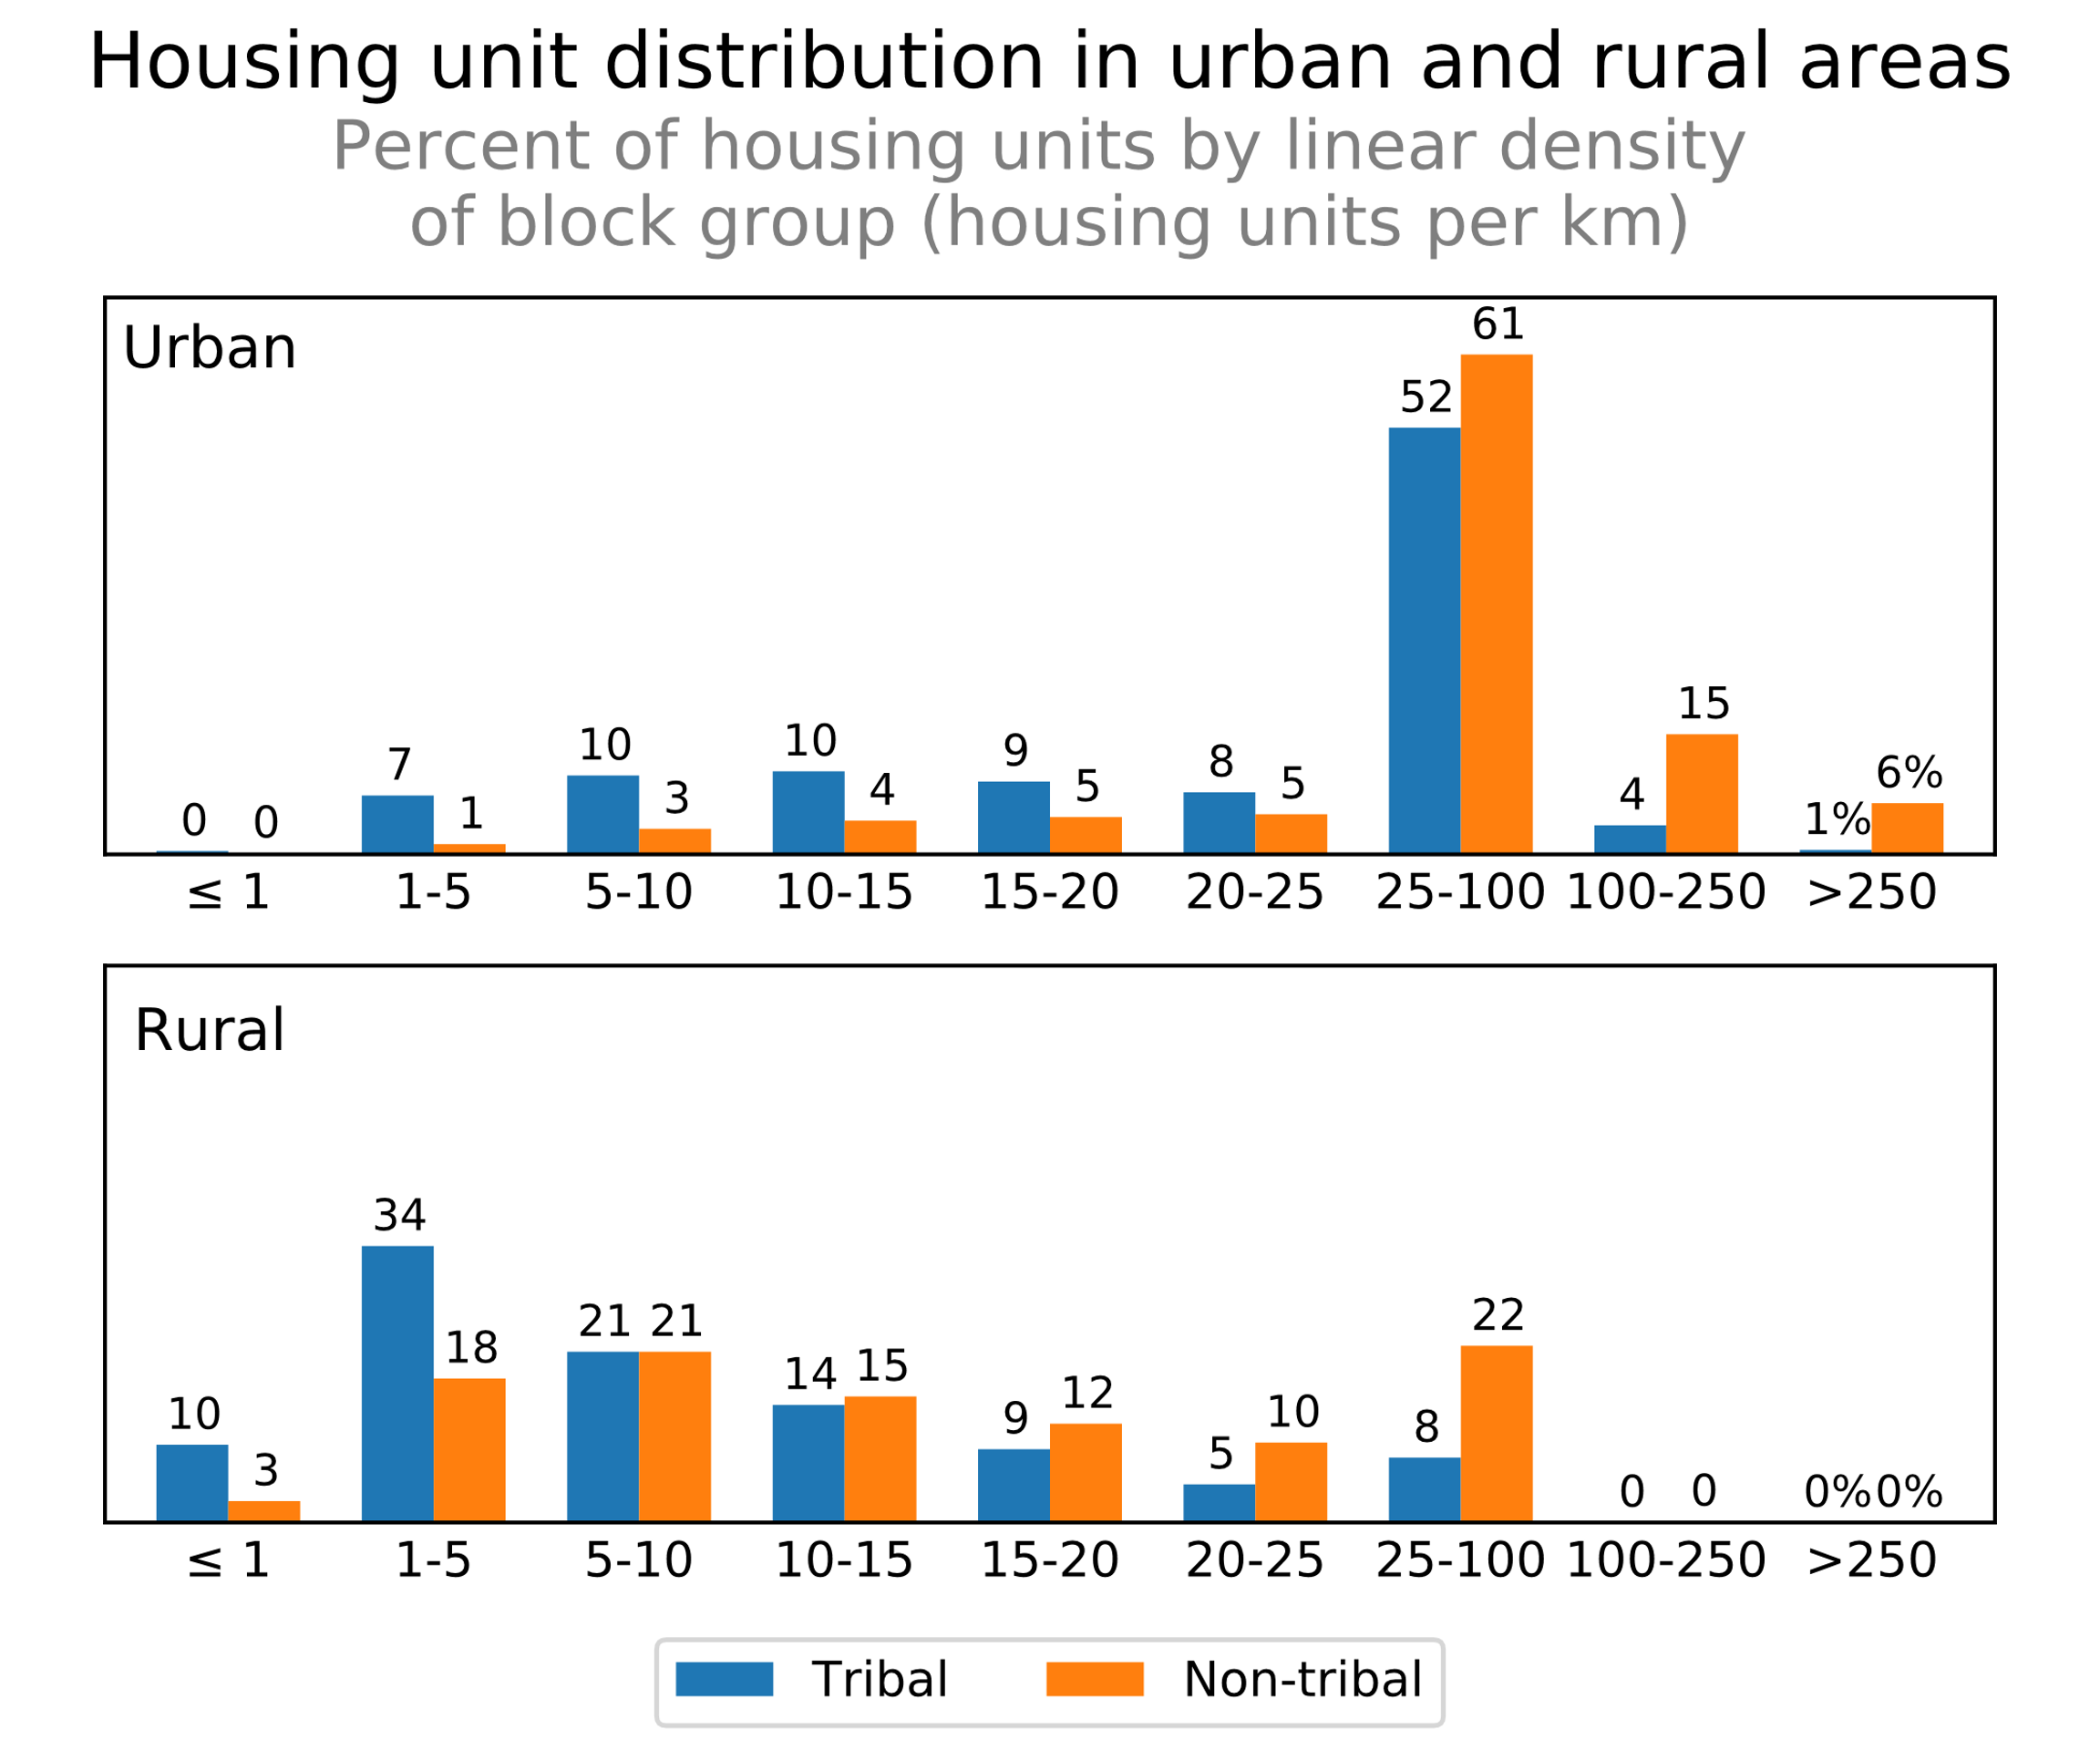

The lower density of Tribal areas is particularly magnified in rural areas; as Figure 1 shows, while only 36% of Tribal housing units in urban areas are located in census block groups with 20 or fewer housing units per kilometer of road distance, 88% of Tribal housing units in rural areas are located in such census block groups. Given that carriers must undertake significantly higher costs to construct broadband networks in remote, isolated areas, the lack of density in rural Tribal areas appears to have a negative effect on broadband deployment.

The Commission has a long-recognized trust relationship with Tribal Nations.[[7]](#footnote-9) This government-to-government relationship guides the Commission’s dealings with Tribal Nations and its efforts to promote Tribal self-sufficiency, economic development, and access to communications facilities and services.[[8]](#footnote-10)Given the complexity and challenges of expanding service to Tribal lands, the Commission has taken a multi-faceted approach that includes: engaging in ongoing consultation with Tribes on a government-to-government basis, consistent with our trust responsibility; making funds available to support broadband access and deployment through the Universal Service Fund (USF or Fund); and evaluating opportunities to make spectrum available for the provision of mobile broadband services on Tribal lands.[[9]](#footnote-11) Moreover, the Commission has found that reducing regulatory barriers to entry and investment will encourage and promote competitive, dynamic, and innovative communication services.[[10]](#footnote-12) Thus, the Commission has acted in both wireline and wireless infrastructure proceedings to reduce the administrative burdens associated with deploying broadband-capable networks.[[11]](#footnote-13) Together, these initiatives best leverage the Commission’s resources and authority to increase the availability of broadband services on Tribal lands.

# CURRENT DEPLOYMENT ON TRIBAL LANDS

The Commission has interpreted Section 254 of the Communications Act as an obligation to ensure universal availability of broadband networks to all Americans, including Americans living on Tribal lands. To that end, the Commission has established a baseline standard for fixed broadband at speeds of 25/3 Mbps for high-cost areas, including Tribal lands.[[12]](#footnote-14) As consumer expectations continue to increase, it is important to evaluate broadband deployment across a range of speeds to determine whether adequate services are available on Tribal lands.

## Data and Methodology Overview

The deployment data underlying this report result from the Commission’s FCC Form 477 data collection. The Commission uses FCC Form 477 to collect voice and broadband data from all facilities-based providers of mobile and fixed telecommunication services. These data are used by the Commission to produce the various maps and reports on the state of voice and broadband coverage in the United States, as well as to inform the Commission’s policy decisions.[[13]](#footnote-15) The population and housing unit counts reflected in this report are based on the same block-level estimates used in the Commission’s *Broadband Deployment Report*.[[14]](#footnote-16)

In this report, the fixed broadband coverage numbers rely on the December 2017 Form 477 fixed-broadband deployment data.[[15]](#footnote-17) Only residential broadband is included in this analysis. The “Any Technology” category on Form 477 includes any fixed broadband technology, the “Any Terrestrial” category excludes satellite but includes all other fixed technologies, and the “Any Wired” category includes only Asymmetric digital subscriber line (ADSL), cable, and fiber.

The mobile broadband coverage numbers in this Report similarly rely on the December 2017 Form 477 mobile broadband deployment data using the centroid methodology for any LTE coverage.[[16]](#footnote-18) Each census block is classified according to the number of LTE providers serving that census block. Census block areas include only land area according to 2010 U.S. Census Bureau figures.[[17]](#footnote-19) The population, number of road miles and area in square miles is summed for the number of providers for Tribal and non-Tribal areas.[[18]](#footnote-20)

The Commission is aware of shortcomings in the Form 477 data collection, and when the FCC Form 477 data are used to inform its funding and policy decisions, the Commission considers the limitations and challenges of the dataset.[[19]](#footnote-21) The Commission has an open proceeding considering ways to improve the accuracy and granularity of that data collection.[[20]](#footnote-22) Among other matters, the Commission sought comment on whether “it should move to a more granular basis for reporting deployment data and, if so, what basis would be appropriate.”[[21]](#footnote-23) The Act directs the Commission to initiate a proceeding to address unserved Tribal areas identified in this report,[[22]](#footnote-24) which will provide the Commission with the opportunity to explore potential options for improving and refining Tribal broadband deployment data, including seeking additional input on the data collection process from both individual Tribes and inter-Tribal organizations on a national and regional basis.

## Fixed Broadband Deployment

In this section, we evaluate fixed broadband deployment on Tribal lands across a range of speeds. While substantial progress has been made in reaching the Commission’s goal of bringing high-speed Internet access to high-cost areas, including Tribal lands, more work remains to increase deployment of fixed broadband options for those living in Tribal areas.

*Overall Deployment.* Figure 2 below underscores the divide between deployment of fixed broadband on Tribal and non-Tribal lands. For example, over 56% of non-Tribal housing units are covered by two or more wired providers of 25/3 Mbps service, while approximately 21% of Tribal housing units are covered by two or more such providers.[[23]](#footnote-25)

**Fig. 2**

|  |  |  |  |  |  |  |  |  |  |  |  |  |
| --- | --- | --- | --- | --- | --- | --- | --- | --- | --- | --- | --- | --- |
| **Deployment of 25/3 Mbps Fixed Service to Non-Tribal and Tribal Housing Units (HUs)** | | | | | | | | | | | | |
|  | **By Any Technology** | | | | **By Any Terrestrial Technology** | | | | **By Any Wired Technology** | | | |
| **#  providers** | **Non-tribal HU (000s)** | **Tribal HU (000s)** | ***Non-tribal*** | ***Tribal*** | **Non-tribal HU (000s)** | **Tribal HU (000s)** | ***Non-tribal*** | ***Tribal*** | **Non-tribal HU (000s)** | **Tribal HU (000s)** | ***Non-tribal*** | ***Tribal*** |
| 0 | 98 | 28 | 0% | 2% | 9,418 | 550 | 7% | 31% | 11,734 | 628 | 8% | 36% |
| 1 | 1,615 | 195 | 1% | 11% | 42,023 | 644 | 30% | 37% | 48,975 | 762 | 36% | 43% |
| 2 | 13,578 | 503 | 10% | 29% | 58,640 | 362 | 43% | 21% | 62,578 | 335 | 46% | 19% |
| 3 or more | 121,962 | 1,024 | 89% | 58% | 27,173 | 194 | 20% | 11% | 13,966 | 26 | 10% | 2% |
| Total | 137,254 | 1,750 | 100% | 100% | 137,254 | 1,750 | 100% | 100% | 137,254 | 1,750 | 100% | 100% |

Even when examining fixed broadband deployment at lower speeds, Tribal housing units lag behind those on non-Tribal lands. For example, as Figure 3 shows, only 6% of housing units on non-Tribal lands lack coverage by any wired provider of 10/1 Mbps, while 25% of housing units on Tribal lands—about 431,000—have no wired option for 10/1 Mbps service. Figure 3 also demonstrates that even those individuals who do have access to such a provider, tend to have access to fewer providers than their counterparts on non-Tribal lands. A significant number of housing units on Tribal lands, 45%, is limited to only one wired option, compared to only 22% of those on non-Tribal lands.

**Fig. 3**

|  |  |  |  |  |  |  |  |  |  |  |  |  |
| --- | --- | --- | --- | --- | --- | --- | --- | --- | --- | --- | --- | --- |
| **Deployment of 10/1 Mbps Fixed Service to Non-Tribal and Tribal Housing Units (HUs)** | | | | | | | | | | | | |
|  | **By Any Technology** | | | | **By Any Terrestrial Technology** | | | | **By Any Wired Technology** | | | |
| **#  providers** | **Non-tribal HU (000s)** | **Tribal HU (000s)** | ***Non-tribal*** | ***Tribal*** | **Non-tribal HU (000s)** | **Tribal HU (000s)** | ***Non-tribal*** | ***Tribal*** | **Non-tribal HU (000s)** | **Tribal HU (000s)** | ***Non-tribal*** | ***Tribal*** |
| 0 | 21 | 26 | 0% | 2% | 4,411 | 287 | 3% | 16% | 7,685 | 431 | 6% | 25% |
| 1 | 745 | 99 | 1% | 5% | 23,829 | 591 | 17% | 34% | 30,989 | 797 | 22% | 45% |
| 2 | 6,631 | 362 | 5% | 21% | 62,997 | 518 | 46% | 30% | 79,661 | 471 | 58% | 27% |
| 3 or more | 129,857 | 1,264 | 94% | 72% | 46,016 | 355 | 34% | 20% | 18,918 | 51 | 14% | 3% |
| Total | 137,254 | 1,750 | 100% | 100% | 137,254 | 1,750 | 100% | 100% | 137,254 | 1,750 | 100% | 100% |

At the higher speeds presented in Figure 4 below, Non-Tribal housing units are more than three times as likely to have at least one provider of 100/10 Mbps service than housing units on Tribal lands. Additionally, only 12% of Tribal housing units have a choice of more than one terrestrial provider of 100/10 Mbps service, as opposed to approximately 46% of non-Tribal housing units, and 12% of Tribal housing units have a choice of more than one wired provider of such service, as compared to approximately 44% of non-Tribal housing units.

**Fig. 4**

|  |  |  |  |  |  |  |  |  |  |  |  |  |
| --- | --- | --- | --- | --- | --- | --- | --- | --- | --- | --- | --- | --- |
| **Deployment of 100/10 Mbps Fixed Service to Non-Tribal and Tribal Housing Units (HUs)** | | | | | | | | | | | | |
|  | **By Any Technology** | | | | **By Any Terrestrial Technology** | | | | **By Any Wired Technology** | | | |
| **#  providers** | **Non-tribal HU (000s)** | **Tribal HU (000s)** | ***Non-tribal*** | ***Tribal*** | **Non-tribal HU (000s)** | **Tribal HU (000s)** | ***Non-tribal*** | ***Tribal*** | **Non-tribal HU (000s)** | **Tribal HU (000s)** | ***Non-tribal*** | ***Tribal*** |
| 0 | 17,505 | 782 | 13% | 45% | 17,505 | 782 | 13% | 45% | 18,127 | 794 | 13% | 45% |
| 1 | 56,427 | 765 | 41% | 43% | 56,427 | 765 | 41% | 43% | 59,162 | 757 | 43% | 43% |
| 2 | 48,587 | 187 | 35% | 11% | 48,587 | 187 | 35% | 11% | 48,769 | 183 | 36% | 11% |
| 3 or more | 14,734 | 17 | 11% | 1% | 14,734 | 17 | 11% | 1% | 11,196 | 16 | 8% | 1% |
| Total | 137,254 | 1,750 | 100% | 100% | 137,254 | 1,750 | 100% | 100% | 137,254 | 1,750 | 100% | 100% |

*Urban/Rural Deployment Differences.* As noted above, the data indicate that a gap exists in fixed broadband deployment among Tribal lands themselves. Examining coverage by terrestrial fixed providers on a more granular geographic level may explain this difference. Figure 5 demonstrates that, while urban non-Tribal housing units experience a higher level of deployment across a variety of speeds than urban Tribal housing units, the difference in deployment is relatively small; by contrast, rural Tribal areas experience much larger coverage gaps at every speed than their rural non-Tribal counterparts.

**Fig. 5**

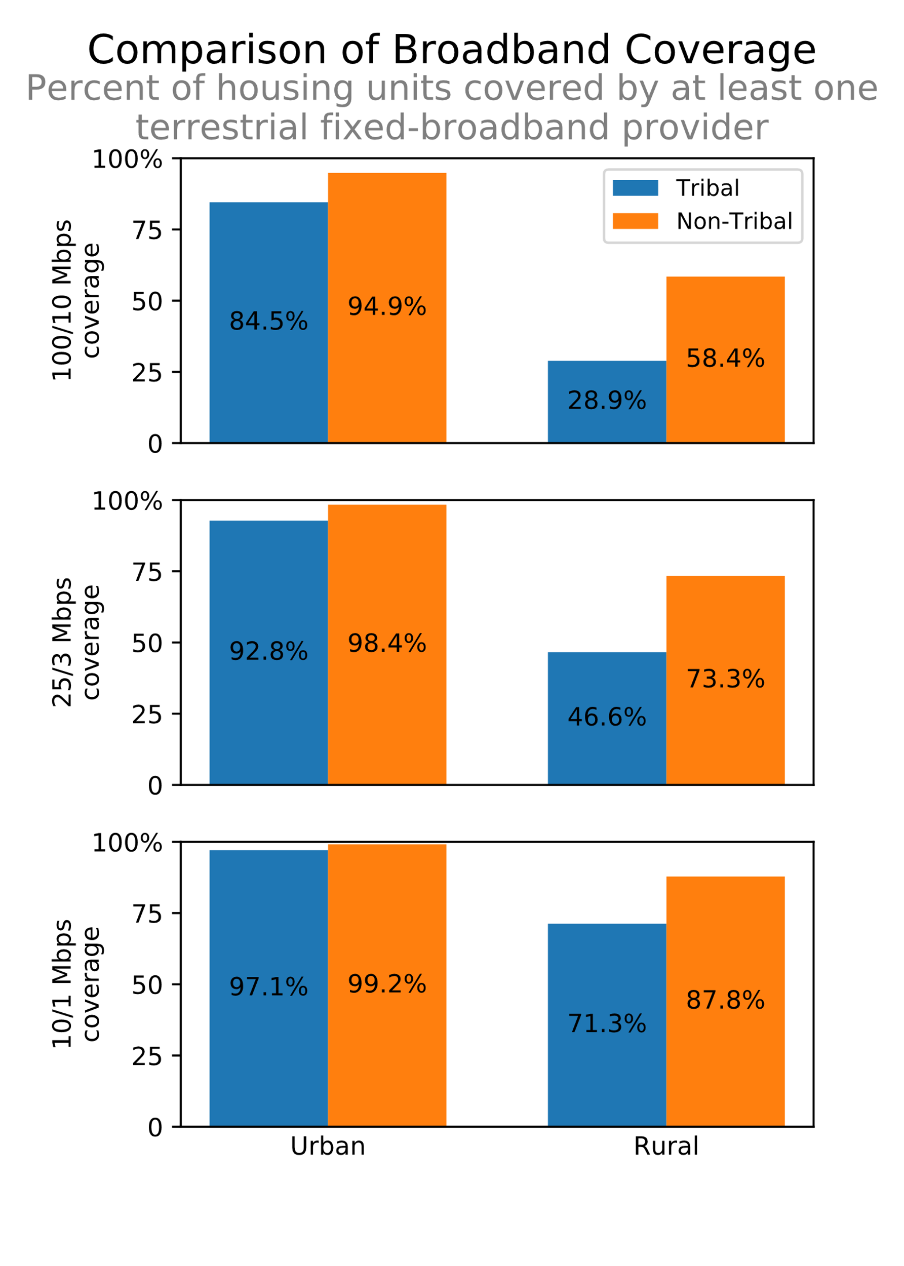

For example, while there is an approximately six percentage point difference in 25/3 Mbps deployment between urban Tribal and urban non-Tribal housing units, that difference jumps to over 26 percentage points when comparing deployment to rural Tribal and rural non-Tribal housing units. Similarly, deployment of 10/1 Mbps speeds to rural Tribal housing units trails deployment to rural non-Tribal housing units by 19 percentage points, as opposed to the two percentage-point difference in 10/1 Mbps coverage between Tribal and non-Tribal housing units in urban areas. Even at higher speeds such as 100/10 Mbps, the disparity is stark—only about 10 percentage points between urban Tribal and urban non-Tribal housing units, as opposed to almost 30 percentage points between rural Tribal and rural non-Tribal housing units.

**Fig. 6**

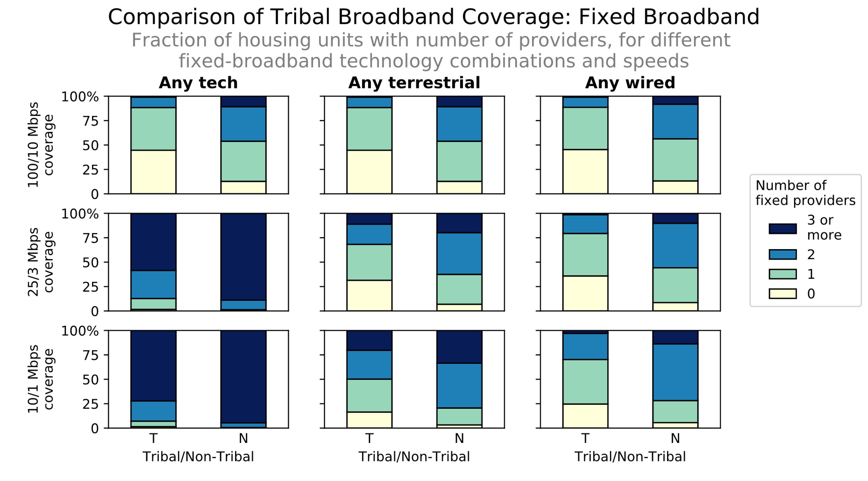

*Comparison of Coverage by Number of Providers*. As Figure 6 reflects, for each group of fixed technologies and performance tier, more individual on Tribal lands lack access to service than their counterparts on non-Tribal lands, and those individuals that are served tend to have access to fewer providers than individuals on non-Tribal lands. About 98% of Tribal housing units are covered by at least one provider of 25/3 Mbps service when all current technologies (satellite, fixed wireless, wired offerings) are considered. When only terrestrial providers are considered, approximately 69% on Tribal housing units are covered by a provider offering 25/3 Mbps service, and that number shrinks to less than 65% when only wired providers are considered. These numbers are significantly lower than the more than 92% of non-Tribal housing units that have access to one or more wired providers of 25/3 Mbps service. Tribal lands also have near ubiquitous access to speeds of 10/1 Mbps across all technologies. When looking at only wired providers, however, about 75% of housing units in Tribal areas have access to at least one provider offering 10/1 Mbps speeds, but only about 30% can choose between two or more providers of such service. This data point stands in contrast to that of those living on non-Tribal lands, where approximately 72% of housing units have access to two or more wired providers of 10/1 Mbps service. Finally, with regard to 100/10 Mbps service, Figure 6 demonstrates that wired technologies currently are the predominant method of delivering such speeds on Tribal lands. Only about 55% of housing units on Tribal lands have access to one or more provider offering such speeds, however, compared to almost 90% of non-Tribal lands.

In sum, across all metrics, Tribal areas continue to trail non-Tribal areas when it comes to fixed broadband deployment, and especially so in rural, lower density areas.

## Mobile Broadband Deployment

This section examines 4G LTE mobile broadband deployment on Tribal lands. Mobile broadband deployment on Tribal lands outpaces fixed broadband deployment. However, mobile broadband deployment on Tribal lands lags behind mobile broadband deployment on non-Tribal lands, with 4G LTE coverage reaching a smaller percentage of the population and road miles on Tribal lands than on non-Tribal lands.

*Overall Deployment.* Figure 7 presents a detailed look at 4G LTE deployment on Tribal lands. Almost 96% of the population on Tribal Lands is covered by at least one 4G LTE provider, leaving approximately 4% of the population on Tribal Lands without 4G LTE coverage by any provider. In comparison, only 0.2% of the population on non-Tribal lands are not covered at all with 4G LTE from any provider. The pattern is similar when considering 4G LTE coverage on roads. Only approximately 86% of road miles on Tribal lands are covered by at least one provider of 4G LTE, whereas almost 94% of non-Tribal road miles are covered. Finally, although the percentage of land area with no 4G LTE coverage is slightly higher for non-Tribal lands as compared with Tribal lands, it is almost twice as likely that there is only one service provider with 4G LTE coverage on Tribal lands when compared to non-Tribal lands, which tend to be covered by a higher number of 4G LTE providers. Given that mobile connectivity and reliability are particularly important on Tribal lands, additional work is needed to improve 4G LTE coverage in these areas.

**Fig. 7**

|  |  |  |  |  |  |  |  |  |  |  |  |  |
| --- | --- | --- | --- | --- | --- | --- | --- | --- | --- | --- | --- | --- |
| **Deployment of 4G LTE Mobile Service to Non-Tribal and Tribal Population (POPs)** | | | | | | | | | | | | |
|  | **Population** | | | | **Road coverage** | | | | **Area coverage** | | | |
| **#  providers** | **Non-tribal POPs (000s)** | **Tribal POPs (000s)** | ***Non-tribal*** | ***Tribal*** | **Non-tribal roads (mi)** | **Tribal roads  (mi)** | ***Non-tribal*** | ***Tribal*** | **Non-tribal area  (sq mi)** | **Tribal area  (sq mi)** | ***Non-tribal*** | ***Tribal*** |
| 0 | 734 | 179 | 0% | 4% | 383,061 | 40,878 | 6% | 14% | 907 | 43 | 27% | 24% |
| 1 | 2,254 | 175 | 1% | 4% | 513,208 | 44,962 | 8% | 15% | 410 | 38 | 12% | 21% |
| 2 | 7,499 | 280 | 2% | 7% | 874,871 | 42,508 | 14% | 15% | 536 | 31 | 16% | 17% |
| 3 | 25,380 | 465 | 8% | 12% | 1,528,663 | 49,230 | 25% | 17% | 733 | 27 | 22% | 14% |
| 4 or more | 289,547 | 2,919 | 89% | 73% | 2,893,267 | 115,827 | 47% | 39% | 768 | 43 | 23% | 24% |
| Total | 325,414 | 4,017 | 100% | 100% | 6,193,070 | 293,405 | 100% | 100% | 3,354 | 182 | 100% | 100% |

*Comparison of Coverage by Number of Providers.* As demonstrated by Figure 8, in terms of both covered population and covered road miles, 4G LTE coverage by at least one provider lags behind coverage on non-Tribal lands. In addition, for Tribal areas where there is coverage, it is more likely that non-Tribal lands will be covered by a greater number of providers than Tribal lands.

**Fig. 8**

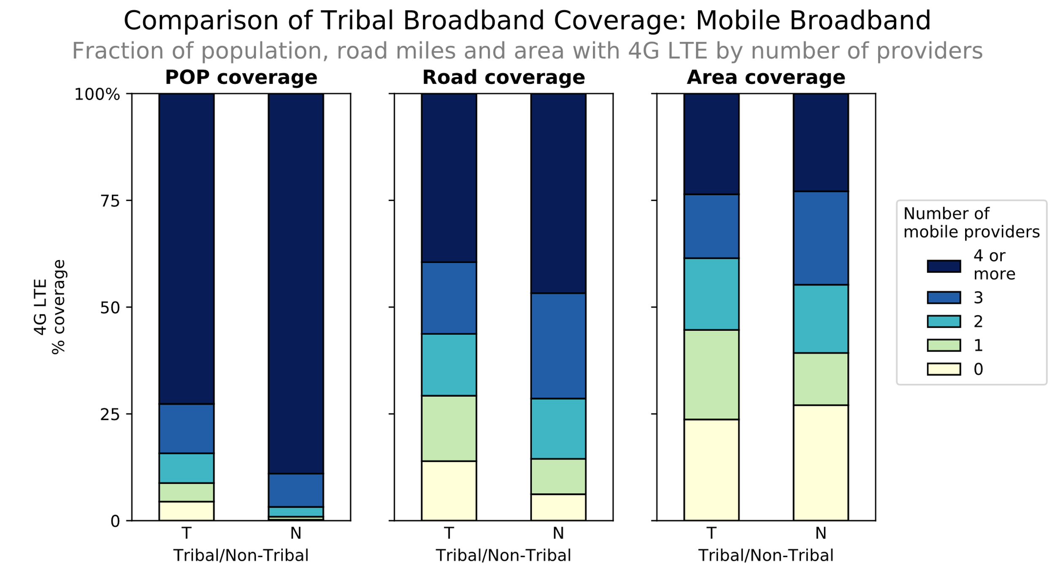

# CONTINUING COMMISSION EFFORTS TO INCREASE TRIBAL DEPLOYMENT

The Commission has consistently sought to leverage its available programs to increase the availability of broadband on Tribal lands. In recent years, the Commission has reformed universal service programs, expanded direct consultation with Tribes, and made available additional, valuable spectrum resources. Because many of these initiatives have been implemented recently, the deployment data discussed above do not yet fully reflect the increased outreach and investment on Tribal lands. The Commission anticipates that more recent reforms will drive increased broadband deployment on Tribal lands.

## Universal Service Programs

The primary means of achieving the Commission’s goal of increasing the availability of fixed and mobile broadband services on Tribal lands is through the universal service program. The Fund targets support to rural areas, including Tribal lands, through four main programs: High-Cost, Lifeline, E-Rate, and Rural Health Care. In establishing or revising rules governing each of these programs, the Commission has considered the impact of deployment on Tribal lands and aims to promote deployment in these areas.

### High-Cost Program

Support awarded to fixed and mobile carriers that serve Tribal lands through the high-cost program is a prime example of the Commission’s efforts to deliver on its commitment to closing the digital divide on Tribal lands. By providing a dedicated funding mechanism where needed, the Commission is making available additional resources exclusively for carriers serving Tribal lands to maintain and expand voice and broadband networks. [[24]](#footnote-26)

*Fixed Services*. The high-cost program has two separate tracks for fixed carriers, based generally on the carrier’s size. For larger incumbent carriers, known as price cap carriers, the Commission has offered universal service support through the Connect America Fund (CAF). Phase II of the CAF employed a two-step approach to provide ongoing support to deploy, provision, and maintain voice and broadband services in areas lacking broadband access, including remote Tribal areas. In the initial stage, ten carriers accepted statewide offers totaling over $1.5 billion in annual support for rural broadband deployment to serve over 3.6 million homes and businesses by the end of 2020.[[25]](#footnote-27) The Commission anticipates that this support, along with carrier investment, will expand broadband to nearly 7.3 million rural consumers in 45 states and one U.S. territory, including Tribal lands.[[26]](#footnote-28)

In areas where price cap incumbent carriers declined this support, the Commission employed a competitive bidding process to award support. The CAF Phase II auction closed in August 2018 and allocated $1.488 billion in funding to be distributed over 10 years to expand rural broadband service to over 700,000 rural homes and small businesses in unserved areas in 45 states through a variety of technologies, including terrestrial- and satellite-based solutions. In total, winning bidders in the CAF Phase II auction committed to deploying broadband service to 17,895 Tribal census blocks. The Commission expects that the CAF Phase II funding commitments will result in further deployment of broadband to Tribal lands. Areas that did not receive funding for buildout through CAF Phase II will be included in the Remote Areas Fund, which will provide support for rural, insular, or other areas that remain eligible for high-cost support. As part of that proceeding, the Commission has committed to consider preferences for Tribal entities or providers serving Tribal lands. [[27]](#footnote-29)

Smaller, rural carriers, known as rate-of-return carriers, historically received universal service support based on recovering their costs plus a return on their investments, calculated by comparing their actual costs to nationwide averages. Many of these carriers continue to receive legacy support in this manner, and the Commission has initiated reforms to increase these carriers’ deployments on Tribal lands. For example, to address the higher costs that legacy carriers typically face in serving Tribal lands, the Commission substantially increased the amount of operating costs that can be recovered by carriers that predominantly serve Tribal lands.[[28]](#footnote-30)

The Commission also has made available a cost model—the Alternative Connect America Cost Model (A-CAM)—for rate-of-return carriers that choose not to receive legacy support. The model-based option allows these carriers to receive predictable support for a 10-year term in exchange for meeting certain broadband deployment obligations. In December 2018, the Commission modernized its rules for distributing support to rate-of-return carriers by allocating additional funding to bring 25/3 Mbps service to rural America.[[29]](#footnote-31) The Commission also modified the A-CAM to encourage increased deployment in Tribal areas. While traditionally the A-CAM incorporates nationwide assumptions about take rates and potential average revenues per subscriber to estimate a per-location funding threshold, the Commission recognized that those same assumptions did not accurately account for the unique challenges of deploying broadband to rural Tribal communities.[[30]](#footnote-32) Thus, the Commission incorporated a Tribal Broadband Factor into the A-CAM, which establishes funding benchmark of $39.38 on Tribal lands, the amount above which serving a location is considered high cost; this is a 25% decrease compared to the $52.50 funding benchmark for non-Tribal locations. The practical effect of the Tribal Broadband Factor is that more locations are considered high cost and more support is available for each high-cost location. The Commission noted that the changes would “efficiently target support to carriers that serve significant Tribal lands, as well as those carriers that serve only a minimal amount of Tribal lands or a small number of housing units on Tribal lands in their study area.”[[31]](#footnote-33) Additionally, the Commission sought comment on ways to incorporate a Tribal Broadband Factor into the legacy rate-of-return system.[[32]](#footnote-34)

*Mobile Services*. To ensure the timely availability of mobile voice and broadband services on Tribal lands, the Commission adopted a dedicated funding mechanism as part of its Mobility Fund. For Mobility Fund Phase I, the Commission set aside $50 million in one-time support for unserved Tribal land areas to be awarded through a separate, Tribal Mobility Fund Phase I auction (Auction 902). A total of five winning bidders submitted $49.8 million in winning bids covering a population of 56,932 in 80 biddable areas. These areas include 18 biddable areas on five Reservations or Tribal lands in Arizona, Montana, New Mexico, and Utah; and 62 biddable areas in 49 Alaska Native Village Statistical Areas and 13 bidding areas otherwise in Alaska Native Regions.[[33]](#footnote-35) Since July 2014, the Wireless Telecommunications Bureau and the Wireline Competition Bureau have authorized support to all five winning bidders, and initial disbursements totaling $16.6 million were made. Final payments totaling over $24.5 million in support have also been disbursed, completing the disbursement process for 86% of the biddable areas.[[34]](#footnote-36)

Mobility Fund Phase II (MF-II) will make up to $4.53 billion in support available over 10 years to primarily rural areas that lack unsubsidized 4G LTE service, with at least $340 million expected to be set-aside for funding service to Tribal lands to be disbursed in the Tribal Mobility Phase II auction.[[35]](#footnote-37) MF-II is intended to incentivize the deployment of mobile wireless service through a reverse auction, and it is critically important to supporting mobile voice and broadband coverage by ensuring that 4G LTE service is preserved and advanced in those areas of the country that lack unsubsidized 4G LTE service. The Commission used carrier-provided data and subsidy data from USAC to create a map of areas presumptively eligible for MF-II support (initial eligible areas map), [[36]](#footnote-38) and it then allowed interested parties to challenge the initial determination that a particular area is ineligible for MF-II support.[[37]](#footnote-39) Sixteen Tribal governments have requested access to USAC’s MF-II Challenge Process portal.[[38]](#footnote-40)

The Commission plans to conduct the Tribal Mobility Fund Phase II auction as a component of the broader Mobility Fund Phase II auction.[[39]](#footnote-41) The Commission determined that reserving this support within MF-II is a fair and reasonable approach to ensuring that Tribal lands are not left behind in the auction.[[40]](#footnote-42) To encourage Tribal participation, the Rural Auctions Broadband Taskforce (RBATF) is conducting outreach to Tribal governments and carriers through in-person events, webinars, and educational materials.[[41]](#footnote-43)

*Fixed and Mobile Services in Alaska*. The Commission has adopted a tailored approach to address the unique challenges of providing fixed and mobile services in Alaska. Alaska is home to 229 of the 573 federally recognized Tribes and, for purposes of the Commission’s high-cost rules, consists entirely of Tribal lands.[[42]](#footnote-44) Among other actions, the Commission in 2016 adopted the $1.5 billion Alaska Plan to provide Alaskan carriers with the option of receiving fixed amounts of support for a term of ten years to maintain, extend, and upgrade their fixed and mobile broadband networks within the state, beginning January 1, 2017.[[43]](#footnote-45) The majority of the $1.5 billion fund was designated as “frozen support,” meaning that carriers choosing to participate in the Alaska Plan would receive, on a yearly basis for the term of the plan, the same level of support they received under existing high-cost mechanisms in prior years.[[44]](#footnote-46) The Commission required these providers to submit individual performance plans, with specific population-based coverage commitments by the end of year five and year ten.[[45]](#footnote-47) The Bureaus approved providers’ submitted commitments in 2016 without change.[[46]](#footnote-48) Mobile providers are required to upgrade their networks to LTE, except in particular circumstances where lower levels of technology are permitted due to such limitations as insufficient middle mile capacity.[[47]](#footnote-49) Mobile providers must update their commitments, however, if they have not committed to provide 10/1 Mbps LTE and new middle mile facilities become commercially available.[[48]](#footnote-50) To complement using frozen support to upgrade existing networks, the Commission established a separate fund, pursuant to which $22 million per year would be allocated via reverse auction to extend mobile services to remote areas of Alaska that currently lack any mobile coverage.[[49]](#footnote-51) For fixed providers participating in the Alaska Plan, the Commission adopted tailored service obligations in exchange for nearly $540 million in support over a 10-year term.[[50]](#footnote-52)

The Commission also adopted a tailored plan for Alaska Communications Systems (ACS), a price cap carrier offering fixed voice and broadband services in Alaska.[[51]](#footnote-53) Under this plan, the Commission required that ACS deploy voice and broadband services that meet the same speed, latency, usage and pricing metrics as established for other CAF recipients to at least 31,571 locations.[[52]](#footnote-54) The Commission specified that 30% of the locations must be deployed by the end of 2018, with an additional 10% per year thereafter until the end of the 10-year term in 2025.[[53]](#footnote-55)

**Fig. 9**

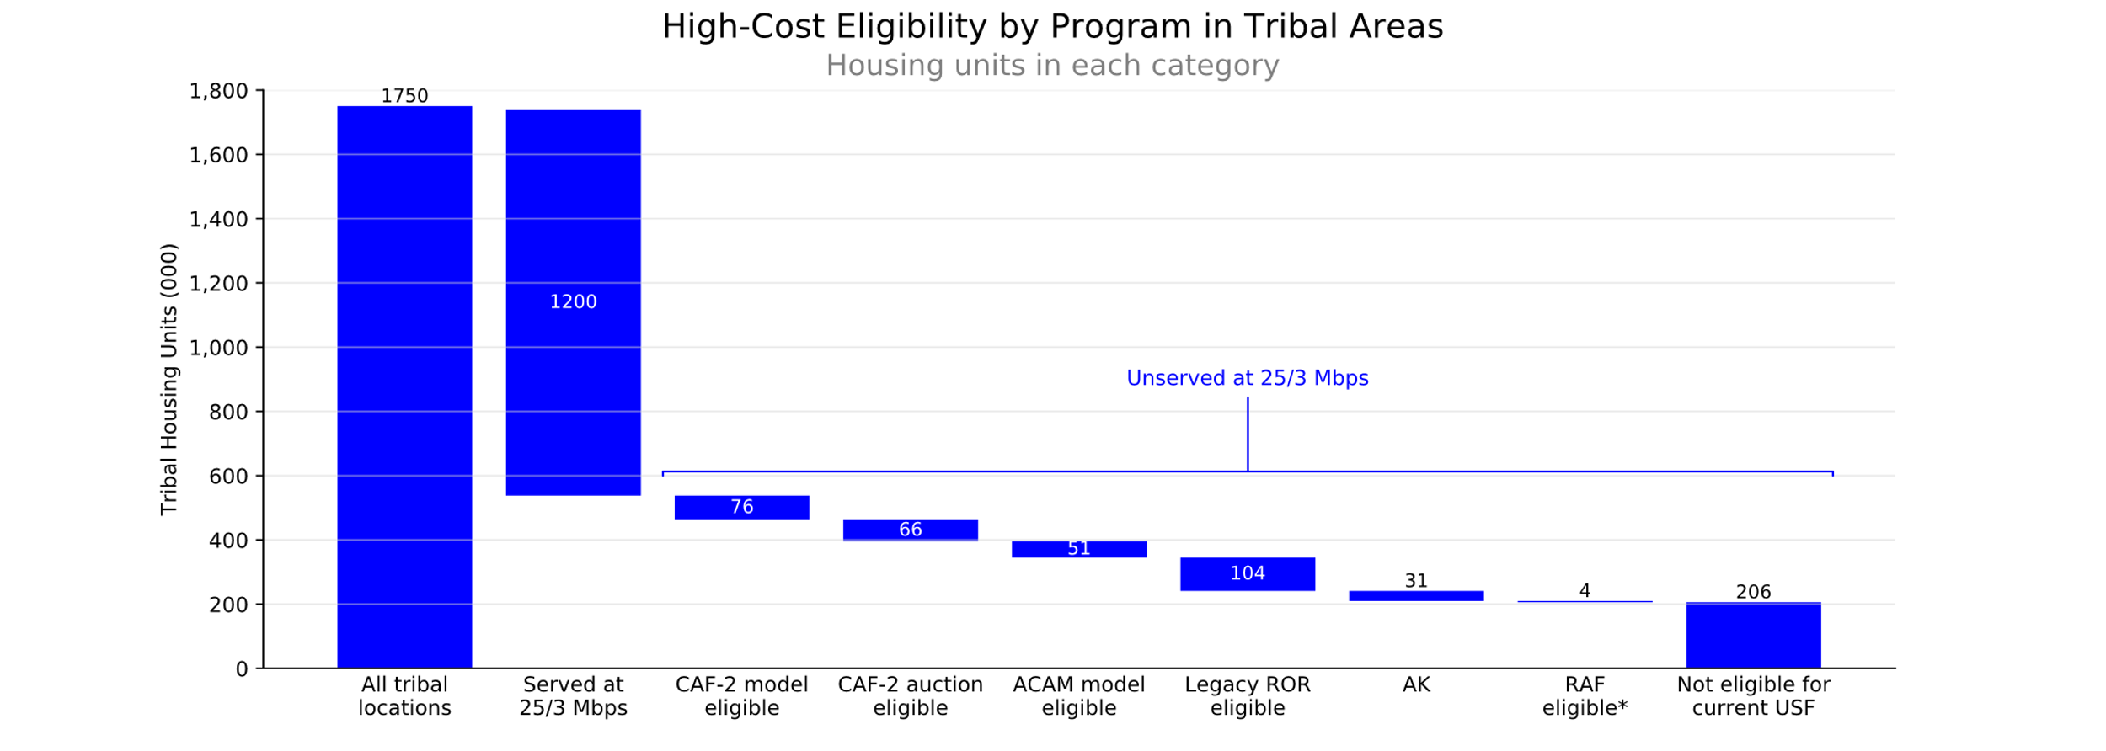

Tribal areas stand to benefit from many of these initiatives. As Figure 9 indicates, of the total 1.75 million housing units in Tribal census blocks, almost 540,000 are completely unserved by a 25/3 Mbps terrestrial fixed broadband service option. Of that number, approximately 330,000 are eligible to receive funding through the various high-cost fund program mechanisms—the CAF model and auction, the A-CAM model, legacy rate-of-return support, the Alaska-focused programs, and the Remote Areas Fund—with the remaining unserved housing units being ineligible for any USF support. However, because the buildout supported by these mechanisms remains in progress, the expected additional coverage on Tribal lands has not yet been captured in the data collected by the Commission.

### Lifeline Program

Lifeline subscribers residing on Tribal lands are eligible to receive a $25 per month subsidy, in addition to the standard $9.25 Lifeline subsidy, to address deployment and affordability challenges for low-income consumers residing on Tribal lands.[[54]](#footnote-56)  The Commission is considering additional Lifeline program reforms to target funds more efficiently to areas most in need of help in securing digital opportunity.[[55]](#footnote-57)  These areas would include rural and Tribal areas, as well as low-income urban areas that are likely to be underserved by providers.  The comment cycle on these issues has closed, and the Commission is reviewing the record as it considers further action.

### E-Rate Program

As part of the Commission’s efforts to modernize the E-Rate program, it has directed that additional discounts be provided to match funding for construction of broadband connections for Tribal schools and libraries from states, Tribal governments, or other federal agencies.[[56]](#footnote-58) The Commission also ordered the creation of a new Tribal consultation, training, and outreach program to assist the Commission with gaining a better understanding of the current state of connectivity among Tribal schools and libraries, and to ensure that Tribal schools and libraries can fully participate in the E-Rate program.[[57]](#footnote-59) The Tribal consultations, trainings, and outreach continue to inform and encourage Tribal participation in the E-Rate program, as well as the other universal service programs.

### Rural Health Care Program

The Commission’s Rural Health Care (RHC) program provides funding to rural health care providers, including those on Tribal lands, for broadband connectivity to support telemedicine services. Approximately one-third of disbursements through that program are directed to health care providers in Alaska.[[58]](#footnote-60) Within the RHC program, the Telecommunications Program ensures that eligible health care providers pay no more than their urban counterparts for telecommunications services, and the Healthcare Connect Fund expands health care provider access to broadband, especially in rural areas, and encourages the creation of state and regional broadband health care networks.

In June 2018, the Commission increased the funding cap for the RHC program for funding year 2017 to $571 million with annual adjustments for inflation to prevent pro-rata funding reductions that could have disproportionally impacted Tribal health care providers, especially those in Alaska.[[59]](#footnote-61) Additionally, the Commission is currently reviewing how to improve the RHC program to maximize efficiencies in promoting the availability of broadband services to rural health care providers, while minimizing waste, fraud and abuse, and will consider improvements in bringing service to Tribal lands as part of that proceeding.

## Tribal Consultations and Outreach

The Commission’s Office of Native Affairs and Policy (ONAP) oversees the agency’s Tribal consultations and plays an important role in the ongoing efforts to increase the deployment and adoption of communications services on Tribal lands and in Native communities.[[60]](#footnote-62) ONAP is engaged in Tribal consultations relating to numerous pending Commission proceedings. For example, ONAP developed and implemented a targeted Tribal consultation plan in connection with the Commission’s Wireless Infrastructure Initiative.[[61]](#footnote-63) Under this plan, the Commission conducted extensive consultation and engagement in Indian country. Commissioners and FCC staff visited nine different states, including Arizona, California, Connecticut, New Mexico, North Carolina, Oregon, South Dakota, Virginia and Wisconsin, in addition to holding consultations at FCC headquarters and numerous, widely attended conference calls.[[62]](#footnote-64) These consultations focused primarily on mobile infrastructure deployment, but also more generally on strategies for achieving broadband deployment on Tribal lands, including the use of universal service support.

In 2018, ONAP supported Commission staff on targeted outreach regarding the Mobility Fund Phase II Auction. As part of the auction, at least $340 million over ten years is expected to be reserved from the overall budget to support the expansion of mobile broadband in Indian country. To encourage Tribal participation in the Mobility Fund, ONAP and staff from the Commission’s Rural Broadband Auctions Task Force made presentations on the auction and its challenge process through in-person events, webinars, and educational materials.[[63]](#footnote-65)

ONAP also leads the reconstituted Native Nations Communications Task Force (Task Force), whose mission is to (1) help execute the Commission’s Tribal Consultation policy; (2) identify barriers to broadband deployment that are unique to Tribal lands; and (3) ensure Tribal concerns are considered in all Commission proceedings related to broadband and other Commission undertakings that affect Tribal interests regarding communications services and facilities.[[64]](#footnote-66) The first meeting of the Task Force took place in December 2018,[[65]](#footnote-67) when the Task Force met with FCC Chairman Pai, FCC Commissioners Carr and Rosenworcel, and other senior Commission staff. Currently, the Task Force is working on its initial assignments, one of which is to assist the Commission in identifying and developing solutions to overcome barriers to increasing deployment of communications infrastructure and services on Tribal lands. In addition to consultation and outreach specific to pending Commission rulemaking proceedings, ONAP conducts general and ad hoc Tribal consultation, as well as outreach efforts aimed at representing the Commission’s programs to Tribes, listening to Tribal concerns, and establishing and maintaining good relationships with Tribes, Tribal entities, and inter-Tribal organizations.

With support from Commission leadership and the Bureaus and Offices, ONAP holds workshops, participates in inter-Tribal organization meetings, engages in direct consultation with individual Tribes, and seeks to expand consultations to locations that historically have received less engagement because of geographical or other factors. ONAP holds FCC Tribal Workshops throughout Indian country to provide Tribal leaders, technical directors, and telecommunications and broadcast media managers with current policy and operational information. In 2018, in conjunction with the Wireline Competition Bureau, ONAP held Workshops in Lac du Flambeau, Wisconsin and Lewiston, Idaho (Nez Perce Reservation). A key focus of the Nez Perce Workshop was to identify and solicit views on removing obstacles to broadband deployment on Tribal lands.

In 2018, ONAP and other Commission staff participated in many ad hoc consultation and outreach efforts focused on increasing the availability of fixed and mobile broadband on Tribal lands. For example, in February, ONAP staff, along with staff from the Consumer and Governmental Affairs Bureau and the Wireline Competition Bureau, visited the Navajo Nation to address broadband deployment issues, including the impact of the Commission’s USF support programs. In August, ONAP presented to Tribes in the Great Lakes region at the Midwest Alliance of Sovereign Tribes Summer Meeting in Wisconsin. Finally, in October, International Bureau staff traveled to Inuvik, Canada, to participate in the 2018 Indigenous Connectivity Summit, where participants compared approaches and sought to find solutions to ensure that indigenous communities across North America can connect to fast, affordable, and reliable Internet service. ONAP also conducts frequent in-person meetings with Tribal leaders and other representatives in the Commission’s offices, as well as routinely holds conference calls.

ONAP also maintains working relationships with national and regional inter-Tribal organizations, which include some of the Tribal community’s most influential members. ONAP routinely presents on a broad range of Commission programs and initiatives—such as the 2.5 GHz rulemaking, Mobility Fund Phase II, and Connected Care Pilot Program, to name a few—and holds listening sessions at inter-Tribal conferences across the country, including the National Congress of American Indians, Affiliated Tribes of Northwest Indians, United South and Eastern Tribes, National Association of Tribal Historic Preservation Officers, and National Tribal Telecommunications Association. It also has facilitated Commission leadership involvement in its work with inter-Tribal organizations, including a meeting at Commission headquarters for the National Congress of American Indians (NCAI) in February 2019, where Chairman Pai and Commissioners O’Rielly, Carr, Rosenworcel, and Starks all engaged with Tribal representatives on a range of broadband deployment issues.

Collectively, these outreach and consultative efforts have better identified and incorporated Tribal interests in Commission activities, with the aim of increasing access to broadband on Tribal lands, which is expected to be reflected in future broadband deployment data.

## Additional Actions to Increase Access to Mobile Broadband on Tribal Lands

### 2.5 GHz Band

In May 2018, the Commission released a Notice of Proposed Rulemaking (NPRM) requesting comment on significant changes to the Educational Broadband Service (EBS) in the 2.5 GHz band. Some of the proposed changes could increase opportunities for the provision of broadband services to Tribal entities on Tribal lands.[[66]](#footnote-68) The 2.5 GHz band has been identified as prime spectrum for next generation mobile operations, including 5G uses. Among other things, the NPRM seeks comment on opening several filing windows for unassigned 2.5 GHz frequencies (also known as “white space”) including one window that would be open only to rural Tribal Nations.[[67]](#footnote-69) As outlined in the NPRM, this window would be limited to participation by “federally-recognized American Indian Tribes and Alaska Native Villages located in rural areas” and asks a number of questions about how such a definition should be applied.[[68]](#footnote-70) In addition, the NPRM seeks comment on other ways that the Commission could encourage the use of 2.5 GHz spectrum on Tribal lands.[[69]](#footnote-71) The NPRM also seeks comment on whether it should instead auction white space in the 2.5 GHz band and make it available to all interested entities, including Tribal Nations, as well as whether to eliminate eligibility and educational use restrictions, which would permit EBS licensees to assign their licenses to any entity, including Tribal Nations.[[70]](#footnote-72)

### Tribal Lands Bidding Credits

The Commission’s rules provide the opportunity for spectrum auction winners to obtain a discount (in the form of a refund) for providing service to qualifying Tribal lands, known as the Tribal Lands Bidding Credit (TLBC).[[71]](#footnote-73) To qualify for a TLBC, the winning bidder must demonstrate that it will serve qualifying Tribal lands[[72]](#footnote-74) and, within 180 days after filing its license application, provide certifications from the applicable Tribal government and attest that it will construct and operate a system capable of serving 75% of the qualifying Tribal land population within three years of license grant. Recipients that do not meet the performance requirement are required to pay back the credit plus interest.

The TLBC was initially implemented in 2000, and the Wireless Telecommunications Bureau has been reviewing TLBC applications and issuing credits since that time for licenses in bands such as AWS-1 (2006), 700 MHz (2008) and AWS-3 (2015).  Most recently, in 2016 and 2017, in the Broadcast Incentive Auction, the Wireless Telecommunications Bureau issued TLBCs for licenses in the 600 MHz band.

### Recent and Planned Spectrum Auctions

The Commission has been undertaking various measures to make spectrum available to promote the proliferation of next-generation networks across the country, including on Tribal lands. With respect to low-band spectrum, the Commission in 2017 completed a two-part incentive auction to repurpose 84 megahertz of spectrum in the 600 MHz band.[[73]](#footnote-75)

For mid-band spectrum, the Commission in July 2018 released an NPRM that seeks to identify potential opportunities for additional terrestrial use—particularly for wireless broadband services—of 500 megahertz of spectrum between 3.7-4.2 GHz.[[74]](#footnote-76) In seeking comment on the appropriate service areas for any flexible use licenses in this band, the NPRM asks commenters to address factors such as encouraging deployment of wireless broadband services to consumers on Tribal lands.[[75]](#footnote-77) Also, as discussed, the Commission has sought comment on proposals to auction spectrum in the 2.5 GHz band.[[76]](#footnote-78) In October 2018, the Commission modified the rules governing the Citizens Broadband Radio Service (CBRS) in the 3.5 GHz band to promote additional investment and encourage broader and more intensive deployment in the band.[[77]](#footnote-79) As part of this action, the Commission made TLBCs available to winning bidders in the 3.5 GHz auction, which will be held in 2020.[[78]](#footnote-80) The Commission also released an NPRM seeking comment on making available up to 1200 megahertz of spectrum for use by unlicensed devices in the 6 GHz band (5.925-7.125 GHz) without interfering with the operation of the licensed services that will continue to use this spectrum so as to advance the Commission’s efforts to make broadband connectivity available to everyone, especially those living in rural and underserved areas.[[79]](#footnote-81)

Additionally, through its *Spectrum Frontiers* proceedings, the Commission has taken measures to make high-band millimeter wave spectrum available for flexible use. These millimeter wave bands will be crucial in the promotion of the deployment of fifth-generation (5G) wireless, the Internet of Things and other advanced spectrum-base services.[[80]](#footnote-82) TLBCs are available to the winning bidders in these auctions.[[81]](#footnote-83)

# Conclusion

As the recent *Broadband Deployment Report* demonstrates, the Commission’s efforts to promote widespread deployment of broadband services have led to increased availability for Americans nationwide. However, more work remains to ensure that those living on Tribal lands, which are among the hardest-to-reach in the country, experience the myriad of benefits of robust broadband service. Although many of the Commission’s current programs will continue to narrow the Tribal broadband gap, additional collaboration between the Commission, Tribal governments, and industry will further the efforts already in place. The Commission looks forward to that focused collaboration. Moreover, consistent with the Act, the Commission will initiate a proceeding in the near future to explore and develop proposals to ensure that those living in Indian country are not left behind as broadband deployment at higher speeds proliferates across the country.

1. *See Consolidated Appropriations Act, 2018*, Pub. L. No. 115-141, Div. P—RAY BAUM’S Act of 2018, § 508(a)(1), 132 Stat. 348, 1095-96 (2018) (RAY BAUM’S Act of 2018). [↑](#footnote-ref-3)
2. *Id.* [↑](#footnote-ref-4)
3. *See* FCC, *Fixed Broadband Deployment Data from FCC Form 477*, *available at* <https://www.fcc.gov/general/broadband-deployment-data-fcc-form-477>; FCC, *Mobile Deployment Form 477 Data*, *available at* <https://www.fcc.gov/mobile-deployment-form-477-data>. [↑](#footnote-ref-5)
4. *Connect America Fund et al*., Report and Order and Further Notice of Proposed Rulemaking, 26 FCC Rcd 17663, 17818-19, para. 479 (2011) (*USF/ICC Transformation Order), aff’d sub nom, In re: FCC 11-161*, 753 F.3d 1015 (10th Cir. 2014). [↑](#footnote-ref-6)
5. *See id. See also* *Connect America Fund et al.*, Report and Order, Order and Order on Reconsideration, and Further Notice of Proposed Rulemaking, 31 FCC Rcd 3087, 3224, paras. 368-69 (2016) (*Rate-of-Return Reform Order*); *Connect America Fund*, Report and Order, 33 FCC Rcd 3602, 3602-03, para. 2 (2018) (*Tribal OpEx Relief Order*). [↑](#footnote-ref-7)
6. *See Rate-of-Return Reform Order*, 31 FCC Rcd at 3224, paras. 368-69; *Tribal OpEx Relief Order*, 33 FCC Rcd at 3602-03, para. 2. [↑](#footnote-ref-8)
7. *See Establishing a Government-to-Government Relationship with Indian Tribes*, Policy Statement, 16 FCC Rcd 4078 (2000). [↑](#footnote-ref-9)
8. *Id.* at 4080-81. [↑](#footnote-ref-10)
9. *See infra* pgs. 9-18. [↑](#footnote-ref-11)
10. *See e.g.*, Inquiry Concerning the Deployment of Advanced Telecommunications Capability to All Americans in a Reasonable and Timely Fashion, 2018 Broadband Deployment Report, 33 FCC Rcd 1660, 1708, para. 96 (2018). [↑](#footnote-ref-12)
11. *See e.g.*, *Accelerating Wireline Broadband Deployment by Removing Barriers to Infrastructure Investment*, 32 FCC Rcd 3266 (2017); *Accelerating Wireless Deployment by Removing Barriers to Infrastructure Investment, Report and Order*, 32 FCC Rcd 9760 (2017). [↑](#footnote-ref-13)
12. *Connect America Fund et al*., Report and Order and Further Notice of Proposed Rulemaking, 31 FCC Rcd 5949, 5959, para. 24 (2016); *Connect America Fund et al*., Report and Order et al., 31 FCC Rcd 3087, 3097-98, para. 25 (2016); *See Connect America Fund, et al.* Report and Order, Further Notice of Proposed Rulemaking, and Order on Reconsideration, FCC 18-176, para. 3 (2018) (*December 2018 Rate-of-Return Order*). [↑](#footnote-ref-14)
13. The semi-annual FCC Form 477 collection currently does not have a formal challenge process as the collection is designed for providers of voice and broadband service to report where they can reasonably provide service upon a request from a customer. [↑](#footnote-ref-15)
14. *See Inquiry Concerning Deployment of Advanced Telecommunications Capability to All Americans in a Reasonable and Timely Fashion*, 2018 Broadband Deployment Report, 33 FCC Rcd 1660 (2018). *See also* FCC Wireline Competition Bureau, *Staff Block Estimates*, *available at* <https://www.fcc.gov/reports-research/data/staff-block-estimates>. [↑](#footnote-ref-16)
15. *See* FCC, *Fixed Broadband Deployment Data from FCC Form 477*, *available at* <https://www.fcc.gov/general/broadband-deployment-data-fcc-form-477>. [↑](#footnote-ref-17)
16. *See* FCC, *Mobile Deployment Form 477 Data*, *available at* <https://www.fcc.gov/mobile-deployment-form-477-data>. The centroid methodology overlays geographic polygons showing wireless coverage onto a map of census blocks. It codes a census block as “covered” if the calculated center point (the “centroid”) of the census block is within the coverage polygon. If a centroid is covered, then all of the population and land area in the corresponding census block is also coded as covered. *See FCC Releases Data on Mobile Broadband Deployment as of December 31, 2015 Collected Through FCC Form 477*, 31 FCC Rcd 10886, 10890 (2016). [↑](#footnote-ref-18)
17. Staff also determined the road length associated with each block using a geography calculation rather than a projection, with distances measured in meters. Road lengths shared between two census blocks were split between blocks so that the total length of roads did not change. The analysis focused on road types (MAF/TIGER Feature Class Codes) of S1400, S1200, and S1740. [↑](#footnote-ref-19)
18. Our assessment of Tribal lands is conducted by examining the census blocks that have been identified by the Census Bureau as federally recognized Tribal lands for the 2010 Census. *See Communications Marketplace Report*, FCC 18-181 at 97 n.598. [↑](#footnote-ref-20)
19. Though staff examine FCC Form 477 data for quality and consistency, the data may understate or overstate deployment of services to the extent that broadband providers fail to report data or misreport data. *See* FCC, *Explanation of Broadband Deployment Data* (Nov. 20, 2017), <https://www.fcc.gov/general/explanation-broadband-deployment-data> (describing quality and consistency checks performed on providers’ submitted data and explaining any adjustments made to the Form 477 data as filed). [↑](#footnote-ref-21)
20. *Modernizing the FCC Form 477 Data Program*, Further Notice of Proposed Rulemaking, 32 FCC Rcd 6329 (2017). [↑](#footnote-ref-22)
21. *Id.* at 6344, para. 44. [↑](#footnote-ref-23)
22. RAY BAUM’S Act of 2018 § 508(b), 132 Stat. at 1096. [↑](#footnote-ref-24)
23. As defined by the U.S. Census Bureau, a “housing unit” includes “a house, an apartment, a group of rooms, or a single room occupied or intended for occupancy as separate living quarters.” *See* United States Census Bureau, *Housing Vacancies and Home Ownership: Definitions*, <https://www.census.gov/housing/hvs/definitions.pdf> (Fourth Quarter 2018). [↑](#footnote-ref-25)
24. *USF/ICC Transformation Order*, 26 FCC Rcd at 17820, para. 482.; *Tribal OpEx Relief Order,* 33 FCC Rcd at 3602, para. 1. [↑](#footnote-ref-26)
25. Press Release, FCC, *Carriers Accept Over $1.5 Billion in Annual Support from Connect America Fund to Expand and Support Broadband for Nearly 7.3 Million Rural Consumers in 45 States and One Territory* (Aug. 27, 2015), <https://www.fcc.gov/document/carriers-accept-over-15-b-support-expand-rural-broadband>. [↑](#footnote-ref-27)
26. *Id.* [↑](#footnote-ref-28)
27. *Connect America Fund, et al.*, Report and Order and Order on Reconsideration, 32 FCC Rcd. 1624, 1645 para. 52 (2017). [↑](#footnote-ref-29)
28. *Tribal OpEx Relief Order,* 33 FCC Rcd at 3603-04, para. 5. [↑](#footnote-ref-30)
29. *See December 2018 Rate-of-Return Order* at para. 14. [↑](#footnote-ref-31)
30. *Id.* at para. 55. [↑](#footnote-ref-32)
31. *Id.* [↑](#footnote-ref-33)
32. *Id.* at paras. 206-09. [↑](#footnote-ref-34)
33. *Tribal Mobility Fund Phase I Auction Closes, Winning Bidders Announced for Auction 902*, 29 FCC Rcd 1974, 1975, para. 1 (2014). [↑](#footnote-ref-35)
34. In addition to support awarded through the Tribal Mobility Fund Phase I auction, some winning bidders in Mobility Fund Phase I Auction 901 received support to deploy mobile voice and broadband services on Tribal lands. For example, GCI Communication Corp. was an Auction 901 winning bidder authorized to receive up to $2.3 million in Mobility Fund Phase I support. The full amount of that support has been disbursed. Standing Rock Telecommunications, Inc., also was a winning bidder in Auction 901 and was authorized to receive up to $3.3 million in Mobility Fund Phase I support, $2.2 million of which has been disbursed to date. [↑](#footnote-ref-36)
35. *Connect America Fund et al*., Report and Order and Further Notice of Proposed Rulemaking, 32 FCC Rcd 2152 at 2165, para. 33 (2017). [↑](#footnote-ref-37)
36. FCC, *Mobility Fund II Initial Eligible Areas Map*, *available at* <https://www.fcc.gov/reports-research/maps/mobility-fund-ii-initial-eligible-areas-map/>. [↑](#footnote-ref-38)
37. *Connect America Fund; Universal Service Reform–Mobility Fund*, Order on Reconsideration and Second Report and Order, 32 FCC Rcd 6282 (2017). [↑](#footnote-ref-39)
38. *Mobility Fund Phase II Challenge Process Portal Update: November 2018*, Public Notice, DA 18-1225 (RBATF 2018). On December 7, 2018, Chairman Pai announced that the Commission has launched an investigation into whether one or more major carriers violated the MF-II reverse auction’s mapping rules and submitted incorrect coverage maps. Press Release, FCC, *FCC Launches Investigation Into Potential Violations of Mobility Fund Phase II Mapping Rules* (Dec. 7. 2018), <https://docs.fcc.gov/public/attachments/DOC-355447A1.pdf>. The Commission has suspended the next step of the challenge process—the opening of a response window—pending the conclusion of this investigation. *Id.* [↑](#footnote-ref-40)
39. *MF-II Report and Order*, 32 FCC Rcd at 2167, para. 37. [↑](#footnote-ref-41)
40. *Id.* at 2165, para. 33. [↑](#footnote-ref-42)
41. *See MF-II Webinar PN*. [↑](#footnote-ref-43)
42. *See e.g.*, *Indian Entities Recognized and Eligible to Receive Services from the United Sates Bureau of Indian Affairs*, Notice, 83 Fed. Reg. 34863 (July 23, 2018); 47 CFR § 54.5 (defining Tribal lands for the purpose of the high-cost rules to “include any federally recognized Indian tribe’s reservation… [and] Alaska Native Regions established pursuant to the Alaska Native Claims Settlement Act (85 Stat. 688)….”). [↑](#footnote-ref-44)
43. *Connect America Fund et al.*, Report and Order and Further Notice of Proposed Rulemaking, 31 FCC Rcd 10139 (2016) (*Alaska Plan Order*). [↑](#footnote-ref-45)
44. *See* *Alaska Plan Order*, 31 FCC Rcd at 10143, 10159, paras. 9, 66 (freezing annual support for wireline providers at 2011 levels and wireless providers at 2014 levels). [↑](#footnote-ref-46)
45. *Wireless Telecommunications Bureau Approves Performance Plans of the Eight Wireless Providers That Elected to Participate in the Alaska Plan*, Public Notice, 31 FCC Rcd 13317, Appx. (WTB 2016); *Wireline Competition Bureau Authorizes Alaska Plan Support for 13 Alaskan Rate of Return Carriers*, Public Notice, 31 FCC Rcd 13347, Appx. B (WCB 2016). [↑](#footnote-ref-47)
46. *Id.* [↑](#footnote-ref-48)
47. *Alaska Plan Order*, 31 FCC Rcd at 10167, para. 86. [↑](#footnote-ref-49)
48. *Id.* at 10172, para. 102. [↑](#footnote-ref-50)
49. *Id.* at 10172, para. 106. [↑](#footnote-ref-51)
50. *Id.* at 10146, para. 6. [↑](#footnote-ref-52)
51. *Connect America Fund*, Order, 31 FCC Rcd. 12086 (2016) (*ACS CAFII Order*). [↑](#footnote-ref-53)
52. *Id.* at 12089-12092, paras. 9-21. [↑](#footnote-ref-54)
53. *Id.* at 12099, para. 44. *See also* Letter from Ruth L. Willard, Senior Director Revenue Management, Alaska Communications Systems Holding Inc., to Marlene H. Dortch, Secretary, FCC, WC Docket No. 10-90 (Feb. 28, 2019) (submitting the list of locations to which ACS deployed broadband services meeting CAF II requirements by December 31, 2018). [↑](#footnote-ref-55)
54. *Federal-State Joint Board on Universal Service et al*., Twelfth Report and Order, Memorandum Opinion and Order, and Further Notice of Proposed Rulemaking, 15 FCC Rcd 12208, 12230, para. 42 (2000). [↑](#footnote-ref-56)
55. *Bridging the Digital Divide for Low-Income Consumers et al*., Fourth Report and Order, Order on Reconsideration, Memorandum Opinion and Order, Notice of Proposed Rulemaking, and Notice of Inquiry, 32 FCC Rcd 10475 (2017). [↑](#footnote-ref-57)
56. *Modernizing the E-rate Program for Schools and Libraries*, Report and Order and Further Notice of Proposed Rulemaking, 29 FCC Rcd 8870 (2014). [↑](#footnote-ref-58)
57. *Id.* at 8967-8970, paras. 243-49. [↑](#footnote-ref-59)
58. *Promoting Telehealth in Rural America*, Notice of Proposed Rulemaking, 32 FCC Rcd. 10631, 10639, para. 12 (2017). [↑](#footnote-ref-60)
59. *Promoting Telehealth in Rural America*, Report and Order, 33 FCC Rcd 6574 (2018). [↑](#footnote-ref-61)
60. The Commission created the Office of Native Affairs and Policy (ONAP) in 2010 as part of its Consumer and Governmental Affairs Bureau to manage the Commission’s Tribal consultation efforts and to increase the deployment and adoption of communications services on Tribal lands and in Native communities. *Establishment of the Office of Native Affairs and Policy in the Consumer and Government Affairs Bureau*, Order, 25 FCC Rcd 11104 (2010). ONAP’s consultation efforts extend to federally recognized Indian tribes, Alaska Native villages, and entities related to Hawaiian home lands. [↑](#footnote-ref-62)
61. *Accelerating Wireless Broadband Deployment by Removing Barriers to Infrastructure Investment*, Notice of Proposed Rulemaking and Notice of Inquiry, 32 FCC Rcd 3330 (2017) (*Wireless Infrastructure NPRM*). [↑](#footnote-ref-63)
62. *Accelerating Wireless Broadband Deployment by Removing Barriers to Infrastructure Investment*, Second Report and Order, FCC 18-30, paras. 17-35 (2018) (noting, at para. 18, that “[o]ne of the in-person consultations was attended by over 70 representatives of more than 50 Tribal Nations and organizations”) (*Wireless Infrastructure Second Report and Order*). [↑](#footnote-ref-64)
63. *See*, *e.g*., *Mobility Fund Phase II Challenge Process Webinar for Tribal Government Officials*, Public Notice, 33 FCC Rcd 5964 (2018) (*MF-II Webinar PN*). The RBATF has also traveled with ONAP to the Tribal Self-Governance Conference (Albuquerque, NM 4/23/18) and Affiliated Tribes of Northwest Indian Convention (Toppenish, WA 5/23/18) to engage with Tribal entities. [↑](#footnote-ref-65)
64. *FCC Seeks Nominations for Tribal Government Representatives to Serve on Renewed FCC Native Nations Communications Task Force*, Public Notice, 33 FCC Rcd 1264 (CGB 2018). [↑](#footnote-ref-66)
65. *Chairman Pai Announces New Appointments to the Native Nations Communications Task Force*, Public Notice, 33 FCC Rcd 10152 (CGB 2018). [↑](#footnote-ref-67)
66. *Transforming the 2.5 GHz Band*, Notice of Proposed Rulemaking, 33 FCC Rcd 4687 (2018). [↑](#footnote-ref-68)
67. *Id.* at 4698-99, paras. 35-38. [↑](#footnote-ref-69)
68. *Id.* at 4698-99, para. 36. [↑](#footnote-ref-70)
69. *Id.* at 4699, para. 39. [↑](#footnote-ref-71)
70. *Id.* at 4705, para. 61. [↑](#footnote-ref-72)
71. *See* 47 CFR §1.2110(f)(3). [↑](#footnote-ref-73)
72. For purposes of the TLBC, qualifying Tribal lands are defined as federally recognized Indian Tribe reservations, Pueblos, or Colonies, including former reservations in Oklahoma, Alaska Native regions, and Indian allotments, with a wireline telephone subscription penetration rate of 85% or less, based on the most recent Census data. [↑](#footnote-ref-74)
73. *See generally* FCC, *Broadcast Incentive Auction and Post-Auction Transition*, *available at* <https://www.fcc.gov/about-fcc/fcc-initiatives/incentive-auctions>. [↑](#footnote-ref-75)
74. *Expanding Flexible Use of the 3.7 GHz to 4.2 GHz Band et al.*, Order and Notice of Proposed Rulemaking, 33 FCC Rcd 6915, 6916, para. 1 (2018). [↑](#footnote-ref-76)
75. *Id.* at 6961, para. 139. [↑](#footnote-ref-77)
76. *See supra* Part IV.C.1. [↑](#footnote-ref-78)
77. *Promoting Investment in the 3550-3700 MHz Band*, Report and Order, FCC 18-149 (2018). [↑](#footnote-ref-79)
78. *Id.* at 51, para. 91. *See also supra* Part IV.C.2 (discussing TLBCs). [↑](#footnote-ref-80)
79. *Unlicensed Use of the 6 GHz Band et al.*,Notice of Proposed Rulemaking, FCC 18-147 (2018). [↑](#footnote-ref-81)
80. *See e.g.*, *Use of Spectrum Bands Above 24 GHz for Mobile Radio Services, et al.*, Report and Order and Further Notice of Proposed Rulemaking, 31 FCC Rcd 8014 (2016) (*Spectrum Frontiers Report and Order*); *Use of Spectrum Bands Above 24 GHz For Mobile Radio Services*, GN Docket No. 14-177, Second Report and Order, Second Further Notice of Proposed Rulemaking, Order on Reconsideration, and Memorandum Opinion and Order, 32 FCC Rcd 10988 (2017); *Use of Spectrum Bands Above 24 GHz For Mobile Radio Services, et al.*, Third Report and Order, Memorandum Opinion and Order, and Third Further Notice of Proposed Rulemaking, 33 FCC Rcd 5576 (2018); *Use of Spectrum Bands Above 24 GHz For Mobile Radio Services*, Fourth Report and Order, FCC 18-180 (2018) (*Spectrum Frontiers Fourth Report and Order*). *See also* FCC, Auction 101: Spectrum Frontiers–28 GHz, <https://www.fcc.gov/auction/101>; FCC, Auction 102: Spectrum Frontiers–24 GHz, <https://www.fcc.gov/auction/102>. [↑](#footnote-ref-82)
81. *See* *Spectrum Frontiers Report and Order*, 31 FCC Rcd at 8100, para. 253; *Spectrum Frontiers Fourth Report and Order* at 14, para. 43 n.73; *Auctions of Upper Microwave Flexible Use Licenses for Next-Generation Wireless Services et al.*, Public Notice, 33 FCC Rcd 7575, 7614, 7659-60, paras. 104-105, 292-93 (2018). [↑](#footnote-ref-83)