**C:\WINDOWS\Desktop\fcc_logo.tif**

**Report on Promoting Broadband Internet Access Service for Veterans,**

**Pursuant to the Repack Airwaves Yielding Better Access**

**for Users of Modern Services Act of 2018**

**Prepared by the:**

**Wireline Competition Bureau**

**Submitted to the:**

**Senate Committee on Commerce, Science, and Transportation**

**House of Representatives Committee on Energy and Commerce**

**May 2019**

**TABLE OF CONTENTS**

[I. INTRODUCTION 1](#_Toc6955790)

[II. BACKGROUND 1](#_Toc6955791)

[III. STATE OF VETERANS’ BROADBAND ACCESS 5](#_Toc6955792)

[A. Data and Methodology Overview 5](#_Toc6955793)

[B. Deployment to Veterans 6](#_Toc6955794)

[C. Broadband Adoption in Households with Veterans 10](#_Toc6955795)

[IV. PROMOTING BROADBAND DEPLOYMENT AND ADOPTION AMONG VETERANS 12](#_Toc6955796)

[A. Barriers to Broadband Adoption for Veterans 12](#_Toc6955797)

[B. Commission Efforts to Promote Veterans’ Broadband Access and Adoption 13](#_Toc6955798)

[C. Other Federal Agency Efforts 15](#_Toc6955799)

[1. Telehealth 15](#_Toc6955800)

[2. Promoting Deployment and Adoption for Education and Job Training 17](#_Toc6955801)

[D. Private and Public Sector Efforts 17](#_Toc6955802)

[1. Discounted Broadband Services Targeting Low-Income Veterans 17](#_Toc6955803)

[2. Digital Relevance and Literacy Efforts for Veterans 18](#_Toc6955804)

[3. Deployment: Fostering Accessibility for Rural Veterans 19](#_Toc6955805)

[V. RECOMMENDATIONS for congress 19](#_Toc6955806)

[VI. Conclusion 21](#_Toc6955807)

[Appendices 22](#_Toc6955808)

# INTRODUCTION

The Federal Communications Commission’s (Commission) top priority is closing the digital divide to promote the benefits of the digital age for all Americans.[[1]](#footnote-3) As part of that goal, the Commission has an obligation to ensure that those who have served and defended our nation can enjoy the economic, health, educational, civic, and social benefits that a broadband connection brings. This Report examines the current state of broadband access and adoption by veterans, particularly by low-income veterans and veterans residing in rural areas. The Report also provides recommendations on how to promote their access to broadband, so that they may fully participate in the digital economy.

This Report explores the availability and adoption of broadband Internet access services by veterans throughout the nation. While we find that many veterans have access to both fixed and mobile broadband options, a significant number still lack access to fixed broadband, mobile broadband, or both. Specifically, for 92.5% of veterans at least one provider of 25 Mbps/3 Mbps fixed broadband services is available, while only 78.4% of veterans have 10 Mbps/3Mbps mobile LTE broadband coverage. Among households with veterans, approximately 85%, or 14.4 million, reported that they had paid connections to the Internet in their homes. However, households with veterans subscribe to mobile broadband services at lower rates than households without veterans. For those veterans who lack a broadband connection, barriers to broadband adoption may include lack of deployment where they live, price, and digital illiteracy or perceived irrelevance. Ensuring that all veterans enjoy the benefits of broadband access implicates not only Commission efforts, but collaboration across other federal agencies, industry stakeholders, and local communities to ensure lasting universal broadband access.

# BACKGROUND

Demographic and social trends among veterans are relevant to understanding broadband adoption rates among veterans and help illuminate where government policies are most needed to benefit them. For example, while veterans are on average less likely to be low-income as compared to the general population,[[2]](#footnote-4) the still significant portion of the veteran population that is low-income is less likely to have a broadband connection at home. A substantial number of veterans also suffer from a disability, reside in rural areas, or are older than the general population. These demographic factors combined create an important need for robust broadband access among these parts of the veteran population, which experience lower rates of access to and adoption of broadband services.[[3]](#footnote-5)

As of 2017, there were approximately 18.2 million veterans in the United States, constituting approximately 7.3% of the adult U.S. population.[[4]](#footnote-6) Recent U.S. Department of Veterans Affairs (VA) and Census Bureau data show that almost 7% of veterans live below the poverty level.[[5]](#footnote-7) Compared to the general population, overall poverty rates are lower for veterans than for non-veterans.[[6]](#footnote-8) However, younger veterans and older veterans with disabilities are generally in poverty more than other veterans.[[7]](#footnote-9) When examined by age alone, the poverty rate is highest among younger veterans, with nearly 12% aged 18-34 considered to be in poverty. However, the poverty rates for veterans with a disability are much higher.

As of 2014, a total of 3.8 million veterans had a service-connected disability rating,[[8]](#footnote-10) and veterans are twice as likely as the general population to be disabled.[[9]](#footnote-11) The poverty rates for older veterans with a disability are much higher—43.2% for ages 55-64 and 48.0% for veterans 65 and older—than for the younger disabled veterans, with only 14.2% those aged 18-34 in poverty and 33.8% for ages 35-54.[[10]](#footnote-12) Veterans living in rural areas are also more likely to have a disability than veterans living in urban areas and non-veterans living in rural areas.[[11]](#footnote-13) Pew Research found that Americans with disabilities are less likely to have a home broadband subscription.[[12]](#footnote-14) As a result, veterans, many of whom have a disability, may encounter related challenges to broadband adoption.

A rural–urban divide also persists among veterans. Approximately 5 million, or 24.1% of veterans, lived in areas designated as rural from 2011-2015.[[13]](#footnote-15) Rural veterans are more likely to be over the age of 55 as compared to urban veterans,[[14]](#footnote-16) and are more likely to have a disability than urban veterans.[[15]](#footnote-17) Rural veterans with unique health care needs may lack access to nearby health care facilities. Nearly three million veterans living in rural and highly rural areas are enrolled in the VA’s health care system, 27% of whom do not have Internet access at home.[[16]](#footnote-18)

Rural veterans are substantially more likely to enroll in the VA’s health care system than urban veterans, and rural veterans are on average older than the general population, more often face health problems, and live further from physical medical facilities.[[17]](#footnote-19) Rural veterans continuously struggle with access to medical care, demonstrating the importance telehealth could have on rural veterans.[[18]](#footnote-20)

Household composition is another demographic variable of interest. Veterans are more likelyto be men living alone than non-veterans. They are also more likely to live in married-couple households and less likely to live in female-headed or female-only households as compared to non-veterans (see Figure 1). Discussed later, household demographics have an effect on fixed and mobile subscriptions among veterans. Interestingly, as veterans are more likely to be men living alone, they also tend to have the lowest subscriptions rates to fixed and mobile broadband (see Figure 6).

**Fig. 1**

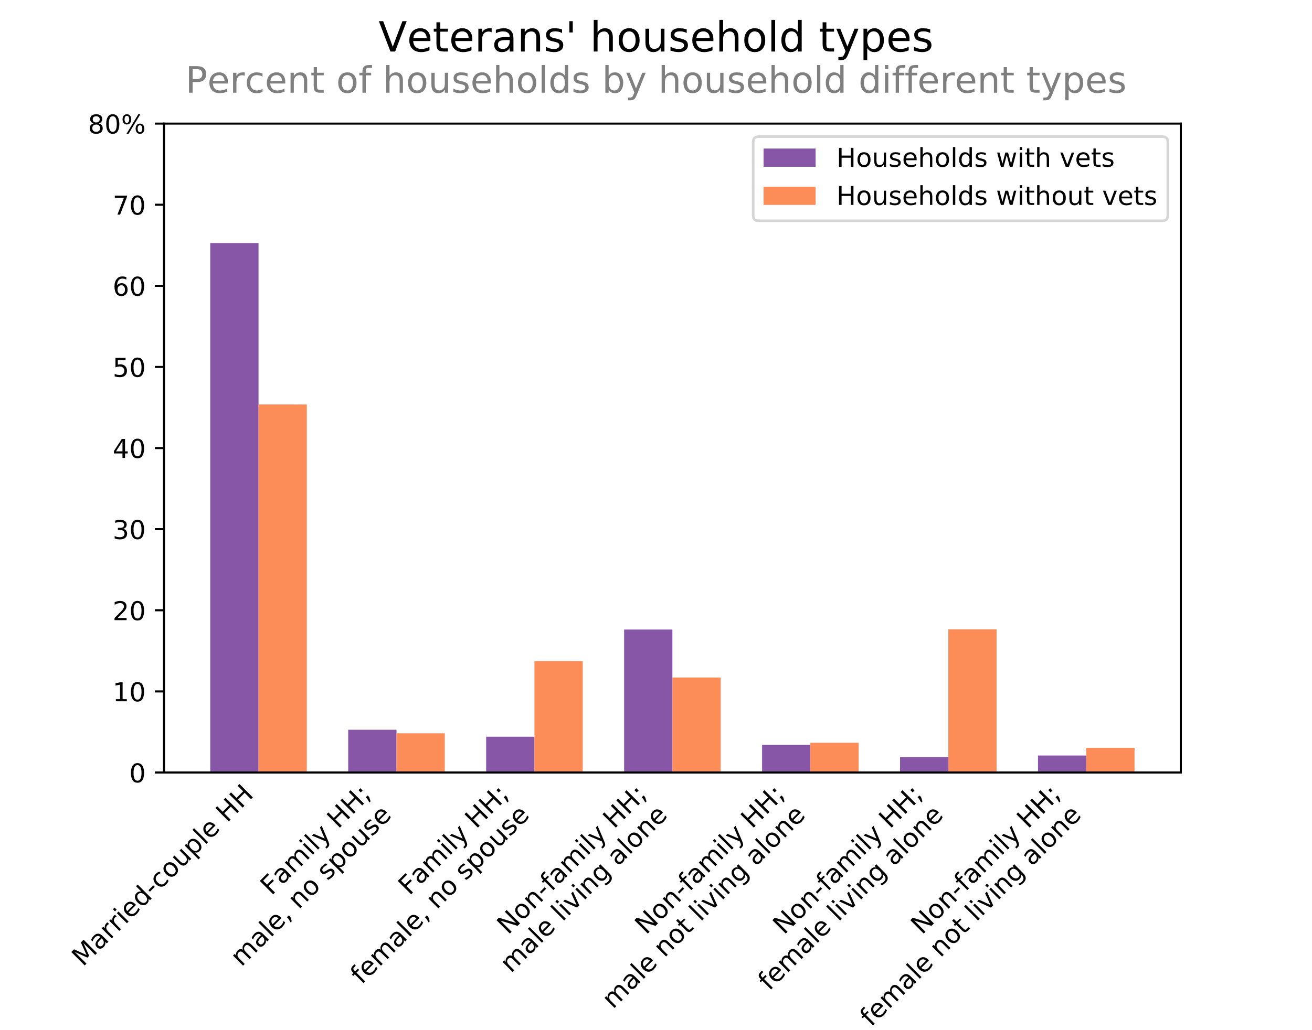

Access to broadband service benefits veterans in several important ways. Like all Americans, veterans benefit from access to online job resources, empowering them to thrive in their careers after military service. A robust broadband connection provides veterans the opportunity to participate in the digital economy. For low-income veterans, broadband service provides increased job opportunities and for rural veterans, in particular, an Internet connection can provide the opportunity to telework, broadening career prospects.

Veterans Organizations state that broadband connectivity is critical for veterans securing post-separation employment.[[19]](#footnote-21) As of January 2019, the unemployment rate among veterans was 3.7%.[[20]](#footnote-22) Once veterans have attained post-separation employment, they can command a higher salary than their non-veteran colleagues.[[21]](#footnote-23) However, a majority of adults in the United States search and apply for jobs online, which creates significant employment disadvantages for veterans if they do not have Internet service to facilitate job searches.[[22]](#footnote-24) Moreover, as veterans find jobs, Internet service opens up opportunities for telework, which could provide significant economic advantages for veterans living in rural areas.[[23]](#footnote-25)

Broadband also provides veterans with significant educational opportunities.[[24]](#footnote-26) The veteran poverty rate is the highest among younger veterans ages 18-34,[[25]](#footnote-27) which is also the demographic that can benefit most from receiving higher education. Likewise, veterans that reside in rural areas, away from a physical campus, can take educational courses online.[[26]](#footnote-28) The National Survey of Veterans reported in 2010 that 73% of veterans who used VA education benefits stated that those benefits allowed them to get a better job.[[27]](#footnote-29) In the same survey, veterans who did not use VA education benefits (36% of those surveyed) indicated that they were unaware that VA offered such benefits.[[28]](#footnote-30)

As demonstrated above, broadband connectivity is crucial to meeting the needs of and providing benefits to veterans, particularly low-income veterans and those residing in rural areas. The Repack Airwaves Yielding Better Access for Users of Modern Services Act of 2018 (RAY BAUM’S Act of 2018) requires the Commission to “submit to Congress a report on promoting broadband Internet access service for veterans, in particular low-income veterans and veterans residing in rural areas.”[[29]](#footnote-31) This Report fulfills that requirement, by examining the state of deployment[[30]](#footnote-32) to and adoption[[31]](#footnote-33) by veterans and “provid[ing] findings and recommendations for Congress with respect to such access and how to promote such access.”[[32]](#footnote-34)

On September 12, 2018, the Commission’s Wireline Competition Bureau sought public comment on these issues, as required by the RAY BAUM’S Act of 2018.[[33]](#footnote-35) In response, interested parties overwhelmingly supported promoting veterans’ broadband adoption through various veteran-centric programs, including telehealth, and digital education, to enhance their lives.[[34]](#footnote-36)

# STATE OF VETERANS’ BROADBAND ACCESS

## Data and Methodology Overview

The deployment data underlying this Report result from the Commission’s FCC Form 477 data collection. The Commission uses FCC Form 477 to collect data from all facilities-based providers of mobile and fixed voice and broadband services. These data are used by the Commission to produce the various maps and reports on the state of voice and broadband coverage in the United States, as well as to inform the Commission’s policy decisions.[[35]](#footnote-37) This Report also uses estimates of total veteran population and demographic characteristics from the 1-Year 2017 American Community Survey Public Use Microdata Sample and the Current Population Survey Computer and Internet Use Supplement for fixed and mobile broadband subscription data.

This Report presents mobile coverage information based on speed data from both the 2017 Ookla Net Index data and the December 31, 2017 FCC Form 477 broadband deployment data. We examine the Ookla speed test data and the Form 477 data for fixed and mobile LTE broadband deployment data, similar to our analysis of these data in the recently released *Communications Marketplace Report*. The analysis of the availability of mobile LTE services with a median speed of 10 Mbps/3 Mbps includes actual speed test data in counties with at least 300 test observations. It is important to note that Ookla gathers crowdsourced mobile speed data through the use of its Speedtest mobile app. The 2017 Ookla data provide information for areas accounting for approximately 92% of the country’s population, and areas that account for 91% of where veterans reside. From the FCC Form 477 deployment data, we rely on census block data indicating that fixed broadband services meeting three speed thresholds (10 Mbps/1 Mbps, 25 Mbps/3 Mbps and 100 Mbps/10 Mbps) can be provided by at least one fixed service provider.

This Report also presents fixed and mobile broadband subscription data from the American Community Survey. This survey data covers approximately 18.2 million veterans, of which 1.8 million were female. The Report also relies on the Current Population Survey, which randomly samples approximately 60,000 households each month. This Report also presents data from the Computer and Internet Use Supplement, which the National Telecommunications and Information Administration sponsors, with data collected every 1-2 years since 2007. Data was most recently collected in November 2017.[[36]](#footnote-38) The Commission is aware of the limitations of the Form 477 data collection, and when the FCC Form 477 data are used to inform its funding and policy decisions, the Commission considers the limitations and challenges of the dataset.[[37]](#footnote-39) The Commission has an open proceeding considering ways to improve the accuracy and granularity of that data collection.[[38]](#footnote-40) Among other matters, the Commission sought comment on whether “it should move to a more granular basis for reporting deployment data and, if so, what basis would be appropriate.”[[39]](#footnote-41)

## Deployment to Veterans

In this section we review the status of broadband deployment to veterans. We assess coverage for three speed thresholds based upon three fixed technology combinations (Any, Terrestrial, and Wired), and mobile LTE. The Any category includes ADSL, fiber, cable, terrestrial fixed wireless, and satellite services; the Terrestrial category includes ADSL, fiber, cable and terrestrial fixed wireless; and the Wired category includes ADSL, fiber and cable.[[40]](#footnote-42)

We first report estimates of veterans with coverage and without coverage for both Terrestrial fixed broadband services and mobile LTE services. First, Figure 2 reports fixed broadband services data, indicating that 92.5% of veterans have access to 25 Mbps/3 Mbps fixed broadband services. At the higher fixed broadband speed of at least 100 Mbps/10 Mbps, the data indicate that 86.7% of veterans have availability. Finally, the data indicate that 96.6% of veterans have availability of fixed broadband at speeds of 10 Mbps/1 Mbps. Figure 2 also reports data estimates of mobile LTE broadband coverage for veterans overall, indicating that 99.8% of veterans have coverage of 5 Mbps/1 Mbps mobile LTE, based on Form 477 data. We recognize, however, that actual speeds tend to be much faster than the minimum advertised speed reported on Form 477. Therefore, we also present estimates based on Ookla speed test data to evaluate the availability of LTE with a median actual speed of 10 Mbps/3 Mbps or higher. The data here indicate that 78.4% of veterans have 10 Mbps/3 Mbps mobile LTE broadband coverage. We rely on the Ookla data[[41]](#footnote-43) to supplement our Form 477 analysis primarily because it allows us to better evaluate the extent to which the typical consumer receives speeds of 10 Mbps/3 Mbps or higher, and these data provide us with the greatest number of observations of actual speeds that customers receive.[[42]](#footnote-44) Given that veterans live throughout the country, it is not surprising that the FCC Form 477 deployment data suggest availability of broadband is not substantially different for veterans than for the population overall.[[43]](#footnote-45)

**Fig. 2**

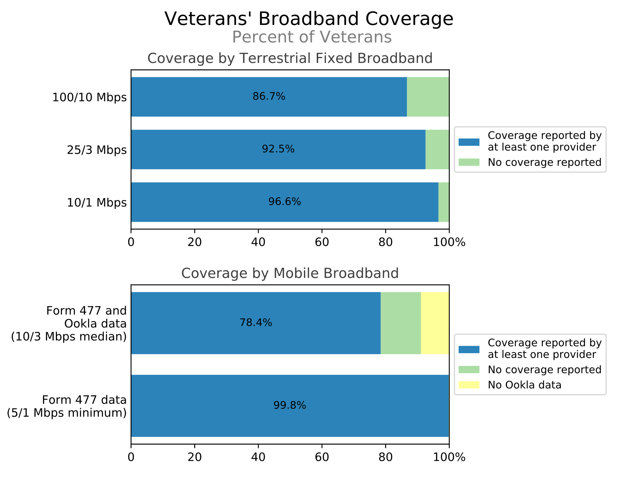

Below, in Figure 3 and Figure 4, we report estimates of the proportion of veterans with coverage for both mobile LTE and fixed broadband services. Figure 3 reports the estimates based upon mobile LTE with a median speed of 10 Mbps/3 Mbps and the three speeds of fixed broadband service, whereas Figure 4 reports the estimates based upon mobile LTE with a minimum advertised speed of 5 Mbps/1 Mbps and these three speed/fixed service combinations. As shown in Figure 3, 78.4% of veterans have coverage of both mobile LTE with a median speed of 10 Mbps/3 Mbps and any fixed broadband of at least 25 Mbps/3 Mbps.[[44]](#footnote-46) At the higher fixed broadband speed of at least 100 Mbps/10 Mbps, the data indicate that 76.2% of veterans have coverage for both mobile LTE with a median speed of 10 Mbps/3 Mbps and any fixed broadband technology of at least 100 Mbps/10 Mbps service and approximately 3% of veterans lack coverage for both 10 Mbps/3 Mbps mobile broadband and 100 Mbps/10 Mbps fixed broadband service.[[45]](#footnote-47)

**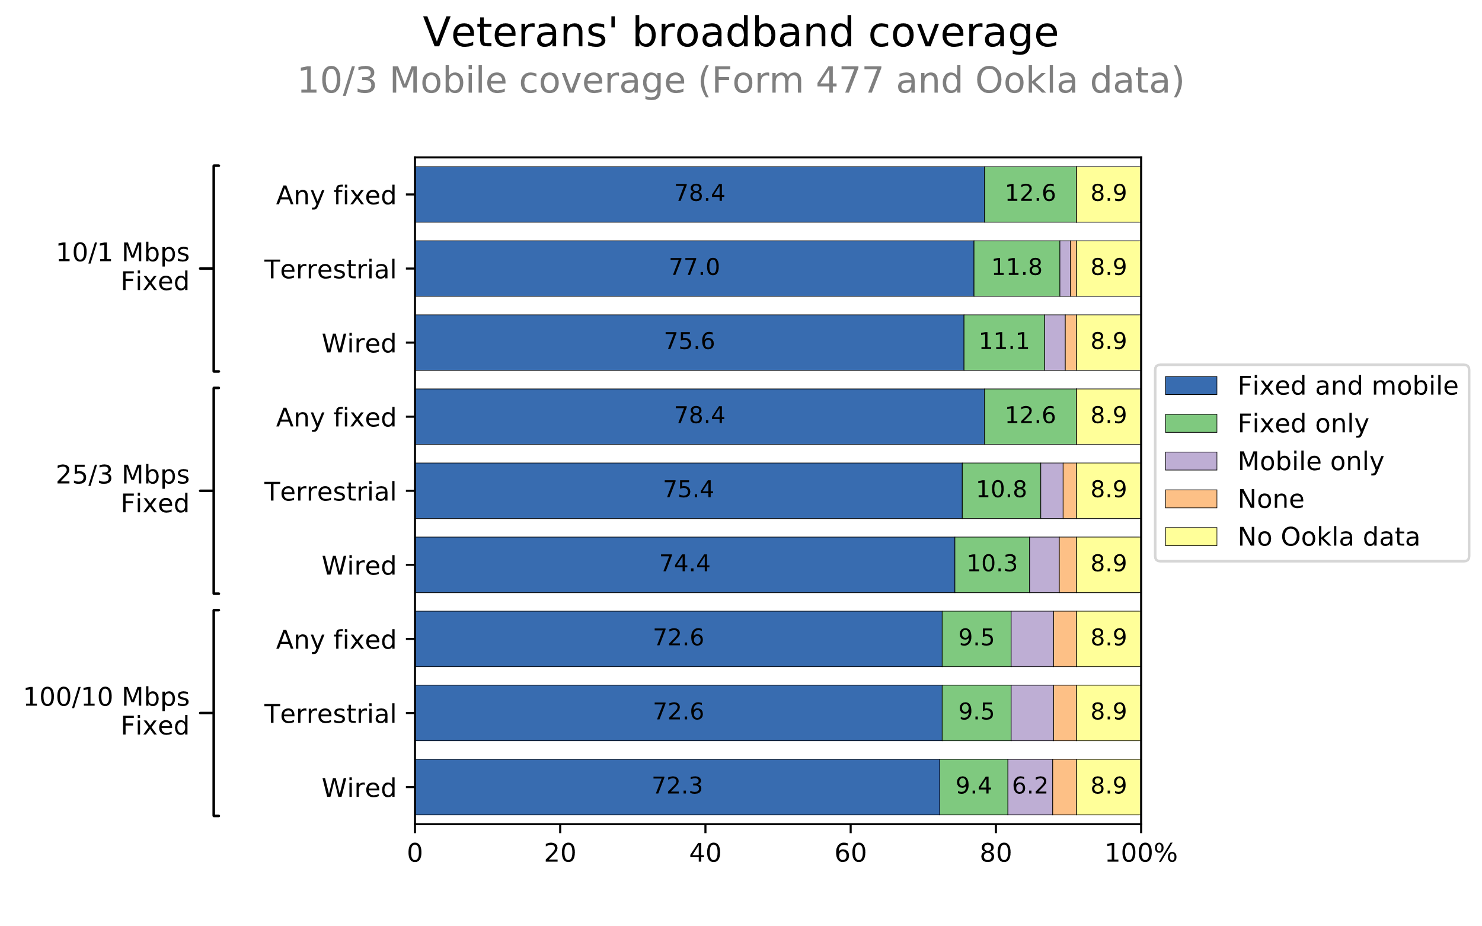Fig. 3**

In contrast, referring to Figures 2 and 4, approximately 0.2% of veterans lack coverage to both 10 Mbps/1 Mbps of any fixed service and mobile LTE with a minimum advertised speed of 5 Mbps/1 Mbps.

**Fig. 4**

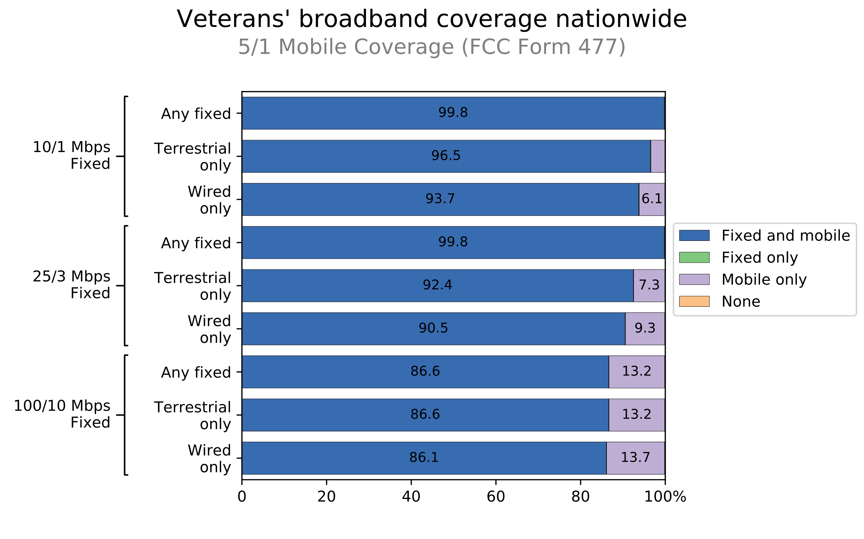

While the vast majority of veterans have both fixed and mobile options, some lack fixed, mobile, or both. For most veterans, broadband access is not the barrier to connectivity.

## Broadband Adoption in Households with Veterans

As of 2017, approximately 85% of households with veterans reported that they had paid connections to the Internet in their homes.[[46]](#footnote-48) In comparison to non-veteran households, veteran households have a slightly higher percentage subscription rate of fixed broadband (See Figure 5). The opposite is true for mobile broadband subscriptions.

**Fig. 5**

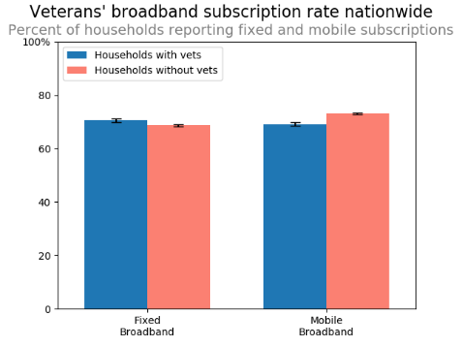.

One aspect of broadband use that may be important to promoting broadband adoption is the question of *how* veterans connect to the Internet. More veterans use a mobile device (62.2%) to connect to the Internet in any location, compared with using a desktop (37.8%) or laptop (44.4%) computer.[[47]](#footnote-49) Approximately 86.7% of veterans reported using fixed high-speed Internet service at home compared to 85.9% of non-veterans.[[48]](#footnote-50) Veterans are less likely to have a smartphone (62.2% vs. 72.4% for non-veterans)[[49]](#footnote-51) and less likely to use mobile broadband service at home (54.6% vs. 61.5% for non-veterans).

Differences between veterans’ and non-veterans’ broadband adoption reflect both the overall demographics of the populations and issues unique to veterans. For example, while veterans are more likely to live in a household without children and the mobile broadband subscription rate for these households lags behind the rate for non-veteran households without children, veteran households with children subscribe to mobile broadband at higher rates than non-veteran households with children.[[50]](#footnote-52) For households with veterans, subscription rates are higher than households without veterans. Income also plays a role: veterans are less likely to be among those with the lowest incomes (in the lowest quintile), a group that tends to subscribe to fixed and mobile broadband at lower rates; veterans are more often in the middle of the income distribution (third and fourth quintiles), groups that adopt fixed broadband at higher rates.

Another variable affecting adoption rates is household composition. Figure 6 shows mobile and fixed subscription rates, respectively, for different types of households. As discussed above, veteran households are more likelyto be men living alone than non-veteran households. Male-only households subscribe to fixed and mobile broadband at lower rates than average, and veteran male-only households subscribe to both fixed and mobile broadband at lower rates than non-veteran male-only households. Fixed and mobile-broadband subscription rates are also lower for female-only households in general, but veteran female-only households are more likely to subscribe to fixed and mobile broadband than non-veteran female-only households.

**Fig. 6**

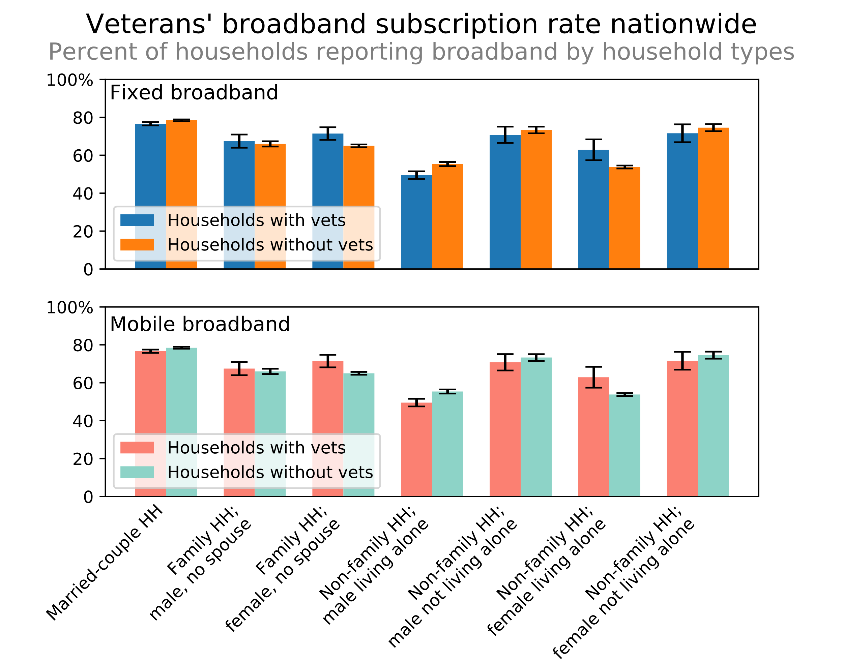

# PROMOTING BROADBAND DEPLOYMENT AND ADOPTION AMONG VETERANS

## Barriers to Broadband Adoption for Veterans

In total, 2.2 million veteran households lack either fixed or mobile broadband connections at home.[[51]](#footnote-53) Many of these veterans who are not connected may face one or more of the following barriers:

*Digital literacy and relevance.* Digital literacy and the perception of the relevance of broadband contribute to gaps for those who have not adopted broadband.[[52]](#footnote-54) Two-thirds of veteran households without Internet users indicate the primary reason is lack of interest or necessity.[[53]](#footnote-55) The tendency of veterans to be older than the general population, coupled with digital literacy challenges for senior citizens, may make digital literacy an especially important challenge for veterans’ broadband adoption.[[54]](#footnote-56) Older veterans who served in World War II are less likely to use the Internet than younger veterans who served in September 2001 or later.[[55]](#footnote-57) Many veteran-led households are also more likely to believe they do not need or are not interested in Internet service at home.[[56]](#footnote-58) This pattern can also be observed in older non-veteran populations, but the tendency of veterans to be, on average, older than the general population makes age-related adoption barriers more prominent.

*Price.* The monthly cost of service or the cost of a computer is often cited as a key barrier to broadband adoption.[[57]](#footnote-59) Veterans are also more likely than non-veterans to cite lack of a computer (or an inadequate computer) as the primary barrier to subscribing to an Internet service.[[58]](#footnote-60) Veterans with the lowest incomes are most likely to go without broadband at home,[[59]](#footnote-61) indicating that price is a significant barrier to adoption. In general, adoption of mobile broadband in veteran households lags just behind adoption of mobile broadband in non-veteran households (see Figure 5). Veteran households in the lowest income quintile are less than half as likely to have a mobile broadband subscription as veterans in the highest income quintile and mobile broadband subscription rates lag behind rates for non-veteran households across all quintiles.[[60]](#footnote-62)

*Location.* Lack of broadband deployment continues to be a major barrier to overall broadband adoption. Veterans residing in rural areas are likely to have more limited access to fixed and mobile broadband services in the home, limiting their access to services such as telemedicine.

## Commission Efforts to Promote Veterans’ Broadband Access and Adoption

The Commission has taken numerous steps to eliminate barriers to broadband deployment and adoption. The Commission stewards the Universal Service Fund (USF or Fund), which plays an essential role in deploying broadband networks in areas that lack broadband infrastructure, connecting low-income consumers, and ensuring that classrooms, libraries, and healthcare providers have access to advanced services.[[61]](#footnote-63) USF resources increase the availability of fixed and mobile broadband in unserved and rural areas.[[62]](#footnote-64) The Commission routinely considers ways to maximize the impact of available USF funding to support and promote broadband deployment.[[63]](#footnote-65) In addition to providing direct support for the deployment and adoption of residential service through the High Cost and Lifeline programs, the Fund supports broadband service for schools and libraries through the E-Rate Program and for clinics, hospitals, and other health care providers through the Rural Health Care Programs. These programs foster deployment of broadband to, and adoption by, rural and low-income veterans.

The Commission has worked to break down the price barriers to high-speed Internet for low-income consumers through the USF’s Lifeline program. There are now an estimated 1.3 million veterans that benefit from the Lifeline program.[[64]](#footnote-66) Low-income veterans can demonstrate their eligibility by demonstrating their participation in the Veterans Pension Benefit in order to qualify for Lifeline enrollment.[[65]](#footnote-67) The Commission is pursuing an automated database connection with the Veterans Benefits Administration that would allow certain low-income veterans to be automatically verified for the Lifeline benefit.

The Commission’s Rural Health Care Program provides funding to rural health care providers for broadband connectivity to support telemedicine services.[[66]](#footnote-68)  Because veterans living in rural areas are more likely to be over the age of 55 and are more likely to have a disability,[[67]](#footnote-69) the Rural Health Care Program’s support for advancements in health care access in rural areas may especially help the veteran population in those areas. In 2017, the annual funding cap for the Rural Health Care Program was increased by 43% from $400 million to $571 million.[[68]](#footnote-70)

The Commission recognizes the need to support the shift in telehealth, and is considering creating a Connected Care Pilot Program to support the delivery of telehealth services to low-income Americans, including veterans, with delivery of health services directly to patients that live in rural areas and those that are not mobile.[[69]](#footnote-71) Veterans in rural areas greatly struggle to receive accessible and affordable health care and are more likely to have a disability.[[70]](#footnote-72) Telehealth services also promote access to care on-demand and can help veterans coping with mental health needs, including post-traumatic stress disorder.[[71]](#footnote-73)

The E-Rate program was created to enhance access to advanced telecommunications and information services for public and nonprofit elementary and secondary schools and libraries.[[72]](#footnote-74) The E-Rate program’s support for libraries can enable veterans residing in unserved rural areas to access online services and build digital literacy skills. E-Rate’s support to libraries is critical as libraries, discussed below, serve as “de facto e-government service centers” for veterans.[[73]](#footnote-75) For example, libraries can help low-income and rural veterans understand their respective benefits online as well as submitting online disability or health claims.[[74]](#footnote-76)

The High Cost Program, which provides direct benefits to rural areas, implements one of Congress’s core universal service policies—to ensure that consumers in expensive-to-serve parts of the country have access to the same voice and broadband services as urban consumers do, and at reasonably similar rates. Approximately 5 million veterans are living in those areas and directly benefit from expanded broadband deployment.[[75]](#footnote-77) The Commission successfully conducted the Connect America Fund Phase II auction to award funding to service providers that commit to offer voice and broadband services to fixed locations in unserved high-cost areas, allocating $1.488 billion, decreased from $5 billion through competitive bidding, in support to be distributed over ten years to further expand high-speed fixed broadband service to over 700,000 unserved rural homes and businesses in 45 states.[[76]](#footnote-78) Similarly, the Commission gave other smaller rural carriers the opportunity to elect model-based support in 2016 and 2018 in exchange for agreeing to deploy additional broadband to unserved locations.[[77]](#footnote-79)

In 2012, the Commission conducted Auction 901, known as Mobility Fund I, which provided up to $300 million in USF support to 33 winning bidders to provide 3G or better mobile voice and broadband services covering more than 83,000 U.S. road miles.[[78]](#footnote-80) The Mobility Fund Phase II auction will make available up to $4.53 billion in new USF funding over ten years for expanding 4G LTE mobile broadband across rural America and in Tribal lands.[[79]](#footnote-81) This will benefit veterans residing in rural areas.

The Commission will continue to consider efforts through the USF and other programs to promote broadband adoption among veterans, such as the Connected Care Pilot Program described earlier, to support broadband service for rural and low-income consumers who benefit from telehealth services, including veterans.[[80]](#footnote-82) Similarly, the Commission’s Broadband Deployment Advisory Committee continues to identify state and local regulatory barriers to broadband deployment and recommend ways to streamline processes to ensure infrastructure can be built in unserved areas where veterans reside.[[81]](#footnote-83) We expect that these efforts will help the Commission gain insight into new ideas that may facilitate broadband deployment and adoption for rural and low-income veterans.

## Other Federal Agency Efforts

### Telehealth

As part of its mission to care for veterans, the VA provides health care for qualifying veterans. The VA has “placed special emphasis on veterans in rural and remote locations”[[82]](#footnote-84) as well as low-income veterans in its telehealth initiatives.[[83]](#footnote-85) As a result, 13% of veterans who receive VA care received it via telehealth in Fiscal Year 2018.[[84]](#footnote-86)

Several VA programs promote veterans’ Internet access. For example, through its Anywhere to Anywhere Telehealth Program and Advancing Telehealth Through Local Access Stations(ATLAS) Program, the VA collaborates with community, private, and alternate agency partners to establish telehealth access points in communities where there is a veteran population without Internet access.[[85]](#footnote-87) Project ATLAS enhances the accessibility of VA health care and promotes digital literacy among veterans by partnering with private companies and veterans service organizations to establish comfortable, private locations in rural communities where veterans can go to connect with their VA health care providers using a broadband connection.[[86]](#footnote-88)

Similarly, in 2016 the VA expanded telemedicine into veterans’ homes through tablet-enabled secure video technology, to enhance access to medical care for low-income veterans and veterans who reside in rural areas, and do not have a home computer.[[87]](#footnote-89)  The VA distributed 6,000 connected iPads with 4G LTE connectivity at no cost to low-incomeand rural veterans for telehealth services at home.[[88]](#footnote-90) Veterans are able to communicate with their medical provider through the VA Video Connect App and manage their wellness plans.[[89]](#footnote-91)

The VA is also currently working with broadband service provider ViaSat to provide high-speed broadband service to Mississippi’s rural veterans, to enable them to access their medical appointments at home through Clinical Video Telehealth.[[90]](#footnote-92) The telehealth van equipped with ViaSat communications equipment utilizes a high-bandwidth broadband connection to see veteran patients in Arkansas, Texas, and Louisiana.[[91]](#footnote-93)

The VA has also implemented telehealth in over 900 VA sites and is available for over 50 specialty areas of care.[[92]](#footnote-94) Through these VA sites, the VA has provided more than 2.29 million telehealth interactions to more than 782,000 veterans enrolled in the VA health care system, an increase of 7.5% from Fiscal Year 2017 services.[[93]](#footnote-95) These initiatives demonstrate the importance of broadband to the health and welfare of veterans, particularly those that reside in rural areas.

### Promoting Deployment and Adoption for Education and Job Training

The federal government’s Broadband Interagency Working Group, which includes 25 federal agencies, was created to ensure that the federal government maximizes its scope of power to support broadband deployment and adoption. This Working Group works to “improve coordination across programs, reduce regulatory barriers to broadband deployment [and adoption], promote awareness of the importance of federal support for broadband investment and digital inclusion programs.”[[94]](#footnote-96) It could provide another avenue for coordination around agencies’ respective efforts to promote broadband deployment and adoption for rural and low-income veterans, particularly those seeking to start or enhance their post-service careers.

The Department of Labor’s Veterans’ Employment and Training Service **helps veterans use broadband service to reach** employment resources.[[95]](#footnote-97) The Department of Labor has a network of more than 2,400 American Jobs Centers through CareerOneStop that can help veterans in person and online with resources specifically geared towards veterans. If a veteran does not have a broadband connection at home, the Department will provide free Internet access at an American Job Center and help the veteran navigate resources in person with a specialist.[[96]](#footnote-98) Efforts like these, that show how broadband service can help veterans pursue career opportunities and enrichment, can be a key driver to help veterans without broadband service understand how the Internet could be relevant to their lives. Efforts such as these raise awareness among agencies about the need for, and importance of, digital literacy for veterans’ employment and education opportunities.

## Private and Public Sector Efforts

Local governments, community and veterans’ organizations, and industry are working in low-income and rural areas to bring affordable broadband, including low-cost services, digital skills courses, and computers to veterans in need. Their work addresses the most commonly cited barriers to broadband adoption for veterans: cost, digital literacy, relevance, and accessibility. Below we discuss examples of private sector efforts to help veterans.

### Discounted Broadband Services Targeting Low-Income Veterans

State and local initiatives, including libraries and companies, provide free or discounted broadband services for veterans, including service specific to low-income veterans, helping them adopt and maintain a broadband service. Frontier Communications has implemented additional programs to benefit low-income veterans in Connecticut.[[97]](#footnote-99)  Frontier’s Veteran’s Discount Program includes broadband service for $19.99 per month, as well as a free modem and free installation.[[98]](#footnote-100) AT&T also offers a discount program providing veterans with a 25% discount on certain wireless plans and a $15 monthly discount for select AT&T broadband services.[[99]](#footnote-101) Similarly, Comcast’s Internet Essentials program was recently expanded to include low-income veterans.[[100]](#footnote-102) Comcast estimates that one million low-income veterans qualify for high-speed Internet for $9.95 per month through Internet Essentials, along with digital skills training courses and discounted computer purchases.[[101]](#footnote-103) Verizon also provides all veterans with discounts on Verizon’s wireline and wireless services.[[102]](#footnote-104)

### Digital Relevance and Literacy Efforts for Veterans

Some veterans may need additional support to feel comfortable using the Internet and to fully appreciate the value and relevance of broadband in their lives.[[103]](#footnote-105) Even among veterans who have broadband at home, some veterans may need to build digital skills to yield the full benefits of the Internet and to access the growing spate of new services available to them online. Many efforts and initiatives are underway for these veterans, working to break down digital literacy and relevance barriers, thereby spurring broadband adoption among all veterans.

For example, 120,000 public libraries in the United States provide free broadband to all members of the public, including rural and low-income veterans.[[104]](#footnote-106)  Public libraries throughout the United States provide digital skills to veterans, helping them understand that home broadband adoption can aid them immensely on a daily basis.[[105]](#footnote-107) In addition to providing free in-library Internet access, library staff provide digital content and applications, with formal instructions to help veterans navigate the digital world.[[106]](#footnote-108)  Libraries also provide in-person technology training.[[107]](#footnote-109)

A broadband connection is also crucial for veterans to access military benefits in addition to other services. For example, the VA’s military benefits, such as disability compensation, medical care, education, and home loans, among others, are accessible in one comprehensive place online.[[108]](#footnote-110) The VA also allows veterans to submit forms and requests online, streamlining the process.[[109]](#footnote-111) In the future, the VA may require all claims to be paperless, transforming the way veterans submit their military benefit claims.[[110]](#footnote-112)

The E-Government Act of 2002 mandated that federal agencies, like the VA, offer government services in a digital format.[[111]](#footnote-113) States and local governments have followed suit.[[112]](#footnote-114) The American Library Association states that libraries are usually the first point of contact for many veterans trying to understand and navigate their benefits online.[[113]](#footnote-115) Local libraries therefore serve as “de facto e-government service centers.”[[114]](#footnote-116) It is clear that low-income and rural veterans can benefit by connecting to the Internet to help them understand their benefits online as well as submitting online disability or health claims.

### Deployment: Fostering Accessibility for Rural Veterans

Several counties are promoting projects aimed at deploying broadband to veterans. In Ward County, Texas, the Ward County Texas Broadband Team is leading a project to promote broadband deployment for veterans through Connected Nation’s Connected Community Engagement Program.[[115]](#footnote-117) The team found that veterans living in Ward County had one of the “bigg[est] gap[s] in digital equity”[[116]](#footnote-118) and that veterans’ biggest challenges to broadband adoption were cost and a lack of infrastructure.[[117]](#footnote-119) From this, Ward County developed a Community Technology Action Plan as a “blueprint” to improve broadband deployment and adoption for its residents.[[118]](#footnote-120)

# RECOMMENDATIONS for congress

Section 504(b)(2) of RAY BAUM’S Act of 2018 requires the Commission to “provide findings and recommendations for Congress” with respect to broadband Internet access for low-income veterans and veterans residing in rural areas, and “how to promote such access.”[[119]](#footnote-121) Leveraging the collective efforts of federal agencies, state and local governments, and industry stakeholders is key to bridging the digital divide for veterans. To aid these efforts, we identify the following areas to Congress as worthy of further review and consideration to increase veterans’ broadband access and adoption.

First, we recommend Congress consider directing agencies and organizations to collect and share broadband deployment and adoption data for veterans. Although many public and private entities are addressing the digital divide for rural and low-income veterans today, disparate data sources describing those efforts make it difficult to gauge successes and failures. Aggregating data sources could show where and how progress is being made for veterans’ broadband access. For example, aggregate VA data that show where veterans live, combined with refined broadband deployment and adoption data in those areas, can help identify where further broadband build-out is needed. Congress may direct agencies and organizations to collect these important data, in order to leverage these data in a way that is most useful to entities working to close the digital divide for veterans.

Second, Congress could direct agencies and organizations to perform veteran-specific outreach and education about broadband, addressing the barriers and challenges to adoption that low-income veterans and veterans living in rural areas face related to digital skills and perceived relevance. The congressional directive could incorporate veteran-specific expertise, such as veterans’ first-hand broadband experiences, including the ease of accessing military benefits online or participating in telehealth programs.[[120]](#footnote-122) The congressional directive could require digital skills programs to be tailored to veterans to provide the most effective forms of outreach and education, showcasing the benefits the Internet can provide, such as education and job opportunities.[[121]](#footnote-123)

Broadband outreach and education strategies not specifically tailored to veterans could be effective at increasing veterans’ familiarity with and adoption of broadband. For example, because veterans are on average older, a program designed to help senior citizens use the Internet could be an effective method of helping older veterans connect. Similarly, a program that helps persons with disabilities use broadband to apply for jobs and build professional skills could also help veterans with disabilities.

Next, Congress could direct federal agencies and other stakeholders to coordinate to enhance education and outreach to veterans. Congress could direct these groups to share ideas and challenges and solutions to promote broadband deployment and adoption among veterans. As discussed above, the Commission’s Lifeline program could be leveraged by other programs that serve low-income veterans, since the Lifeline program accepts the Veterans Pension Benefit as a qualifying enrollment program. Building on efforts to increase adoption generally, broadband service providers could offer veterans zero-rating programs for access to vital services, such as VA telehealth, to help rural and low-income veterans realize the benefits of a broadband connection.

Should Congress advance this directive, additional coordination between federal agencies could hone specialized knowledge that each agency has specific to veterans, from benefits, telehealth, jobs, and broadband.[[122]](#footnote-124) For example, the Commission and the VA have formed a partnership to help implement telehealth services for veterans, sharing the same goal of improving the quality of veterans’ health care through telemedicine.[[123]](#footnote-125) Commission and VA staff traveled together to Citrus County, Florida to visit the Community Based Outpatient Clinic, learning how telehealth can expand medical access to veterans.[[124]](#footnote-126)

We also recommend that Congress consider requiring that funding agencies take into account the needs of low-income veterans and veterans living in rural areas when directing broadband deployment loans and grants, such as those distributed by the Rural Utilities Service or other agencies.[[125]](#footnote-127) To this end, as Congress has the power of the purse,[[126]](#footnote-128) it may designate these loans and grants as partially veterans-specific for broadband deployment.

# Conclusion

The Commission’s top priority is closing the digital divide so that all Americans can enjoy the benefits of broadband.[[127]](#footnote-129) This priority is especially important for rural and low-income veterans who have served and sacrificed for their country. Achieving this goal involves not only Commission efforts, but the collaborations of other federal agencies, industry stakeholders, and local communities to ensure both universal broadband availability and increased broadband adoption.

# 

# Appendices

**Form 477**

**Veteran Broadband Coverage by State**

| **State Abbreviation** | **Both** | **Fixed Only** | **Mobile Only** | **None** |
| --- | --- | --- | --- | --- |
| AL | 87.30 | 0.02 | 12.62 | 0.06 |
| AK | 85.13 | 0.66 | 9.12 | 5.09 |
| AZ | 87.28 | 0.00 | 12.58 | 0.14 |
| AR | 76.58 | 0.02 | 23.18 | 0.22 |
| CA | 96.03 | 0.02 | 3.87 | 0.08 |
| CO | 92.33 | 0.05 | 7.47 | 0.15 |
| CT | 99.13 | 0.00 | 0.87 | 0.00 |
| DE | 97.79 | 0.00 | 2.21 | 0.00 |
| DC | 97.48 | 0.00 | 2.52 | 0.00 |
| FL | 96.14 | 0.01 | 3.84 | 0.01 |
| GA | 92.48 | 0.03 | 7.47 | 0.02 |
| HI | 96.30 | 0.02 | 3.65 | 0.03 |
| ID | 83.99 | 0.26 | 14.84 | 0.92 |
| IL | 92.24 | 0.00 | 7.74 | 0.01 |
| IN | 89.40 | 0.00 | 10.60 | 0.00 |
| IA | 90.04 | 0.08 | 9.81 | 0.07 |
| KS | 90.53 | 0.00 | 9.46 | 0.01 |
| KY | 90.48 | 0.69 | 8.64 | 0.19 |
| LA | 87.17 | 0.00 | 12.81 | 0.01 |
| ME | 91.25 | 1.52 | 6.80 | 0.43 |
| MD | 97.52 | 0.00 | 2.48 | 0.00 |
| MA | 97.86 | 0.00 | 2.13 | 0.01 |
| MI | 89.83 | 0.05 | 10.05 | 0.07 |
| MN | 93.34 | 0.03 | 6.60 | 0.03 |
| MS | 81.92 | 0.00 | 17.96 | 0.11 |
| MO | 86.96 | 0.07 | 12.84 | 0.13 |
| MT | 84.67 | 0.95 | 13.13 | 1.25 |
| NE | 86.42 | 0.03 | 13.47 | 0.08 |
| NV | 92.96 | 0.12 | 6.83 | 0.09 |
| NH | 94.11 | 0.06 | 5.76 | 0.07 |
| NJ | 98.99 | 0.00 | 1.01 | 0.00 |
| NM | 86.42 | 0.05 | 13.21 | 0.32 |
| NY | 96.82 | 0.09 | 3.01 | 0.07 |
| NC | 94.49 | 0.26 | 5.21 | 0.04 |
| ND | 94.52 | 0.17 | 5.27 | 0.04 |
| OH | 94.41 | 0.02 | 5.51 | 0.06 |
| OK | 78.46 | 0.00 | 21.38 | 0.15 |
| OR | 90.47 | 0.07 | 9.03 | 0.43 |
| PA | 94.55 | 0.05 | 5.35 | 0.05 |
| RI | 98.59 | 0.00 | 1.41 | 0.00 |
| SC | 90.97 | 0.01 | 9.01 | 0.00 |
| SD | 89.58 | 0.10 | 10.22 | 0.10 |
| TN | 90.79 | 0.19 | 8.90 | 0.13 |
| TX | 91.80 | 0.02 | 8.16 | 0.02 |
| UT | 95.55 | 0.02 | 4.32 | 0.11 |
| VT | 87.78 | 0.75 | 10.76 | 0.71 |
| VA | 92.30 | 0.10 | 7.54 | 0.06 |
| WA | 96.83 | 0.16 | 2.93 | 0.07 |
| WV | 82.79 | 2.37 | 13.01 | 1.82 |
| WI | 89.30 | 0.10 | 10.38 | 0.21 |
| WY | 82.02 | 0.77 | 16.69 | 0.53 |
| PR | 95.12 | 0.05 | 4.80 | 0.03 |

**Veteran** **Broadband Coverage by State**

**Ookla**

| **State Abbreviation** | **Both** | **Fixed Only** | **Mobile Only** | **None** | **No Ookla Data** |
| --- | --- | --- | --- | --- | --- |
| AL | 64.47 | 15.46 | 4.79 | 2.67 | 12.61 |
| AK | 58.97 | 20.13 | 1.76 | 10.00 | 9.15 |
| AZ | 72.43 | 14.59 | 7.98 | 3.97 | 1.04 |
| AR | 46.47 | 18.15 | 4.42 | 5.68 | 25.28 |
| CA | 90.19 | 5.57 | 3.02 | 0.67 | 0.55 |
| CO | 78.91 | 6.53 | 3.73 | 1.38 | 9.44 |
| CT | 99.13 | 0.00 | 0.87 | 0.00 | 0.00 |
| DE | 70.27 | 27.51 | 1.55 | 0.67 | 0.00 |
| DC | 97.48 | 0.00 | 2.52 | 0.00 | 0.00 |
| FL | 89.69 | 5.43 | 2.18 | 0.92 | 1.77 |
| GA | 78.65 | 3.32 | 2.83 | 0.73 | 14.47 |
| HI | 96.30 | 0.02 | 3.64 | 0.03 | 0.00 |
| ID | 39.44 | 32.86 | 3.15 | 3.60 | 20.95 |
| IL | 81.54 | 4.19 | 3.58 | 0.95 | 9.73 |
| IN | 73.45 | 6.95 | 5.52 | 1.49 | 12.59 |
| IA | 45.01 | 14.67 | 2.72 | 0.82 | 36.78 |
| KS | 71.14 | 0.89 | 3.88 | 0.30 | 23.79 |
| KY | 65.68 | 7.83 | 2.95 | 1.11 | 22.43 |
| LA | 67.02 | 15.85 | 3.93 | 3.82 | 9.37 |
| ME | 9.11 | 76.61 | 0.05 | 5.28 | 8.96 |
| MD | 82.29 | 12.74 | 1.70 | 0.61 | 2.67 |
| MA | 97.50 | 0.18 | 2.12 | 0.02 | 0.18 |
| MI | 76.05 | 8.95 | 4.53 | 2.92 | 7.56 |
| MN | 78.09 | 1.99 | 4.38 | 0.40 | 15.14 |
| MS | 28.10 | 37.25 | 2.55 | 4.06 | 28.03 |
| MO | 64.14 | 12.03 | 3.20 | 2.11 | 18.52 |
| MT | 47.80 | 13.19 | 2.01 | 1.32 | 35.67 |
| NE | 51.87 | 10.03 | 2.35 | 1.26 | 34.49 |
| NV | 83.68 | 7.37 | 5.05 | 0.44 | 3.46 |
| NH | 48.44 | 40.05 | 0.89 | 3.58 | 7.03 |
| NJ | 98.99 | 0.00 | 1.01 | 0.00 | 0.00 |
| NM | 42.97 | 36.03 | 1.16 | 6.49 | 13.35 |
| NY | 81.19 | 12.01 | 1.07 | 1.24 | 4.49 |
| NC | 66.04 | 22.66 | 1.29 | 2.44 | 7.57 |
| ND | 55.33 | 0.17 | 2.52 | 0.04 | 41.93 |
| OH | 87.78 | 3.42 | 3.42 | 0.73 | 4.64 |
| OK | 48.91 | 25.15 | 6.41 | 9.70 | 9.82 |
| OR | 76.35 | 9.62 | 5.52 | 2.49 | 6.02 |
| PA | 84.74 | 4.79 | 3.28 | 0.94 | 6.25 |
| RI | 98.59 | 0.00 | 1.41 | 0.00 | 0.00 |
| SC | 81.57 | 3.80 | 5.85 | 0.20 | 8.58 |
| SD | 41.44 | 0.10 | 2.41 | 0.10 | 55.96 |
| TN | 77.03 | 3.33 | 4.49 | 0.63 | 14.52 |
| TX | 70.36 | 18.78 | 2.40 | 3.96 | 4.50 |
| UT | 75.89 | 14.07 | 2.53 | 0.65 | 6.86 |
| VT | 19.91 | 34.78 | 0.32 | 3.68 | 41.30 |
| VA | 66.04 | 18.61 | 2.11 | 2.90 | 10.34 |
| WA | 86.33 | 8.88 | 1.42 | 1.00 | 2.37 |
| WV | 20.84 | 34.93 | 1.26 | 3.56 | 39.40 |
| WI | 72.80 | 8.07 | 4.63 | 2.47 | 12.04 |
| WY | 0.00 | 52.00 | 0.00 | 4.65 | 43.35 |
| PR | 0.00 | 0.05 | 0.00 | 0.03 | 99.92 |

1. *See* Federal Communications Commission Strategic Plan 2018-2022 at i (2018) <https://www.fcc.gov/document/strategic-plan-2018-2022>. [↑](#footnote-ref-3)
2. National Center for Veterans Analysis and Statistics, U.S. Department of Veterans Affairs, *Veteran Poverty Trends* at 3 (May 2015), *available at* <https://www.va.gov/vetdata/docs/SpecialReports/Veteran_Poverty_Trends.pdf> (using data from the 2012 American Community Survey Public Use Microdata Sample) (noting an 6.9% poverty rate for veterans compared to a 14.4% poverty rate for non-veterans) (Veterans Poverty Trends Report). [↑](#footnote-ref-4)
3. *See, e.g.*, Kelly Ann Holder, U.S. Department of Commerce, Economics and Statistics Administration, U.S. Census Bureau, Veterans in Rural America: 2011-2015 at 2 (Jan. 2017), <https://www.census.gov/content/dam/Census/library/publications/2017/acs/acs-36.pdf> (Veterans in Rural America Report). Veterans living in rural areas are more likely to be over the age of 55 (72.1%) as compared to veterans living in urban areas (65.6%) and non-veterans living in rural areas (28.0%). [↑](#footnote-ref-5)
4. U.S. Census Bureau, Veterans Day 2018: Nov. 11 (Oct. 17, 2018), [https://www.census.gov/newsroom/facts-for-features/2018/veterans-day.html (2017](https://www.census.gov/newsroom/facts-for-features/2018/veterans-day.html%20(2017) ACS 1-Year Estimates); U.S. Census Bureau, 2017 American Community Survey 1-Year Estimates. *See also* Peter J. Ahn, Department of Veterans Affairs, Office of Enterprise Integration, Veteran Population Projection Model 2016 (June 2017), <https://www.va.gov/vetdata/docs/Demographics/New_Vetpop_Model/Vetpop16_Executive_Summary.pdf>; U.S. Department of Commerce, U.S. Census Bureau Releases Key Statistics on Our Nation’s Veterans (Nov. 9, 2017), [https://www.commerce.gov/news/blog/2017/11/us-census-bureau-releases-key-statistics-our-nations-veterans.](https://www.commerce.gov/news/blog/2017/11/us-census-bureau-releases-key-statistics-our-nations-veterans) [↑](#footnote-ref-6)
5. *See* Veterans Poverty Trends Report at 3 (noting an 8.7% increase in veterans living in poverty in the 2010-2012 time period, compared to the 2005-2007 time period). [↑](#footnote-ref-7)
6. *See* *id.* at 3-4. [↑](#footnote-ref-8)
7. *See* *id.* at 5-6. [↑](#footnote-ref-9)
8. “A ‘service-connected’ disability is one that was a result of a disease or injury incurred or aggravated during active military service.’” U.S. Census Bureau, *Veteran’s Day 2015: Nov. 11, 2015* (Nov. 4, 2015), <https://www.census.gov/newsroom/facts-for-features/2015/cb15-ff23.html>. [↑](#footnote-ref-10)
9. *See* Giulia McHenry, *NTIA Data Offers Window into Understanding Veterans’ Computer and Internet Use* (Nov. 8, 2017), <https://www.ntia.doc.gov/blog/2017/ntia-data-offers-window-understanding-veterans-computer-and-internet-use> (Veterans’ Computer and Internet Use). In this same survey, the National Telecommunications and Information Administration also found that disabled veterans are more likely to not use the Internet. *Id.* [↑](#footnote-ref-11)
10. *See* Veterans Poverty Trends Report at 5-6. [↑](#footnote-ref-12)
11. Veterans in Rural America Report at 2. [↑](#footnote-ref-13)
12. Americans with disabilities are also less likely to have a smartphone, tablet, or desktop/laptop computer, compared with Americans without disabilities. *See* Monica Anderson et al., *Disabled Americans are Less Likely to Use Technology* (Apr. 7, 2017), <http://www.pewresearch.org/fact-tank/2017/04/07/disabled-americans-are-less-likely-to-use-technology/>. [↑](#footnote-ref-14)
13. Veterans in Rural America Report at 2, 4. In comparison, during the same period there were approximately 15.8 million veterans living in urban areas and 41.7 million non-veterans living in rural areas. Census defines two types of urban areas: urbanized areas with a population of 50,000 or more and urban clusters with a population between 2,500 and 50,000. All remaining areas are designated as rural. Urban areas represent 3% of land area but 81% of the population, while rural areas make up 97% of land area and 19% of the overall population. *Id.* [↑](#footnote-ref-15)
14. *Id.* at 2. [↑](#footnote-ref-16)
15. *Id.* [↑](#footnote-ref-17)
16. Office of Rural Health, U.S. Department of Veterans Affairs, Rural Veteran Health Care Challenges (last updated June 12, 2018), <https://www.ruralhealth.va.gov/aboutus/ruralvets.asp> (VA Rural Veterans Overview). The VA uses the Rural-Urban Commuting Areas system to define rurality, developed by the Department of Agriculture and the Department of Health and Human Services. Rural Areas are considered land areas not defined as urban or highly rural. Highly Rural Area are defined as sparsely populated areas – less than 10% of the working population commutes to any community larger than an urbanized cluster, which is typically a town of no more than 2,500 people.  *Id.* [↑](#footnote-ref-18)
17. *See* VA Rural Veterans Overview (“58 percent of rural Veterans are enrolled in the VA health care system – significantly higher than the 37 percent enrollment rate of urban Veterans”); Verizon Comments at 3; Budd McLaughlin, *Lack of Broadband Access Blocks Alabama Veterans and Families from Online Resources* (Nov. 8, 2011), <http://blog.al.com/huntsville-times-business/2011/11/lack_of_broadband_access_block.html>; The Voice of the Commonwealth’s Counties, *Broadband in Virginia Commonwealth’s Current Initiatives* at 27 (Nov. 12, 2012), <http://www.vaco.org/AnnualConferenceFiles/12ACFiles/Presentations12/Jackson.Broadband.Presentation.11.12.12.pdf>. [↑](#footnote-ref-19)
18. *See* Verizon Comments at 2. [↑](#footnote-ref-20)
19. *See* Center for Rural Strategies Community Solutions, International Delta Veterans Group Antioch, CA, Disabled American Veterans (DAV), Chapter 14, Washington DC, High Ground Veterans Advocacy, Minnesota Assistance Council for Veterans, National Alliance to End Homelessness, National Association for Black Veterans, Veterans Education Success, Veterans Enterprise Training Academy (VETS Group), VetsFirst, Vietnam Veterans of America Reply at 2 (Veterans Organization Reply); Comcast Comments at 8; TracFone Comments at 2-3; NTCA Comments at 8, n.22 (citing Drew DeSilver, Most-Recent Veterans Say Military Prepared Them for Civilian Work at 1 (2013), <http://www.pewresearch.org/fact-tank/2013/11/11/most-recentveterans-say-military-prepared-them-for-civilian-work/>). [↑](#footnote-ref-21)
20. *See* United States Department of Labor, *Veterans’ Employment and Training Services*, <https://www.dol.gov/vets/newsletter/> (last visited Apr. 15, 2019) (DOL Veterans Services). [↑](#footnote-ref-22)
21. *See* Statista, *Median Income of Year-Round Full-Time Working Veterans in the U.S. in 2016 by Gender*, <https://www.statista.com/statistics/186056/earnings-of-veterans-in-the-us-by-gender/of-veterans-in-the-us-bygender/> (last visited Apr. 15, 2019); NTCA Comments at 7. [↑](#footnote-ref-23)
22. *See* Aaron Smith, Searching for Work in the Digital Era at 1 (2015), <http://www.pewinternet.org/2015/11/19/searching-for-work-in-the-digital-era/>; NTCA Comments at 8, n.23. [↑](#footnote-ref-24)
23. *See* Global Workplace Analytics and Flexjobs, 2017 State of Telecommuting in the U.S. Employee Workforce at 7, 14, 15 (2017), <https://www.flexjobs.com/2017-State-of-Telecommuting-US/>; NTCA Comments at 9, n.27. [↑](#footnote-ref-25)
24. Veterans Organizations Reply at 1-2. [↑](#footnote-ref-26)
25. *See* Veterans Poverty Trends Report at 5. [↑](#footnote-ref-27)
26. *See, e.g.*, Kim Parker, *et al.*, *Online Learning* (Aug. 11, 2011), <http://www.pewsocialtrends.org/2011/08/28/i-online-learning/> (discussing higher education’s efforts to be more accessible and flexible for students by providing courses and degrees online). [↑](#footnote-ref-28)
27. *See* Westat, National Survey of Veterans, Active Duty Service Members, Demobilized National Guard and Reserve Members, Family Members, and Surviving Spouses at xv, 63 (2010), <https://www.va.gov/survivors/docs/nvssurveyfinalweightedreport.pdf> (National Survey of Veterans); NTCA Comments at 7-8. [↑](#footnote-ref-29)
28. *See* National Survey of Veterans at xv. [↑](#footnote-ref-30)
29. *See* Consolidated Appropriations Act, 2018, Pub. L. No. 115-141, Div. P—RAY BAUM’S Act of 2018, § 504(b), 132 Stat. 348, 1094 (2018) (RAY BAUM’S Act of 2018). [↑](#footnote-ref-31)
30. Broadband deployment refers to locations with broadband connectivity services. For instance, the Broadband Deployment Report annually reports on the proportion of Americans with broadband connectivity for the following fixed and mobile services: (1) those with access to fixed services; (2) those with access to mobile LTE services; (3) those with access to both fixed *and* mobile LTE services; and (4) those with access to at least one of either fixed *or* mobile LTE services. *See Inquiry Concerning the Deployment of Advanced Telecommunications Capability to All Americans in a Reasonable and Timely Fashion*, 2018 Broadband Deployment Report, 33 FCC Rcd 1660, 1678, paras. 45-46 (2018) (*2018 Broadband Deployment Report*). [↑](#footnote-ref-32)
31. Broadband adoption refers to the percentage or number of households that subscribe to broadband services, including fixed and/or mobile services. [↑](#footnote-ref-33)
32. RAY BAUM’S Act of 2018, § 504(b). [↑](#footnote-ref-34)
33. *See* *Wireline Competition Bureau Seeks Comment on Promoting Broadband Internet Access Service for Veterans*, WC Docket 18-275, Public Notice (WCB Sept. 12, 2018) (*Veterans Broadband Public Notice*); RAY BAUM’S Act of 2018, § 504(c), 132 Stat. 1094. [↑](#footnote-ref-35)
34. *See, e.g.*, American Library Association Reply at 3, n.12 (discussing NTCA’s telehealth partnership connecting veterans with medical professionals at Veterans Affairs medical centers through video conferencing made available at the County library in McKee, Kentucky). The Veterans Organizations and the National Association of Veterans strongly support promoting broadband adoption for vital health care services through telehealth, learning, and career opportunities. *See* National Association of Veterans Reply at 2; Veterans Organizations Reply at 1-2. [↑](#footnote-ref-36)
35. The semi-annual FCC Form 477 collection currently does not have a formal challenge process as the collection is designed for providers of voice and broadband service to report where they can reasonably provide service upon a request from a customer. [↑](#footnote-ref-37)
36. Data are available via: <https://www.ntia.doc.gov/data/digital-nation-data-explorer#sel=internetUser&demo=veteran&pc=prop&disp=chart>. [↑](#footnote-ref-38)
37. Though staff examine FCC Form 477 data for quality and consistency, the data may understate or overstate deployment of services to the extent that broadband providers fail to report data or misreport data. *See* FCC, *Explanation of Broadband Deployment Data* (Nov. 20, 2017), <https://www.fcc.gov/general/explanation-broadband-deployment-data> (describing quality and consistency checks performed on providers’ submitted data and explaining any adjustments made to the Form 477 data as filed). [↑](#footnote-ref-39)
38. *Modernizing the FCC Form 477 Data Program*, Further Notice of Proposed Rulemaking, 32 FCC Rcd 6329 (2017). [↑](#footnote-ref-40)
39. *Id.*, 32 FCC Rcd at 6344, para. 44. [↑](#footnote-ref-41)
40. Both the Ookla Net Index data and Form 477 data are combined with block group estimates of total veterans from the 2013-2017 ACS to understand the availability of these services. [↑](#footnote-ref-42)
41. We note that, generally, crowd-sourced data can provide the benefit of generating a large volume of data at a very low cost and of measuring actual consumer experience on a network in a wide variety of locations, indoor and outdoor. Crowd-sourced data, however, are often not collected pursuant to statistical sampling techniques, and may require adjustments to construct a representative sample from the raw data. For instance, crowd-sourced mobile data come from a self-selected group of users, and there often is little control for most tests regarding such parameters as when people implement the test, whether the test is performed indoors or outdoors, the geographic location of the tester, and the vintage of the consumer’s device. *2018 Broadband Deployment Report*, 33 FCC Rcd at 1679, para. 47, n.139. [↑](#footnote-ref-43)
42. The data collected by the Ookla Speedtest mobile app include test results for download speed, upload speed, and latency, as well as other information, such as the location of the test and operating system of the handset. The results presented in this Report are based on tests that were executed in the second half of the year for 2014, 2015, 2016 and 2017 on the smartphone’s cellular connection, and using LTE technology. Test data was excluded if it had missing GPS location data or if the reported download or upload speed was less than zero or greater than 100 Mbps. Multiple tests by a single phone in the same locality and in the same day were averaged (using the median). [↑](#footnote-ref-44)
43. The location of veterans for analysis of broadband availability comes from the 5-year American Community Survey estimates for 2013-2017. U.S. Census Bureau, 2013-2017 American Community Survey 5-Year Estimates. [↑](#footnote-ref-45)
44. Any fixed technology includes wired technologies (ADSL, fiber and cable), terrestrial fixed wireless, and satellite. The 100% figure can be derived from the table (100%=78.4% for those that have coverage for “Fixed and Mobile” + 12.6% for those with coverage for “Fixed only”). [↑](#footnote-ref-46)
45. The 3% figure can be derived from the table (3.2%=100% - 72.6% for those that have coverage for “Fixed and Mobile” - 9.5% for those that have access to “Fixed only” - 5.8% for those that have coverage for “Mobile only,” or approximately 3%.). [↑](#footnote-ref-47)
46. In Census parlance, the household responds to a question about “Access to the Internet” with “Yes, by paying a cell phone company or Internet service provider.” [↑](#footnote-ref-48)
47. These questions ask about device use in general, not in a specific location, and do not indicate whether the veteran has a subscription to mobile or fixed broadband at home. Veteran use rates for laptop computers and Internet-enabled mobile phones are lower than non-veteran use rates, but higher for use of desktop computers. National Telecommunications and Information Administration, *Digital Nation Data Explorer, Internet-enabled Mobile Phone Use* (June 6, 2018), <https://www.ntia.doc.gov/data/digital-nation-data-explorer#sel=internetUser&demo=veteran&pc=prop&disp=chart>; National Telecommunications and Information Administration, *Digital Nation Data Explorer, Desk-Top Computer Use* (June 6, 2018), <https://www.ntia.doc.gov/data/digital-nation-data-explorer#sel=internetUser&demo=veteran&pc=prop&disp=chart>; National Telecommunications and Information Administration, *Digital Nation Data Explorer, Lap-Top Computer Use* (June 6, 2018), <https://www.ntia.doc.gov/data/digital-nation-data-explorer#sel=internetUser&demo=veteran&pc=prop&disp=chart>. [↑](#footnote-ref-49)
48. National Telecommunications and Information Administration, *Digital Nation Data Explorer* (June 6, 2018), <https://www.ntia.doc.gov/data/digital-nation-data-explorer#sel=internetUser&demo=veteran&pc=prop&disp=chart> (Digital Nation Data Explorer). [↑](#footnote-ref-50)
49. Digital Nation Data Explorer. [↑](#footnote-ref-51)
50. Based on analysis of FCC Form 477 subscription data and veterans’ location and demographic information from the 2013-2017 5-year American Community Survey estimates. U.S. Census Bureau, 2013-2017 American Community Survey 5-Year Estimates. [↑](#footnote-ref-52)
51. The American Community Survey also tracks variables for dial-up, which we do not include in this Report, and satellite broadband. Nearly 649,000 households with veterans report satellite Internet service without an additional fixed-broadband connection. Overall, ACS reports nearly 8 million paid satellite-based Internet connections.  Since this value is significantly larger than the 1.6 million residential satellite subscriptions reported by service providers to the FCC on Form 477, it suggests that a significant number of survey respondents could be mistakenly reporting having satellite broadband service. [↑](#footnote-ref-53)
52. *See* Comcast Comments at 5; NTCA Comments at 4-5; American Library Association Reply at 2-3. [↑](#footnote-ref-54)
53. *See* Digital Nation Data Explorer. [↑](#footnote-ref-55)
54. *See* National Survey of Veterans at 75; NTCA Comments at 4. [↑](#footnote-ref-56)
55. *See* *id.* [↑](#footnote-ref-57)
56. *See* Veterans’ Computer and Internet Use; Comcast Comments at 8-9; NTCA Comments at 3. [↑](#footnote-ref-58)
57. According to Pew Research Center, 66% of broadband non-adopters cite either the monthly cost of services or the cost of a computer as a barrier to adoption. *See* John Horrigan and Maeve Duggan, Pew Research Center, Home Broadband 2015 at 4 (2015), <http://www.pewinternet.org/2015/12/21/home-broadband-2015/> (Pew Home Broadband Study); Colin Rhinesmith et al., Benton Foundation, The Complexity of ‘Relevance’ as a Barrier to Broadband Adoption (Jan. 6, 2016), <https://www.benton.org/blog/complexity-relevance-barrier-broadband-adoption> (noting research indicating that costs may be a barrier even in some cases when “relevance” is identified as the reason for not adopting broadband). *See* NTCA Comments at 3, 5; TracFone Comments at 3; National Association of American Veterans Reply at 1-2; Veterans Organizations Reply at 1-2; AT&T *Ex Parte* at 1; Comcast Comments at 2; Verizon Comments at 2; American Library Association Reply at 1. [↑](#footnote-ref-59)
58. *See* Digital Nation Data Explorer. [↑](#footnote-ref-60)
59. *See* National Survey of Veterans at 106; NTCA Comments at 5. [↑](#footnote-ref-61)
60. Based on analysis of FCC Form 477 subscription data and veterans’ location and demographic information from the 2013-2017 5-year American Community Survey estimates. U.S. Census Bureau, 2013-2017 American Community Survey 5-Year Estimates. [↑](#footnote-ref-62)
61. *See* 47 U.S.C. § 254(b). [↑](#footnote-ref-63)
62. *Connect America Fund et al.*, Report and Order and Further Notice of Proposed Rulemaking, 26 FCC Rcd 17663, 17668-69, paras. 1-5 (2011) (*USF/ICC Transformation Order*), *aff’d sub nom*, *In re: FCC 11-161*, 753 F.3d 1015 (10th Cir. 2014). [↑](#footnote-ref-64)
63. *Connect America Fund, et al.*, Report and Order, Third Order on Reconsideration, and Notice of Proposed Rulemaking, FCC 18-29, para. 4 (2018) (taking several steps to increase broadband deployment in rural areas through the High Cost program, including maximizing available funding for broadband networks); *Bridging the Digital Divide for Low-Income Americans*, Fourth Report and Order, Order on Reconsideration, Memorandum Opinion and Order, Notice of Proposed Rulemaking, Notice of Inquiry, 32 FCC Rcd 10475, 10475, para. 1 (2018) (directing Lifeline funds to the areas in which they are most needed, to encourage investment in broadband-capable networks); *Promoting Telehealth in Rural America*, Report and Order, FCC 18-82, para. 1 (2018) (increased the funding cap for the Rural Healthcare program to $571 million to prevent pro-rata funding reductions that could have disproportionally impacted rural health care providers, especially those in Alaska). [↑](#footnote-ref-65)
64. #### *See* *Federal-State Joint Board on Universal Service Lifeline and Link Up Lifeline and Link Up Reform and Modernization*, WC Docket 11-42, Universal Service Administrative Company filing (Feb. 25, 2016),<https://www.fcc.gov/ecfs/filing/60001486281>; NaLA Comments at 2; TracFone Comments at 2.

    [↑](#footnote-ref-66)
65. 47 CFR § 54.409. [↑](#footnote-ref-67)
66. Telecommunications Act of 1996, Pub. L. No. 104-104, 110 Stat. 56 (1996) (1996 Act). The 1996 Act amended the Communications Act of 1934 (Communications Act or Act). See S. Conf. Rep. No. 104-230 at 133 (1996); 47 U.S.C. §§ 254(b)(3), (h)(1)(A), (h)(2)(A); *Federal-State Joint Board on Universal Service*, Report and Order, 12 FCC Rcd 8776 (1997) (subsequent history omitted). [↑](#footnote-ref-68)
67. Veterans in Rural America Report at 2. [↑](#footnote-ref-69)
68. *See* Federal Communications Commission, Remarks of FCC Chairman Ajit Pai at the “Anywhere to Anywhere, Together” Telehealth/Virtual Care Thought Leader Summit at 2 (Dec. 6, 2018), <https://docs.fcc.gov/public/attachments/DOC-355421A1.pdf> (Anywhere to Anywhere Telehealth Conference). [↑](#footnote-ref-70)
69. *Promoting Telehealth for Low-Income Consumers*, WC Docket No. 18-213, Notice of Inquiry, FCC 18-112,para. 11 (Aug. 2, 2018) (*Telehealth Notice of Inquiry*). [↑](#footnote-ref-71)
70. *See Telehealth Notice of Inquiry*, para. 2; *see also* Rand Health Quarterly, Balancing Demand and Supply for Veterans (2016), https://www.rand.org/pubs/research\_reports/RR1165z4.html; Letter from Senator Deb Fischer to FCC Commissioner Brendan Carr (July 10, 2018) (“Nebraskans, particularly seniors and veterans, living far from populous cities must overcome not only the digital divide, but also the patient doctor divide.”). [↑](#footnote-ref-72)
71. *See* Veterans Organizations Reply at 1; American Psychiatric Association, Telepsychiatry, <https://www.psychiatry.org/psychiatrists/practice/telepsychiatry> (last visited Apr. 15, 2019); Letter from Senator Cory Gardner to FCC Commissioner Brendan Carr (July 9, 2018) (noting high suicide rates in Colorado and observing that telepsychiatry has the potential to alleviate challenges caused by lack of access to mental health care professionals); Eric Wicklund, Telehealth Can Work for Veterans Dealing with Depression at 3 (2016), <https://mhealthintelligence.com/news/telehealth-can-work-for-veterans-dealing-with-depression>. [↑](#footnote-ref-73)
72. *See* 47 U.S.C. § 254(h)(2)(A). [↑](#footnote-ref-74)
73. *See* American Library Association Reply at 2, n.10. [↑](#footnote-ref-75)
74. *See, e.g.*, American Library Association Reply at 2 (asserting that libraries are usually the first point of contact for many veterans trying to understand and navigate their respective benefits online). [↑](#footnote-ref-76)
75. *See* Veterans in Rural America Report at 2, 4. [↑](#footnote-ref-77)
76. *See* *Connect America Fund Phase II Auction (Auction 903) Closes Winning Bidders Announced FCC Form 683 due October 15, 2018*, WC Docket 10-90, Public Notice (WCB 2018). [↑](#footnote-ref-78)
77. *Connect America Fund et al.*, Report and Order, Order and Order on Reconsideration and Further Notice of Proposed Rulemaking, 31 FCC Rcd 3087, 3090, paras. 4-5 (2016). [↑](#footnote-ref-79)
78. *See Connect America Fund*; *Universal Service Reform – Mobility Fund II*,Report and Order and Further Notice of Proposed Rulemaking, 32 FCC Rcd 2152, 2155, para. 7 (2017)(*Mobility Fund II Report & Order*)*.* [↑](#footnote-ref-80)
79. *See* *Mobility Fund II Report & Order*, 32 FCC Rcd at 2154, para. 2. [↑](#footnote-ref-81)
80. *See* *Telehealth Notice of Inquiry*, 33 FCC Rcd 7825. [↑](#footnote-ref-82)
81. *See* Federal Communications Commission Broadband Deployment Advisory Committee, State Model Code for Accelerating Broadband Infrastructure Deployment and Investment, (Dec. 12, 2018), <https://www.fcc.gov/sites/default/files/bdac-12-0607-2018-model-code-states-final-approved-sections.pdf>. [↑](#footnote-ref-83)
82. *See* U.S. Department of Veteran Affairs, VA Telehealth Services, *Fact Sheet* (2019) (VA Telehealth Services). [↑](#footnote-ref-84)
83. *See* Fierce Healthcare, *The VA Tried Loaning out Thousands of iPads to Veterans for Telehealth. Now they Plan to Double the Program* (Sept. 19, 2018), https://www.fiercehealthcare.com/tech/va-expects-to-double-tablet-leasing-program-for-at-need-veterans-potentially-distributing-12 (VA Tablet Program). [↑](#footnote-ref-85)
84. *See* VA Telehealth Services. [↑](#footnote-ref-86)
85. *See* Federal News Network, *VA’s Telehealth Program is already the Largest in the Nation. It’s About to get Bigger* (Dec. 6, 2018), <https://federalnewsnetwork.com/veterans-affairs/2018/12/vas-telehealth-program-is-already-the-largest-in-the-nation-its-about-to-get-bigger/> (VA Telehealth Program). [↑](#footnote-ref-87)
86. *See* VA Telehealth Program. [↑](#footnote-ref-88)
87. *See* [VA](https://fccoffice-my.sharepoint.com/personal/lauren_garry_fcc_gov/Documents/VA) Tablet Program. [↑](#footnote-ref-89)
88. *See* *id*. [↑](#footnote-ref-90)
89. *See id*. [↑](#footnote-ref-91)
90. *See* Lauren B. Graves, *Connecting Mississippi’s Rural Veterans to Mental Health Care via Telehealth* (Fall 2016), <https://www.ruralhealth.va.gov/docs/news/ORH_Newsletter_Fall2016_FINAL.pdf>. [↑](#footnote-ref-92)
91. *See* Jen FiField, *For Rural Veterans,* *New Approaches to Health Care* (Aug. 3, 2017), <https://www.pewtrusts.org/en/research-and-analysis/blogs/stateline/2017/08/03/for-rural-veterans-new-approaches-to-health-care>; Viasat, *Veterans in Rural Areas Get Connected to VA Services with New TeleMental Health Service*, <https://www.viasat.com/news/veterans-rural-areas-get-connected-va-services-new-tele-mental-health-service> (last visited Apr. 15, 2019). [↑](#footnote-ref-93)
92. *See* VA Telehealth Services; NTCA Comments Attachment at 1. [↑](#footnote-ref-94)
93. *See id*. [↑](#footnote-ref-95)
94. *See* National Telecommunications and Information Administration, *Broadband Interagency Working Group* <https://www.ntia.doc.gov/category/broadband-interagency-working-group> (last visited Apr. 15, 2019). [↑](#footnote-ref-96)
95. *See* United States Department of Labor, Veterans’ Employment and Training Services, <https://www.dol.gov/vets/aboutvets/aboutvets.htm> (last visited Apr. 15, 2019) (DOL Veterans’ Services); Comcast Comments at 9 (discussing the Department of Labor’s vital role toward helping veterans secure employment). [↑](#footnote-ref-97)
96. *See, e.g.*, *Careeronestop, Veteran and Military Transition Center, WorkSource Montgomery American Job center in Wheaton Maryland*, <https://www.careeronestop.org/Veterans/Toolkit/find-american-job-centers-detail.aspx?location=20815&radius=25&ct=0&y=0&w=0&e=0&sortcolumns=Program%20Type,GEOCODE&sortdirections=DESC,ASC&currentpage=1&olds=0&return=1&centerID=53208&dist=4.1> (last visited Apr. 15, 2019); *see also* DOL Veterans’ Services. [↑](#footnote-ref-98)
97. *See* Frontier Communications, *Frontier Communications Reaches Acquisitions-Related Agreement with Connecticut Attorney General and Office of Consumer Counsel* (Aug. 12, 2014), <http://investor.frontier.com/news-releases/news-release-details/frontier-communications-reaches-acquisition-related-agreement>. [↑](#footnote-ref-99)
98. Frontier Communications, *Connecticut Veteran’s Discount*, <https://frontier.com/resources/discountprograms/ct-veterandiscount> (last visited Apr. 15, 2019). [↑](#footnote-ref-100)
99. *See* AT&T *Ex Parte* at 1. [↑](#footnote-ref-101)
100. *See* Comcast Comments at 2. [↑](#footnote-ref-102)
101. *See* *id*. [↑](#footnote-ref-103)
102. *See* Verizon Comments at 2. [↑](#footnote-ref-104)
103. *See* NTCA Comments at 4; Comcast Comments at 5. [↑](#footnote-ref-105)
104. *See* American Library Association Reply at 1-2. [↑](#footnote-ref-106)
105. *See* *id.* at 2. [↑](#footnote-ref-107)
106. *See* *id.* [↑](#footnote-ref-108)
107. *See* *id.* [↑](#footnote-ref-109)
108. *See* U.S. Department of Veterans Affairs*, Explore Benefits that Help Veterans Thrive*, <https://explore.va.gov/> (last visited Apr. 15, 2019). [↑](#footnote-ref-110)
109. *See* United States Department of Veterans Affairs, *National Deployment of Paperless Claims Processing System Underway* (Jan. 14, 2013), <https://www.va.gov/opa/pressrel/pressrelease.cfm?id=2418>. [↑](#footnote-ref-111)
110. *See* Jim Thomas, *The Benefits of a Paperless Claim* (Feb. 13, 2013), <https://www.blogs.va.gov/VAntage/8736/the-benefits-of-a-paperless-claim/>. [↑](#footnote-ref-112)
111. *See* American Library Association Reply at 2. [↑](#footnote-ref-113)
112. *See* *id*. [↑](#footnote-ref-114)
113. See *id*. [↑](#footnote-ref-115)
114. *See* American Library Association Reply at 2, n.10. [↑](#footnote-ref-116)
115. *See* Connected Nation, *Ward County’s New Broadband Plan: Connecting Children, Veterans, Farmers to High-Speed Internet* (Feb. 1, 2018), <https://connectednation.org/blog/2018/01/31/ward-countys-new-broadband-plan-connecting-children-veterans-farmers-to-high-speed-internet/>. [↑](#footnote-ref-117)
116. *See* *id.* [↑](#footnote-ref-118)
117. *See* Connected Community Engagement Program, Community Technology Action Plan, Ward County, Texas: November 2017 at 26 (2017), <http://connectmycommunity.org/wpcontent/uploads/2018/01/WardCo_Connected_Plan_Final.pdf>. [↑](#footnote-ref-119)
118. *See* *id.* at 4. [↑](#footnote-ref-120)
119. *See* RAY BAUM’S Act of 2018, § 504(b)(2). [↑](#footnote-ref-121)
120. *See* Comcast Comments at 9. [↑](#footnote-ref-122)
121. *See, e.g.*, Comcast Comments at 5-6; American Library Association Reply at 2; Florida A&M University, *Center for Public Computing and Workforce Development*, <http://its.famu.edu/about/center-for-public-computing> (last visited Apr. 15, 2019). [↑](#footnote-ref-123)
122. *See, e.g.*, United States Department of Energy, DOE and the VA Team Up to Improve Healthcare for Veterans (May 18, 2017), <https://www.energy.gov/articles/doe-and-va-team-improve-healthcare-veterans>. [↑](#footnote-ref-124)
123. *See* [Anywhere](https://fccoffice-my.sharepoint.com/personal/lauren_garry_fcc_gov/Documents/Anywhere) to Anywhere Telehealth Conference at 1-3. [↑](#footnote-ref-125)
124. *See* Fred Hiers, FCC Head Visits Lecanto in Effort to Bring Internet to All (May 3, 2018), <https://www.chronicleonline.com/news/local/fcc-head-visits-lecanto-in-effort-to-bring-internet-to/article_9add1eee-4f0f-11e8-a967-43a3eb3f88d6.html>. [↑](#footnote-ref-126)
125. *See* Verizon Comments at 4-5. [↑](#footnote-ref-127)
126. *See* Beau Rothschild, *When Congress Asserts the Power of the Purse* (Sept. 26, 2018), <https://www.washingtontimes.com/news/2018/sep/26/when-congress-asserts-the-power-of-the-purse/>. [↑](#footnote-ref-128)
127. *See* Federal Communications Commission, *Bridging the Digital Divide for All Americans*, <https://www.fcc.gov/about-fcc/fcc-initiatives/bridging-digital-divide-all-americans> (last visited Apr. 15, 2019). [↑](#footnote-ref-129)