October 2018 Hurricane Michael’s
Impact on Communications:
Preparation, Effect, and Recovery

Public Safety Docket No. 18-339

Report and Recommendations

A Report of the Public Safety and Homeland Security Bureau
Federal Communications Commission
May 2019

Table of Contents

I. EXECUTIVE SUMMARY 3
II. BACKGROUND 4
III. THE STORM: Preparations, Causes of Prolonged Service Outages, and Restoration Efforts 10
A. Preparations for Hurricane Michael’s Landfall 10
B. Effect of Hurricane Michael on Various Communications Platforms 11
1. Wireless 11
2. Other Communications Segments 18
3. Public Safety Answering Points 21
IV. adherence to and effectiveness of the wireless resiliency Cooperative Framework 22
V. Conclusions and Recommendations 23
A. Backhaul 23
B. Roaming 24
C. Disposition of Hurricane Michael Inquiry Docket 24

APPENDIX: List of Commenting Parties, PS Docket No. 18-339

EXECUTIVE SUMMARY
- Hurricane Michael, one of the most powerful storms to make landfall in the United States, inflicted billions of dollars in damage and resulted in the loss of dozens of lives on the American mainland. It is estimated the hurricane caused over $25 billion in damages and resulted in 57 known deaths. The storm had significant effects on communications, and also adversely affected other critical sectors including transportation, power, food and agriculture.
- The storm cut a path from the Gulf Coast, up through the Panhandle, continuing into Georgia and the Carolinas, before veering off into the Atlantic just south of the Chesapeake Bay. Communications in many areas in Georgia, Alabama, and most of Florida were mildly affected by the hurricane. In these areas, communications providers rebounded within 48 hours after Hurricane Michael made landfall on October 10, 2018. In other areas, particularly the Florida Panhandle, the effects were more pronounced. Specifically, wireless subscribers in Bay and Gulf Counties had limited service for over a week.
- The Bureau undertook an inquiry into what went right, and what went wrong, on various communications platforms in the areas affected by the storm. While the Bureau invited comments from all sectors of the communications industry (e.g., broadcasting, cable, wireline, satellite), it was most particularly interested in the experience of mobile wireless communications. Initial reports, both in the news media and in conversations between Commission staff and representatives of the mobile wireless industry, indicated that there were, in some instances, significant lapses in consumer connectivity. The Bureau sought to understand why and how those lapses occurred, and what could be done in the future to minimize such lapses. This Report presents the Bureau’s findings and recommendations. Because the initial belief that the mobile wireless communications industry was particularly affected was borne out by outage data, the Report places special emphasis on wireless service performance before, during, and after Hurricane Michael, with an emphasis on hardest-hit Bay and Gulf Counties in Florida.
- Hurricane Michael demonstrated starkly how some wireless providers in the Florida Panhandle were able to rebound from this devastating storm through foresight and appropriate planning, while others stalled in their efforts to restore full service. Some providers, working in the same area and facing the same challenges as others, were back in service considerably sooner than others.
- The poor level of service several days after landfall by some wireless providers cannot simply be attributed to unforeseeable circumstances specific to those providers. A lack of coordination and cooperation between certain wireless service providers on the one hand, and utilities and debris clearance crews on the other, unnecessarily prolonged critical backhaul repairs and full restoration of functioning wireless service. The Bureau learned of numerous cases in which a wireless provider had restored service to customers only to have that service brought down as third-party crews damaged communications assets while clearing trash or restoring power lines and utility poles. Such lack of coordination among wireless providers, utilities, and debris clearance crews unnecessarily prolonged the time customers lacked service.
- The Bureau finds that three key factors – insufficiently resilient backhaul connectivity, inadequate reciprocal roaming arrangements, and lack of coordination between wireless service providers, power crews, and municipalities – were the predominant causes of the unacceptable lack of service. The Bureau further concludes that a lack of coordination and cooperation among wireless providers themselves (exacerbated by inadequate roaming arrangements) inhibited their ability to increase service availability via roaming. Some providers appear not to have comported with the Wireless Resiliency Cooperative Framework (Framework), the voluntary commitment that several nationwide service providers proposed and committed to abide by in 2016. Specifically, it appears that some wireless providers demurred from seeking assistance from potential roaming partners and, therefore, remained inoperable.
- We note that certain findings in this Report are based on information submitted in the Commission’s Disaster Information Reporting System (DIRS), a voluntary web-based system allowing providers to report communications infrastructure status and situational awareness information during times of crises, or information discovered as a result of communications with providers about those filings. Because information submitted in DIRS is sensitive, for national security and/or commercial reasons, DIRS filings are treated as presumptively confidential. Accordingly, the Report protects identifying information from disclosure where necessary to preserve DIRS confidentiality.

BACKGROUND
- Hurricane Michael, driven by high Category 5 winds, hit the Florida Panhandle on October 10, 2018. It was the strongest recorded storm to hit the Panhandle and the strongest to hit the continental United States since Hurricane Andrew in 1992. It caused severe damage to infrastructure in the State of Florida, particularly in Bay and Gulf Counties, as well as significant damage to Southeastern and Mid-Atlantic states. Lives were lost, power was out, communications service was disrupted, and economies were impacted.
- In anticipation of the hurricane’s landfall, the Commission issued two public notices, the first reminding the public and key communications service providers that the Commission’s Operations Center was available 24/7 to assist relief and restoration efforts, and the second providing emergency communications providers with detailed information on how to obtain waivers of the Commission’s rules and/or special temporary authorizations (STAs) to maintain or provide necessary communications. The Commission also created a one-stop webpage for Hurricane Michael-related information. At the request of and in coordination with the Federal Emergency Management Agency (FEMA) and the Department of Homeland Security’s (DHS) National Coordinating Center for Communications (NCC), the Commission activated the Disaster Information Reporting System (DIRS) for counties across Florida, Georgia, and Alabama located in the expected path of the storm.
- The Bureau activated its Incident Management Team to monitor the hurricane’s impact in affected areas prior to landfall, on October 8, 2018, and participated in daily calls with FEMA and the NCC to discuss the status of communications in areas impacted by Hurricane Michael as well as industry efforts to restore communications functionality and infrastructure. The Commission issued dozens of STAs and waivers of its rules to assist communications providers. The chart below, maintained by the FCC’s Operations Center, gives details of the type of relief each bureau granted:
Hurricane Michael –Commission Relief and Assistance
 | Requests for Assistance | Requests for Information | Special Temporary Authorizations | Waivers
International |  |  | 2 | 1
Media |  |  | 2
Public Safety & Homeland Security | 5 | 4 | 1
Wireless Telecommunications |  |  | 46 | 2
Wireline Competition |  |  |  | 2

This assistance took the form of regulatory flexibility needed for stakeholders to continue to operate in the affected areas or otherwise maintain service in compliance with the Commission’s rules.
- Initially, the recovery of wireless communications in Florida appeared to be working reasonably well. While DIRS data indicated substantial communication outages along Hurricane Michael’s destructive path, the Bureau understood that telecommunications providers had pre-positioned equipment and also had deployed cells on wheels (COWs) and cells on light trucks (COLTs) to get wireless service up and running in many locations.
- Over the course of the days following landfall, however, while most communications services had been restored for upwards of 95 percent of the populations covered by the DIRS activation, the Panhandle region generally, and Bay and Gulf Counties specifically, continued to suffer from a severe lack of wireless communications service. Government officials found the slow progress in service restoration there to be completely unacceptable, with a significant disconnect between the urgency those leaders conveyed in conversations with providers, and providers’ actions in the worst affected areas.
- On November 16, 2018, the Bureau issued a public notice seeking comment on providers’ preparation for and response to Hurricane Michael. The Bureau was interested in how well providers implemented widely-known best practices that they themselves had a significant role in developing. The Bureau noted that nationwide communications service providers had been instrumental in developing industry best practices addressing operations in high-risk areas like the hurricane-prone Gulf Coast. The Bureau asked whether and how those best practices were implemented before, during, and after Hurricane Michael. It also asked about the extent to which service providers were able to pre-position equipment, supplies, and/or resources close to the affected areas in advance of the storm; how the pre-positioning of such assets impacted the continued availability of communications services during the storm; and whether the pre-positioning of such assets facilitated recovery.
- The Bureau also wanted to know the most effective means to restore connectivity within the wireless infrastructure and how long it took to restore communications. In the early days of restoration efforts, there were press reports of some wireless providers having to restore fiber links disabled by repair efforts from other entities, including power utilities. The Public Notice sought comment on how often and when these cuts occurred, what caused these fiber cuts, and what steps, if any, wireless communications providers took to minimize them. The Public Notice asked about the impact of Hurricane Michael on television and radio broadcasters, whether they faced unique challenges, and if there were any unique impacts from this storm as compared to previous ones. The Bureau also sought comment on any pre-storm broadcast-specific response best practices that were implemented, and their effectiveness.
- Given the vital role that the integrity of the 911 systems plays in the United States, the Bureau asked what, if any, effect Hurricane Michael had on public safety answering points (PSAPs, also known as 911 call centers). Specifically, it sought comment on a PSAP’s ability to (1) receive 911 calls, and whether redundancy and diversity in the circuits to the PSAP contribute significantly to 911 reliability, and (2) handle the call volume before, during, and after landfall. The Public Notice also asked what the Commission could have done differently, to improve its own response and post-storm restoration efforts, as well as the communications-related effects of the storm and its aftermath on consumers. In response to the Public Notice, commenters filed 13 comments and 18 ex parte filings.
- We note that this fact-finding inquiry and resulting Report is just part of a larger effort the Bureau is conducting with the goal of improving wireless network resiliency. The Bureau is also conducting a line of inquiry into the effectiveness of the Framework. The framework set out a five-pronged approach for enhancing coordination during an emergency: (1) providing for reasonable roaming under disasters arrangements when technically feasible; (2) fostering mutual aid during emergencies; (3) enhancing municipal preparedness and restoration; (4) increasing consumer readiness and preparation; and (5) improving public awareness and stakeholder communications on service and restoration status. Following Hurricane Michael, the Bureau issued letters to each of the signatories of the Framework, asking them to provide post-disaster action reports for the 2017 and 2018 hurricane seasons. The Bureau also issued three Public Notices seeking comment on ways to improve wireless network resiliency. The Bureau is evaluating this record, together with the findings in this Report, to inform recommendations it may make to the Commission on measures to expedite service restoration efforts in the face of an emergency and to inform the FCC’s ongoing review of the efficacy of the Framework.
- We further note that the Bureau’s efforts are still only a part of an overarching Commission effort to promote communications network resiliency. In response to the devastation caused to the communications sector during the 2017 and 2018 hurricane seasons, the Commission added a dedicated working group to the Broadband Deployment Advisory Committee (BDAC). The Commission charged the BDAC Disaster Response and Recovery Working Group (BDAC Working Group) with making recommendations on measures to improve the resiliency of broadband infrastructure before a disaster occurs, strategies that can be used during the response to a disaster to minimize the downtime of broadband networks, and actions that can be taken to more quickly restore broadband infrastructure during disaster recovery. Of particular applicability to this Report given its observations regarding backhaul, the BDAC Working Group also is charged with developing best practices for coordination among wireless providers, backhaul providers, and power companies during and after a disaster.

THE STORM: Preparations, Causes of Prolonged Service Outages, and Restoration Efforts

Preparations for Hurricane Michael’s Landfall
- AT&T indicates that prior to the storm, it deployed 32 COWs and COLTs, a Flying COW (much like a drone) in Mexico Beach, Florida; seven emergency communications vehicles and emergency Communications Portables, a hazardous material and mobile command center; and four device charging sites. Similarly, Southern Linc notes that once it understood Hurricane Michael’s likely path and severity, it began preparations including refueling backup generators, increasing staffing, and pre-positioning equipment, supplies, personnel and resources as close as possible to the storm’s projected path of destruction, and coordinated with partners to secure pre-positioning of wireless assets in three Florida counties, including Bay County.
- Sprint observed that, for Hurricane Michael, it identified several staging locations near the potential impact area prior to the storm making landfall based on the storm’s projected path. T-Mobile noted that it pre-staged assets including mobile generators, COWs, and COLTs, temporary microwave/satellite communications, and supplies that likely would be necessary for rapid service restoration. It states such pre-staging was sufficient to ensure coverage in the most severely damaged areas while repairs to aerial fiber and power lines, as well as some T-Mobile sites, were being completed.
- Verizon states that it prepared for Hurricane Michael by moving COWs and COLTs from the Carolinas and prepositioning them, together with fuel resources, at preplanned staging areas as close as possible to the anticipated landfall location, and that its workers topped-off all generators with fuel and establish refueling stations across six states to prepare for the storm. It added that it maintains battery backup power at all cell sites and backup generators at approximately ninety percent of its permanent sites.
- The American Cable Association (ACA) notes its member companies maintain plans according to which they preposition fuel, generators, and other materials at locations they expect to be just outside the disaster area; identify customers whose service restoration should be prioritized if possible; coordinate extensively within their companies to ensure all available resources are brought to bear effectively when the storm arrives; and instruct customer service staff on how to answer questions about the storm and its potential impact on service.
- Comcast states its preparation called for its crews to test and refuel backup generators to keep facilities operational in case of commercial power outages; it also noted deploying another 200 generators to the Florida Panhandle, staging fuel trucks nearby to support recovery operations, and sending two trucks of materials and equipment to Panama City and Tallahassee.
- We note that some wireless providers did not obtain and implement supplemental roaming agreements in advance of the storm. Providers would have greatly improved the availability of wireless service for their customers had they secured and activated such agreements. Indeed, in one situation, a wireless service provider neglected to establish and implement roaming agreements prior to the storm, resulting in its customers being without cell service for several days, while neighboring customers on a different network received service.

Effect of Hurricane Michael on Various Communications Platforms

Wireless
- Wireless service providers’ pre-storm preparation allowed for a rapid restoration of power to cell sites. Backhaul recovery took longer, leaving many customers in Bay and Gulf Counties without wireless service for over a week following landfall when service was needed most. The primary reason for this was that electric power utility crews, telecommunications providers, and debris clearance crews each performed their own restoration without consulting other parties, at least initially. This lack of coordination among some wireless providers and backhaul providers, the power (electricity) sector, and municipalities (as related to debris removal) in the days following landfall made communications service difficult to restore and sustain. The Bureau was concerned to learn of reports, in the press and from service providers, backhaul providers, and wireless providers, about entities working at seeming cross-purposes. For example, there were situations in which, as soon as telecommunications was restored, debris clearance crews unintentionally ripped down newly-installed aerial fibers, or utility companies, in the process of putting up several thousand new utility poles, inadvertently damaged existing underground fiber nearby.
- While restoration in both Georgia and Alabama proceeded relatively swiftly, data from the Networks Outage Reporting System (NORS) indicates the massive damage caused by the storm and lack of coordination following the storm caused certain wireless providers in the Florida Panhandle to suffer significant infrastructure damage for ten days or longer. Specifically, it appears that some wireless providers did not adequately coordinate with power companies and clearance crews during restoration. Had these wireless providers done so, it is likely that damage to backhaul facilities would have been reduced, thereby resulting in swifter restoration of wireless service in Bay and Gulf Counties.
- Wireless providers who participated in DIRS reported significant network impairments following the storm, which led to service outages in the disaster area. The largest outages happened near the coastal region where the hurricane winds reached sustained speeds of 155 mph. As Hurricane Michael made its way inland and the wind speed diminished, so too did the number of outages. The Panhandle and adjacent southern Georgia experienced the largest disruption of wireless service from the hurricane as the diagram below shows:
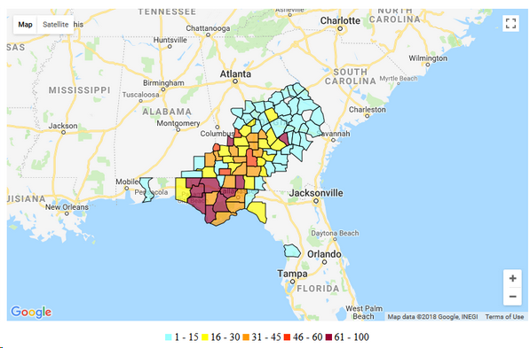
Figure 1: Percent Cell Sites Out-of-Service by County, as of October 11, 2018
- The leading cause of cell site outages on the first day of the storm were power outages, as high winds brought down overhead power lines. Gulf Power reported the need to essentially “rebuild” its electrical distribution network in its regional service area, which included replacing 7,000 distribution poles and 200 miles of distribution lines. The leading cause of wireless service outages in the days after landfall was damage to the extensive aerial and underground cabling networks used to provide backhaul service to wireless cell sites. Utility repair crews and debris removal teams clearing roads and municipal areas frequently inflicted this damage. These crews appear to have worked in an uncoordinated way, resulting in damage to communications infrastructure even after it had been repaired.
- Figure 2 below shows how the outages reported in the Disaster Information Reporting System (DIRS) diminished during the restoration process. Of note is how wireless service in Alabama was fully restored by October 15 and in Georgia shortly after that, well before Florida reached a similar level of service restoral. Because it was hit with the greatest force, Florida’s restoration was slower and showed little change from October 19 through October 25. Furthermore, the initial damage and restoration times in Bay and Gulf Counties were considerably worse.

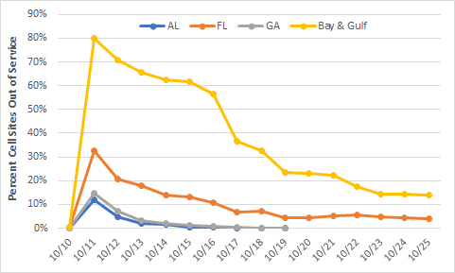
Figure 2: Cell Site Restoration Timeline
- Figure 3 shows the status for DIRS-reporting counties in Florida as of October 20, ten days after landfall. Of note, Bay and Gulf Counties still show up to 45% cell sites down while surrounding counties have less than 15% cell sites down.
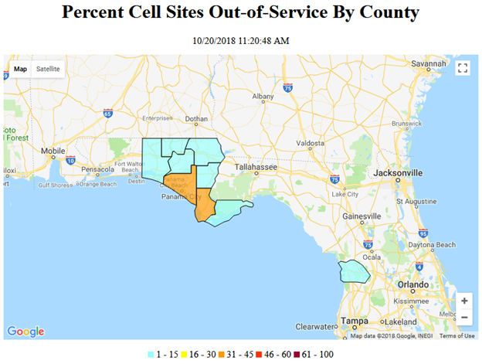
Figure 3: Cellular Outages in Florida by county on October 20, 2018
- DIRS tracks cells sites out of service due to failed connectivity between sites (backhaul), loss of power at the site (power), and storm damage to the site (damage). Figure 4 breaks down, for Bay County, the impairments reported in DIRS using these categories. Most cell site outages in Bay County, like other counties in the disaster area, were attributed to the lack of backhaul or power. Figure 4 reveals that cell sites out of service due to power outages were restored much more quickly than those out of service due to backhaul outages. Back-up power assets, like generators, are easier to pre-deploy and activate, which could account for the fast decline in power outages as a cause of cell site outage. The activation of pre-staged backhaul resources, on the other hand, can take longer and the resulting service restoration can be temporary given the ongoing utility restoration and debris removal efforts.
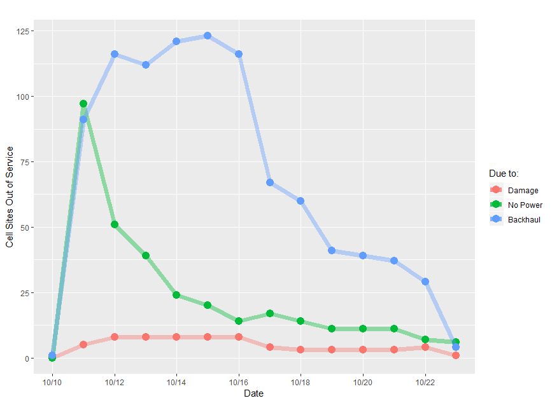
Figure 4: Bay County Florida Cell Sites Out of Service by Cause
- Cell site outages attributed to backhaul issues began to increase in the days following the storm. Several providers reported many backhaul outages resulting from the recovery effort itself, citing a significant lack of coordination between those wireless providers, their backhaul providers, and utility companies repairing downed wires. Aerial fiber was most susceptible to damage during the hurricane (e.g., wind damage, trees on wires), while buried fiber sustained damage as part of the recovery effort. For example, Uniti Fiber (Uniti) provides backhaul services to Verizon Wireless in Bay and Gulf Counties. Uniti indicates it experienced at least 33 separate fiber cuts during the recovery effort. These fiber cuts included damage to sections that already had been repaired. Commenters attributed fiber cuts to debris removal crews, power company restorations, and returning homeowners clearing their property. Uniti and T-Mobile mentioned that they posted signs to deter digging along the fiber rights-of-way.
- Figure 5 breaks down, for Gulf County, the impairments reported in DIRS using these categories described above. Gulf County has a population less than a tenth that of Bay County, with one tenth the cell sites. As in Bay County, backhaul damage was the largest and most persistent cause of cell site outages.

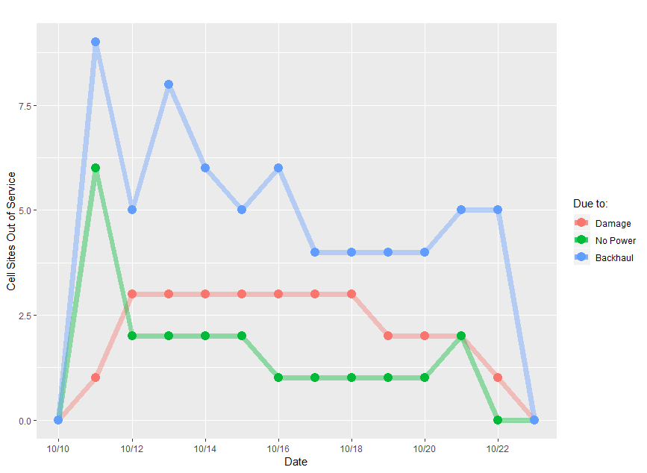
Figure 5: Gulf County Florida Cell Sites Out of Service by Cause
- AT&T, T-Mobile, Sprint, and Verizon all noted leveraging deployable assets to get their networks up and running prior to full fiber restoration in the area. Verizon noted leveraging deployable assets to provide limited service for governments and first responders. T-Mobile used pre-staged microwave assets to reconfigure its microwave network in order to compensate for lost backhaul and route traffic to operational cell sites.
- Regional service provider Southern Linc noted that by the end of day of October 11 (i.e., that day after Hurricane Michael hit the Panhandle), 60 percent of its sites that had been taken down by the storm had been restored to service, including all of its affected sites in southeastern Alabama. By the end of the following day, all of Southern Linc’s priority sites in Florida, including those in Bay County, had been restored or replaced with coverage through a variety of methods, including the deployment of over 20 mobile assets (e.g., generators, COWs, and satellite backhaul), repairing and replacing equipment, adding new microwave paths, adding new Integrated Digital Enhanced Network (iDEN) sites on towers that previously housed only LTE sites, and other measures. It noted that as restoration efforts wrapped up in Georgia and Alabama, it moved crews and deployable assets to the hardest hit areas of the Florida Panhandle to enhance its restoration efforts in that area.
- Regarding best practices, they are developed by communications sector practitioners and are “regularly and expertly reviewed and updated, expanded, or in some cases deleted to provide the most valuable and dependable source of industry guidance.” They are understood to be recommendations or guidelines, developed in a collaborative atmosphere within the membership of a given communications platform (e.g., broadcast, wireless, wireline, etc.) for the purpose of preserving, enhancing, restoring, and maintaining communications. While the record (including comments, ex partes, and conversations with wireless service providers immediately after the storm) reflects commenters’ appreciation of implementing best practices, we note that with limited exception, commenters referred to implementation of best practices without reference to the specific set of established best practices noted in the Public Notice. At the end of the day, it appeared that any positive action taken before, during, or after Hurricane Michael’s landfall that lessened the storm’s consequences was described as a “best practice.”

Other Communications Segments

Wireline and Cable
- Immediately after Hurricane Michael struck, wireline and cable providers fared similar to wireless providers. As Figure 3 shows (derived from anonymized DIRS data), the aggregate number of customers out of service dropped steadily from October 10 to October 19 where it remained steady until DIRS was deactivated. Both segments (wireline and cable) benefited by having outside plant that was more likely to be protected: buried fiber; buried coaxial cable; or buried twisted pair cable. But although these facilities would be more likely to survive the storm, they were also vulnerable to disruption due to uncoordinated activities of repair crews.

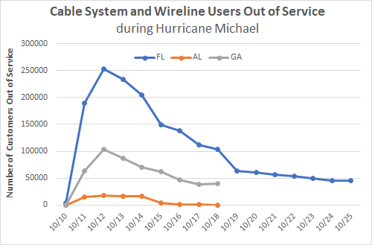
Figure 6: Aggregate Wireline and Cable Subscribers Out of Service
- Charter indicates the storm destroyed outdoor supporting infrastructure in two parts of its network and extensive damage to another, resulting in over 130 miles of line damage and service outages to over 1,250 customers. By October 24, 2018, Charter had restored service to over 42% of its customers in Washington County. Unfortunately, some customers in the community of Gadsden County, in the Panhandle, remained without service as of December 2018.
- Comcast reports that by the end of October 2018, it had restored connectivity to more than 80 percent of all its customers affected by Hurricane Michael (i.e., in the Panhandle), although restoration remained particularly difficult in Panama City and Marianna, where infrastructure was severely damaged and certain areas were either physically inaccessible or still deemed unsafe to begin repairs. Comcast reports that in the hardest hit areas it serves (the Panhandle), it had to tear out and rebuild its network from the ground up, installing more than 195 miles of new plant in the first two weeks of work, and an additional 650 miles across the affected areas once the project is finished.

Broadcast
- Bay and Gulf Counties have a total of 37 broadcast stations. The DIRS-activation area, which included Florida, Georgia, and Alabama, has 635 broadcast stations. According to press reports, in the wake of the storm, WKGC-FM 90.7, based in Panama City, was the only broadcast station in Bay County that was on air through Hurricane Michael’s landfall and beyond. Other broadcast stations in the DIRS activation area became operational within 24 hours. However, for some stations, particularly in hard-hit Bay and Gulf Counties, the damage was long-lasting or even permanent. NAB suggests the situation facing broadcasters would have been significantly worse if broadcasters had not planned, prepared, and practiced for situations such as Hurricane Michael throughout the year, allowing them to trigger emergency plans addressing everything from fuel reserves to news-sharing arrangement with other stations.
- Figure 5 shows the number of broadcast stations, including radio and television stations, reported out of service in DIRS.
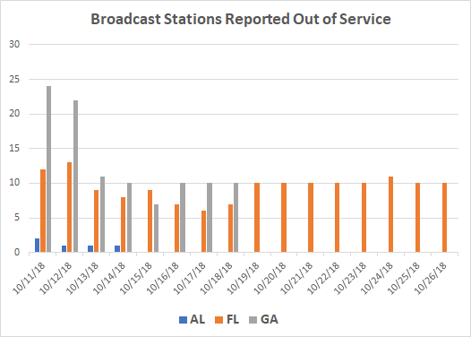
Figure 7: Broadcast Stations Reported Out of Service in DIRS
- The Bureau notes that a high number of broadcast outages were reported in DIRS; further, these outages lasted for a considerable interval. All of the stations were off the air due to damaged transmitter sites. We further note that, while broadcasters from other counties may have reached people in Bay and Gulf Counties, only WKGC-FM was broadcasting from Bay and Gulf County during the storm.

Satellite
- Hughes Network states that its geostationary orbit satellite system and its ground infrastructure were not impacted by the storm, and that its customers in the DIRS-designated area were able to receive broadband satellite services except during the height of the storm. Hughes further notes that because satellite is not tied to the terrestrial networks subject to storm damage, it could be used to establish mission critical communications in areas of high impact, allowing first responders to transfer data and coordinate rescue and recovery efforts. Hughes concludes that satellite was able to continue services to subscribers during the Hurricane Michael recovery effort and also worked with FEMA to help residents communicate with the outside world to assist recovery, including contacting family members.
- DIRECTV explained that their service “was not impacted by Hurricane Michael except to the extent that individual satellite dishes on consumer homes were damaged or destroyed.” It added that it does not have any uplink facilities in Florida and its remaining national uplink facilities were not affected by the hurricane. Any DIRECTV customer with an undamaged satellite dish should have been able to receive service after the hurricane struck.

Public Safety Answering Points
- During the hurricane, wireline providers reported on their ability to deliver 911 calls and to deliver location information on 911 calls to individual PSAPs. The following chart shows that the day after the storm made landfall, 911 calls were either delivered to the appropriate PSAP or rerouted to another PSAP, temporary facility, or administrative line. This meant that after October 11, if people could make calls, their 911 calls were getting through to the PSAP. Some of these calls did not have Automatic Number Identification (ANI) or Automatic Location Identification (ALI).
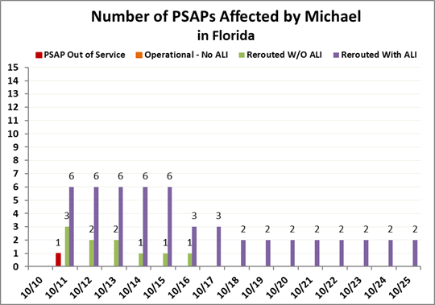
Figure 8: Number of PSAPs Affected in Florida
- Bay County E911 indicated that two of its 911 facilities (Springfield Police Department & Fire Department and Lynn Haven Police Department & Fire) were destroyed. Springfield remained inoperable as of late December 2018, and its dispatchers moved into the central Bay County 911 PSAP. Calls customarily destined for the Springfield PSAP were routed to Bay County’s 911 PSAP. Lynn Haven’s dispatchers moved into trailers, and received 911 calls, albeit without ALI.
- Bay County further noted that even after the Springfield and Lynn Haven locations became uninhabitable, 911 calls to those PSAPs were completed to alternate locations. Redundancy and route diversity were essential to the resiliency of 911 service. For example, when the Panama City PSAP was unable to take calls, its calls were re-routed to the central Bay County 911 PSAP. When that PSAP became overloaded, calls then flipped over to PSAPs as far away as Tallahassee (three counties and 100 miles away).
- The lines between the selective router and the 911 call center in Gulf County are underground so 911 calls that made it to the selective router were likely to be received at the PSAP. Gulf County 911 also notes that a few days after Hurricane Michael’s landfall, the National Guard installed a satellite communications system. On the same day, AT&T and Verizon brought in assets which gave the 911 call center full Internet capability. Additionally, AT&T was able to route 911 calls to call takers’ wireless phones provided by FirstNet. Finally, the State of Florida provided a deployable radio network and dropped a cache of radio to PSAPs and others, allowing PSAPs to talk with state law enforcement officials. Verizon admits that “users’ ability to dial 911 via [its] wireless network tracked the state of our macro network in the counties most affected by the storm. 911 call attempts originating on our network dropped significantly after the storm in those counties and increased as we restored service.”

adherence to and effectiveness of the wireless resiliency Cooperative Framework
- The Public Notice asked questions on implementation of the first two prongs of the Framework (roaming and mutual aid), as well as the timeliness and effectiveness of the service providers’ implementation. As noted above, the Bureau is concurrently reviewing the effectiveness of the Framework as a whole. Hurricane Michael provides a case study illustrating how the signatories are putting the Framework into action.
- Commenters indicated that the Framework worked very well during Michael, and that the Commission should not take steps to alter it. AT&T, for example, states that “[t]he Framework again proved extremely effective by facilitating various collaborative efforts across the wireless industry,” and the Commission should continue to support it in its current, voluntary form. AT&T cautioned against any Commission action to overhaul the basic voluntary nature of the Framework, stating that “rethinking the Framework itself risks taking a step backward with respect to disaster response.” Sprint stated that the Framework was effective in preparation for and during Hurricane Michael as wireless service providers worked to make wireless networks available to consumers and public safety, while T-Mobile noted that, while it did not need assistance, it nevertheless coordinated with wireless service providers regarding potential disaster recovery scenarios. Verizon notes that the Framework worked as intended regarding roaming arrangements, mutual aid, interaction with various jurisdictions, and outreach efforts.
- The Bureau notes that the effusive praise given by Framework signatories that commented in this docket simply does not ring true, in light of the lengthy wireless outages in Bay and Gulf Counties. Clearly there was a breakdown in restoration efforts, in that some wireless providers fared as well as one might expect given the challenges that Hurricane Michael presented, while others did not. Specifically, at least some wireless providers did not take advantage of the types of disaster-related roaming agreements envisioned in the Framework, allowing their customers to remain in the dark rather than roam on a competitor’s network. At least tens of thousands wireless customers had to wait days, unnecessarily, for their mobile phone service to be restored while their provider held off entering into roaming arrangements.

Conclusions and Recommendations

Backhaul
- Backhaul outages loomed large as an impediment to communications recovery. Uncoordinated post-storm recovery efforts between and among communications, utility, and debris removal teams created unnecessary delays to a speedy return to service. Customers who had communications service restored – only to lose it again almost immediately because of a fiber cut – provide a clear example of how better cross-sector coordination could have improved the restoration process.
- As a result, we recommend that:
- communications providers participate in training activities with state Emergency Operations Centers and within working groups of the National Association of Regulatory Utility Commissioners to improve coordination of restoration activities.
- the Commission increase coordination with the Federal Energy Regulatory Commission to identify ways for Federal regulators to harmonize restoration practices across sectors.
- wireless providers use diverse backhaul options, such as microwave links and satellite links, in hurricane-prone areas.
- wireless providers ensure familiarity with applicable best practices, especially as they relate to cooperation and coordination with local utilities.
- communications providers and power companies in hurricane-prone areas enter into coordination agreements regarding mutual preparation and restoration efforts that can be activated when a storm strikes.

Roaming
- The record suggests that some wireless providers proactively established a protocol such that its customers could roam on a competitor’s network. Other providers appeared to believe their own network would weather the storm and they would not need comprehensive pre-storm roaming agreements in place. In areas prone to natural disasters, wireless providers that lease backhaul circuits should arrange well in advance to roam on other providers’ networks should the need arise.
- We recommend that:
- all wireless providers should establish clauses in their commercial roaming agreements in hurricane-prone areas that would enable activation of roaming prior to a storm’s landfall.
- Framework signatories take full advantage of the types of disaster-related roaming agreements envisioned as the first principle of the Framework.
- wireless mobile providers in a shared market should establish appropriate roaming agreements as part of their pre-storm provisioning process.

Disposition of Hurricane Michael Inquiry Docket
- With publication of this Report, PS Docket No. 18-339, “Public Safety and Homeland Security Bureau Seeks Comment on Hurricane Michael Preparation and Response,” IS CLOSED.
APPENDIX
List of Commenting Parties
Docket No. 18-339

Commenters:

AT&T Services, Inc. (AT&T)
American Cable Association (ACA)
Charter Communication (Charter)
Comcast Corporation (Comcast)
CTIA
Edison Electric Institute (Edison)/
Utilities Technology Council (UTC)
Free Press
Gulf Power
National Association of Broadcasters (NAB)
Southern Company Services, Inc.
(Southern Linc)
Sprint Corporation (Sprint)
T-Mobile USA, Inc. (T-Mobile)
Verizon

Ex Parte Presentations:
AT&T
Bay County (Florida) Emergency Operations Center (Bay County E911)
Comcast
Common Ground Alliance
Competitive Carriers Association (CCA)
First Responder Network Authority (FirstNet)
Gulf County (Florida) Emergency Operations Center (Gulf County E911)
Hughes Network Systems, LLC (Hughes)
Network Reliability Steering Committee (NSRC)
North American Telecommunications Damage Prevention Council (NTDPC)
Salvation Army, Florida State Liaison
Sprint
Sunshine 811
T-Mobile
Uniti Fiber (Uniti)
U.S. Department of Energy
U.S. Department of Homeland Security
Verizon

National Centers for Environmental Information, National Oceanic and Atmospheric Administration (NOAA), Assessing the U.S. Climate in 2018 (2019), https://www.ncei.noaa.gov/news/national-climate-201812.
Id.
Olivia Michael, Hurricane Michael death toll continues to rise (Jan. 11, 2019), https://www.wjhg.com/content/news/Hurricane-Michael-death-toll-continues-to-rise-504241911.html.
Patricia Sullivan, Emily Wax-Thibodeaux, & Annie Gowen, “It’s All Gone”: Tiny Florida town nearly swept away by Hurricane Michael, Washington Post, Oct. 12, 2018, https://www.washingtonpost.com/national/its-all-gone-tiny-florida-beach-town-nearly-swept-away-by-hurricane-michael/2018/10/12/f1a110c0-ce56-11e8-a3e6-44daa3d35ede_story.html. Bay and Gulf Counties are located directly on the Gulf Coast where the storm first made landfall. Bay County is home to Panama City as well as Mexico Beach, which sustained extreme damage from the hurricane.
See Public Safety and Homeland Security Bureau Seeks Comment on Hurricane Michael Preparation and Response, Public Notice, PS Docket No. 18-339, 33 FCC Rcd 11239 (2018) (Public Notice).
The storm was the most intense storm to make landfall on Florida, the third most intense hurricane to make landfall in the contiguous United States, and the fourth most intense storm to make landfall based on windspeed. National Centers for Environmental Information, National Oceanic and Atmospheric Administration, Assessing the U.S. Climate in 2018 (2019), https://www.ncei.noaa.gov/news/national-climate-201812.
See The FCC’s Public Safety & Homeland Security Bureau Launches Disaster Information Reporting System (DIRS), Public Notice, 22 FCC Rcd 16757 (PSHSB 2007) (DIRS Public Notice).
DIRS Public Notice, 22 FCC Rcd at 16758.
The National Hurricane Center (NHC) defines Category 5 as sustained winds (i.e., lasting at constant speed for at least one minute) of between 157 or more. See Saffir-Simpson Hurricane Wind Scale, https://www.nhc.noaa.gov/aboutsshws.php. In April 2019, the NHC reclassified Hurricane Michael from a Category 4 to a Category 5 storm, after analyzing additional data. See Ian Livingston, “Hurricane Center reclassifies Michael to Category 5, the first such storm to make landfall since 1992,” Washington Post, Apr. 19, 2019, https://www.washingtonpost.com/weather/2019/04/19/hurricane-center-upgrades-michael-category-first-since-andrew/?utm_term=.5a044476d96e, citing National Hurricane Center Tropical Cyclone Report: Hurricane Michael, https://www.nhc.noaa.gov/data/tcr/AL142018_Michael.pdf.
A week after Hurricane Michael’s initial impact, over 46 percent of cell sites in Bay County were still down, while nearly 35 percent of such sites were down in Gulf County. By comparison, the county with the next highest percentage of cell sites out, Washington, had “only” 1 of every 5 sites down. See Communications Status Report, FCC, Communications Status Report for Areas Impacted by Hurricane Michael at 4, October 17, 2018 (rel. Oct. 17, 2018), https://www.fcc.gov/document/hurricane-michael-communications-status-report-october-17-2018 (last visited Feb. 26, 2019).
See generally, Hurricane Michael is the most powerful storm to hit Florida Panhandle on record, CBS News (Oct. 10, 2018), https://www.cbsnews.com/news/hurricane-michael-is-the-most-powerful-storm-to-hit-florida-panhandle-on-record; Officials: Hurricane Michael killed at least 35 in Florida, 45 total, WCTV (Oct. 29, 2018) https://www.wctv.tv/content/news/officials-hurricane-michael-killed-at-least-35-in-florida-45-total-498873341.html.
Over 2.5 million people in the affected area lost power. See EEI/UTC Comments at 6-7.
See Federal Communications Commission Provides 24/7 Emergency Contact Information for Hurricane Michael, Public Notice, 33 FCC Rcd 9805 (2018).
See The Public Safety and Homeland Security Bureau, in Coordination with Multiple Other Bureaus, Issues Procedures to Provide Emergency Communications in Areas Affected by Hurricane Michael, Public Notice, 33 FCC Rcd 9806 (2018).
See https://www.fcc.gov/michael.
See FCC, Disaster Information Reporting System (DIRS), https://www.fcc.gov/general/disaster-information-reporting-system-dirs-0. “DIRS is a voluntary, efficient, web-based system that communications companies, including wireless, wireline, broadcast, and cable [and Voice over Internet Protocol] providers, can use to report communications infrastructure status and situational awareness information during times of crisis. DIRS streamlines the reporting process and enables communications providers to share network status information with the Commission quickly and efficiently.” Id. (last visited Mar. 13, 2019).
Public Safety & Homeland Security Bureau Announces the Activation of the Disaster Information Reporting System in Response to Hurricane Michael, Public Notice, 33 FCC Rcd 8955 (2018). DIRS was deactivated for Hurricane Michael on October 26, 2018. See FCC’s Public Safety & Homeland Security Bureau Announces Deactivation of the Disaster Information Reporting System for Hurricane Michael, Public Notice, 33 FCC Rcd 10190 (2018).
The Commission’s Incident Management Team (IMT) is administered through the Operations and Emergency Management Division, Public Safety and Homeland Security Bureau. The Commission’s IMT provides incident management support during incidents or events that cross divisions or bureaus within the FCC. It includes members from each of the Commission’s bureaus and office. See also https://www.fema.gov/media-library-data/1517245784438-0438c1119f1cd4be1f7065244ef67d74/NIMS_508_2_Incident_ManagementTeam.pdf (last visited Mar. 13, 2019).
See, e.g., Request for Waiver of Section 54.514 of the Commission’s Rules, et seq., Order, 33 FCC Rcd 10186 (2018).
DIRS information provides cellular site outage information on permanent sites. It does not account for the supplemental coverage and capacity that providers bring in before and after the storm using deployable assets. All cellular providers reported deploying cells on wheels (COWs), cells on light trucks (COLTs), satellite backhaul and microwave technology in response to Hurricane Michael.
News, FCC, Statement of Chairman Pai on Hurricane Michael; FCC Will Continue Working with Federal Partners and Private Sector To Ensure Communications Services Are Restored Quickly, https://docs.fcc.gov/public/attachments/DOC-354513A1.pdf (Oct. 11, 2018) (last visited Feb. 26, 2019).
See, e.g., News, FCC, Statement of Chairman Pai on Hurricane Michael Restoration Efforts, https://docs.fcc.gov/public/attachments/DOC-354581A1.pdf (Oct. 16, 2018) (last visited Feb. 26, 2019); see also Debbie Elliott, “Hurricane Michael's Damage To Communications Systems Has Slowed Recovery,” National Public Radio (Oct. 22, 2018), https://www.npr.org/2018/10/22/659611105/hurricane-michaels-damage-to-communications-systems-has-slowed-recovery (last visited Apr. 15, 2019) (noting that Bay County Emergency Services Chief Mark Bowen found high rate of cell service outage almost two weeks after landfall to be unacceptable). Verizon initially offered free service for three months for its Bay and Gulf County customers; it extended free service to its customers in an additional seven counties in the Panhandle. https://www.verizon.com/about/news/hurricane-michael-network-updates (last visited Feb. 26, 2019). T-Mobile offered free service through the end of October 2018 to some, but not all, of its Bay and Gulf County customers. https://support.t-mobile.com/community/community/news-updates/blog/2018/10/15/hurricane-michael-update-panhandle-recovery-begins (last visited Feb. 26, 2019); AT&T offered free service through October 21, 2018, https://about.att.com/story/2018/hurricane_michael_relief.html, while Sprint waived customer bills for a month, https://bestmvno.com/sprint/sprint-offering-those-impacted-by-hurricane-michael-1-free-month-of-service/ (both last visited Feb. 26, 2019).
See Public Notice.
Examples of best practices are those issued by the Communications Security, Reliability and Interoperability Council (CSRIC), https://opendata.fcc.gov/Public-Safety/CSRIC-Best-Practices/qb45-rw2t/data, and Alliance for Telecommunications Solutions (ATIS), https://www.atis.org/bestpractices/. See Public Notice at note 18. We note that ATIS’ Network Reliability Steering Committee (NRSC) recently updated its hurricane checklist, which lists hundreds of best practices with which a mobile wireless provider can comply to lessen a storm’s impact on telecommunications, See Emergency Preparedness and Response Checklist, ATIS 0100019, https://www.atis.org/01_committ_forums/nrsc/documents/ (Mar. 1, 2019) (last visited Mar. 14, 2019). See also Framework Best Practices: CTIA Best Practices: https://api.ctia.org/docs/default-source/default-document-library/best-practices-for-enhancing-emergency-and-disaster-preparedness-and-restoration.pdf.
Public Notice at 3, citing CSRIC and ATIS Best Practices.
Public Notice at 3.
Public Notice at 3-4.
See, e.g., Jon Brodkin, “Verizon fiber suffered ‘unprecedented’ damage from Hurricane Michael,” Ars Technica (Oct. 15, 2018) https://arstechnica.com/information-technology/2018/10/verizon-fiber-suffered-unprecedented-damage-from-hurricane-michael/ (last visited Apr. 11, 2019) (citing Verizon as saying that as soon as it had repaired fiber and restarted service, it experienced new cuts from other restoration efforts including road clearance and electric pole replacement); Sean Kinney, “Hurricane clean up crews re-cutting previously repaired Verizon fiber,” RCR Wireless News (Oct. 19, 2019), https://www.rcrwireless.com/20181019/carriers/verizon-hurricane-clean-up (last visited Apr. 11, 2019).
Public Notice at 3-4.
Public Notice at 4-5.
Public Notice at 5.
Public Notice at 4.
Public Notice at 5-6.
Letter from Joan Marsh, AT&T; Charles McKee, Sprint; Grant Spellmeyer, U.S. Cellular; Scott Bergmann, CTIA; Steve Sharkey, T-Mobile; and William H. Johnson, Verizon, to Marlene Dortch, Secretary, Federal Communications Commission, PS Docket Nos. 11-60, 13-239 (filed Apr. 27, 2016) (Framework). In December 2016, the Commission adopted an Order supporting the Framework. See Improving the Resiliency of Mobile Wireless Communications Networks, Including Broadband Technologies, Order, 31 FCC Rcd 13745 (2016) (Framework Order). See also Letter from Kara Leibin Azocar, Regulatory Counsel, Federal Affairs, GCI Communication Corp to Marlene Dortch, Secretary, FCC (providing notice of its intent to participate in the Framework) (filed Sept. 1. 2017); Letter from Michael D. Rosenthal, Director of Legal and External Affairs, Southern Communications Services, Inc. d/b/a Southern Linc to Marlene Dortch, Secretary, FCC (providing notice of its intent to participate in the Framework) (filed Sept. 5, 2017).
Framework at 1-3. An emergency or disaster activates the Framework where FEMA declares Emergency Support Function 2 (ESF-2) and the FCC activates DIRS for a given disaster. Framework at 2-3.
See FCC Launches Re-Examination of Wireless Resiliency Framework in Light of Recent Hurricanes, https://docs.fcc.gov/public/attachments/DOC-354963A1.pdf (rel. Nov. 6, 2018); see also https://www.fcc.gov/document/fcc-seeks-industry-input-review-wireless-resiliency-framework for the individual letters sent to each of the Signatories.
See Public Safety and Homeland Security Bureau Seeks Comment on Improving Wireless Network Resiliency to Promote Coordination Through Backhaul Providers, Public Notice, PS Docket No. 11-60, DA 18-1238 (rel. Dec 10, 2018) (seeking comment on how to ensure that wireless service providers and backhaul providers better coordinate with each other, as well as other stakeholders, both before and during an emergency event and as part of post-event restoration efforts); Public Safety and Homeland Security Bureau Seeks Comment on Improving Wireless Network Resiliency Through Encouraging Coordination With Power Companies, Public Notice, PS Docket No. 11-60, DA 19-13 (rel. Jan. 3, 2019) (seeking information to help identify actions the Bureau, communications providers and power companies can take to encourage and increase coordination in the power and communications sectors before, during, and after an emergency or disaster); Public Safety and Homeland Security Bureau Seeks Comment on Improving the Wireless Resiliency Cooperative Framework, Public Notice, PS Docket No. 11-60, DA 19-242 (rel. Apr. 1, 2019) (asking for feedback on the implementation and effectiveness of each prong of the Framework, including the Signatories’ responses to letters sent by the PSHSB Chief and how to best monitor and document its efficacy).
See FCC Announces Membership of the Broadband Deployment Advisory Committee’s Disaster Response and Recovery Working Group, Public Notice, 33 FCC Rcd 11006 (2018) (BDAC Working Group Announcement Public Notice). The BDAC is organized under, and operates in accordance with, the Federal Advisory Committee Act (FACA). See Federal Advisory Committee Act, 5 U.S.C. App. The BDAC’s mission is to provide advice and recommendations to the Commission on how to accelerate the deployment of high-speed Internet access. See FCC Announces the Establishment of the Broadband Deployment Advisory Committee and Solicits Nominations for Membership, Public Notice, 32 FCC Rcd 1037 (2017); FCC Announces the Re-Charter of the Broadband Deployment Advisory Committee and Solicits Nominations for Membership, Public Notice, 33 FCC Rcd 11747 (2018).
BDAC Working Group Announcement Public Notice at 1.
BDAC Working Group Announcement Public Notice at 1.
AT&T Comments at 3 citing https://about.att.com/pages/hurricane_michael. There were two charging stations in Panama City, one in Marianna, and one in Wewahitchka. Id.
Southern Linc Comments at 11.
Id.
Sprint Comments at 2.
T-Mobile Comments at 3.
Id. T-Mobile also describes with specificity the best practices from ATIS’s Disaster Roaming Guide and Resource (ATIS-0100054) with which it adhered in preparation for Hurricane Michael: ATIS Best Practices 9-7-10455 and 9-9-1037, relating to establishing and utilizing escalation processes in disaster situations; T-Mobile states it implemented this best practice by developing service level agreements and escalation paths for providers serving the same markets. T-Mobile Comments at 8, 9.
Verizon Comments at 5.
Verizon Comments at 9.
ACA Comments at 2-3.
The Edison Electric Institute was so struck by the lack of coordination between communications and power companies that it recommends the Commission enter into memoranda of understanding (MOUs) with other federal agencies to formally establish ongoing meetings with each other and to engage with industry stakeholders during these meetings, stating that such cross-sector intergovernmental efforts would improve coordination and efficiency in both policy and in practical activities, such as hurricane response. See EEI/UTC Comments at 15-16. See also Sprint Ex Parte at 2 (stating that crews “attempting to clear a roadway or other area” might “inadvertently cut fiber cables that are carrying large amounts of data and voice traffic,” and emphasizing the need for better coordination between personnel working on cleanup efforts, power companies, local public safety agencies and fiber backhaul providers).
See, e.g., Marguerite Reardon, “Fiber outages slow cell recovery after Hurricane Michael,” CNet, https://www.cnet.com/news/fiber-outages-slow-cell-recovery-after-hurricane-michael/ (Oct. 16, 2018) (“Verizon . . . explained that in some cases even after service is restored, it quickly goes out again. New fiber cuts arise as recovery workers begin clearing roads and removing debris from residential properties, and as electric poles get replaced”); Sarah Krouse, “Fiber Damage Vexes Verizon After Hurricane Michael,” Wall Street Journal (Oct. 14, 2018), https://www.wsj.com/articles/fiber-damage-vexes-verizon-after-hurricane-michael-1539541926 (stating that Verizon’s “overwhelming problem is fiber,” and that even as the service provider repairs some fiber, recovery and cleanup efforts can cause trees and debris to create new cuts) (last visited both Mar. 14, 2019). See also Uniti Ex Parte at 1 “[the power company restoring utility poles has] cut Uniti Fiber’s operational and working telecommunications property at least 33 times” (emphasis in original). Uniti is the backhaul provider for Verizon.
See e.g., Verizon Comments at 3 (noting the importance of communications with power companies and residents to prevent fiber cuts as backhaul is repaired and restored).
See Verizon Comments at 6; Uniti Ex Parte at 1. See also ATIS Industry Best Practice 9-9-0655.
National Centers for Environmental Information, National Oceanic and Atmospheric Administration (NOAA), Assessing the U.S. Climate in 2018 (2019), https://www.ncei.noaa.gov/news/national-climate-201812.
Gulf Power Comments at 2.
T-Mobile Comments at 3.
National Coordinating Center (NCC) Ex Parte at 1; Uniti Ex Parte at 1.
T- Mobile Ex Parte at 1-2.
Verizon Ex Parte at 2.
See, e.g., Verizon Comments at 6-7 (“Verizon worked with Gulf Power in an effort to stop the cuts and also launched a public relations campaign using signs, television spots and media outreach to educate the public more broadly on the need to avoid cutting fiber in restoration efforts. That continuing public relations campaign was particularly important as new contractors flooded into the area from other locations without knowledge of the cuts that occurred.”); T-Mobile Ex Parte at 2 (noting T-Mobile’s support for greater coordination among all entities during restoration); AT&T Comments at 4-5 (tying the loss of commercial power and backhaul to communications lapses among industry stakeholders and regulators).
Verizon Comments at 11-13.
Uniti Ex Parte at 1. But see Gulf Power Comments at 4 (suggesting that its repair efforts caused no more than four cuts to Uniti’s newly-installed fiber).
Verizon Comments at 13 (“Repeated fiber cuts that took place after the storm plagued recovery efforts. While many cuts related to Gulf Power’s efforts to repair the electric grid, . . . other cuts were made by road contractors and homeowners as they cleared debris. In the Panama City area, there were dozens of manmade cuts to Verizon’s fiber, more than the number of cuts caused by the storm itself. Many of these cuts were to fiber that had just been restored.”)
See Verizon Comments at 13; T-Mobile Comments at 3 (“Most of this damage [to aerial fiber] was caused by the storm itself, but in some cases aerial cables were cut inadvertently during the debris clearing process unrelated to T-Mobile’s network restoration efforts’); Sprint Comments at 4 (“[Sprint’s backhaul provider] had teams working around the clock to restore the fiber, but unfortunately temporary fiber runs that had been deployed were again interrupted when they were cut by other recovery teams as they were moving around the impacted area”); AT&T Comments at 4-5 (“Loss of backhaul can arise from a disruption to either the fiber optic or microwave connection to the network, sometimes after the storm due to fiber cuts as other infrastructure is being repaired”); Uniti Ex Parte at 1 (asserting that Gulf Power, while restoring the electric grid, cut Uniti’s operational fiber at least 33 times); and Gulf Power Comments at 4 (stating that its investigation determined it had cut newly-installed fiber four (4) times).
See Uniti Ex Parte at 1; T-Mobile Ex Parte at 2.
https://www.census.gov/quickfacts/fact/table/gulfcountyflorida,baycountyflorida/PST045218. The U.S. Census Bureau estimates that, as of July 1, 2018, Bay had a population of 183,563, while Gulf had 16,160. Id.
See, e.g., AT&T Comments at 4 (stating that it deployed COWs, Flying COWs, and COLTs, equipped with satellite backhaul as needed, as quickly as possible to the affected areas); see also AT&T Ex Parte (Feb. 15, 2019) at 1-2 (indicating it deployed twenty-two FirstNet satellite cell-on-light-trucks to the DIRS-designated area to restore wireless communications, for use by public safety users, AT&T customer, and its roaming partners); Sprint Comments at 5 (indicating Sprint deployed solutions to help restore service to its wireless network, including dispatch of satellite-based cell sites-on-light-trucks in the first week following the storm).
Verizon Comments at 14. Assets included satellite picocell on trailers (SPOTs), COLTs, and microwave paths.
T-Mobile Ex Parte at 1-2.
Southern Linc Comments at 11-12.
Southern Linc Comments at 11-12. Southern Linc indicates it is currently transitioning its network from the iDEN (integrated digital enhanced network) air interface to an all-LTE platform. Id. at 3.
Southern Linc Comments at 11-12.
CSRIC IV Working Group 7 Final Report at 3.
See Public Notice at 3.
Charter Comments at 3.
Comcast Comments at 6.
Comcast Comments at 7.
See Emily Reigart, “After Hurricane Michael, WKGC Was the Voice of Bay County Emergency Management,” (Oct. 29, 2018), https://www.radioworld.com/blog-1/after-hurricane-michael-wkgc-was-the-voice-of-bay-county-emergency-management. We note, however, that the Commission’s Media Bureau found six full-service FM stations and three AM stations within 10 miles of WKGC, which is located in Panama City, Bay County. Of the six FM stations, two indicate that they went off the air, one indicated operations at reduced power, and three did not explicitly state whether they were operational or silent. Of the three AM stations, one indicated it went silent, while the other two did not give their status. Under Commission rules, stations may be silent for up to 10 days without Commission authority. 47 CFR § 73.1740.
See, e.g., “Communications Status Report for Areas Impacted by Hurricane Michael, October 12, 2018,” https://docs.fcc.gov/public/attachments/DOC-354529A1.pdf (last visited Mar. 27, 2019).
See, e.g., Eryn Doin, After Hurricane Michael, even the radio will never be the same (Oct. 24, 2018), https://www.newsherald.com/news/20181024/after-hurricane-michael-even-radio-will-never-be-same (“[f]ive days after the storm, Powell Broadcasting, a radio staple in the Bay County area, announced that due to substantial damage to their Panama City Beach facility, they would cease operations, pulling out of the local market for good.”)
NAB Comments at 2, 4.
Hughes Ex Parte at 1.
Hughes Ex Parte at 1.
Hughes Ex Parte at 2.
AT&T Ex Parte at 1 (Apr. 15, 2019).
AT&T Ex Parte at 1 (Apr. 15, 2019).
AT&T Ex Parte at 1 (Apr. 15, 2019).
Bay County Ex Parte at 1.
Bay County Ex Parte at 1-2.
Bay County Ex Parte at 2.
Gulf County Ex Parte at 1.
Gulf County Ex Parte at 2.
Verizon Comments at 21.
Public Notice at 4.
AT&T Comments at 5-7.
AT&T Comments at 6-7.
Sprint Comments at 6-7.
T-Mobile Comments at 6. See also Verizon Comments at 15-16, “Verizon’s adherence to the Framework worked as intended, and our use of roaming arrangements, mutual aid, support of and participation with the affected municipal and state governments, and consumer and stakeholder outreach, ultimately contributed to our service restoration efforts and helped to mitigate the impact on consumers and first responders;” CTIA Comments at 2-3, “the Framework offered wireless providers tools to expedite the restoration of service to consumers and government and public safety officials. These tools were complemented by the inherent flexibility of the Framework, which enabled wireless providers to deploy new and innovative technologies for the restoration of service and to make other targeted contributions to the communities affected by this storm.”
Verizon Comments at 15-16.
See, e.g., ATIS Industry Best Practice 9-9-0655 (suggesting that network operators, service providers, property managers, and public safety should coordinate hurricane and other disaster restoration work with electrical and other utilities as appropriate).

